Role
Federal Treasury —
Payment, accounting, control, information system in the field of financial activities of public-legal entities

Vision
To represent a dynamically developing,
reliable and advanced
treasury system

Mission
To serve the Russian State, contributing to strengthening
sustainability, reliability and transparency of the financial system
of the Russian Federation, and also ensuring safety
of financial resources of public-legal entities

Our values are:
Professionalism
Customer focus
Transparency
Objectivity
Integrity
Command

Commitment to excellence

General Provisions

Main functions and authorities imposed on the Federal Treasury

The Federal Treasury (the Treasury of Russia) is in the competence of the Ministry of Finance of the Russian Federation and in accordance with Decree of the Government of the Russian Federation of December 1, 2004, # 703 On the Federal Treasury is a federal executive power body (a federal service) that in accordance with the legislation of the Russian Federation carries out law enforcement functions related to ensuring execution of the federal budget, cash services for execution of budgets of the budget system of the Russian Federation, preliminary and current control over maintenance of operations with funds from the federal budget by chief controllers, controllers and recipients of funds of the federal budget.
The Federal Treasury is responsible for execution of the following budget authorities and state functions.

Brief overview of key functions of the Federal Treasury
Types of functions |  | For the Russian Federation | For all public-legal entities
Constitutive |  | 1. Setting the order for managing operations funds in the single federal budget account. | 1. Setting the order for cash services for execution of budgets of the budgetary system of the Russian Federation.  2. Setting the mode of accounts for accounting of funds of budgets of the fiscal system of the Russian Federation.  3. Setting the order for opening and maintaining personal accounts of participants of the fiscal process and also of legal entities (their separate subdivisions), that are not recipients of budget funds in accordance with the Fiscal Code of the Russian Federation.  4. Setting the order for carrying out cash payments at the expense of funds of budgetary and autonomous institutions.
Law enforcement | Operational | 1. Management of operations with funds in the single federal budget.  2. Opening and maintenance of personal accounts of participants of the budget process, and also of legal entities (their separate subdivisions), that are not recipients of budget funds in accordance with the Fiscal Code of the Russian Federation.  3. Advising budget data to participants of the fiscal process *.  4. Cash services of execution of the federal budget.  5. Carrying out operations with funds of legal entities (their separate subdivisions), which are not recipients of budget funds in accordance with the Fiscal Code of the Russian Federation.  6. Organization of execution of judicial acts which envision levy of execution on funds of the federal budget on cash liabilities of federal public institutions.  7. Carrying out compensatory and other payments to certain categories of citizens.  8. Carrying out foreign currency transactions.  9. Execution and accounting for operations with funds from revenue generating activities ** and operations with funds received under interim order.  10. Levy to the federal budget revenue of unused balances of inter-budget transfers. | `1. Opening of accounts with the Central Bank of the Russian Federation and cre organizations.  2. Cash services of execution of budgets of the fiscal system of the Russian Federation.  3. Opening and maintenance of personal accounts of participants of the fiscal process, and also of legal entities (their separate subdivisions), which are not recipients of budget funds in accordance with the Fiscal Code of the Russian Federation.  4. Making cask payments from budgets of the fiscal system of the Russian Federation.  5. Levying as budget revenue of the fiscal system of the Russian Federation of unused balances of inter-budgetary transfers.  Additionally:  - Advising budget data to participants of the fiscal process (under agreement)*.  - Execution and accounting for operations with funds from revenue generating activities and operations with funds received under interim order (under agreement)*.  - Carrying out operations with funds of legal entities (their separate subdivisions), which are not recipients of budget funds in accordance with the Fiscal Code of the Russian Federation*.  - Organization of execution of judicial acts which envision levy of execution on funds of budgets of the fiscal system of the Russian Federation (in case if personal accounts of participants of the fiscal process of a constituent of the Russian Federation (municipal formation) are open with the Federal Treasury bodies)*.
Law enforcement | Accounting | 1. Maintenance of a consolidated registry of participants of the fiscal process.  2. Accounting for indicators of the consolidated budget financing targets of the federal budget.  3. Maintenance of the registry of state and municipal contracts and also of civil-legal agreements of budgetary institutions for supply of goods, execution of works, provision of services.  4. Preparation and maintenance of the cash plan of execution of the federal budget.  5. Accounting for operations on cash execution of the federal budget.  6. Accounting of operations on cash receipts and cash payments of legal entities (their separate subdivisions), which are not recipients of budget funds in accordance with the Fiscal Code of the Russian Federation.  7. Accounting for inflows into revenues of the federal budget. | 1. Accounting for inflows into the fiscal system of the Russian Federation and their allocation among budgets of the fiscal system of the Russian Federation.  2. Preparation of budgetary reports.  3. Accounting for amounts of entry fees and their allocation between budgets of countries participants of the Customs Union.  4. Preparation of reports on cash payments of budgetary and autonomous institutions *.
Law enforcement | Control | 1. Authorization of payment of cash liabilities of recipients of funds of the federal budget administrators of sources of financing the deficit of the federal budget*.  2. Suspension of operations in personal accounts of participants of the fiscal process on the federal level in cases stipulated by the fiscal legislation of the Russian Federation.  3. Authorization of expenses of federal budgetary institutions, which are financially supported from subsidies not related to recovery of standard costs associated with provisions of state services (execution of works). | 1. Suspension of operations on accounts opened with the Central Bank of the Russian Federation and credit organizations with violations of the budget legislation of the Russian Federation.  Additionally:  - (Authorization of payment of cash liabilities of recipients of budget funds and administrators of sources of financing the deficit of the budget (under agreement)*.  - Authorization of expenses of federal budgetary institutions, which are financially supported from subsidies not related to recovery of standard costs associated with provisions of state (municipal) services (execution of works) *.
*) The function carried out by the Federal Treasury when executing the federal budget can be expanded to all public-legal entities under additionally concluded agreement.

**) Carrying out and accounting for operations with funds from revenue generating activities of federal budgetary institutions, with respect to which federal executive power bodies – main controllers of funds of the federal budget pursuant to provisions of Art. 33, para 15 of Federal Law of May 8, 2010, # 83-FZ On Making Amendments in Certain Legal Acts of the Russian Federation in connection with improvement of the legal situation of state (municipal) institutions, did not make a decision about granting subsidies to them from the federal budget in accordance with Art. 78.1, para 1, of the Fiscal Code of the Russian Federation, is done until January 1, 2012.

The Structure and Characteristics of the Federal Treasury Bodies

The structure of the Federal Treasury bodies is represented by the central office of the Federal Treasury (hereinafter referred to as CA FH), which consists of 12 offices responsible for major areas of activities, and 84 territorial bodies: Interregional operational office of the Federal Treasury and 83 offices of the Federal Treasury for constituents of the Russian Federation (hereinafter referred to as OFT for constituents of the Russian Federation).

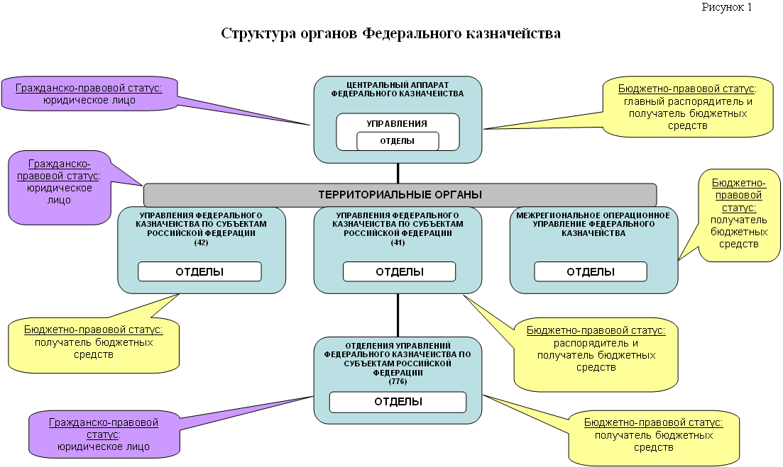

The Federal Treasury carries out its activities directly and through its territorial bodies in interaction with other federal executive power bodies, executive power bodies of constituents of the Russian Federation, local self-governing bodies, the Central Bank of the Russian Federation, public associations and other organizations.
OFT for constituents of the Russian Federation carry out their activities directly and through offices subordinated to them, the number of which as of the beginning of 2012 was 776.

The allocation scheme of territorial bodies of the Federal Treasury is approved by Order of the Ministry of Finance of the Russian Federation of December 30, 2011, # 510.

Organizational structure

The Central Office of the Federal Treasury:

- Management (Head (general manager) of the Federal Treasury, five deputies of the general manager, assistant of the general manager)
- Budgetary payment development office
- Budgetary accounting and reporting office
- Ensuring execution of the federal budget office
- Fiscal operation office
- Functional activities improvement office
- Internal control (audit) and performance activities evaluation office
- Administrative office
- Financial office
- Legal office
- Information system office
- Information secrecy and security office
- Financial technology office

Organizational and staff structure of the Office of the Federal Treasury for a constituency of the Russian Federation approved by decision of the Collegium of the Federal Treasury of October 27, 2010, and approved by Order of the Federal Treasury of March 3, 2011, # 58:

- Manager
- Deputy managers
- Manager’s assistant
- Revenue department
- Operational department
- Expense department
- Defense and law enforcement agencies service department
- Federal registries maintenance department
- Budget execution cash service department
- Budget accounting and reporting on budgetary operations department
- Internal control and audit department
- Administrative department
- Financial support department
- Information system department
- Engineering support department
- Information secrecy and safety department
- Human resource department
- State procurement department
- Legal department
- Mobilization training and civil defense department

Departments established for exercise of authorities of the Federal Treasury Office for the constituent of the Russian Federation in the relevant territory.

