**PEMPAL Treasury COP**

**Thematic Group Workshop on Cash Management and Forecasting**

**_____________________________________________________________**

**Ankara, Turkey**

[](http://www.google.com/url?url=http://turktrip.ru/ankara&rct=j&frm=1&q=&esrc=s&sa=U&ved=0ahUKEwjLy4nq7-PLAhVDVSwKHckKC24QwW4IFjAA&sig2=qH6A1tFlC-sFjBFp_xOozw&usg=AFQjCNHlVoHAtfMiRUksYoWsb4mrUXQpjQ)On March 16-18, 2016, PEMPAL Treasury Community of Practice (TCOP)[1] held a Cash Management Working Group (WG) meeting in Ankara, Turkey. The workshop was organized as part of the TCOP action plan implementation and was aimed at exchanging experiences regarding issues with Cash Management and Forecasting in TCOP member countries. The topic is of particular relevance for PEMPAL member countries as many have been gradually strengthening their cash management function and are interested in how to move from passive to more active cash management practices. The event also provided the opportunity to discuss and agree on key areas of focus for future events of the working group. The meeting was attended by 38 specialists representing 11 countries (Albania, Azerbaijan, Belarus, Croatia, Kazakhstan, Kyrgyzstan, Moldova, Russian Federation, Tajikistan, Turkey and Ukraine). The workshop was largely facilitated by the Turkish hosts, particularly **Mr. Ilyas Tufan**, Head of the Department of Cash Management, Prime Ministry Undersecretariat of the Treasury, supported by World Bank experts.[2] Logistical support was provided by the PEMPAL Secretariat based at the World Bank Office in Moscow.

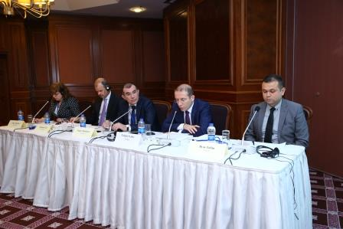**Mr. Tașkin Temiz**, Deputy Undersecretary, Prime Ministry Undersecretariat of Treasury, opened the workskop and commenced by expressing his condolences to those who died in the recent atrocities in Ankara. He welcomed the PEMPAL working group on Cash Management to Ankara, and expressed his expectations that all will learn from each other. Mr Temiz provided some background on recent Turkish PFM reforms including improved transparency, strengthened internal controls, ICT reforms, performance budgeting and of course cash management, the main theme for this event. The Law on Public Finance and Debt Management (2002) and the Law on Public Financial Management and Control (2003) also provided a strengthened platform for improvements in the following period, including a rejuvenation of the treasury single account (TSA) with daily transfers of idle balances to reduce the cash float and borrowing costs. **Mr. Vugar Abdullayev,** Chair of the PEMPAL Treasury Community of Practice, also expressed his condolences regarding the recent tragic events. He thanked the Undersecretariat of Treasury for its support in hosting this event and indicated how appropriate it was to be here in Ankara, given the strength of the system of cash management in government in Turkey. Cash management has heightened in importance given the recent challenges for many countries which have seen reducing cash flows, thus this event is very timely and useful for all participants. **Mr. Johannes Zutt,** Country Director of the World Bank, began by also expressing his condolences for the recent events. He also welcomed the TCOP working group on behalf of the World Bank Group. He reiterated the World Bank’s commitment to peer learning programs such as PEMPAL which has been very successful in this regard. He also indicted that Turkey is very much a leader in PFM reform and the Turkish participants are always very active, particularly in the area of cash management, with Turkey delivering presentations and involved in the TCOP working group at all previous events. **Ms. Elena Nikulina**, PEMPAL Team Leader, World Bank, followed by also thanking the hosts for inviting the PEMPAL Working Group to Ankara. She particularly thanked Mr Ilyas Tufan, and his Department of Cash Management for putting together this excellent agenda. Ms Nikulina indicated that this is a relatively recent WG. It started with a series of thematic videoconferences (VCs) which saw some of the highest participation levels of any VCs since PEMPAL TCOP started. In 2015 at the annual TCOP plenary meeting in Tirana, Albania, cash forecasting and TSA design were core themes for the event. It was clear that a further specific event on this topic was required and so the PEMPAL Leadership Group approached Turkey, given its strong track record.

The thematic program started with presentations by the host country primarily delivered by specialists from the Ministry of Finance of Turkey. **Mr. Turgay Cetin,** Finance Expert, General Directorate of Budget and Fiscal Control, MoF, delivered the first presentation on the Turkish legal framework in relation to PFM, in particular the Law on Budget (5018). Mr Cetin, indicated that the Turkish PFM system is anchored in article 161 of the Constitution which determines that the annual budget is the key financial allocation and control mechanism for public finance. Underpinning this is the Law on Budget. The law defines a three-year (one year actuals and two years of forward estimates) budget and requires the government to define the medium and long-term macro fiscal and policy framework. The three-year budget includes key targets such as the deficit, and the underlying estimates of revenues and expenditures. Turkey has an E-budget web-based system that allows quarterly releases from the appropriations. The releases are based on agency requests and a review of the current capacity of Turkey for spending releases.

**Mr. Mahmut Varol**, Head of Department, General Directorate of Public Accounts (GDPA), MoF, gave the second presentation on the role of his department in cash management. The GDPA is responsible for developing the public accounts system including the supporting ICT, monitoring the system’s performance, training and certifying the capacity of accounting officers, and for compiling and publishing financial statistics. KBS which is an integrated financial system (figure below) underpins public finance management in the Turkish government. The system includes six subsystems which together support overall public accounting. KBS covers 2300 accounting units and 60,000 spending units, and has over 432,000 users, including 150,000 users who are using the system as a core part of their PFM roles in government. Each accounting unit has a payment and collection account in the Central Bank, and these sub-accounts feed up into a consolidated TSA. A key feature of the system is that each payment has a scheduled payment date – this enhances cash management and forecasting capacity, as the timing and values of all cash outflows are clearly known.

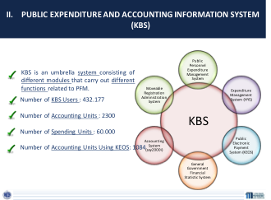

**Mr. Murat Ozgur**, Head of Group, Revenue Administration, MoF, delivered the third and final presentation for the first session of the workshop on the main sources of revenue for Turkey, and the systems for collection. Turkey allows clients to pay taxes and other revenues in a number of different ways including by cash, cheque, through the use of debit/credit cards, paying directly at a bank or post office, or via internet banking. At the end of the day each taxes collected by the tax offices are transferred through Ziraatbank, which is then consolidated centrally in that bank, before being swept to the Central Bank TSA. Taxes collected by the commercial banks are directly transferred to the Central Bank. The banks do not transfer money the same day – cash is transferred within 3-7 days, and for credit cards on the 20th day after receipt.

The second session of Day one focused on Cash Management and Forecasting in Turkey and was led off by **Mr. Emrah Pilavoglu**, Treasury Expert, Cash Management Unit, Prime Ministry Undersecretariat of Treasury. Treasury receives cash and information from a range of different sources as reflected in the slide below. The Treasury sets an annual cash plan well in advance of the coming year, and this informs the borrowing schedule required. Once the year starts the plan is updated daily and TSA balance forecast is produced daily, for three months in advance. Turkey has an electronic Cash Request System (CRS) implemented in 2011 and used by nearly 200 public institutions and this informs the forecast. Monthly meetings are also convened with large spending agencies to verify the likely flows. The Debt Department is also provided with regular updates accordingly. Following all the consultations a draft plan is prepared and submitted to the Director General for endorsement and then the final monthly cash plan is approved by the Undersecretary. In 2011 all payment accounts at Ziraat Bank were closed and reopened at the Central Bank. The Treasury sets key performance indicators for its cash forecast on a yearly basis and the deviations from the daily cash program are monitored each day. Significant variations are investigated and the causes are determined. The Treasury is also audited by the Court of Accounts regarding their performance in this area. Turkey receives market rate interest on balances in the TSA; and it is seeking to reduce idle balances. Both the Central and Ziraat Banks receive fees for banking services, as defined in bilateral agreements with the Treasury.

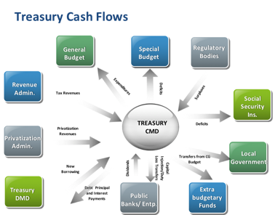

The Treasury has implemented a risk management approach to managing the cash position. It has established a liquidity buffer where it defines the minimum target levels of the TSA and the daily cash reserves required and maximum target levels for foreign exchange balances. If it envisages to fall below the minimum required balance the short term borrowing takes place to ensure an adequate cash buffer remains in place. The liquidity buffer:

* ensures market confidence
* gives positive signals to investors
* prevents a liquidity squeeze in the market; and
* helps Turkey cope with periods of market volatility.

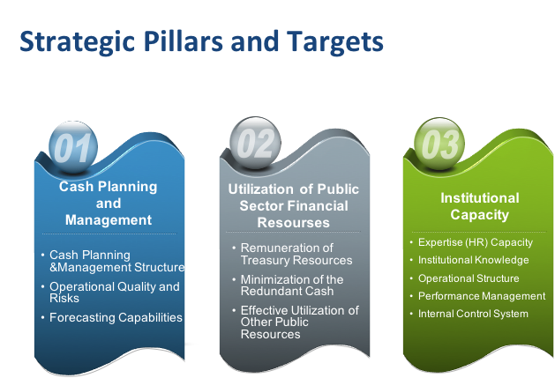

The second presentation for session two provided an insight on Turkey’s Strategic Roadmap for Cash Management and was delivered by **Mr. Ilyas Tufan**, Head of Department of Cash Management, Prime Ministry Undersecretariat of Treasury. The slide below shows the three pillars of the Strategic Plan:

Turkey has also developed key strategies to achieve maximum results for each pillar and identified the gaps and challenges for each of these areas. This in turn provides the roadmap for addressing each gap and the development of an integrated strategic plan. The PEMPAL network was very impressed to learn that Turkey has undertaken such an important planning process, and now has a clear roadmap for further reforms and development.

The afternoon session of day one began with a presentation by **Dr. Kircicegi Korkmaz**, IT Specialist, Central Bank of Turkey. The public electronic payments system (PEPS) is fully automated. Payments are created and approved in accounting offices of budget institutions before being consolidated centrally in the MoF. The MoF then passes the payment file through to the Central Bank before it is loaded into the interbank payment system. Every accounting office has a domestic payment account and a domestic revenue account at the central bank. Account balances are consolidated daily to determine the government’s overnight cash position and to maximize the return on its balances and minimize borrowing.

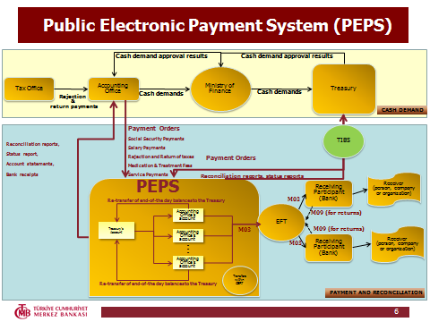

The second presentation for the afternoon was delivered by **Ms. Gulten Sanlialp,** Branch Manager, Ziraat Bank on the role of the bank in the government payment system. Ziraat Bank represents one seventh of the Turkish commercial banking sector and has 1,800 branches across Turkey, with further branches located in 18 countries. An operational protocol is signed each year between: Ziraat Bank and the Central Bank with the approval by the Treasury and the MoF. The bank holds over 1,500 accounts for the MoF, for all of the accounting offices (equivalent of a regional treasury office). Historically, there was no central reporting structure, thus all arrangements were deconcentrated between bank sub-offices and the accounting offices. This has recently changed with arrangements now more centralized.

The final session on Day one was small group discussions on the presentations by the Turkish hosts. Each group was asked to discuss the strengths of the Turkish PFM and cash management system and the challenges. Box 1 (Below) summarizes the key points raised by participants.

|  |
| --- |
| **Box 1**  **Group Discussions - Key Observations on day one -  Turkish PFM and Cash Management and Forecasting System**  **Strengths**   * Annual, monthly and daily cash planning updated on a rolling three month basis * Plans are received directly from spending units. Even privatization revenues are very closely monitored to the specific day and even hour (very large flows) * Error margin of 5.5% for revenues and 4.5% for expenditures (reduced gradually from year to year) which is a challenging performance target and something on which the Treasury’s performance is monitored (Court of Accounts) * The role of the Treasury in overall central government cash control for the state. The Treasury is subordinate to the Prime Minister not MoF which strengthens its influence. * Insourcing of accounting function saves on costs for government. MoF undertakes an accounts processing role for the ministries and provinces * The partnership with Ziraat Bank eliminates the need for duplicating functions within government * Treasury’s accounts are remunerated at the Central Bank which reduces some of the investment risk for the Treasury * High degree of automation and timely provision of information * Strong understanding of future requirements through the Cash Management strategic planning process   **Challenges**   * Coordination between MoF and Treasury for budget execution given the traditional role is split between two bodies – in some cases the MoF and Treasury may have different views on issues * 10-15% of the general government operations are not in the TSA * Limited current use of shorter term borrowing and investment instruments although there are plans for the future * Public institutions are not always able to provide the more specific information required for analysis * Delays in collecting revenues for tax and credit cards – this is in lieu of direct payments to the commercial banks – but is it the optimal arrangement for Turkey? * Rigid legal framework which will inevitably mean the need for further amendments in the future in order to incorporate planned improvements   **Further issues to Explore**   * What are the incentives for the line ministries to forecast accurately? |

The World Bank advisors were asked to comment on the final session and the day as a whole.

**Mr. Mark Silins** indicated that the strengthes of the Turkish system were its level of automation and integration, the access to timely and relatively reliable information for determining future cashflows, and the strong performance management framework which has been developed. The Stategic plan is also a useful model for ensuring that future reforms are targetted and properly sequenced. The key challenges are the delays in revenue collections being transferred to the TSA, the coverage of the TSA which should ideally be expanded, and some of the reported rigid requirements included in laws, which seem on occasion to be driving sub-optimal arrangements. One thing the final discussions showed was that there are many similarities across countries but there also remain many differences. This is due to historical reasons, each government’s appetite for risk and other local challenges. This event provides an opportunity for each country to question how they are currently undertaking cash management, given that other countries are doing things somewhat differently. Are the institutional arrangements and business processes in our country optimal? Stepping back from your own country environment and understanding how other countries do things differently provides opportuntiies for you to consider to undertake further improvements.

**Mr. Mike Williams** provided the following comments:

Many of the countries represented at the meeting have made considerable progress in developing their cash management systems. In particular they have a good practice TSA, which brings together most government cash (albeit there are still some extra-budgetary funds, social security funds etc outside); and modern payment and information management systems which can ensure that there is never any need for cash to lie idle in spending units’ bank accounts. At the same time there has been good progress in cash flow forecasting, with some countries able to look more than three months ahead and on a daily basis at least for the early part of the forecast period.

Many countries are therefore able to lift their eyes to a new horizon – which means thinking about what more active cash management might require – i.e. the use of short-term borrowing and lending instruments in such a way as to smooth cash flows somewhat, with all the benefits that that potentially brings. But that gives rise to new and rather different challenges, for example:

* The availability of suitable instruments (very short-term borrowing instruments, reverse repo or collateralised deposits).
* The skills to manage such instruments (including management of the collateral, except insofar as that can be contracted out).
* How much weight can be placed on the forecasts; including any prudential margin; which in turn is one of the factors feeding into the calculation of the cash flow buffer.
* The institutional arrangements; who has responsibility for what, and how are debt and cash management best coordinated (or integrated)?

This is a wider agenda; which opens up new issues; not least HR and organisational issues – but it will be next phase in the development of cash management for many member countries.

**Day two** was faciliated by **Ms. Elena Nikulina** who introduced the key topics and reminded participants about the results of discussions on cash management and forecasting issues that the TCOP had at the May plenary meeting in Tirana which shaped the agenda of the Ankara event. One of decisions taken by the TCOP Executive Committee after the Tirana meeting was to undertake a thematic survey on the TSA, cash management and forecasting issues.

The agenda of the day commenced with **Mr**. **Mark Silins**, World Bank Advisor, delivering a brief report on the results of the survey. All eleven countries attending the event responded to the survey which extended to over 30 questions. The slide[3] below shows the country responses to what is included in each countries TSA.

**The key findings of the survey were:**

* TSAs are primarily held at the CB – this is considered the choice of least risk for countries
* Coverage of the TSA is relatively comprehensive – but almost every country has further opportunities for consolidation
* In a significant number of instances payments are not made directly from the TSA which may result in funds leaving the TSA too soon, reducing potential overnight cash balances
* Further analysis maybe required to determine whether the timing for all funds entering and leaving the TSA optimize the cash balance
* Countries are not always being remunerated for their cash by the Central Bank or commercial banks
* In two instances commercial banks are allowed access to a cash float – resulting in delays for revenues being transferred to the TSA. It would be important to have an objective assessment of the costs verses the benefits of these arrangements
* Three countries still have cash or cheque payments. These are expensive and higher risk payment options for countries
* While countries indicated very few additional bank accounts, seven indicated they are remunerated for balances held in commercial banks. Further investigation is required to determine whether these are government operational accounts or for investment purposes only
* While six countries forecast the daily cash position one month in advance, five forecast one week or less in advance. Good practice recommends moving towards a three month rolling daily forecast
* Eight countries target the cash balance of the TSA and eight also target a cash buffer. Six countries do both.

It was proposed to expand the survey to include all PEMPAL countries and to also benchmark the results of this survey with an earlier survey conducted in 2010.

Day two continued with three country presentations on the TSA and cash management arrangements from Moldova, Albania and the Russian Federation.

**Ms Natalia Apostol**, Head of Forecasting and Cash Management, State Treasury, MoF, Moldova, delivered the first presentation. Natalia provided a brief history regarding the evolution of the TSA in Moldova, its structure and coverage. Importantly, recent reforms have seen a significant expansion regarding the coverage of the TSA to include the health and social funds and extrabudgetary institutions. Local budgets also continue to be included in the TSA. Natalia summarized the key issues and challenges faced by the State Treasury of Moldova in the process of developing TSA as:

* Resistance from central and local authorities to transfer cash to the TSA;
* Imperfect legal basis for cash management;
* Imperfect information systems;
* Treasury requirements for the recording and control of cash (application of Budget Classification and the Chart of Accounts);
* Political and economic instability;
* Instability of financial-banking sector; and
* Lack of qualified staff.

The second country presentation was delivered by **Ms. Mimoza Pilkati**, Director of the Treasury Operations Department, MoF, Albania. Mimosa provided background on the evolution of the TSA in Albania and provided specific details on how Albania targets the cash balance of the TSA. It has a minimum balance which is the maximum likely cummulative cash requirements over a three day period, which is approximately 3 billion lek, and the ceiling, which is the average expenditure requirements for statutory expenditures over a one month period, which is 9 billion lek.

Furture reforms for Albania include:

* + Expanding the TSA coverage by including all government-funded entities, including the autonomous and statutory government bodies as well as extrabudgetary funds (EBFs) and special accounts;
  + Donors to be encouraged to integrate their funds with the TSA or, at a minimum, to route final payments through the TSA;
  + Centralization of revenues collection;
  + Implementation of an integrated FMIS based on the functioning treasury infromation system;
  + Developing a liquidity forecasting programme; and
  + Improving TSA’s integration with other policy areas.

The final country presentation was delivered by by **Mr. Stanislav Prokofiev**, Deputy Head of the Federal Treasury of Russia. The TSA coverage at the federal level includes the budgetary funded entities, the autonomus bodies that receive transfers and collect own revenues and the three major extra budgetary funds. Further expansion to the members of the federation is planned but on a voluntary basis. The MoF maintains a cash buffer in a reserve fund, which the TSA can access as required. Future plans are to consolidate the constituent (provincial) and local government bodies into a master account, which goes beyond the TSA, to include the equivalent of TSAs at the subnational levels. Forecasting will thus be undertaken for the whole country. Forecasting will commence at the municipal level, and cascade upwards to the member of the federation and finally to the consolidated federation forecast prepared by the Treasury. The slide above highlights the instruments available to the Russian Federation for liquidity management. This includes forward (term) REPOS which go beyond overnight and relate to an agreed rate for a date in the future. Russia holds auctions for this purpose and the forward REPOS are collatoralized. Treasury will also be seeking to undertake foreign exchange transactions in 2018 on behalf of other bodies (eg universities), rather than those bodies doing these transactions bilaterally and on a less competitive basis.

The final presentation for day two was by **Mr.** **Mike Williams,** World Bank Expert, on Targeting the Cash Balance: the Cash Buffer. Mike indicated that there is no simple answer for the development of a cash buffer, but he offered a simple toolkit that could help in designing the buffer. He further indicated that it was useful to distinguish between the transactional buffer, which reflects the day to day cumulative volatility, from the the safety buffer, which reflects the chance of a failure in the markets and access to liquidity. Countries should have a financing continuity plan alongside their business continuity plan to plan for the possibility of failures or major catastrophic events. A summary of the presentation is highlighted below:

* Cash buffers is just one part of the ”financing continuity plan”
* Need to also consider:
  + Underlying volatility
  + Ability to forecast and take advantage of the forecast
  + Ability to react
  + Safety nets
* Distinguish between a transactions buffer; and a safety or precautionary buffer
* Avoid formulaic approaches: identify the drivers and consider the opportunity cost
* Are there signalling advantages from telling the market what the buffer is?

The afternoon of day two was devoted to participants forming two smaller groups for discussions on how to expand the operations of the TSA and whether countries can, and should, target the TSA balance and establish cash buffers. On Day three the two groups reported back to the full session with the key points from the groups reflected in Box 2 below:

|  |
| --- |
| **Box 2 – Summary of Group discussion on Day Two**   * **Problems faced by countries in extending the TSA coverage**   *Group 1*   * “Efficiency-Autonomy dilemma” - efficiency focus for whole of government for cash management verses the right to autonomy for each entity * Different actors with different autonomous legal frameworks and institutional structures * Availability of IT technology and supportive legislation to effectively design the system * Increasing institutional coverage of the TSA makes for a more complex forecasting process * Special accounts for investment projects and donor funds are still present in several countries. Separation might be a condition of donors * Challenges with expanding integration and TSA coverage when you have COTS software – who will undertake the upgrade?   *Group 2 (Elements not currently included in the TSA)*   * Azerbaijan - Investment projects financed by donors * Belarus - Local budget funds, special funds of public institutions, investment projects financed by donors * Kyrgyzstan - Social fund, medical fund, investment projects financed by donors * Kazakhstan - Pension fund, self-financing public institutions * Russia - Budgets of the Russian Federation constituents, municipalities, foreign exchange assets * Ukraine - Foreign exchange assets * **Overcoming these Issues**   *Group 1*   * Defining the concept of autonomy properly – autonomy does not mean no accountability nor does it prevent centralized processing * Idle balances in various accounts will often mean you are borrowing your own money (idle government balances within the banking system) * Convincing policy makers by quantifying the potential benefits of an extended TSA * Incremental extension of the TSA by obtaining “buying in” from autonomous institutions * Innovative payment systems and services which will attract autonomous bodies * Establishing appropriate accounting systems and using chart of accounts to segregate and control cash balances for autonomous bodies and development partners   *Group 2*   * A political decision at the highest level (in Russia, the transfer of the Pension Fund to TSA was announced in Presidential Address) * Incentives through interest rates (to provide compensation for possible loss of revenue from independent depositing) * Assurance of quality, sound and continuing service, risk minimization   **Challenges in targeting the cash balance and creating a cash buffer**  *Group 1*   * Lack of efficient interaction between stakeholders involved in the process * Lack of infrastructure for cash planning * Insufficient resources for cash buffer * Lack of appropriate risk management framework (credit, market and operational risks) * Forecasting what should happen instead of what will happen   *Group 2*   * Only one country in the group applies the mechanism of targeting cash balance / buffer (Russian Federation); the mechanism has been operating without problems * The other countries have not yet felt an urgent need for creating such a tool, the environment has not yet developed, although the issue could be considered for the future * In some countries, there is a stable cash surplus - Azerbaijan, Kazakhstan * In several countries there are reserve funds that can be used to bridge cash gaps, as well as a possibility to attract funds from the Central Bank * In the countries where there are no such sources, they have to resort to cash rationing in difficult periods * Short-term cash gap financing instruments are still not well developed in the majority of countries (in most cases, the redemption period of treasury securities is 3 months and more - short-term bills are not developed; Russia is an exception - REPO and other instruments) * No trained human resources to carry out active cash management transactions   *Possible Solutions*   * Closer collaboration with debt managers * Better interaction with stakeholders (eg Central Bank) * Establishing a strong risk management infrastructure * Cash forecasts should be based on realistic budgets * Publishing cash buffer or not – the group felt that there were benefits and also risks in publishing the information on the amount of cash buffer and therefore the decision needed to be taken after an assessment of both. |

Following the group reports Mark Silins and Mike Williams were asked to field general questions from the plenary group. They were also invited to comment on the group presentations and process, along with the workshop as a whole. They provided the following key observations:

* Scope of TSA – generally speaking coverage should be as broad as possible within general government – the TSA would not normally extend to government business enterprises. Thus it would ideally include funds, special means, autonomous general government bodies that are delivering government functions. If bodies are largely funded by government revenues, even if they retain them for their own operations, they probably should be included in the TSA.
* Cash management should be considered from a whole of government view to eliminate fragmented policies and management –autonomy should not be at the expense of efficient cash management.
* It is important to undertake an objective assessment of the costs to government of retaining idle balances outside the TSA - this is what will influence decision-makers.
* Why borrow money in government when you have idle cash balances – this does not make sense – effectively you are borrowing to finance your own money and paying interest on it.
* Skills – Active cash management is as challenging as debt management – understanding money markets is a common skill set. Ideally the function should be centralized to ensure a concentration of expertize.
* Development Partner accounts – DPs have in general signed up to an agreement to use country systems – but they need assurance that their funds are safe from misuse/ reallocation.
* How to ensure proper autonomy continues? If you want to consolidate you cannot remove organizational autonomy to make decisions – you should offer a client service, and ensure you always deliver against those services;
* Insourcing opportunities – accounting operations and processing – If Treasuries provide quality payment services this can be offered to autonomous bodies as an incentive! This will require a unified CoA and the ability to aggregate and separate cash balances within the general ledger.
* Cash management and forecasting have a natural developmental progression on which countries need to focus. Gradually moving from passive to active cash management - consolidation in a TSA; building capabilities to report cash flows each day in the system; improving forecasting abilities; rough tuning and then fine tuning.



Mike Williams also shared a number of further slides which highlighted the integration of cash flow management and forecasting with other PFM policy processes (left) and how to move from passive to active cash management. This will be used for further discussions via Video conference in the near future.

The concluding session of the workshop focussed on future activities for the Working Group. A list of the key topics identified for further discussions appears below:

* Role of the treasury in cash management
* Risk management as part of cash management
* Approaches to improve cash management (instruments, automation, HR capacities, etc.)
* Use of financial instruments for cash management
* Interaction between the cash management and debt management functions

Participants suggested, also, to organize group study visits to the countries with advanced experience in cash management (Sweden, Russian Federation)

The next TCOP event at which cash management issues are expected to be addressed will be TCOP plenary meeting planned for early June 2016 in Chisinau, Moldova.

All the workshop materials can be found at the PEMPAL website:

<https://www.pempal.org/events/pempal-tcop-thematic-group-meeting-cash-management>

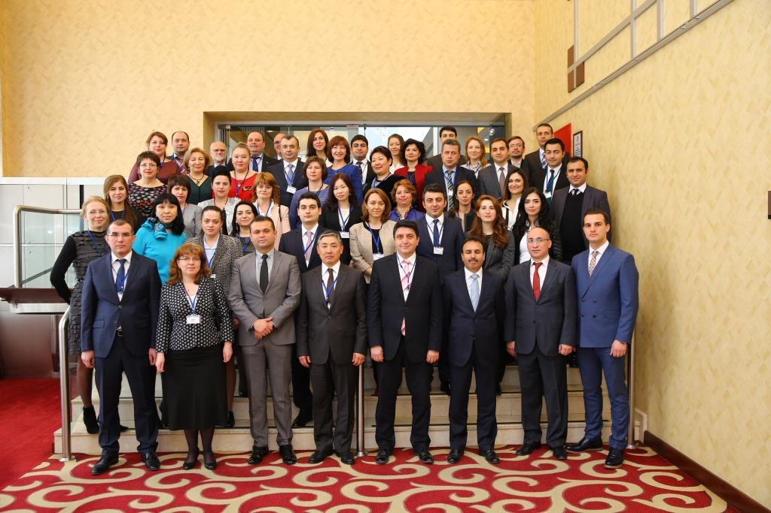

1. **The Public Expenditure Management Peer-Assisted Learning network** (PEMPAL) is aimed at improvement of efficiency, effectiveness and transparency of public expenditures in the countries of Central and Eastern Europe and Central Asia. The program supports activities aimed at uniting practicing specialists in the field of public finance in communities of practice for the purpose of peer learning by means of benchmarking performance results for conducting reforms in the area of public finance. For additional information about PEMPAL, please visit: [www.pempal.com](http://www.pempal.com).
2. Elena Nikulina, Ion Chicu, Lilli Razlog, Mark Silins and Mike Williams
3. The no response to tax and non-tax revenue in the TSA refers to whether there is full coverage of all tax and non-tax revenues. This in the two countries responding no, some tax and non-tax revenues are not included in the TSA