PEM PAL BCOP SV to CROATIA
FEEDBACK SURVEY

On December 1-4, 2015, peer-learning visit of PEMPAL BCOP on budget transparency and participation took place in Croatia. After the event, the on-line survey in three languages was created. The aim of the survey was to receive event feedback.

Link to the survey – https://ru.surveymonkey.com/r/CYQQYZS

The survey started to collect responses on December 8 and finished on December 14, 2015.
Invitations to take part in the survey were sent to 19 participants of the visit, which includes six representative from the host of this visit (Ministry of Finance of Croatia), two members of the Resource Team/Secretariat and eleven visitors from PEMPAL countries.
12 responses (63.2%) were received. In this report, we analyze all 12 responses. For further calculation, we take this quantity as 100%.
All these responses will be included in the general Feedback Event Database. All responses are not identified by source and sent on a confidential basis to Nina Duduchava of the World Bank who prepares this report.
The questionnaire comprises five parts: About the Respondent, Event Delivery, Event Administration, Overall Impression, and Recommendations for the Future. There are a total of 23 questions.
ABOUT THE RESPONDENT

Q1 You are..

12 (100%) respondents gave answers.
Answer Options | Response Percent | Response Count
Representative of PEMPAL member country | 58,3% | 7
Representative of BCOP Executive Committee | 25,0% | 3
Resource person | 8,3% | 1
Invited speaker | 8,3% | 1

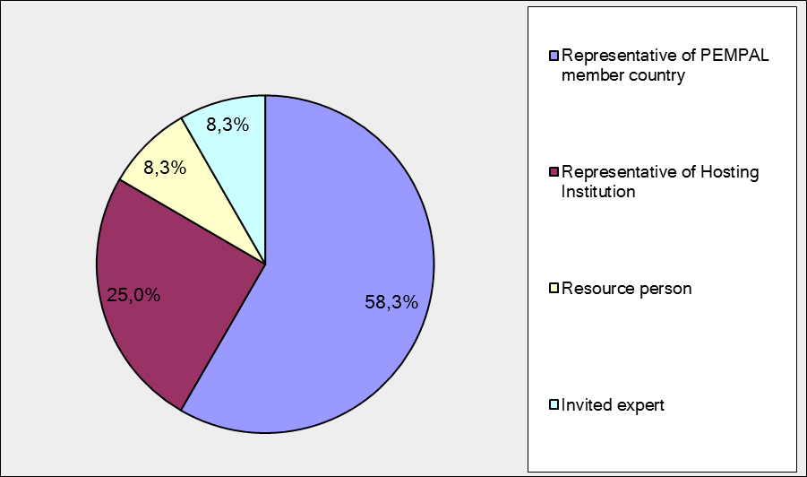
Q2. Was this your first participation in a PEMPAL event?

12 respondents (100%) answered this question.

Answer Options | Response Percent | Response Count
Yes | 33,3% | 4
No | 66,7% | 8

Q3. How many PEMPAL events have you attended before?

This question was seen only by those respondents who chose “No” in the previous question.
8 respondents answered this question.

1-2 | 3-4 | 5-6 | more than 6 | Response Count
0 | 5 | 1 | 2 | 8
PART I EVENT DELIVERY

Q4. How do you rate your participation in this event?
12 (100%) answers were given.
Answer Options | Response Percent | Response Count
Active | 75,0% | 9
Average | 25,0% | 3
Passive | 0,0% | 0

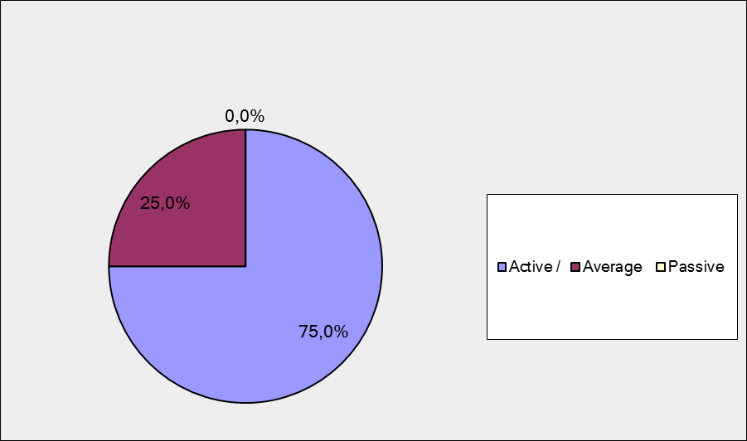

Q5. How do you rate the duration of the event overall?
12 respondents (100%) answered this question.

Answer Options | Response Percent | Response Count
Too short | 16,7% | 2
About right | 83,3% | 10
Too long | 0,0% | 0

Q6. How much do you agree with the following statements about the participants of the event?
12 respondents (100%) replied to this question.
Answer Options | 1 strongly disagree | 2 | 3 | 4 | 5 Strongly agree | Response Count | Average
a) The level of the event was appropriate for a person with my experience and knowledge | 0 | 0 | 1 | 2 | 9 | 12 | 4,7
b) I learned from the experience of other participants in the event | 0 | 0 | 0 | 3 | 9 | 12 | 4,8
с) Participants had about equal level of prior expertise relevant to the event topics | 0 | 2 | 0 | 6 | 4 | 12 | 4,0
d) Content of presentations, hand-outs and other materials were appropriate for a person with my level of knowledge | 0 | 0 | 0 | 3 | 9 | 12 | 4,8
Q7. How much do you agree with the following statements about the content design of the event?
12 responses (100%) were received.
Answer Options | 1 strongly disagree | 2 | 3 | 4 | 5 Strongly agree | Response  Count | Average
a) The event agenda was properly planned | 0 | 0 | 0 | 1 | 11 | 12 | 4,9
b) The content of the event was properly prepared | 0 | 0 | 0 | 1 | 11 | 12 | 4,9
с) The event addressed issues important to my work | 0 | 0 | 0 | 2 | 10 | 12 | 4,8
d) The event covered a right number of topics for the amount of time available | 0 | 0 | 2 | 3 | 7 | 12 | 4,4
e) Presentations made during the event were relevant and useful | 0 | 0 | 0 | 3 | 9 | 12 | 4,8
f) Enough time was reserved for questions to speakers | 0 | 1 | 1 | 5 | 5 | 12 | 4,2
3 comments were left:
- Overall, events in Croatia were of the highest level of quality. I liked the study tour to Rijeka. The presentations we heard were presentation. Many thanks for useful SV and useful knowledge acquired, it will be helpful for me.
- As a representative of the host country I think that the study visit meet my expectations. I apologize if I'm not objective.
- The schedule/duration of the meetings could have been more flexible in order to digest more carefully the wealth of information we received.
Q8. How much do you agree with the following statements about the outcomes of the event?
12 responses (100%) were received.

Event objective has been achieved: | 1 strongly disagree | 2 | 3 | 4 | 5  Strongly agree | Response Count | Average
a) To explore Croatian experience in implementing reforms on budget transparency and participatory budgeting, at both State and local government. | 0 | 0 | 0 | 3 | 9 | 12 | 4,75
b) To hold face-to face meeting of the BCOP Working Group on Budget Transparency and Literacy, including a working session to prepare Group's next meeting and knowledge products. | 0 | 0 | 0 | 2 | 10 | 12 | 4,83
3 comments were left:
- For my own use, I I investigate the Croatian experience in the implementation of reforms on improving budget transparency and proactive budgeting at the state level. At the local level it is too early for us, not for our mentality.
- It was very interesting to find out about the experience of Croatia, an EU country. In terms of applying similar practices in my country, I express only some possible reserves about IT system transparency in terms of protection of personal data.
- Croatia shared its experience with honesty andenthusiasm, which we greatly appreciated..
PART 2 EVENT ADMINISTRATION

Q9. Please rate the quality of the organization and administration of the event:
Answered question – 12 (100%).
Answer Options | 1 low | 2 | 3 | 4 | 5 high | Response Count | Average rating
Quality of organization | 0 | 0 | 0 | 2 | 10 | 12 | 4,8
Quality of administration | 0 | 0 | 0 | 0 | 12 | 12 | 5
There were left 3 comments.
It was very inconvenient having to travel to a third country to get the visa for Croatia. Maybe it is possible to get a visa in advance and send to the country of the invited person?
There were no problems with any of the logistics (transport, accommodation ...). It is great to have such events where everything fully adheres to the agenda.
Q10. Did you receive agenda and event information in sufficient time before the event for them to be useful?
12 (100%) answers were given. And all the responses were “Yes”.
Q11. Did you receive practical information (about the accommodation and other facilities, etc.) prior to the event?
12 (100%) answers were given. And all of them were “Yes”.
Q12. Are you satisfied with the quality of simultaneous interpretation provided during the event? Q13. Are you satisfied with the quality of written translation of event materials?
12 responses were given (100%) to Q12 and Q13.
Answer Options | 1 low | 2 | 3 | 4 | 5 high | Response Count | Average rating
Simultaneous interpretation | 0 | 0 | 1 | 3 | 8 | 12 | 4,6
written translation | 0 | 0 | 1 | 1 | 10 | 12 | 4,8
There were left 3 comments to Q12 and 2 comments to Q13.
Q12
I am very satisfied with the interpretation.
Since the allotted time was short, the translator did not always had time to translate everything. Given the difference in technical terms from different countries sometimes participants need a little more time for reflection to digest all of the information.
Q13
I was satisfied with the written translation.
PART 3 OVERALL IMPRESSION
Q14. Did the event disappoint, meet, or exceed your expectations?

There are 12 (100%) answered question.

Answer Options | Response Percent | Response Count
Disappoint | 0,0% | 0
Meet | 58,3% | 7
Exceed | 41,7% | 5

Q15. What did you like most about the event?

10 comments were left.
- Practical examples / presentations of employees in the local government and the ways to motivate citizens to greater involvement in the budgeting process.
- Presenters professionally covered their topics, the cultural program was very rich and informative and well planned. The sessions offered a great coverage of topics on the reform of the Croatian economy. We appreciated that the host Ministry of Finance arranged also for the presentations of the representatives from the local government levels to share their experience with our Working Group. The Secretariat and the Resource Team representatives worked professionally, harmoniously, and timely.
- Most of all I liked the study visit to Rieka where we met and shared experiences with the representatives of the local government authorities. A well-prepared event.
- Great organization and a great contribution of the participants as well.
- I liked everything.
- The level of information. Very specific and useful.
- Active participation of all participants.
- The goals and objectives of the visit were achieved fully.
- The ability to see the formats of the actual budgets for citizens.
- It was a very warm reception from the Croatian side. The organization of the event was at a high level. A lot of useful materials and practical examples. The high level of competence of the speakers.

Q16. What did you not like most about the event?
4 comments were left. And 3 of them are like “I liked everything”
- It was inconvenient to obtain a visa in Istanbul. Due to the flight delay I was late to Croatian consulate, which is located in Istanbul.
Q17. Do you plan to brief your colleagues on this event?
12 responses were given (100%). And all responses (100%) were “Yes”.

Q18. How do you plan to brief your colleagues?
12 (100%) responses were given
Answer Options | Response Percent | Response Count
Share materials | 83,3% | 10
Make a presentation | 33,3% | 4
Prepare a back-to-office report | 75,0% | 9
No comment was left:
Q19. How much do you agree with the following statement?
12 respondents (100%) replied to this question.

Answer Options | 1 not at all | 2 | 3 | 4 | 5 completely | Response Count | Average
I will be able to apply the knowledge acquired at this event to my work | 0 | 0 | 2 | 3 | 7 | 12 | 4,4
Q20. How can you apply the acquired knowledge?

10 comments were left.
- Apply in practice.
- The received materials will be useful in the preparation of regulations and guidelines on transparency and budget literacy, in the most important areas of the gained knowledge, and in introducing reform strategy
- In our country, a project of the European Union works within the Ministry of Finance. I will use Croatian experiences as the basis for defining our needs in terms of budgets for citizens, in which we can get technical support by this project.
- By using the experience of other countries, as well as independent experts from the host country in my daily work.
- I will participate on development of budget for citizens in my country and will use Croatian experiences.
- I will try to influence the budget process to become more transparent.
- Together with colleagues from the ministry I will try to increase the transparency of the budget and to fix improve my country’s OBI rankings.
- I will try to adapt the learned lessons in my country,
- I will apply lessons learned immediately upon return, including the lessons learnt from our discussion with the colleagues from Croatian local government level, in particular to conduct a survey regarding the citizens' proposals for the allocation of next year's budget.
- On the basis of the report on the study tour, I will make a number of proposals for improving budget transparency tools in my country.
Q21. Overall, my satisfaction with the event was...

Answered question – 12 (100%). All respondents considered themselves as Highly satisfied (5)!

RECOMMENDATIONS FOR THE FUTURE

Q22. Do you have any suggestions to improve the content, approach and other aspects of such events in future?

3 comments were left with suggestions.

It would be good if other countries of this working group can in future also demonstrate their experience in more detail.

I’d like to have one of themeetings from agenda in the working office of colleagues from the host-country.

To make a schedule of presentations a little bit more relaxed in orderto provide more time for discussions, because the participants could communicate more in the format of "round table" on each given topic. This would help us continue to think in the same direction.

Q23. Are there any other products, research or services that PEMPAL could provide that would be useful for your work?

4 informative comments were left.

1. I would like to continue studying this theme, we need more information.

2. Developments of a budget for the citizens at the local level. Materials on financial and fiscal decentralization.

3. I am interested in the topic of budget transparency.

4. Probably it would be useful to have more information about the budgetary system (even just schematically) of all countries members, basic laws (budget, taxes).

