PEMPAL BCOP EXECUTIVE COMMITTEE MEETING IN PARIS FEEDBACK SURVEY

On July 6—7, 2017, the PEMPAL BCOP Executive Committee meeting took place in Paris, France.
After the event, the on-line survey in three languages was created on the base of the standard set of questions developed by Secretariat. The aim of the survey was to receive event feedback and to learn plans for the future.

Link to the survey – https://www.surveymonkey.com/r/PT2GKF5

The survey started to collect responses on July 10 and finished on July 19, 2017.
Invitations to take part in the survey were sent to all participants of the event. We sent 14 invitations.
9 persons started to response to the survey. From these 9 responses 1 was from representative of PEMPAL countries, 6 — from members of BCOP Executive Committee, and 2 — from resource persons.
In this report, we analyze all 9 responses. For further calculation, we take this quantity as 100%.

All these responses will be included in the general Feedback Event Database.
The questionnaire comprises five parts: About the Respondent, Event Delivery, Event Administration, Overall Impression, and Recommendations for the Future. There are a total of 25 questions in the survey.
ABOUT THE RESPONDENT

Q1 You are...

9 (100%) respondents gave answers. Among them: 1 representative of PEMPAL countries (but not a member of Executive Committee), 2 resource persons, 6 members of BCOP Executive Committee.
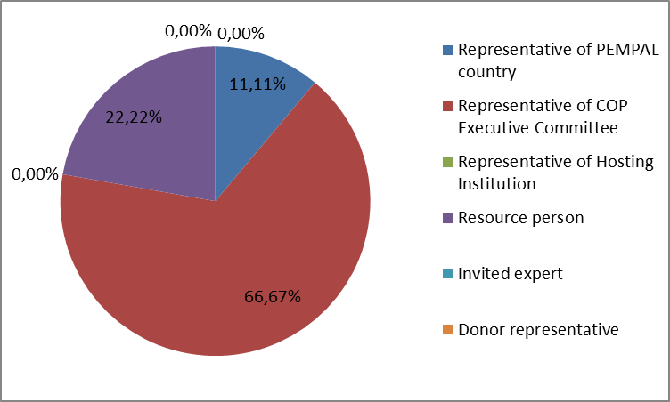

Q2. Was this your first participation in a PEMPAL event?

9 respondents (100%) answered this question. And 88.9% of them replied “No”.

Answer Options | Response Percent | Response Count
Yes | 11,1% | 1
No | 88,9% | 8

Q3. How many PEMPAL events have you attended before?

This question was seen only by those respondents who chose “No” in the previous question.
8 respondents answered this question.

1-2 | 3-4 | 5-6 | more than 6 | Response Count
0 | 0 | 2 | 6 | 8
PART I EVENT DELIVERY

Q4. How do you rate your participation in this event?

9 (100%) answers were given. 6 respondents think that their participation in the event was ‘Active’. 3 respondents think that their participation was ‘Average’. No one chose the option “Passive”.

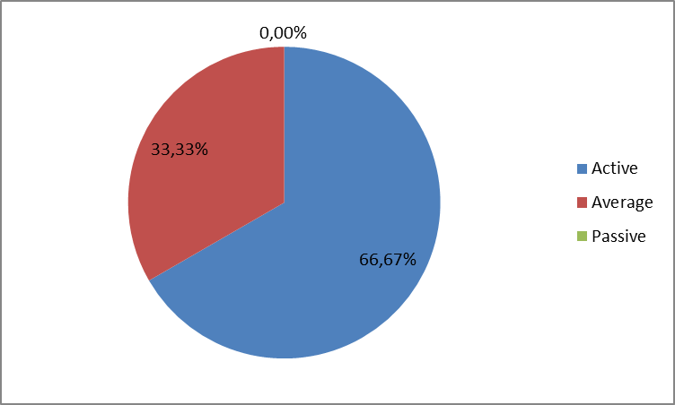

Q5. How do you rate the event duration overall?

9 respondents (100%) answered this question. And 100% of them rated the event duration as “About right”.
Q6. How much do you agree with the following statements about the participants of the event?
9 respondents (100%) replied to this question.
Answer Options | 1 strongly disagree | 2 | 3 | 4 | 5 Strongly agree | Response Count | Average
a) The level of the event was appropriate for a person with my experience and knowledge | 0 | 0 | 0 | 0 | 9 | 9 | 5
b) I learned from the experience of other participants in the event | 0 | 0 | 0 | 1 | 8 | 9 | 4,9
c) Participants had about equal level of prior expertise relevant to the event topics | 0 | 0 | 1 | 4 | 4 | 9 | 4,3
d) Content of presentations, hand-outs and other materials were appropriate for a person with my level of knowledge | 0 | 0 | 0 | 2 | 7 | 9 | 4,8
Q7. What have you learned from other participants?
5 comments were left.
- The session about recent developments of budget reforms in present countries at the beginning was very useful.
- Expense checks should be continued. It would be good to include them as an obligation in the Budget Law. Work on increasing of budget transparency and citizen literacy should continue to be actively included in budgetary processes.
- About their latest development on PFM reforms
- The most useful information was sharing other countries' experience in the area of spending reviews.
- Budget Transparency Toolkit was launched by OECD, GIFT, IFAC, and PEFA Secretariat. Also draft OECD toolkits on gender budgeting and performance budgeting were shared, and country cases of Iceland, Ukraine (gender budgeting); Germany, Croatia and Netherlands (spending reviews) were outlined. Discussions on the benefits and issues related to independent fiscal institutions were also discussed between participants.
Q8. How much do you agree with the following statements about the outcomes of the event?
9 responses (100%) were left.
Event objectives has been achieved: | 1 strongly disagree | 2 | 3 | 4 | 5 Strongly agree | Response Count | Average
a) Attend the 13th annual meeting of the OECD Senior Budget Officials' regional network for Central, Eastern and South-Eastern European Countries (CESEE- SBO) to discuss and share progress on performance budgeting and fiscal transparency reforms | 0 | 0 | 0 | 2 | 7 | 9 | 4,8
b) Discuss progress with action plan implementation and the required actions to implement the new PEMPAL Strategy 2017-22 | 0 | 0 | 0 | 2 | 7 | 9 | 4,8

No comments were left.
Q9. Please rate the quality of the leadership, management and/or technical services provided to the event by the following:
Answer Options | 1 low | 2 | 3 | 4 | 5 high | Response Count | Average
BCOP Executive Committee | 0 | 0 | 0 | 1 | 8 | 9 | 4,9
BCOP Resource Team | 0 | 0 | 0 | 0 | 8 | 8 | 5

3 comments were left:

As usual, the organization of PEMPAL events was performed impeccably and at the highest level.

Event organization is always at a high level.

Question 9 is a new addition to the survey template as agreed under the new strategy. The revised post-event survey template is being piloted for this meeting, given it is the first being held under the new strategy. We need to give thought as to whether the COP Executive Committees and/or resource teams should be able to rate their own skills as a group or the related question should be filtered out, based on them selecting that they belong to these groups in the earlier questions.
Q10. Please rate the quality of services provided by the event speaker(s):
Answer Options | 1 low | 2 | 3 | 4 | 5 high | Response Count | Average
Quality of service | 0 | 0 | 0 | 1 | 8 | 9 | 4,9
1 comment was left: All speakers have shown good knowledge of the subject.

PART 2 EVENT ADMINISTRATION
Q11. Please rate the quality of the organization and administration of the event:
Answered question – 9 (100%). All the ratings are best.
Answer Options | 1 low | 2 | 3 | 4 | 5 high | Response Count | Average
Quality of organization
- choice of venue | 0 | 0 | 0 | 1 | 8 | 9 | 4,9
- travel arrangements | 0 | 0 | 0 | 0 | 9 | 9 | 5,0
- event logistics | 0 | 0 | 0 | 1 | 8 | 9 | 4,9
- contribution provided by hosts | 0 | 0 | 0 | 2 | 7 | 9 | 4,8
Quality of administration
- Secretariat staff responsiveness | 0 | 0 | 0 | 0 | 9 | 9 | 5,0
- written communication | 0 | 0 | 0 | 1 | 8 | 9 | 4,9
- participant registration | 0 | 0 | 0 | 0 | 9 | 9 | 5,0

There was left 1 informative comment.
- Ksenia from our PEMPAL Secretariat was excellent. Welcome reception provided by OECD and the Netherlands MoF was very good and OECD building where meeting was held was very good.

Q12. Did you receive agenda and event information in sufficient time before the event for them to be useful?
9 (100%) answers were given. And 100% responses were “Yes”.
Q13. Did you receive practical information (about the accommodation and other facilities, etc.) prior to the event?
9 (100%) answers were given. And 100% responses were “Yes”.
Q14. Are you satisfied with the quality of written translation of event materials?
9 (100%) answers were given.
Answer Options | 1 low | 2 | 3 | 4 | 5 high | Response Count | Average
Quality of written translation | 1 | 0 | 1 | 2 | 5 | 9 | 4.0
2 comments were left.
- We did not get translations of all the materials. What we got was good. Oral translation was not at the level of earlier events. Interpreters did not know the specific terms used in such meetings. Part of the translation from the Russian language is missing. May be it was a problem in translating from Russian to English.
- Given OECD was organising the meeting, we did not receive the presentations and handouts in sufficient time before the event to have them translated by PEMPAL. This is outside the control of PEMPAL given the event planning is handled by OECD Secretariat. Our PEMPAL Secretariat did however, get translated the PEMPAL related presentations, and all materials needed for the BCOP ExecCom meeting held immediately after the event, which were all provided in sufficient time for translation given our more stringent event planning guidelines.
PART 3 OVERALL IMPRESSION
Q15. Did the event disappoint, meet, or exceed your expectations?

8 (88.9%) participants answered the question.
Answer Options | Response Percent | Response Count
Disappoint | 0,00% | 0
Meet | 50,00% | 4
Exceed | 50,00% | 4

Q16. What did you like best about the event?

5 comments were left.
Participants like different aspects of the event:

- The opportunity to see the differences of priorities and troubles in PEMPAL countries reforms comparing with the OECD countries.
- Presentations of different experiences of OECD countries.
- The topics.
- The most useful part of the event were the discussions in which different countries and representatives of international institutions shared their knowledge and experience on different topics, mostly related to performance-based budgeting and spending reviews.
- "The close cooperation evident between international organisations at the meeting was great to see (i.e. OECD, World Bank, PEFA Secretariat, GIFT, UN Woman, IFAC, PEMPAL). OECD toolkits on good practices were also very valuable particularly the new Budget Transparency Toolkit. PEMPAL participation formed a significant part of the agenda and BCOP ExCom members were very active in discussions and comments. It is evident that the profile of the PEMPAL network is being raised outside the ECA region as BCOP shares progress and results of its work in these forums. BCOP was also praised for the quality and usefulness of its knowledge product on Citizens Budgets by GIFT, OECD and others.".
Q17. What did you not like most about the event?

2 comments were left.

- Short time for discussions.
- The discussions.

Q18. Do you plan to brief your colleagues about the event?
8 (88.9%) participants answered the question. And 100% of them responded “Yes”.
Q19. How do you plan to brief your colleagues?
Answered question – 8 (88.9%). Most of respondents was going to prepare a report and share materials.
Answer Options | Response Percent | Response Count
Share materials | 66,67% | 6
Make a presentation | 22,22% | 2
Prepare a back-to-office report | 66,67% | 6
1 comment was given:
- I will talk to my colleagues in informal conversations.
Q20. If your Ministry plans to promote this event, or PEMPAL in general, in internal or external media (e.g. MoF or other government website, MoF journal, television, radio, newspapers), please provide specific details so we can report to donors on any positive promotion of the value and benefits of PEMPAL.
2 comments were left.
- We plan to put information on a web portal. In addition, I often have lectures for budget users. At these lectures I always talk about information I learned at PEMPAL.
- This question has been added to the survey template and is being piloted for this event. It was agreed as part of new strategy that we should capture any planned promotional activities of member countries. It is usually more applicable if member country hosts events (given sometimes media coverage and interviews are conducted). However, we will monitor if any responses are provided outside that context.
Q21. How much do you agree with the following statement?
9 respondents (100%) answered this question. Average rating is positive.
Answer Options | 1 not at all | 2 | 3 | 4 | 5 completely | Response Count | Average
I will be able to apply the knowledge acquired at this event to my work | 0 | 0 | 0 | 2 | 7 | 9 | 4,8
Q22. How can you apply the acquired knowledge?
5 comments were left.
- I will use the acquired knowledge through the larger planned changes to the law on subordinate legislation
- I participate in all activities focused on development of budget processes, so I will use the acquired knowledge very well, as I have already mentioned, I also use the acquired knowledge in my lectures to budget users.
- By my daily work.
- The shared experience of other countries related to the methodology of performance-based budgeting as well as the conducting and implementation of spending reviews can be discussed and whenever possible used in our country.
- I will use the toolkits on budget transparency and draft toolkit on program and performance budgeting as references to find good practices and further information. Also PEMPAL had discussions with PEFA Secretariat on possible joint meeting in Vienna for BCOP's next plenary, given PEFA already have a meeting scheduled there in first quarter 2018.
Q23. Overall, my satisfaction with the event was...

Answered question – 9 (100%). There were no negative answers.
1 not satisfied | 2 | 3 | 4 | 5 highly satisfied | Response Count | Average
0 | 0 | 0 | 1 | 8 | 9 | 4,9

Q24. If you have any other comments you would like to provide us, please provide them here.

No comments were left.

PART 4 RECOMMENDATIONS FOR THE FUTURE

Q25. Do you have any suggestions to improve the content, approach and other aspects of such events in future:
1 comment was left: I consider it very useful to use questionnaires in which different countries can share their priorities in the process of selection of topics for future events.

