PEMPAL BCOP WG MEETING IN PARIS FEEDBACK SURVEY

On November 23, 2016, BCOP Working Group for Program and Performance Budgeting held a workshop in Paris, France.
After the event, the on-line survey in three languages was created on the base of the standard set of questions developed by Secretariat. The aim of the survey was to receive event feedback and to learn plans for the future.

Link to the survey – https://www.surveymonkey.com/r/RVXW9HX

The survey started to collect responses on December 5 and finished on December 13, 2016.
Invitations to take part in the survey were sent to all participants of the event. We sent 29 invitations.
16 persons started to response to the survey. From these 16 responses –3 — from invited experts, 3 — from representative pf COP Executive Committee and 10 from the representatives of PEMPAL countries.
In this report, we analyze all 16 responses. For further calculation, we take this quantity as 100%.

All these responses will be included in the general Feedback Event Database.
The questionnaire comprises five parts: About the Respondent, Event Delivery, Event Administration, Overall Impression, and Recommendations for the Future. There are a total of 29 questions in the survey.
ABOUT THE RESPONDENT

Q1 You are...

16 (100%) respondents gave answers. Among them: 10 representatives of PEMPAL countries, 3 invited experts and 3 — from representative of COP Executive Committee.
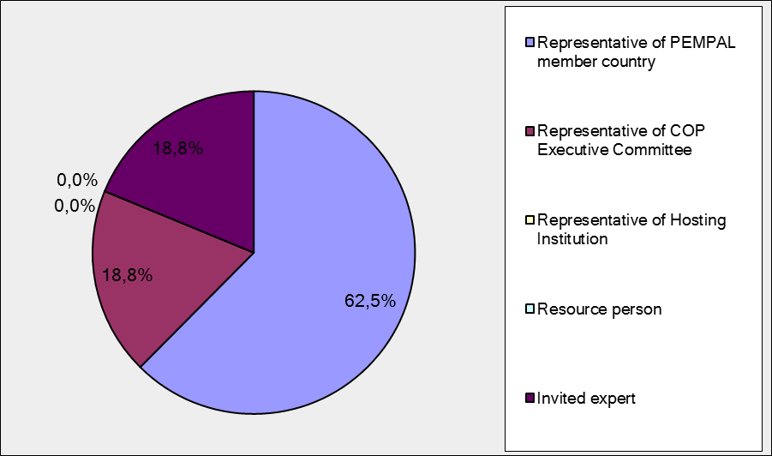

Q2. Was this your first participation in a PEMPAL event?

16 respondents (100%) answered this question. And 87.5% of them replied “No”.

Answer Options | Response Percent | Response Count
Yes | 12,5% | 2
No | 87,5% | 14

Q3. How many PEMPAL events have you attended before?

This question was seen only by those respondents who chose “No” in the previous question.
14 respondents answered this question.

1-2 | 3-4 | 5-6 | more than 6 | Response Count
4 | 2 | 2 | 6 | 14
PART I EVENT DELIVERY

Q4. How do you rate your participation in this event?

16 (100%) answers were given. 10 respondents think that their participation in the event was ‘Active’. 6 respondents think that their participation was ‘Average’. No one chose the option “Passive”.

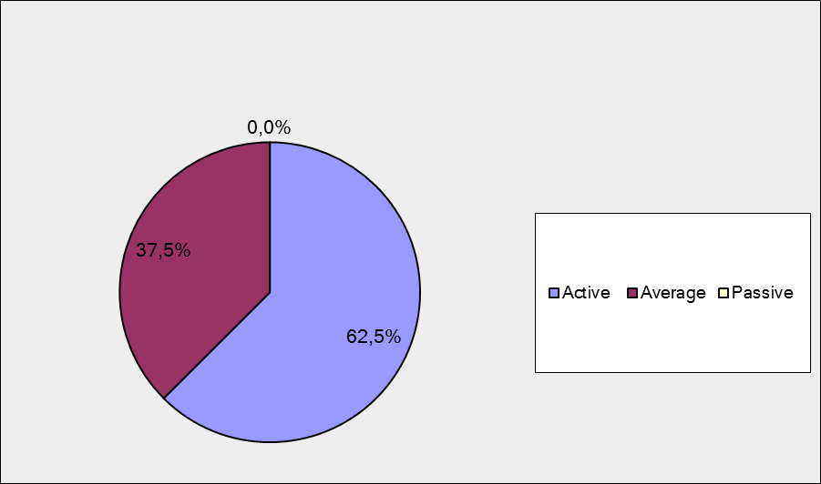

Q5. How do you rate the event duration overall?

16 respondents (100%) answered this question. And most of them rated the event duration in a positive way.

Answer Options | Response Percent | Response Count
Too short | 56,3% | 9
About right | 43,8% | 7
Too long | 0,0% | 0

Q6. How much do you agree with the following statements about the participants of the event? (Please rate each item):
14 respondents (87.5%) replied to this question.
Answer Options | 1 strongly disagree | 2 | 3 | 4 | 5 Strongly agree | Response Count | Average
a) The level of the event was appropriate for a person with my experience and knowledge | 0 | 0 | 0 | 2 | 12 | 14 | 4,9
b) I learned from the experience of other participants in the event | 0 | 0 | 3 | 5 | 6 | 14 | 4,2
с) Participants had about equal level of prior expertise relevant to the event topics | 0 | 1 | 2 | 6 | 5 | 14 | 4,1
d) Content of presentations, hand-outs and other materials were appropriate for a person with my level of knowledge | 0 | 0 | 0 | 3 | 11 | 14 | 4,8
Q7. Describe your own level of expertise, as compared to that of other participants?
7 comments were left.
- Experience in performance budgeting in each country is unique. Opportunity to exchange the experience is important. In detail. In mechanisms. Not from official data, but from the "first hand". The experience is comparable, conclusions are individual.
- On the specific topic I presented, I had a lot more knowledge of the practice. But that is also why I was invited, I presume
- "I have experience in the area of program budgeting and medium-term forecasting. The participants had a good experience and potential in this area, that allows us to share this experience. The exchange of knowledge between participants let us to improve work in the field of program budgeting. Evaluation of budget programs is interesting for me personally. I would also like to explore the evaluation of the effectiveness on the example of PEMPAL-member country".
- Compared to other participants, it seems my level of expertise concerning program budgeting, the contents of program budgeting, performance measures etc. is quite high, while other countries have greater experience in spending reviews and, as such, their representatives have demonstrated a much higher level of expertise in that area.
- Croatia has been implementing performance budgeting for several years now and performance indicators have also been introduced. We have implemented one spending review. Even though performance indicators are still not used in the planning process, I believe I have more experience than the average participant.
- I was involved in performance budgeting developing in several countries for the last 15 years.
- I think that my level of expertise was similar to that of the other participants.
Q8. What have you learned from other participants?
5 informative comments were left.
- How in another country the spending reviews are conducted and the struggles that countries have in introducing such instruments
- I learned about a good experience of Ireland and the Netherlands in the review of public expenditure. In addition, I received knowledge about public finance law in France. Studying the experience of countries in which the Performance-based budgeting is very developed will allow our countries to direct work on program budgeting in a positive direction.
- 1. There is no unique, identical approach when it comes to introducing program budgeting and performance budgeting, each approach is rather individual and every country must take stock of its characteristics and choose the optimal solution for itself. 2. We need to start from defining what we really want to accomplish with this kind of budgeting process and set the aim thereof. We need to re-evaluate our ambitions and expectations. 3. The budget should not be encumbered with too much performance information and data. It is extremely important to recognize and present in the budget the performance indicators significant for the government and the public. It is also important for budget users to be able to monitor other indicators which are significant for their work and monitoring the business results. 4. Achievements from other reform processes should also be up to speed with the budgeting reform process. 5. It is not possible to establish a direct link between the decision-making on the allocation of funds and the information on the effectiveness of the program. 6. Try to simplify the entire system. 7. Link performance measures with key goals and establish monitoring mechanisms. Political support and clear communication mechanisms are necessary for the implementation of this concept.
- I learned about current status of performance budgeting in several countries
- The most interesting part was the exchange of experiences and practices among different countries.

Q9. How much do you agree with the following statements about the content design of the event? (Please rate each item):
13 respondents (81.3%) replied to this question.
Answer Options | 1 strongly disagree | 2 | 3 | 4 | 5 Strongly agree | Response Count | Average
a) The event agenda was properly planned | 0 | 0 | 2 | 1 | 10 | 13 | 4,6
b) The content of the event was properly prepared | 0 | 0 | 0 | 1 | 12 | 13 | 4,9
с) The event addressed issues important to my work | 0 | 0 | 0 | 1 | 12 | 13 | 4,9
d) The event covered a right number of topics for the amount of time available | 1 | 2 | 2 | 3 | 5 | 13 | 3,7
e) Presentations made during the event were relevant and useful | 0 | 0 | 1 | 0 | 12 | 13 | 4,8
f) Enough time was reserved for questions to speakers | 0 | 2 | 4 | 3 | 4 | 13 | 3,7

2 comments were left:
- The content design of the event was excellent, but given the amount of information contained in the presentations and the interest shown by the participants, it would have been optimal if the workshop had lasted a day and a half, instead of just one day.
- Themes of presentations were very interesting, detailed, but we do not have time at all for answers to any questions asked during the workshop.

Q 10. How much do you agree with the following statements about the outcomes of the event? (Please rate each item):
12 responses (75%) were left.
Event objectives has been achieved: | 1 strongly disagree | 2 | 3 | 4 | 5 Strongly agree | Response Count | Average
a) Review findings from performance budgeting cases of the selected countries outlined in the World Bank’s new report Towards Next Generation Performance Budgeting: Reflections on the Experience of Seven Reforming Countries | 0 | 1 | 0 | 3 | 7 | 11 | 4,5
b) Review in detail the French experience in performance budgeting implementation, presented by the Ministry of Finance of France | 0 | 1 | 0 | 4 | 6 | 11 | 4,4
c) Identify the key trends in spending reviews in selected OECD countries | 0 | 1 | 0 | 5 | 6 | 12 | 4,3
d) Hold face-to-face round table of the Working Group to reflect on lessons learnt from advanced countries, share updates on the Working Group countries’ developments, and decide on future activities of the Working Group | 0 | 1 | 1 | 2 | 6 | 10 | 4,3

1 comment was left.

Due to the limited duration of the workshop, the round table session was cut short, however, key information on the progress achieved by the Working Group member states was presented.

PART 2 EVENT ADMINISTRATION
Q 11. Please rate the quality of the organization and administration of the event:
Answered question – 13 (81.3%). All the ratings are best.
Answer Options | 1 low | 2 | 3 | 4 | 5 high | Response Count | Average
Quality of organization
choice of venue | 0 | 0 | 0 | 0 | 13 | 13 | 5
travel arrangements | 0 | 0 | 0 | 0 | 11 | 11 | 5
event logistics | 0 | 0 | 0 | 0 | 10 | 10 | 5
Quality of administration
secretariat staff responsiveness | 0 | 0 | 0 | 0 | 12 | 12 | 5
written communication | 0 | 0 | 0 | 0 | 11 | 11 | 5
participant registration | 0 | 0 | 0 | 0 | 11 | 11 | 5

There were left 3 informative comments.
- The organizers and administrators did a terrific job.
- "I have had the opportunity to participate in other events and compare the organization quality with the organization of all PEMPAL events. When it comes to the quality of organization and administration, PEMPAL gets the highest marks. At this event too, the travel logistics and especially the level of service provided by the Secretary staff were extraordinary."
- Thanks Secretariat (Ksenia Galantsova) for the prompt and professional attitude, support and organization of the event.

Q 12. Did you receive agenda and event information in sufficient time before the event for them to be useful?
13 (81.3%) answers were given. And 100% responses were “Yes”.
Q 13. Did you receive practical information (about the accommodation and other facilities, etc.) prior to the event?
13 (81.3%) answers were given. And 100% responses were “Yes”.
Q14. Are you satisfied with the quality of simultaneous interpretation provided during the event?
11 (68.8%) answers were given.
Answer Options | 1 low | 2 | 3 | 4 | 5 high | Response Count | Average
 | 0 | 0 | 0 | 1 | 10 | 11 | 4,9
2 comments were given.
- Did not use interpretation.
- The interpreters did their best. We were almost not able to tell the amount of effort that was put into the interpretation for speakers who did not speak English very well.
Q15. Are you satisfied with the quality of written translation of event materials?
11 (68.8%) answers were given.
Answer Options | 1 low | 2 | 3 | 4 | 5 high | Response Count | Average
 | 0 | 0 | 1 | 1 | 9 | 11 | 4,7
There was not any comment.

PART 3 OVERALL IMPRESSION
Q16. Did the event disappoint, meet, or exceed your expectations?

11 (68.8 %) participants answered the question. And for all of them the event met their expectation.

Q17. What did you like best about the event?

3 comments were left. Participants like different aspects of the event:
- "Every topic was important and well presented - especially practical approaches of spending reviews organization and particularities of French PBB.
- "During the event I enjoyed the presentation of the participants and how the lecturers themselves reading a lecture at a high level. Simultaneous translation was excellent.
- Excellent organisation, extremely well done presentations, competent speakers who could answer questions.
Q18. What did you not like most about the event?

3 comments were left.
1 of them is comments like: “I do not have any complaints.”
Other 2 comments:
- We needed more time to explore the presentations and discussions in more detail, but the general feedback is highly positive.
- It was not enough time for questions and answers.

Q19. Do you plan to brief your colleagues about the event?
12 (75%) participants answered the question. And 100% of them responded “Yes”.
Q20. How do you plan to brief your colleagues?
Answered question – 12 (75%). Most of respondents was going to share materials.

Answer Options | Response Percent | Response Count
Share materials | 91,7% | 11
Make a presentation | 25,0% | 3
Prepare a back-to-office report | 75,0% | 9
2 comments were given:
- We will study the presentations more thoroughly also taking into account other sources of information on the country provided in the presentation becouse the experience of reforms in the represented countries will be useful in our country.
- By suggesting specific steps which need to be taken in the upcoming period with the aim of implementing program budgeting, but within the context of the lessons learned at the Working Group workshop.
Q21. How much do you agree with the following statement?

11 respondents (68.8%) answered this question. Average rating is positive.

Answer Options | 1 not at all | 2 | 3 | 4 | 5 completely | Response Count | Average
I will be able to apply the knowledge acquired at this event to my work | 0 | 0 | 0 | 5 | 6 | 11 | 4,5
Q22. How can you apply the acquired knowledge?

6 comments were left.
- 1. Organizing training sessions for budgetary institutions; 2. Amending of methodological framework where is needed to insure the implementation of conclusions and recommendations. 3. Initiation of discussions with top management on identification of formula for institutionalization of spending reviews.
- In the beginning I will apply acquired knowledge for reducing the number of programs and indicators. I will pay attention to their quality not quantity. Also, I will suggest to my superiors to carry out work on analysis of our program budgets, as that is done in France, i.e., we will divide them by sectors and will identify the exact number of programs, measures and performance indicators related to each sector. We will improve feedback based on the experience of France."
- By suggesting specific steps that need to be taken in order to implement program budgeting. One of these will be a measure to reduce the number of performance indicators so that this information does not encumber the budget documentation, but still provides enough data for the public to have an idea about the work of the institutions and how public resources are being spent. The documentation that is presented to the government for adoption will contain a definition of program budgeting that Ivor laid out, but the goal of PB will be a bit modified and made less ambitious. By establishing a strong link with mid-term planning and by strengthening the planning business approach with budgetary users, along with the obligation to plan and monitor more indicators which are significant for their work and for monitoring business results in relation to the indicators that should go into program budgeting. By reviewing other related reform processes and proposing measures which will simplify and connect the whole system.
- In change in legal documents
- When the Ministry of Finance prepares its next spending review. Also by answering enquiries made by budget users regarding performance indicators in the processes of budget development and reporting on the execution of the state budget.
- Applying good practices.
Q23. Overall, my satisfaction with the event was...

Answered question – 12 (75%). There were no negative answers.
1 not satisfied | 2 | 3 | 4 | 5 highly satisfied | Response Count | Average
0 | 0 | 1 | 3 | 8 | 12 | 4,6

PART 4 RECOMMENDATIONS FOR THE FUTURE

Q24. Do you have any suggestions to improve the content, approach and other aspects of such events in future:
3 comments were left.
- Please, do not underestimate the time needed for questions, speeches, exchanging of views etc. It is extremely important that every topic to be analyzed and discussed in detail - this approach will increase perception and understanding of subjects presented.
- Possibly exchange some implementing regulations, manuals, methodologies especially with neighboring countries and similar.
- I'd like to have a little more time for question-answers.

Q25. Are there any other products, research or services useful for your work that PEMPAL could provide?

4 comments were left.

It would be interesting to organize an experience exchange meeting for IT professionals working together with the budget department.

Methodological (not only organizational) approaches of spending reviews.

I would like to receive the law on the public finances of France (LOLF) in Russian if such is possible.

Guidelines, recommendations on the topics of meetings.

Q26. Have you also attended the meeting of the OECD Network for Performance and Results held on November 24 and 25 in Paris?
13 respondents (81.3%) answered this question. And 53.8% of them replied “No”.

Answer Options | Response Percent | Response Count
Yes | 46,2% | 6
No | 53,8% | 7
Q27. How much do you agree with the following statements about the outcome of the event?
This and the next questions were seen only by those respondents who chose “Yes” in the previous question.
5 respondents answered this question.
Event objectives has been achieved: | 1 strongly disagree | 2 | 3 | 4 | 5 Strongly agree | Response Count | Average
Learn about the current state of affairs and plans of the OECD countries in terms of performance budgeting | 0 | 0 | 1 | 1 | 3 | 5 | 4,4

1 comment was left: PEMPAL Workshop gave me more information than the OECD meeting.

Q28-29 have no responses.

