PEMPAL BCOP PLENARY MEETING IN TASHKENT
FEEDBACK SURVEY
On March, 18-21, the PEMPAL BCOP Plenary meeting took place in Tashkent, Uzbekistan.

After the event, the on-line survey in three languages was created on the base of the standard set of questions developed in June 2017. The aim of the survey was to receive event feedback and to learn plans for the future.

Link to the survey – https://www.surveymonkey.com/r/XS3H886

The survey started to collect responses on March 25 and finished on April 8, 2019.
Invitations to take part in the survey were sent to all participants of the event. We sent 72 invitations.
44 persons started to response to the survey. In this report, we analyze all 44 responses. For further calculation, we take this quantity as 100%.

All these responses will be included in the general Feedback Event Database.
The questionnaire comprises five parts: About the Respondent, Event Delivery, Event Administration, Overall Impression, and Recommendations for the Future. There are a total of 27 questions in the survey.
ABOUT THE RESPONDENT

Q1 You are...

44 (100%) respondents gave answers. Among them: representatives of PEMPAL country (but not members of the Executive Committee) — 23; representatives of BCOP Executive Committee — 5; representatives from hosting institution — 4; resource persons — 2; invited experts — 8; donor representatives — 2.
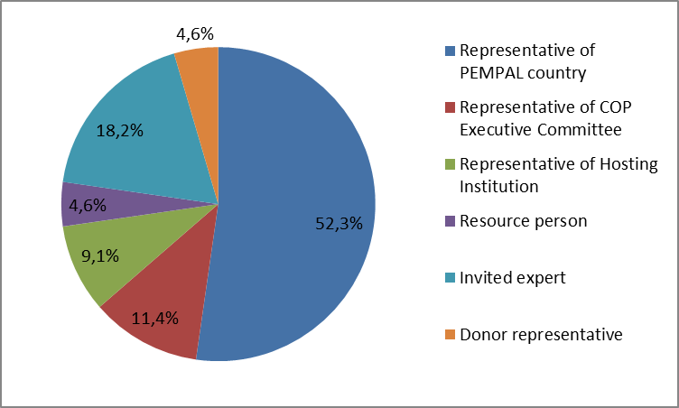

Q2. Was this your first participation in a PEMPAL event?

44 respondents (100%) answered this question.
Answer Options | Response Percent | Response Count
Yes | 54,6% | 24
No | 45,5% | 20

Q3. How many PEMPAL events have you attended before?

This question was seen only by those respondents who chose “No” in the previous question.
20 respondents replied.

1-2 | 3-4 | 5-6 | more than 6 | Response Count
7 | 1 | 3 | 9 | 20
PART I EVENT DELIVERY

Q4. How do you rate your participation in this event?

44 (100%) answers were given. 18 respondents think that their participation in the event was ‘Active’. 23 respondents think that their participation was ‘Average’. 3 persons chose the option “Passive”.

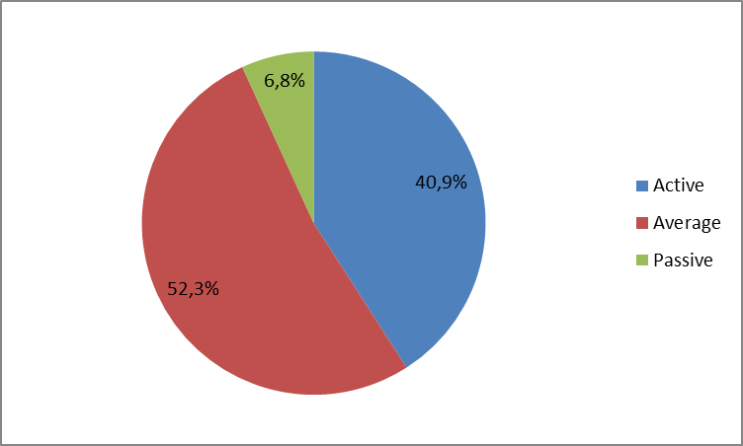

Q5. How do you rate the event duration overall?

44 respondents (100%) answered this question.

Answer choices | Response Percent | Response Count
Too short | 18,2% | 8
About right | 77,3% | 34
Too long | 4,6% | 2

Q6. How much do you agree with the following statements about the participants of the event?
44 respondents (100%) replied to this question.
Answer Options | 1 strongly disagree | 2 | 3 | 4 | 5 Strongly agree | Response Count | Average
a) The level of the event was appropriate for a person with my experience and knowledge | 1 | 0 | 2 | 14 | 27 | 44 | 4,5
b) I learned from the experience of other participants in the event | 0 | 0 | 4 | 16 | 24 | 44 | 4,5
c) Participants had about equal level of prior expertise relevant to the event topics | 1 | 0 | 16 | 19 | 8 | 44 | 3,8
d) Content of presentations, hand-outs and other materials were appropriate for a person with my level of knowledge | 0 | 0 | 4 | 14 | 26 | 44 | 4,5
Q7. What have you learned from other participants?
16 comments were left.
- There is always room to improve the existing situation.
- Participatory budgeting.
- I got more new information about capital budgeting. These information is useful for us recent developing step.
- Even though I have already heard many talks on budget participation and literacy, I get new information every time and I hear new ideas which could potentially be implemented in my country. We saw the trends in capital budgeting. Furthermore, we heard about global best practices for spending reviews.
- Practical aspects of Participatory budgeting were most interesting for me.
- The practical experience of the participants gives me opportunity to consider their successful and unsuccessful examples in my work.
- Different practice in participatory budgeting.
- Experience of their countries.
- How to use performance budgeting in my work.
- Exchanging experiences of other countries is very useful.
- Different time budget planning demands different approaches
- Found answers to some questions arising in the course of daily work.
- Active participation in discussions, the ability to make a presentation.
- Experience exchange in PFM sphere
- Certain activities implemented by some countries...
- Experiences in reform implementation in their country.
Q8. How much do you agree with the following statements about the content design of the event?
43 respondents (97.7%) replied to this question.
Answer Options | 1 strongly disagree | 2 | 3 | 4 | 5 Strongly agree | Response Count | Average
a) The event agenda was properly planned | 0 | 0 | 6 | 10 | 27 | 43 | 4,5
b) The content of the event was properly prepared | 0 | 0 | 3 | 11 | 29 | 43 | 4,6
c) The event addressed issues important to my work | 0 | 0 | 2 | 12 | 29 | 43 | 4,6
d) The event covered a right number of topics for the amount of time available | 0 | 1 | 7 | 14 | 21 | 43 | 4,3
e) The topics for the group discussions were relevant | 0 | 0 | 1 | 11 | 28 | 40 | 4,7
f) Enough time was reserved for group discussions | 0 | 0 | 6 | 18 | 18 | 42 | 4,3
g) Presentations made during the event were relevant and useful | 0 | 0 | 3 | 13 | 27 | 43 | 4,6
h) Enough time was reserved for questions to speakers | 0 | 2 | 1 | 14 | 26 | 43 | 4,5

4 informative comments were left:
- Handouts and comments gave a very pleasant, homely atmosphere.
- It is necessary to have more time for questions and discussions.
- Group discussions need more time. The format of such discussions and the preparation of the conclusion based on the discussion results need to be improved.
- The event organization was perfect, kudos to everyone.
Q9. How much do you agree with the following statements about the outcomes of the event?
42 responses (95.5%) were left.
Event objectives has been achieved: | 1 strongly disagree | 2 | 3 | 4 | 5 Strongly agree | Response Count | Average
a) Provide the opportunity for BCOP member countries to review approaches and trends in capital budgeting/public investment planning (including the developments in OECD countries), familiarize themselves with new assessment tools used by the World Bank, and discuss possible approaches and options for PEMPAL countries | 0 | 0 | 2 | 14 | 26 | 42 | 4,6
b) Provide the opportunity for BCOP member countries to review the most recent work and advance discussions within the topics of the two BCOP working groups, including:- the newest status and trends in performance budgeting in PEMPAL and OECD countries and the newest developments in the area of spending reviews;- mechanisms of engagement of stakeholder groups in budget discussion at the national level in advanced countries and PEMPAL member countries and implementation of participatory budgeting approach at sub-national level | 0 | 0 | 3 | 10 | 29 | 42 | 4,6
с) Update members on overall BCOP progress since the last plenary meeting and to report back on countries’ priorities gathered in the pre-meeting survey to inform the development of the BCOP Action Plan 2019-20 | 0 | 0 | 2 | 12 | 28 | 42 | 4,6

2 informative comments were left:
- After this conference each participant has the opportunity to complete his/her previous knowledge and experience.
- Representatives of member countries were actively participating and sharing information on the current developments in their countries. International experts talked about the latest global trends relating to the topics of our plenary event.
Q10. Please rate the quality of the leadership, management and/or technical services provided to the event by the following:
41 responses (93.2%) were given.
Answer Options | 1 low | 2 | 3 | 4 | 5 high | Response Count | Average
BCOP Executive Committee | 0 | 0 | 1 | 5 | 33 | 39 | 4,8
BCOP Resource Team | 0 | 0 | 0 | 6 | 34 | 40 | 4,85

5 comments were left:
- Organized, working, kind, professional.
- The resource team, together with the Executive Committee, has chosen topics that are relevant to all participating countries.
- The Executive Committee and the resource team provided all the necessary information, they were open to questions and provided quality related services.
- Everything was perfectly organized, all praise!
- Thanks to the Executive Committee and the resource team for the excellent organization of the plenary.
Q11. Please rate the quality of services provided by the event speaker(s):
42 responses (95.5%) were given.
Answer Options | 1 low | 2 | 3 | 4 | 5 high | Response Count | Average
Quality of service | 0 | 0 | 3 | 12 | 27 | 42 | 4,6
5 comments were left:
- All of their topics were done professionally.
- All speakers were very familiar with their topics and ready to answer all questions.
- I would especially like to mention the presentations on participatory budgeting, where practical aspects and interest in promoting this area were revealed.
- I would like to hear more practical examples, especially in terms of unsuccessful experience.
- Perfect!

PART 2 EVENT ADMINISTRATION
Q12. Please rate the quality of the organization and administration of the event:
Answered question – 28 (93.3%).
Answer Options |  | 1 low | 2 | 3 | 4 | 5 high | Response Count | Average
 | Quality of organization
- choice of venue |  | 0 | 0 | 3 | 4 | 34 | 41 | 4,8
- travel arrangements |  | 1 | 0 | 2 | 4 | 32 | 39 | 4,7
- event logistics |  | 0 | 0 | 0 | 6 | 32 | 38 | 4,8
- contribution provided by hosts |  | 0 | 0 | 2 | 2 | 35 | 39 | 4,8
 | Quality of administration
- Secretariat staff responsiveness |  | 0 | 0 | 0 | 4 | 36 | 40 | 4,9
- written communication |  | 0 | 0 | 0 | 5 | 35 | 40 | 4,9
- participant registration |  | 0 | 0 | 0 | 4 | 37 | 41 | 4,9
There were left 5 informative comments.
- I particularly impressed with the kindness of our hosts. Praise!
- The Secretariat was available at all times, as always. The logistics, organization, communication, registration, all were top quality. The location choice and host contributions were fantastic, surpassing all expectations
- Administration (Secretariat) was always available. Quickly solves issues. Ksenia — well done!
- Everything was organized perfectly.
- Early morning flight.

Q13. Did you receive agenda and event information in sufficient time before the event for them to be useful?
41 (93.2%) answers were given. And 100% of responses were “Yes”.
Q14. Did you receive practical information (about the accommodation and other facilities, etc.) prior to the event?
40 (90.9%) answers were given. And 100% of responses were “Yes”.
Q15. Are you satisfied with the quality of simultaneous interpretation provided during the event?
41 (93.2%) answers were given.
Answer Options | 1 low | 2 | 3 | 4 | 5 high | Response Count | Average
Quality of sim. interpretation | 0 | 0 | 1 | 10 | 30 | 41 | 4.7

3 comments were left:
- No objection. Professional, kind, helpful.
- The interpreters were well prepared for the event, they were following all topics and we had no issues with the interpretation. They were at our disposal even after the official part of the event was over.
- Excellent.

Q16. Are you satisfied with the quality of written translation of event materials?
41 (93.2%) answers were given.
Answer Options | 1 low | 2 | 3 | 4 | 5 high | Response Count | Average
Quality of written translation | 0 | 0 | 2 | 9 | 30 | 41 | 4,7

2 comments were left.
1. The quality of written translations is high.
2. Excellent.
PART 3 OVERALL IMPRESSION
Q17. Did the event disappoint, meet, or exceed your expectations?

41 (93.2%) participants answered the question.
Answer Options | Response Percent | Response Count
Disappoint | 0,0% | 0
Meet | 85.4% | 35
Exceed | 14.6% | 6

Q18. What did you like best about the event?

19 comments were left.
Participants like different aspects of the event. In 4 comments were mentioned that “Everything was excellent, I have nothing in particular to comment, everything was perfect”.
- The organization and exchange of experience
- Organization and administration of the event. As well as thematic materials.
- First of all, I liked the organizational part, the chosen topics.
- The event is organized very well and comfortable
- The whole organization - topics for the event-cooperation and interaction.
- All topics were dealt with excellently. However, I would like to specially point out the hospitality and contribution of the host.
- Hosting party – Uzbekistan.
- …the hosts gave the maximum - very kind and always helpful.
- Practical examples (2 comments)
- Presentations by specialists of the Ministry of Finance, which allowed to evaluate possible problems and clear advantages of work with citizens.
- Reports of performance budgeting.
- Conducting a workshop on proactive budgeting, that all the participants of the meeting were involved.
- Presentation on the Russian Federation experience in implementation of participatory (proactive) budgeting.
- Opportunity to put into practice in our country the other countries experience.
- Sharing experiences with representatives of other countries.

Q19. What did you not like most about the event?
8 informative comments were left. 6 of them were “Nothing” or “the event was very suitable”.
Rest 2 comments:
- Ivan Shulga presentation.
- Travel arrangements

Q20. Do you plan to brief your colleagues about the event?
40 (90.9%) participants answered the question. And 100% of them responded “Yes”.
Q21. How do you plan to brief your colleagues?
Answered question –39 (88.6%).
Answer Options | Response Percent | Response Count
Share materials | 61,5% | 24
Make a presentation | 7,7% | 3
Prepare a back-to-office report | 48,7% | 19
2 comments were given:
- Non formal meeting and briefing about the event
- As usually.
Q22. If your Ministry plans to promote this event, or PEMPAL in general, in internal or external media (e.g. MoF or other government website, MoF journal, television, radio, newspapers), please provide specific details so we can report to donors on any positive promotion of the value and benefits of PEMPAL.
6 informative comments were left.
- I am often a lecturer in workshops in my country on issues of budget planning and execution, transparency, budgetary funding, especially at the local level. On these occasions, I mention the positive experiences of other PEMPAL member countries.
- Yes, of course. At the moment I am preparing materials for the local magazine
- We plan to publish a report about the event on the website.
- The Ministry of Finance posted a press release of this event on the website.
- It is possible to publish an article in the "Finance, Accounting, Audit" magazine.
- Place on the website of the Ministry of Finance a press release about our attendance of this event and photos from the workshop.
Q23. How much do you agree with the following statement?
41 respondents (93.2%) answered this question. Average rating is positive.
Answer Options | 1 not at all | 2 | 3 | 4 | 5 completely | Response Count | Average
I will be able to apply the knowledge acquired at this event to my work | 0 | 0 | 9 | 12 | 20 | 41 | 4,3

Q24. How can you apply the acquired knowledge?
13 comments were left.
- See that someone is doing better than us and try to apply it in our work area and inform my superiors about aspects not within my scope of work.
- I can apply them in my work in the future, when we are preparing investment programs of the Surkhandarya region.
- While drafting laws and by-laws, and at seminars for public administration employees and heads of local units and budget users.
- The acquired knowledge will be used and useful in discussions with the Ministry of Finance and in further implementation of participatory budgeting mechanisms and improving financial literacy of the population.
- In budgeting and spending review implementation.
- In the development of budgeting innovations, as well as of guidance materials and regulatory framework.
- On budget execution.
- I will use the knowledge we gained to further improve our current understanding.
- The knowledge acquired during the event will be applied in the work when implementing the strategy for reforming the PFM system.
- To assist in the promotion of participatory budgeting in Uzbekistan.
- I will try to apply it in my work.
- I will try to apply the acquired knowledge in my work.
- I will apply some of the presented models in my work.
Q25. Overall, my satisfaction with the event was...

Answered question – 41 (93.2%). There were no negative answers.
1 not satisfied | 2 | 3 | 4 | 5 highly satisfied | Response Count | Average
0 | 0 | 1 | 13 | 27 | 41 | 4,6

Q26. If you have any other comments you would like to provide us, please provide them here.

2 informative comments were left:

I would like to participate in the future events of the PEMPAL

For further PEMPAL meetings to include SOE as one of the issue how it influence on the budget.

PART 4 RECOMMENDATIONS FOR THE FUTURE

Q27. Do you have any suggestions to improve the content, approach and other aspects of such events in future:
5 informative comments were left:
- It will be pleasure if the lecturer`s (presenters) give specific situations of the theme. At the last event the presenter's gave common principles
- Pay attention to the group discussion format.
- When planning an event schedule, I propose to leave a day off in the middle of workshops.
- Make more detailed presentations of successful country experiences.
- To leave the time for rest before the scheduled flight, ie. return.

