PEM PAL BCOP Plenary meeting
FEEDBACK SURVEY

On February 24-26, 2016, the PEMPAL BCOP plenary meeting took place in Minsk, Belarus.
After the event, the on-line survey in three languages was created. The aim of the survey was to receive event feedback.

Link to the survey – https://www.surveymonkey.com/r/3XCBD5K

The survey started to collect responses on March 1 and finished on March 18, 2016.
Invitations to take part in the survey were sent to 58 participants of the workshop.
30 responses (51.7%) were received. In this report, we analyze all 30 responses. For further calculation, we take this quantity as 100%.
All these responses will be included in the general Feedback Event Database. All responses are not identified by source and sent on a confidential basis to Nina Duduchava of the World Bank who prepares this report.
The questionnaire comprises five parts: About the Respondent, Event Delivery, Event Administration, Overall Impression, and Recommendations for the Future. There are a total of 23 questions.
ABOUT THE RESPONDENT

Q1 You are..

30 (100%) respondents gave answers.
Answer Options | Response Percent | Response Count
Representative of PEMPAL member country | 70,0% | 21
Representative of COP Executive Committee | 16,7% | 5
Representative of Hosting Institution | 0,0% | 0
Resource person | 3,3% | 1
Invited expert | 10,0% | 3
Donor representative | 0,0% | 0

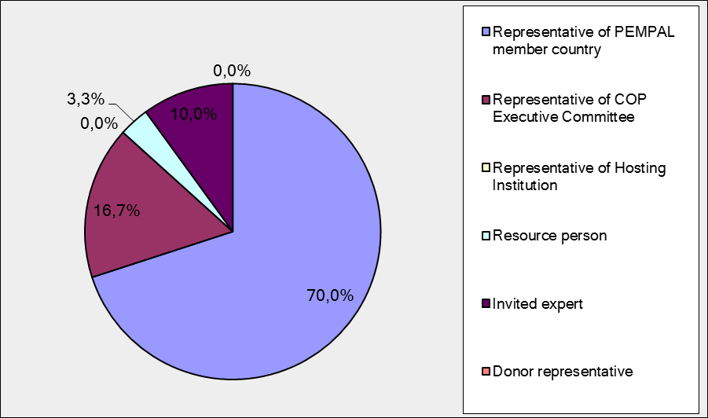
Q2. Was this your first participation in a PEMPAL event?

30 respondents (100%) answered this question.
Answer Options | Response Percent | Response Count
Yes | 26,7% | 8
No | 73,3% | 22

Representative of PEMPAL member country

Answer Options | Response Percent | Response Count
Yes | 28,6% | 6
No | 71,4% | 15

Q3. How many PEMPAL events have you attended before?

This question was seen only by those respondents who chose “No” in the previous question.
22 respondents answered this question.

1-2 | 3-4 | 5-6 | more than 6 | Response Count
4 | 6 | 6 | 6 | 22

Representative of PEMPAL member country

1-2 | 3-4 | 5-6 | more than 6 | Response Count
4 | 4 | 6 | 1 | 15

PART I EVENT DELIVERY

Q4. How do you rate your participation in this event?
30 (100%) answers were given.
Answer Options | Response Percent | Response Count
Active | 60,0% | 18
Average | 36,7% | 11
Passive | 3,3% | 1

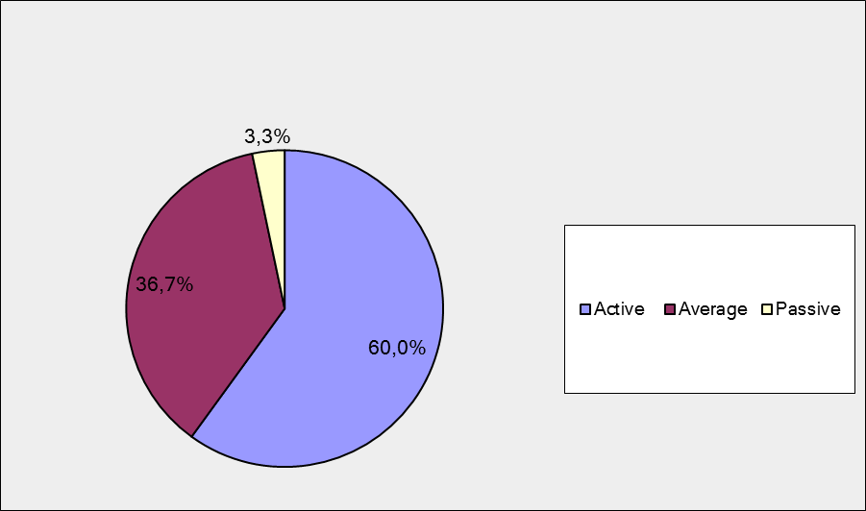

Representative of PEMPAL member country

Answer Options | Response Percent | Response Count
Active | 47,6% | 10
Average | 47,6% | 10
Passive | 4,8% | 1

Q5. How do you rate the duration of the event overall?
30 respondents (100%) answered this question.

Answer Options | Response Percent | Response Count
Too short | 3,3% | 1
About right | 93,3% | 28
Too long | 3,3% | 1

Representative of PEMPAL member country

Answer Options | Response Percent | Response Count
Too short | 4,8% | 1
About right | 90,5% | 19
Too long | 4,8% | 1
Q6. How much do you agree with the following statements about the participants of the event?
30 respondents (100%) replied to this question.
Answer Options | 1 strongly disagree | 2 | 3 | 4 | 5 Strongly agree | Response Count | Average
a) The level of the event was appropriate for a person with my experience and knowledge | 0 | 1 | 1 | 4 | 24 | 30 | 4,7
b) I learned from the experience of other participants in the event | 0 | 0 | 3 | 10 | 17 | 30 | 4,5
с) Participants had about equal level of prior expertise relevant to the event topics | 0 | 1 | 5 | 18 | 6 | 30 | 4,0
d) Content of presentations, hand-outs and other materials were appropriate for a person with my level of knowledge | 0 | 0 | 2 | 5 | 23 | 30 | 4,7
Representative of PEMPAL member country

Answer Options | 1 strongly disagree | 2 | 3 | 4 | 5 Strongly agree | Response Count | Average
a) The level of the event was appropriate for a person with my experience and knowledge | 0 | 0 | 1 | 3 | 17 | 21 | 4,8
b) I learned from the experience of other participants in the event | 0 | 0 | 3 | 7 | 11 | 21 | 4,4
с) Participants had about equal level of prior expertise relevant to the event topics | 0 | 1 | 1 | 14 | 5 | 21 | 4,1
d) Content of presentations, hand-outs and other materials were appropriate for a person with my level of knowledge | 0 | 0 | 1 | 5 | 15 | 21 | 4,7
Q7. How much do you agree with the following statements about the content design of the event?
30 responses (100%) were received.
Answer Options | 1 strongly disagree | 2 | 3 | 4 | 5 Strongly agree | Response  Count | Average
a) The event agenda was properly planned | 0 | 0 | 0 | 7 | 23 | 30 | 4,8
b) The content of the event was properly prepared | 0 | 0 | 0 | 6 | 24 | 30 | 4,8
с) The event addressed issues important to my work | 0 | 0 | 1 | 12 | 17 | 30 | 4,5
d) The event covered a right number of topics for the amount of time available | 0 | 0 | 2 | 8 | 20 | 30 | 4,6
e) Presentations made during the event were relevant and useful | 0 | 0 | 0 | 12 | 18 | 30 | 4,6
f) Enough time was reserved for questions to speakers | 0 | 0 | 0 | 8 | 22 | 30 | 4,7

Representative of PEMPAL member country

Answer Options | 1 strongly disagree | 2 | 3 | 4 | 5 Strongly agree | Response  Count | Average
a) The event agenda was properly planned | 0 | 0 | 0 | 5 | 16 | 21 | 4,8
b) The content of the event was properly prepared | 0 | 0 | 0 | 6 | 15 | 21 | 4,7
с) The event addressed issues important to my work | 0 | 0 | 1 | 7 | 13 | 21 | 4,6
d) The event covered a right number of topics for the amount of time available | 0 | 0 | 2 | 7 | 12 | 21 | 4,5
e) Presentations made during the event were relevant and useful | 0 | 0 | 0 | 10 | 11 | 21 | 4,5
f) Enough time was reserved for questions to speakers | 0 | 0 | 0 | 7 | 14 | 21 | 4,7

2 comments were left: (Here and after all comments from Representative of PEMPAL member country ara Bold)
- The agenda was well designed. For any topic it is always good to have a general introduction, which was made and then further developed through the cases of individual countries. Otherwise, this part of the workshop through examples of individual countries is most useful. Looking at the broader context, a whole picture remains incomplete concerning those countries which do not have rules and those where local authorities have a major impact to the system of general government.
- The list of presentations was good selected. I liked that discussions was dynamic, that all participants showed interest

Q8. How much do you agree with the following statements about the outcomes of the event?
30 responses (100%) were received.
Event objective has been achieved: | 1 strongly disagree | 2 | 3 | 4 | 5  Strongly agree | Response Count | Average
a) Share PEMPAL and international approaches on the use of fiscal rules, their impact and lessons learnt. | 0 | 0 | 1 | 13 | 16 | 30 | 4,5
b) Provide the opportunity for BCOP member countries to exchange experiences and discuss possible approaches and options to using fiscal rules in the context of discussion groups | 0 | 0 | 1 | 10 | 19 | 30 | 4,6
c) Provide an update to members on the work of the BCOP since the last plenary meeting. | 0 | 0 | 2 | 10 | 18 | 30 | 4,5
d) Gather feedback on priorities from members to inform the development of the BCOP Action Plan 2016-17. | 0 | 0 | 4 | 7 | 19 | 30 | 4,5
Representative of PEMPAL member country
Event objective has been achieved: | 1 strongly disagree | 2 | 3 | 4 | 5  Strongly agree | Response Count | Average
a) Share PEMPAL and international approaches on the use of fiscal rules, their impact and lessons learnt. | 0 | 0 | 1 | 10 | 10 | 21 | 4,4
b) Provide the opportunity for BCOP member countries to exchange experiences and discuss possible approaches and options to using fiscal rules in the context of discussion groups | 0 | 0 | 1 | 7 | 13 | 21 | 4,6
c) Provide an update to members on the work of the BCOP since the last plenary meeting. | 0 | 0 | 1 | 9 | 11 | 21 | 4,5
d) Gather feedback on priorities from members to inform the development of the BCOP Action Plan 2016-17. | 0 | 0 | 2 | 7 | 12 | 21 | 4,5
3 comments were left:
- The objectives of the event are achieved. Of course, always remains a certain segment uncovered seen with questions and answers to these questions through discussion. In this issue, in my opinion, a question remaining open was the practical application of fiscal rules, and specific methodology for calculating the FR.
- It is important that you can hear and talk directly all the experience in one place . You can also analyze efficiency of our own experience or assumptions.
- Year after year you can notice the improvement of the meetings in terms of substance of problems discussed
PART 2 EVENT ADMINISTRATION

Q9. Please rate the quality of the organization and administration of the event:
Answered question – 30 (100%).
Answer Options | 1 low | 2 | 3 | 4 | 5 high | Response Count | Average rating
Quality of organization | 0 | 0 | 0 | 4 | 26 | 30 | 4,9
Quality of administration | 0 | 0 | 0 | 2 | 28 | 30 | 4,9
Representative of PEMPAL member country
Answer Options | 1 low | 2 | 3 | 4 | 5 high | Response Count | Average rating
Quality of organization | 0 | 0 | 0 | 3 | 18 | 21 | 4,9
Quality of administration | 0 | 0 | 0 | 2 | 19 | 21 | 4,9
There were left 4 comments.
This segment is still at a high level.
On the road, and stay in Minsk did not have any unpleasant situation.
Everything was organized well, so that the participants had no reason to worry.
My impression is that PEMPAL is highly efficient and well-functioning!
Q10. Did you receive agenda and event information in sufficient time before the event for them to be useful?
30 (100%) answers were given. And 96.7% of responses (29) were “Yes”. 1 respondent (Representative of PEMPAL member country) replied “No”.
Q11. Did you receive practical information (about the accommodation and other facilities, etc.) prior to the event?
30 (100%) answers were given. And all of them were “Yes”.
Q12. Are you satisfied with the quality of simultaneous interpretation provided during the event? Q13. Are you satisfied with the quality of written translation of event materials?
29 responses were given (96.7%) to Q14 and 30 (100%) – to Q15.
Answer Options | 1 low | 2 | 3 | 4 | 5 high | Response Count | Average rating
interpretation | 0 | 1 | 3 | 6 | 19 | 29 | 4,5
translation | 0 | 1 | 0 | 8 | 21 | 30 | 4,6
Representative of PEMPAL member country
Answer Options | 1 low | 2 | 3 | 4 | 5 high | Response Count | Average rating
interpretation | 0 | 0 | 2 | 6 | 12 | 20 | 4,5
translation | 0 | 1 | 0 | 7 | 13 | 21 | 4,5
There were left 2 comments to Q12 and 1 comments to Q13.
Q12
The simultaneous interpretation should be designed in a manner when a person listens English in certain channel then he could listen English what other person speaks in different language. If he should change channel, he could not focus on listening.
Interpretation was good. Some speakers were difficult to understand (in English) so translation of them lagged behind.
Q13
More detailed data have not been translated.
PART 3 OVERALL IMPRESSION
Q14. Did the event disappoint, meet, or exceed your expectations?

There are 30 (100%) answered question.

Answer Options | Response Percent | Response Count
Disappoint | 0,0% | 0
Meet | 86,7% | 26
Exceed | 13,3% | 4

Representative of PEMPAL member country
Answer Options | Response Percent | Response Count
Disappoint | 0,0% | 0
Meet | 85,7% | 18
Exceed | 14,3% | 3

Q15. What did you like most about the event?

20 comments were left. 3 comments were like “I liked all the event.”

Organization was mentioned twice, for example: “Good organization”

Exchange experience was mentioned 5 times. For example:: I liked most review of the experience of countries in the region, such as Kyrgyzstan, Russia.
Presentations, discussions, and experts were mentioned in 7 comments. For example: “The ability to share experiences with … experts from international organizations, whose presentations have allowed to look more extensively and systematically to the problems of the fiscal rules establishment and implementation. “Openness of experts and their desire to pass on their experience and achievements.”

Other comments:

- Fiscal rules are a lot clearer after the presentations and discussions with other participants of the plenary meeting.
- Discussion in working groups.
- The quality of the presentation and supporting materials by participants
- Relevance of the theme
- Useful selected examples of fiscal policies in some countries
- "The discussion in the working group on budgetary rules (group 3). Sweden Presentation"
- Working in groups
- comparative studies on fiscal rules applicable to participating countries
- Professionalism of some participants

Q16. What did you not like most about the event?
12 comments were left. And 5 of them are like “Everything was very well organized”
- The lack of exchange of practical experiences between countries.
- Too long day duration of the workshop.
- The whether
- Cultural program (we spent about 3 hours on the road):
- The formation of working groups, or inability of countries to participate in working groups and study visits organized by PEM PAL.
- Some presentations partially repeated each other (in terms of the general methodology, international experience, etc). In addition, some presentations were too long and full of very specific and technical aspects (it was practically impossible to understand and appreciate these aspects during 30-minute report)
- The group discussions could maybe have started in smaller groups to make sure that everyone would be active.
Q17. Do you plan to brief your colleagues on this event?
30 responses were given (100%). And 29 responses (96.7%) were “Yes”. 1 respondent (Representative of PEMPAL member country) replied “No”.
Q18. How do you plan to brief your colleagues?
28 (93.3%) responses were given
Answer Options | Response Percent | Response Count
Share materials | 71,4% | 20
Make a presentation | 28,6% | 8
Prepare a back-to-office report | 53,6% | 15

Representative of PEMPAL member country

Answer Options | Response Percent | Response Count
Share materials | 70,0% | 14
Make a presentation | 35,0% | 7
Prepare a back-to-office report | 60,0% | 12

2 comments were left:
Orally
“During informal conversations”

Q19. How much do you agree with the following statement?

29 respondents (96.7%) replied to this question.
Answer Options | 1 not at all | 2 | 3 | 4 | 5completely | Response Count | Average
I will be able to apply the knowledge acquired at this event to my work | 0 | 0 | 6 | 13 | 10 | 29 | 4,1

Representative of PEMPAL member country

Answer Options | 1 not at all | 2 | 3 | 4 | 5completely | Response Count | Average
I will be able to apply the knowledge acquired at this event to my work | 0 | 0 | 4 | 9 | 7 | 20 | 4,2

Q20. How can you apply the acquired knowledge?

17 comments were left.
- In preparing the report on the execution of fiscal rules
- Through my daily work
- As far as possible making localizing of the acquired knowledge, while taking into account the specific of our country legislation.
- When solving specific tasks and activities
- In my country, this is a very important issue. FR (fiscal rules) are changing and comply with the relevant institutions and experts.
- In changes of the regulatory framework, in work with the regions
- I am going to apply it in my work
- In preparing proposals to amend budget legislation.
- When considering if there is any need for us to make changes to our fiscal rules. It was also a reminder of the importance of sticking to the rules we have in place.
- Practical application and amendment of legislation
- coordinating preparation and promotion of the citizen budget
- I will make a report to my bosses, that there is such a practice, and it would cost us to implement it.
- Developing fiscal rules on national level and designing rules for subnational levels.
- When necessary, either in practice or analyze for myself
- The knowledge has additional value in reaching decisions taking in mind the importance of fiscal rules
- In preparing the budget and changes in fiscal rules regulations.
- By providing input to national PFM agenda formulation
Q21. Overall, my satisfaction with the event was...

Answered question – 30 (100%).
.
Answer Options | 1not satisfied | 2 | 3 | 4 | 5 highly satisfied | Response Count | Average
&nbsp | 0 | 0 | 0 | 9 | 21 | 30 | 4,7

Representative of PEMPAL member country

Answer Options | 1not satisfied | 2 | 3 | 4 | 5 highly satisfied | Response Count | Average
&nbsp | 0 | 0 | 0 | 8 | 13 | 21 | 4,6

RECOMMENDATIONS FOR THE FUTURE

Q22. Do you have any suggestions to improve the content, approach and other aspects of such events in future?

14 comments were left and 10 of them with suggestions.

More concrete examples

More exchange of practical experience between countries

Perhaps more presentation of individual country cases.

It possible to cover more than one subject at one event.

"More practical examples. More work in groups "

Trying to attract as PEMPAL member countries more EU Member States

"1. More feedback from expert side on outputs of groups, country cases etc. 2. Events should be redesigned a little bit as to conferee them less official and more openness from the both sides - PEMPAL participants and experts."

Enable all member countries of PEM PAL to participate in working groups and study visits, or if it is not possible to involve all countries due to limited resources, give to all countries equal chances.

It is necessary to present more practical examples of the topics explored

Invite more presenters from the countries going ahead in area we are interested in.

Q23. Are there any other products, research or services that PEMPAL could provide that would be useful for your work?

5 informative comments were left.
- No, not PEMPAL itself but through other workshops realized.
- It would be interesting to have a review of different countries experience on funding instruments of local budgets (borrowing, deposit funds, methods of using balances, local warranty)
- Research the best practices of leading countries
- links to different specific materials, like you already done
- Materials in electronic form:

