PEMPAL BUDGET LITERACY AND TRANSPARENCY WORKING GROUP (BLTWG) LEARNING VISIT ON PUBLIC PARTICIPATION IN PORTUGAL AND JOINT BLTWG-GIFT WORKSHOP
FEEDBACK SURVEY

On October, 15-17, the BCOP Working Group on Budget Literacy and Transparency met in Cascais, Portugal, to exchange knowledge with Global Initiatives of Fiscal Transparency (GIFT) and learn from Portuguese government on mechanisms of public participation.

After the event, the on-line survey in three languages was created based on of the standard set of questions developed in June 2017. The aim of the survey was to receive event feedback and to inform plans for the future.

Link to the survey – https://www.surveymonkey.com/r/6X5VZD5

The survey started to collect responses on October 23 and finished on November 3, 2018.

Invitations to take part in the survey were sent to 13 BCOP member participants of the event. 8 persons started to response to the survey. In this report, we analyze all 8 responses. For further calculation, we take this quantity as 100%.

All these responses will be included in the general Feedback Event Database.
The questionnaire comprises five parts: About the Respondent, Event Delivery, Event Administration, Overall Impression, and Recommendations for the Future. There are a total of 30 questions in the survey.
ABOUT THE RESPONDENT

Q1 You are...

8 (100%) respondents gave answers. Among them: representatives of PEMPAL country (but not members of the Executive Committee) — 2; representatives of BCOP Executive Committee — 5, and 1 resource person.
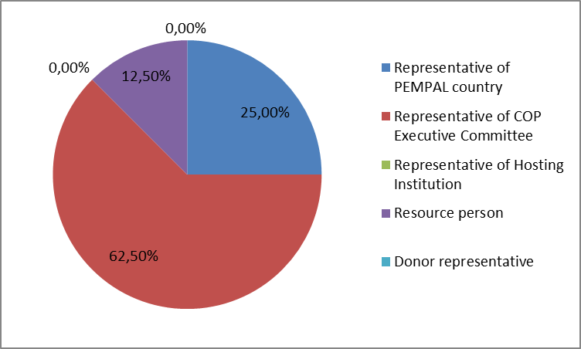

Q2. Was this your first participation in a PEMPAL event?

8 respondents (100%) answered this question. And 100% of responses were “No”.

Q3. How many PEMPAL events have you attended before?

8 respondents (100%) replied.

1-2 | 3-4 | 5-6 | more than 6 | Response Count
0 | 0 | 2 | 6 | 8
PART I EVENT DELIVERY

Q4. How do you rate your participation in this event?

8 (100%) answers were given. 6 respondents think that their participation in the event was ‘Active’. 2 respondents think that their participation was ‘Average’. No one chose the option “Passive”.

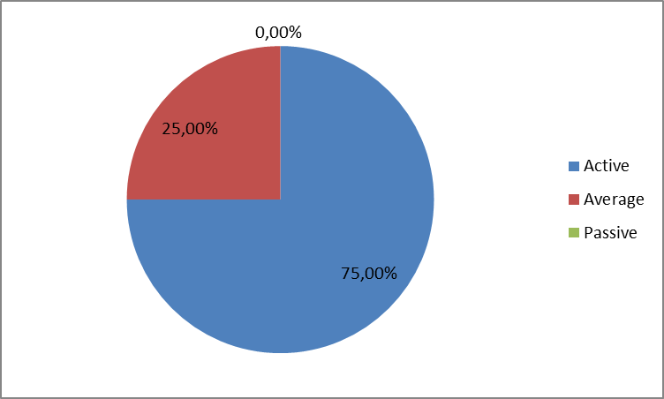

Q5. How do you rate the event duration overall?

8 respondents (100%) answered this question.
Answer choices | Response Percent | Response Count
Too short | 12.5 | 1
About right | 87.5 | 7
Too long | 0,0 | 0

Q6. How much do you agree with the following statements about the participants of the event?
8 respondents (100%) replied to this question.
Answer Options | 1 strongly disagree | 2 | 3 | 4 | 5 Strongly agree | Response Count | Average
a) The level of the event was appropriate for a person with my experience and knowledge | 0 | 0 | 0 | 1 | 7 | 8 | 4,9
b) I learned from the experience of other participants in the event | 0 | 0 | 0 | 3 | 5 | 8 | 4,6
c) Participants had about equal level of prior expertise relevant to the event topics | 0 | 0 | 0 | u | 4 | 8 | 4,5
d) Content of presentations, hand-outs and other materials were appropriate for a person with my level of knowledge | 0 | 0 | 0 | 3 | 5 | 8 | 4,6
Q7. What have you learned from other participants?
5 comments were left.

- Learn to look differently at familiar things
- We have seen how citizens participate in the budgets of Cascais and Sakhalin.
- Broadened my knowledge of public participation tools, governments use worldwide; familiarized with participatory budgeting model applied in Portugal and Russia
- Representatives of GIFT member countries speak freely, their presentation presentations are interactive.
- Presentations were informative, outlining the practical experience of implementation. Informal communication is diversified, taking into account the specifics of the budget system of countries, which is also useful for comparative analysis and risk identification.
Q8. How much do you agree with the following statements about the content design of the event?
8 respondents (100%) replied to this question.
Answer Options | 1 strongly disagree | 2 | 3 | 4 | 5 Strongly agree | Response Count | Average
a) The event agenda was properly planned | 0 | 0 | 0 | 1 | 7 | 8 | 4,9
b) The content of the event was properly prepared | 0 | 0 | 0 | 2 | 6 | 8 | 4,8
c) The event addressed issues important to my work | 0 | 0 | 0 | 3 | 5 | 8 | 4,6
d) The event covered a right number of topics for the amount of time available | 0 | 0 | 0 | 4 | 4 | 8 | 4,5
e) The topics for the group discussions were relevant | 0 | 0 | 0 | 3 | 5 | 8 | 4,6
f) Enough time was reserved for group discussions | 0 | 0 | 0 | 2 | 6 | 8 | 4,8
g) Presentations made during the event were relevant and useful | 0 | 0 | 0 | 2 | 5 | 7 | 4,7
h) Enough time was reserved for questions to speakers | 0 | 0 | 1 | 3 | 4 | 8 | 4,4

One comment was left: There was not enough time for questions and answers. But the questions asked were interesting and detailed because all procedures are very important when implementing.
Q9. How much do you agree with the following statements about the outcomes of the event?
8 responses (100%) were left.
Event objective has been achieved: | 1 strongly disagree | 2 | 3 | 4 | 5 Strongly agree | Response Count | Average
a) Facilitate knowledge exchange on public participation in the budget process with members of the Global Initiative for Fiscal Transparency | 0 | 0 | 0 | 2 | 6 | 8 | 4,8
b) Learn from Portuguese government on approaches they use for encouraging public participation in the budget process | 0 | 0 | 0 | 2 | 6 | 8 | 4,8

2 comments were left:
1. Representatives of the Portuguese authorities did not always give full and clear answers to the questions asked.
2. Portugal presentations were presented in three aspects. Visit to the municipal facility. Fully allowed to reveal the topic of the workshop.
Q10. Please rate the quality of the leadership, management and/or technical services provided to the event by the following:
8 responses (100%) were given.
Answer Options | 1 low | 2 | 3 | 4 | 5 high | Response Count | Average
BCOP Executive Committee | 0 | 0 | 0 | 0 | 8 | 8 | 5
BCOP Resource Team | 0 | 0 | 0 | 0 | 7 | 7 | 5
One comment was left: Small group presentations were informative and useful. The joint presentation of the World Bank Russian office with the Sakhalin region was a good solution, which allowed to fully cover the topic.

Q11. Please rate the work of the event speaker(s):
8 responses (100%) were given.
Answer Options | 1 low | 2 | 3 | 4 | 5 high | Response Count | Average
Quality of service | 0 | 0 | 0 | 3 | 5 | 8 | 4,6
2 comments were left:

Probably due to lack of time, not all practical details were found out.

I’d like note the presentation of Nelson Diaz on a book outlining 30 world experiences in participatory budgeting. And the opportunity to get the publication itself for further work.

PART 2 EVENT ADMINISTRATION
Q12. Please rate the quality of the organization and administration of the event:
Answered question – 8 (100%).
Answer Options |  | 1 low | 2 | 3 | 4 | 5 high | Response Count | Average
 | Quality of organization
- choice of venue |  | 0 | 0 | 0 | 0 | 7 | 7 | 5
- travel arrangements |  | 0 | 0 | 0 | 1 | 7 | 8 | 4,9
- event logistics |  | 0 | 0 | 0 | 3 | 4 | 7 | 4,6
- contribution provided by hosts |  | 0 | 0 | 0 | 1 | 7 | 8 | 4,9
 | Quality of administration
- Secretariat staff responsiveness |  | 0 | 0 | 0 | 0 | 8 | 8 | 5
- written communication |  | 0 | 0 | 0 | 0 | 8 | 8 | 5
- participant registration |  | 0 | 0 | 0 | 0 | 8 | 8 | 5
There was left 1 comment: Many thanks to Ksenia for her titanic work!

Q13. Did you receive agenda and event information in sufficient time before the event for them to be useful?
8 (100%) answers were given. And 100% of responses were “Yes”.
Q14. Did you receive practical information (about the accommodation and other facilities, etc.) prior to the event?
8 (100%) answers were given. And 100% of responses were “Yes”.
Q15. Are you satisfied with the quality of simultaneous interpretation provided during the event?
8 (100%) answers were given.
Answer Options | 1 low | 2 | 3 | 4 | 5 high | Response Count | Average
Quality of sim. interpretation | 0 | 0 | 0 | 2 | 6 | 8 | 4,75

1 comment was left: Thanks to the interpreters for work not only during official working hours.
Q16. Are you satisfied with the quality of written translation of event materials?
7 (87,5%) answers were given.
Answer Options | 1 low | 2 | 3 | 4 | 5 high | Response Count | Average
Quality of sim. interpretation | 0 | 0 | 0 | 1 | 6 | 7 | 4,85

No comment was left.
Q17. Did the paperless approach in distributing materials affect your ability to understand/absorb information during the event?
8 (100%) answers were given.
Answer Choices | Response Percent | Response Count
Yes | 12,5 | 1
No | 87,5 | 7
Q18. Did you try to access event presentations on the web site in preparation for the event?
8 (100%) answers were given. And 100% of responses were “Yes”.
Q19. Did you find the practice of posting presentations on the web site before the event helpful?
8 (100%) answers were given. And 100% of responses were “Yes”.

PART 3 OVERALL IMPRESSION
Q20. Did the event disappoint, meet, or exceed your expectations?
8 (100%) answers were given.

Answer Choices | Response Percent | Response Count
Disappoint | 0,0 | 0
Meet | 62,5 | 5
Exceed | 37,5 | 3

Q21. What did you like best about the event?
5 comments were left.
Participants like different aspects of the event.
- The topic was very interesting. I will be able to apply the gained knowledge during discussions with local government representatives in my country.
- Practical examples from the practice of different countries, their experience in different levels of fiscal transparency. Modes of inclusion of citizens in the budget process.
- Diversity of agenda, which included knowledge exchange with GIFT network and experts, as well as learning visit about participatory budgeting practices, which comprised overview of Portuguese national and sub-nation experience and explanation, how this approach was translated to Russian context of multi-level budget system.
- I liked the form of the event, i.e. joint meeting of two different organizations dealing with the same issues (to a certain extent). GIFT countries experience is very interesting in the sense that the GIFT participants are the countries from Central and South America and Africa.
- Successful solution. Joint event of GIFT and PEMPAL. The participation of not only civil servants, but also NGOs, representatives of scientific organizations and the media, helped to make multilateral the discussion of the workshop topic. Representation of Africa, America, Southeast Asia, the European continent, and post-Soviet countries was a distinctive feature, positively influenced to the workshop results.

Q22. What did you not like most about the event?
3 informative comments were left:

- Everything was at a high level. I have no objections.
- Venue was a bit far from the hotel, but I realize that the facility was appropriate in general and it was host in-kind contribution
- Way from the place of residence to the meeting venue took considerable time.

Q23. Do you plan to brief your colleagues about the event?
8 (100%) answers were given. And 100% of responses were “Yes”.
Q24. How do you plan to brief your colleagues?
Answered question – 8 (100%). Most of respondents will prepare a back-to-office report.
Answer Options | Response Percent | Response Count
Share materials | 50,0 | 4
Make a presentation | 25,0 | 2
Prepare a back-to-office report | 87,5 | 7
No comments were given.
Q25. If your Ministry plans to promote this event, or PEMPAL in general, in internal or external media (e.g. MoF or other government website, MoF journal, television, radio, newspapers), please provide specific details so we can report to donors on any positive promotion of the value and benefits of PEMPAL.
2 comments were left:
- May be we will publish an article in the magazine “Finance, Accounting and Audit”.
- A decision was taken to develop and publish the “Citizens Budget” methodological guide, which will be distributed free of charge and posted on the MoF’s website.
Q26. How much do you agree with the following statement?
7 respondents (87.5%) answered this question. All the ratings are positive.
Answer Options | 1 not at all | 2 | 3 | 4 | 5 completely | Response Count | Average
I will be able to apply the knowledge acquired at this event to my work | 0 | 0 | 0 | 3 | 4 | 7 | 4,6
Q27. How can you apply the acquired knowledge?
5 comments were left.
- In trainings for budget users and during conversations with local government representatives in my country.
- Transferring knowledge to colleagues as well as improving future proposals within the competence of the ministry.
- I can invite experts participating in the event to other knowledge events; I can refer to practices, presented at the event, in providing advice to clients
- When developing a public finance management program.
- When drafting normative legal acts for local governments on initiative participatory budgeting.
Q28. Overall, my satisfaction with the event was...

Answered question – 7 (87.5%). There were no negative answers.
1 not satisfied | 2 | 3 | 4 | 5 highly satisfied | Response Count | Average
0 | 0 | 0 | 1 | 6 | 7 | 4,85

Q29. If you have any other comments you would like to provide us, please provide them here.

One comment was left. Thank you for organizing and administrating the workshop and study visit.

PART 4 RECOMMENDATIONS FOR THE FUTURE

Q30. Do you have any suggestions to improve the content, approach and other aspects of such events in future:
2 comments were left:
- The event was held at a high level.
- Actual PFM concepts are many-sided, therefore the effectiveness of joint activities is high. We need more widely practice joint activities also between PEMPAL communities.

