PEMPAL BCOP MEETING IN MOSCOW FEEDBACK SURVEY

On June 22-23, 2017 meeting of BCOP Budget Transparency and Literacy Working Group took place in Moscow, Russia.
After the event, the on-line survey in three languages was created on the base of the standard set of questions developed by Secretariat. The aim of the survey was to receive event feedback and to learn plans for the future.

Link to the survey – https://www.surveymonkey.com/r/CC682DH

The survey started to collect responses on June 26 and finished on July 10, 2017.
Invitations to take part in the survey were sent to all participants of the event. We sent 16 invitations.
9 persons started to response to the survey. From these 9 responses 1 was from invited experts, 2 — from representative of COP Executive Committee, and 6 from the representatives of PEMPAL countries.
In this report, we analyze all 9 responses. For further calculation, we take this quantity as 100%.

All these responses will be included in the general Feedback Event Database.
The questionnaire comprises five parts: About the Respondent, Event Delivery, Event Administration, Overall Impression, and Recommendations for the Future. There are a total of 23 questions in the survey.
ABOUT THE RESPONDENT

Q1 You are...

9 (100%) respondents gave answers. Among them: 6 representatives of PEMPAL countries, 1 invited expert, 2 representative of COP Executive Committee.
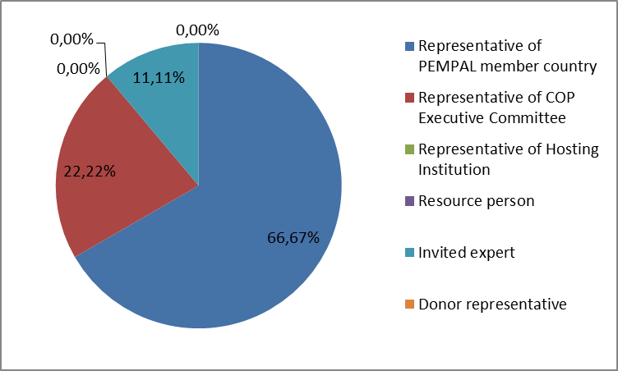

Q2. Was this your first participation in a PEMPAL event?

9 respondents (100%) answered this question. And 66.7% of them replied “No”.

Answer Options | Response Percent | Response Count
Yes | 33,33% | 3
No | 66,67% | 6

Q3. How many PEMPAL events have you attended before?

This question was seen only by those respondents who chose “No” in the previous question.
6 respondents answered this question.

1-2 | 3-4 | 5-6 | more than 6 | Response Count
1 | 0 | 1 | 4 | 6
PART I EVENT DELIVERY

Q4. How do you rate your participation in this event?

9 (100%) answers were given. 7 respondents think that their participation in the event was ‘Active’. 2 respondents think that their participation was ‘Average’. Noone chose the option “Passive”.

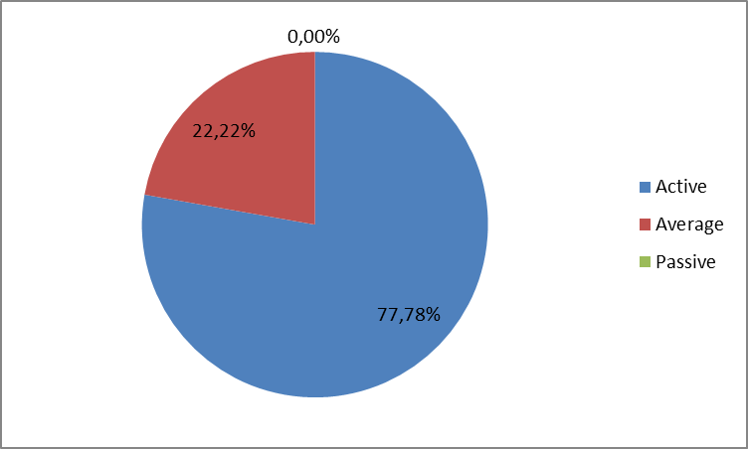

Q5. How do you rate the event duration overall?

9 respondents (100%) answered this question. And most of them rated the event duration in a positive way.

Answer Options | Response Percent | Response Count
Too short | 33,33% | 3
About right | 66,67% | 6
Too long | 0,00% | 0

Q6. How much do you agree with the following statements about the participants of the event? (Please rate each item):
9 respondents (100%) replied to this question.
Answer Options | 1 strongly disagree | 2 | 3 | 4 | 5 Strongly agree | Response Count | Average
a) The level of the event was appropriate for a person with my experience and knowledge | 0 | 0 | 0 | 1 | 8 | 9 | 4,9
b) I learned from the experience of other participants in the event | 0 | 0 | 1 | 3 | 5 | 9 | 4,4
c) Participants had about equal level of prior expertise relevant to the event topics | 0 | 0 | 2 | 5 | 2 | 9 | 4,0
d) Content of presentations, hand-outs and other materials were appropriate for a person with my level of knowledge | 0 | 0 | 0 | 2 | 7 | 9 | 4,8
Q7. How much do you agree with the following statements about the content design of the event? (Please rate each item):
9 respondents (100%) replied to this question.
Answer Options | 1 strongly disagree | 2 | 3 | 4 | 5 Strongly agree | Response Count | Average
a) The event agenda was properly planned | 0 | 0 | 0 | 3 | 5 | 8 | 4,6
b) The content of the event was properly prepared | 0 | 0 | 0 | 2 | 7 | 9 | 4,8
c) The event addressed issues important to my work | 0 | 0 | 0 | 1 | 8 | 9 | 4,9
d) The event covered a right number of topics for the amount of time available | 0 | 0 | 2 | 5 | 2 | 9 | 4,0
e) Presentations made during the event were relevant and useful | 0 | 0 | 0 | 3 | 6 | 9 | 4,7
f) Enough time was reserved for questions to speakers | 0 | 0 | 2 | 3 | 4 | 9 | 4,2

1 comment was left:
- Participation of this event was nice and useful, the agenda was interesting.

Q8. How much do you agree with the following statements about the outcomes of the event? (Please rate each item):
9 responses (100%) were left.
Event objectives has been achieved: | 1 strongly disagree | 2 | 3 | 4 | 5 Strongly agree | Response Count | Average
a) Participate in the Russia Budget Literacy conference to learn about the results of the joint project between the Ministry of Finance of the Russian Federation and the World Bank | 0 | 0 | 0 | 2 | 7 | 9 | 4,8
b) Conduct a working group meeting to discuss tools for assessing budget transparency and to conduct discussions on future work in participatory budgeting practices | 0 | 0 | 0 | 1 | 8 | 9 | 4,9

No comments were left.

PART 2 EVENT ADMINISTRATION
Q9. Please rate the quality of the organization and administration of the event:
Answered question – 9 (100%). All the ratings are best.
Answer Options | 1 low | 2 | 3 | 4 | 5 high | Response Count | Average
Quality of organization | 0 | 0 | 0 | 1 | 8 | 9 | 4,9
Quality of administration | 0 | 0 | 0 | 0 | 9 | 9 | 5

There were left 2 informative comments.
- World Bank Conference on budget literacy and the meeting of the Working Group of the PEMPAL Budget Community on Budget Transparency and Literacy were conducted at a very high professional level. Participants were provided with all necessary materials, the atmosphere was friendly and business-like. Also I want to note a very high organizational part: the venue, trip organization, transfer to the hotel and back and choice of the hotel. Administrative support: +10 on a five-point scale. Thanks to all the organizers of this event, especially many thanks to Ksenia. I hope very much that I will see again all the event organizers and WG members.
- Thanks to Secretariat (especially to Ksenia Galantsova) for prompt and well-coordinated work with participants of PEMPAL events.

Q10. Did you receive agenda and event information in sufficient time before the event for them to be useful?
9 (100%) answers were given. And 100% responses were “Yes”.
Q11. Did you receive practical information (about the accommodation and other facilities, etc.) prior to the event?
9 (100%) answers were given. And 100% responses were “Yes”.
Q12. Are you satisfied with the quality of simultaneous interpretation provided during the event?
9 (100%) answers were given.
Answer Options | 1 low | 2 | 3 | 4 | 5 high | Response Count | Average
 | 0 | 0 | 0 | 1 | 8 | 9 | 4,9
1 comments were given: Nothing to add. Work of the translators team was great. Small technical problems - where they do not exist?
Q13. Are you satisfied with the quality of written translation of event materials?
9 (100%) answers were given.
Answer Options | 1 low | 2 | 3 | 4 | 5 high | Response Count | Average
 | 0 | 0 | 0 | 1 | 8 | 9 | 4,9
No comments were left.

PART 3 OVERALL IMPRESSION
Q14. Did the event disappoint, meet, or exceed your expectations?

9 (100%) participants answered the question.
Answer Options | Response Percent | Response Count
Disappoint | 0,00% | 0
Meet | 77,78% | 7
Exceed | 22,22% | 2

Q15. What did you like best about the event?

5 comments were left.
Participants like different aspects of the event:

- We have open discussion about some specific issues.
- I liked that there were many different opinions on certain issues in the conference. At the WG meeting - that they listened to the opinion of all the participants.
- The program of the event was rich, there were raised very actual topics concerning practice of many countries in the field of budget literacy. We liked the location of the Marriott hotel and service. In the course of the event, we were able to learn about experience of foreign colleagues and experts, as well as experience of the Russian regions (what problems they face on).
- Learning interesting and useful information
- Friendly atmosphere, event organization, open discussions.
Q16. What did you not like most about the event?

3 comments were left.

- It is not the case
- Weather was not good. But as they say - the heavenly chancellery is out of our power.
- Program of the event was very interesting, but the allowed time was not enough to give some issues more attention...

Q17. Do you plan to brief your colleagues about the event?
9 (100%) participants answered the question. And 100% of them responded “Yes”.
Q18. How do you plan to brief your colleagues?
Answered question – 9 (100%). Most of respondents was going to prepare a report.

Answer Options | Response Percent | Response Count
Share materials | 66,67% | 6
Make a presentation | 11,11% | 1
Prepare a back-to-office report | 88,89% | 8
2 comments were given:
- Also, I will write an article to our magazine (monthly magazine of MoF of the Republic of Tajikistan - distributed throughout the country).
- I will present to the Minister my back-to-office report.
Q19. How much do you agree with the following statement?
9 respondents (100%) answered this question. Average rating is positive.
Answer Options | 1 not at all | 2 | 3 | 4 | 5 completely | Response Count | Average
I will be able to apply the knowledge acquired at this event to my work | 0 | 0 | 0 | 3 | 6 | 9 | 4,7
Q20. How can you apply the acquired knowledge?
5 comments were left.
- Sharing the materials, trying to convince my superiors about the usefulness of increasing the transparency of the budget construction
- I will try to hold open budget hearings at the local level. Involve the public, the population in the matter of reviewing the budget. Also I have some other ideas.
- When writing normative legal documents, commentary and explanations in scientific reports.
- We will probably have opportunity to work on some projects relating budget literacy, so I will use the materials received
- I will be able to apply my knowledge in preparing methodological and instructive documents, as well as plans of actions to ensure budget transparency.
Q21. Overall, my satisfaction with the event was...

Answered question – 9 (100%). There were no negative answers.
1 not satisfied | 2 | 3 | 4 | 5 highly satisfied | Response Count | Average
0 | 0 | 0 | 1 | 8 | 9 | 4,9

PART 4 RECOMMENDATIONS FOR THE FUTURE

Q22. Do you have any suggestions to improve the content, approach and other aspects of such events in future:
1 comment was left: Set a monthly videoconference with the WG members (specific day, time). In this case, more aspects could be discussed and a lot of work could be done.

Q23. Are there any other products, research or services useful for your work that PEMPAL could provide?

2 comments were left.

The process of budget planning, starting with the local level.

Implementation of OECD tools for assessment a degree of budget transparencyа.

