PEMPAL IACOP Plenary meeting in Prague
FEEDBACK SURVEY

On March 21-23th, 2016, Plenary meeting of PEMPAL IACOP on Progress in Internal Control and Internal Audit Reforms took place in Prague, the Czech Republic.
After the event, the on-line survey in three languages was created on the base of the standard set of questions developed by Secretariat. The aim of the survey was to receive event feedback and to learn plans for the future.

Link to the survey – https://ru.surveymonkey.com/r/QW9SMZR

The survey started to collect responses on April 1 and finished on April 19, 2016.
Invitations to take part in the survey were sent to all participants of the event. We sent 63 invitations.
36 persons complete their responses. In this report, we analyze all 36responses. For further calculation, we take this quantity as 100%.

All these responses will be included in the general Feedback Event Database.
The questionnaire comprises five parts: About the Respondent, Event Delivery, Event Administration, Overall Impression, and Recommendations for the Future. There are 25 questions in the survey.
ABOUT THE RESPONDENT

Q1. You are...

36 (100%) respondents gave answers. Among them: 28 representatives of PEMPAL countries, 2 invited experts, and 6 resource persons.
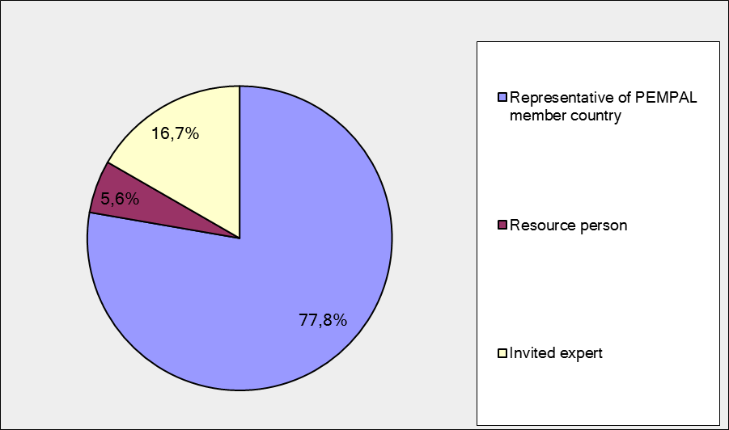

Q2. Was this your first participation in a PEMPAL event?

36 respondents (100%) answered this question.

Answer Options | Response Percent | Response Count
Yes | 19,4% | 7
No | 80,6% | 29

Q3. How many PEMPAL events have you attended before?

This question was seen only by those respondents who chose “No” in the previous question.
29 respondents answered this question.

1-2 | 3-4 | 5-6 | more than 6 | Response Count
6 | 4 | 5 | 14 | 29
PART I EVENT DELIVERY

Q4. How do you rate your participation in this event?

36 (100%) answers were given. 25 respondents think that their participation in the event was ‘Active’.10 respondents think that their participation was ‘Average’. One chose the option “Passive”.

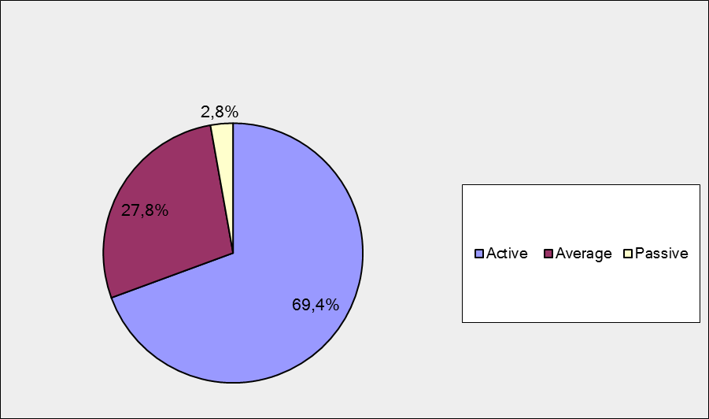

Q5. How do you rate the event duration overall?

36 respondents (100%) answered this question. Most of them rated the event duration in a positive way.

Answer Options | Response Percent | Response Count
Too short | 16,7% | 6
About right | 77,8% | 28
Too long | 5,6% | 2

Q6. How much do you agree with the following statements about the participants of the event? (Please rate each item):
36 respondents (100%) replied to this question.
Answer Options | 1 strongly disagree | 2 | 3 | 4 | 5 Strongly agree | «5», % | Response Count | Average
a) The level of the event was appropriate for a person with my experience and knowledge | 0 | 0 | 1 | 8 | 27 | 75 | 36 | 4,7
b) I learned from the experience of other participants in the event | 0 | 0 | 5 | 6 | 25 | 69.4 | 36 | 4,6
с) Participants had about equal level of prior expertise relevant to the event topics | 0 | 4 | 5 | 17 | 10 | 27,8 | 36 | 3,9
d) Content of presentations, hand-outs and other materials were appropriate for a person with my level of knowledge | 0 | 0 | 0 | 8 | 28 | 77,8 | 36 | 4,8
Q7. Describe your own level of expertise, as compared to that of other participants?
13 comments were left.
- Practically equal
- I believe my indispensable level of expertise allowed me to keep up with other participants, follow their presentations, comments, suggestions, and thus expand my knowledge by learning from other participants, especially from their views on a particular issue, enabling me to help improve the internal control system in my country.
- I am a practice worker it means that I work in the Internal Audit Department and put into practice the knowledge in the area of internal control and internal audit compared to the participants with theoretical knowledge -
- In comparison with developed countries - insufficient, in comparison with the beginners - I have something to share
- Some participants did not have the expertise required to discuss thoroughly specific topics but this was a minority.
- My experience allows me to follow and enhance my knowledge from PEMPAL workshops
- High
- High university level I(comparable to others) and management
- Manager of the internal audit division within the CHU framework, authorised internal auditor for the public sector (national certificate), 10 years of experience in internal audit
- About equal to the level of developments in countries that are not part of EU still.
- Entirely familiar with and involved in the PIFC and PIC concepts
- My knowledge in this area a bit less than knowledge of my colleages with whom we discussed questions around the table
- Our system is more advanced and developed than the other participants (at this moment).
Q8. What have you learned from other participants?
13 informative comments were left.
- Experience of other countries in the implementation of PIFC
- -Clear understanding of the development of internal audit and control system
- I've learned different experiences that participants of other countries have shared regarding the level of implementation of the reforms in the area of Internal Control, and the challenges that they are facing. Their experiences are a valuable information and will assist us in our efforts to reform the internal control systems.
- Although I have already quite some experience in the field, it is always useful to hear other experiences to keep an open mind and to challenge own ideas and structures.
- I received a lot of new information on the internal control system and got acquainted with innovations and developments in this area, practical experience in different countries was very interesting, it provides an opportunity not only to expand professional horizons, but also to find answers to many practical questions.
- Exchange of similar experiences
- More lesson learned
- Alternative ways of approaching issues regarding internal control
- Application manner of the internal audit methodology within the scope of continuous training and quality control
- "Approach to better report the situation of PIFC across the country, Self-assessment and quality assessment of IA, Training in FMC for a very large public"
- Their experiences, positive and negative, as high quality information for reflecting on the advantages and disadvantages of particular solutions.
- Understanding of the goals and objectives of the reforms in the field of internal auditing
- Certification systems for internal auditors, procedures, internal audit practice..

Q9. How much do you agree with the following statements about the content design of the event? (Please rate each item):
36 respondents (100%) replied to this question.
Answer Options | 1 strongly disagree | 2 | 3 | 4 | 5 Strongly agree | «5»,  % | Response Count | Average
a) The event agenda was properly planned | 0 | 0 | 2 | 14 | 20 | 55.6 | 36 | 4,5
b) The content of the event was properly prepared | 0 | 0 | 4 | 9 | 23 | 63.9 | 36 | 4,5
с) The event addressed issues important to my work | 0 | 0 | 3 | 2 | 31 | 86,1 | 36 | 4,8
d) The event covered a right number of topics for the amount of time available | 0 | 2 | 5 | 11 | 18 | 50 | 36 | 4,3
e) The topics for the group discussions were relevant | 0 | 1 | 0 | 7 | 27 | 75 | 35 | 4,6
f) Presentations made during the event were relevant and useful | 0 | 1 | 2 | 1 | 32 | 88,9 | 36 | 4,8
g) Enough time was reserved for questions to speakers | 0 | 3 | 5 | 9 | 19 | 52.7 | 36 | 4,2

9 comments were left. Here and after comments with criticism are underlined.
- Although there was not enough time after every presentation, there was time during the table discussions. These table discussions were very interesting and better focused to specific topics than the general questions in the Q&A after the presentations. So, I would suggest more time for table discussions and workshops than increasing time for Q&A.
- This event was a qualitative and efficient, lively and interesting. The target audience was stable and mutual understanding was reached in the discussion and questions-answers.
- More world café type of activities.
- I believe it would be better to shorten the number of topics and make more room for discussion
- The program was a little too full. Less topics in the same time would allow more deepness in the discussions.
- There is a strong need for allotting more time for Q&A
- The agenda for the first two days was too cluttered, a plethora of activities for one work day.
- Everything was planned and carried out at a high professional level. Very interesting and useful presentations by experts.
- Very good experts (ex. JP Garitte, Richard Mags) and is o good idea to correlate multiple levels of expertise (European Commission, Member States, etc).
Q 10. How much do you agree with the following statements about the outcomes of the event?
Answered question – 36 (100%).

Event objective has been achieved | 1 strongly disagree | 2 | 3 | 4 | 5 Strongly agree | «5»,  % | Response Count | Average
a) Learn from country successful experience in implementation of the public internal control (PIC) with focus on the Czech Republic | 0 | 0 | 3 | 15 | 18 | 50 | 36 | 4,4
b) Share key recent developments in the internal audit in different regions and countries to identify good practices | 0 | 0 | 1 | 5 | 30 | 83,3 | 36 | 4,8
c) Introduce the IACOP updated strategy and the new Internal Control Working Group | 0 | 0 | 3 | 8 | 25 | 69,4 | 36 | 4,6
d) Update on the progress made on the IACOP Strategic Plan and our added value activities | 0 | 1 | 0 | 9 | 26 | 72,2 | 36 | 4,7
e) Share the knowledge created and report on the progress made in the IACOP working groups: Internal Audit Quality Assessment Guide and IACOP Position Paper on RIFIX (Relationship of Internal Audit with Financial Inspection and External Audit) | 0 | 0 | 0 | 6 | 30 | 83,3 | 36 | 4,8

3 comments were left:

- Hopefully we come back to the experiences with the different instruments (such as the IA Quality Assessment Guide) in following meetings so that the instruments can be fine-tuned and updated according the lessons learned in the concrete experiences.
- All event objectives were achieved. I did not have feeling that something was incomplete..
- We need more opportunities to discuss and to share information..

PART 2 EVENT ADMINISTRATION
Q 11. Please rate the quality of the organization and administration of the event:
Answered question – 36 (100%).
Answer Options | 1 low | 2 | 3 | 4 | 5 high |  | «5»,  % | Response Count | Average
Quality of organization
choice of venue | 0 | 1 | 3 | 10 | 22 |  | 61.1 | 36 | 4,5
travel arrangements | 0 | 0 | 1 | 8 | 27 |  | 75 | 36 | 4,7
event logistics | 0 | 0 | 2 | 12 | 21 |  | 58.3 | 35 | 4,5
contribution provided by hosts | 1 | 1 | 5 | 8 | 19 |  | 52.7 | 34 | 4,3
Quality of administration
Secretariat staff responsiveness | 0 | 0 | 3 | 4 | 29 |  | 80.6 | 36 | 4,7
- written communication | 0 | 0 | 1 | 6 | 29 |  | 80.6 | 36 | 4,8
- participant registration | 0 | 0 | 2 | 2 | 32 |  | 88,9 | 36 | 4,8

There were left 5 comments.
- Thank you
- Hotel and flight booking were quite last minute so I could no longer chose the flights that I wanted. But staff was very helpful the arrange an alternative flight because my original flight was cancelled so I am very satisfied with that. Thanks!
- We must pay tribute to the members of the Secretariat for their efficiency and professionalism in the organization of the event. The presence of complex situations and unresolved issues did not become an obstacle to them, they were all overcome. thanks them so much!
- The hotel was located far from the city centre.
- Very good organisators
Q 12. Did you receive agenda and event information in sufficient time before the event for them to be useful?
36 (100%) answers were given. 88.9% responses (32) were “Yes”. 11.1% responses (4) were “No”.
Q 13. Did you receive practical information (about the accommodation and other facilities, etc.) prior to the event?
36 (100%) answers were given. 88.9% responses (32) were “Yes”. 11.1% responses (4) were “No”.

Q14. Are you satisfied with the quality of simultaneous interpretation provided during the event?
36 (100%) answers were given.
Answer Options | 1 low | 2 | 3 | 4 | 5 high | «5»,  % | Response Count | Average
 | 0 | 0 | 2 | 2 | 32 | 88.9 | 32 | 4,8

5 comments were given. 4 commenters were very satisfied. For example: “Congratz to the interpreters!.”
Other comment:
- The possibility of direct interpretation from Russian into BSC and vice versa.

Q15. Are you satisfied with the quality of written translation of event materials?
36 (100%) answers were given.
Answer Options | 1 low | 2 | 3 | 4 | 5 high | «5»,  % | Response Count | Average
 | 0 | 1 | 3 | 9 | 23 | 63.9 | 36 | 4,5

5 comments were given:
- There are some moments…
- There were some mistakes in the handouts (translated), the text in English. On the whole, better than at the previous event in Yerevan. There is a lot of work and improve!
- Comments about the Russian translation.
- There were not enough materials in Serbian, specifically the quantity of documents in Serbian that were the products of working groups (the Guide, etc.) was insufficient, so I was left without any..
- Translation of materials into Russian sometimes was not right.

PART 3 OVERALL IMPRESSION
Q16. Did the event disappoint, meet, or exceed your expectations?

36 (100%) participants answered the question. No one was disappointed.

Answer Options | Response Percent | Response Count
Disappoint | 0,0% | 0
Meet | 80,6% | 29
Exceed | 19,4% | 7

Q17. What did you like best about the event?

14 comments were left. All of them are valid.
Participants like different aspects of the event:

World cafe were mentioned in 3 comments.
Interactive work was mentioned twice. For example: “The interactive way to learn and share information…”
Presentations were mentioned ones: “I would like the presentations from invite experts.…”
Experts were mentioned twice. For example: “ high level of professionalism of experts…”
Organization was mentioned in 1 comment.
Work in groups was mentioned in 2 comments.
Prepared documents were mentioned twice. For example: “Open discussions and achieving concrete results, with useful materials being produced”

Other comments:
- Introduction to different views of participants in the field of internal audit (especially of Russian participants)
- Discussion of internal audit news in different regions and countries experience, implementation of internal control in public sector by the example of the Czech Republic
- Plenary meeting, city tour by old tram.
- Discussed questions (topics),
- The exchange of experiences and open discussions.
- The general spirit of mutual understanding!
- I participated for the first time in a fishbowl!
- The presentations and how informed the speakers were on their presentation topics.
Q18. What did you not like most about the event?

10 comments were left.
2 comment were: “there was no such thing.”
Other 8 comments:

Little time was devoted to round table discussions in groups.

It was not very clear during the preparation of the seminar what was expected from me. But it worked out very well.

Host country attitude, but in general it was not so noticeable.

Too many presentations. Many presenters absent.

Some presentations were too long.

A very full program which resulted in people walking in and out.

10 hours in conference room

-the hotel (the heating system in the room).

Q19. Do you plan to brief your colleagues about the event?:
35 (97.2%) participants answered to the question. And 100% of them responded “Yes”.
Q20. How do you plan to brief your colleagues?
Answered question – 35 (97.2%).

Answer Options | Response Percent | Response Count
Share materials | 65,7% | 23
Make a presentation | 45,7% | 16
Prepare a back-to-office report | 77,1% | 27

1 comment was given:
- Mouth to mouth.
Q21. How much do you agree with the following statement?

35 respondents (97.2%) answered this question. Average rating is positive.

Answer Options | 1 not at all | 2 | 3 | 4 | 5 completely | «5»,  % | Response Count | Average
I will be able to apply the knowledge acquired at this event to my work | 0 | 0 | 3 | 8 | 24 | 68,6 | 35 | 4,6

Q22. How can you apply the acquired knowledge?

14 comments were left.

- Knowledge on risk assessment
- Guidance on internal audit quality assessment will be tested in practice
- In the development and improvement of legislation and methodology of internal audit and internal control
- Learning from the others experiences, as well as using the materials shared during this event in the daily work.
- The instruments are very useful (for instance the IA Quality Assurance Guide).
- Publication in in-house magazine, in work with students and in scientific research with the National Analysis Center.
- By providing better advice
- Translation of main materials
- Use materials in training programs
- In the preparation of regulations and the working methodology of public sector internal auditing
- In improving the current system of FMC by having a better impact of the PIFC annual report to the Government
- I will use them in the planning and design of future regulations.
- In work with draft of the relevant regulations
- I will improve the procedures at the level of the institution.
Q23. Overall, my satisfaction with the event was...

Answered question – 35 (97.2%). There were no negative answers.
1 not satisfied | 2 | 3 | 4 | 5 highly satisfied | «5»,  % | Response Count | Average
0 | 0 | 0 | 8 | 27 | 77 | 35 | 4,8

PART 4 RECOMMENDATIONS FOR THE FUTURE

Q24. Do you have any suggestions to improve the content, approach and other aspects of such events in future:
10 comments were left, and 7 of them consists suggestions.
- I think the approach used for Prague was very good and can only be further improved, as well as the content. I find it would be useful to have a short presentation by an IIA representative at every meeting, on the standards and novelties in standard application. It would also be useful to have the Internal Control Standards prepared and presented.
- I really appreciate group work on the World Café method because it allows communicating with the experts. I suggest to use this method in the future
- Although there was a good balance between presentations and open discussions, I would prefer some more time for the round table discussions and workshops.
- We need printed materials on foreign countries experience in English and Russian, please make easier access to Wiki, since it is difficult to register and gain access to the content.
- "Hotel in the real center, walking distance. Less presentations. Build in buffers."
- Leading debate and find solutions for a specific problem or challenge
- A few less topics for the agenda..

Q25. Are there any other products, research or services useful for your work that PEMPAL could provide?

7 comments were left and 4 of them are informative.

It would be good to conclude an agreement on bilateral cooperation between the MoF of such countries as Bulgaria, Croatia ,Hungary, Armenia etc.

All practical instruments such as templates and tools are useful.

Methodological guidance, methodology and implementation of internal control system are necessary for the countries are in implementation phase. This event provided interesting material on PEMPAL activities. Thank you so much! I would like to have more of such products.

Quality assessment guide for financial management and control in public sector.

