PEMPAL IACOP WG in Prague
FEEDBACK SURVEY

On March 24th, 2016, Internal Control WG of PEMPAL IACOP meeting took place in Prague, the Czech Republic..
After the event, the on-line survey in three languages was created on the base of the standard set of questions developed by Secretariat. The aim of the survey was to receive event feedback and to learn plans for the future.

Link to the survey – https://ru.surveymonkey.com/r/QLP58TJ

The survey started to collect responses on April 1 and finished on April 19, 2016.
Invitations to take part in the survey were sent to all participants of the event. We sent 39 invitations.
25 persons complete their responses. In this report, we analyze all 25responses. For further calculation, we take this quantity as 100%.

All these responses will be included in the general Feedback Event Database.
The questionnaire comprises five parts: About the Respondent, Event Delivery, Event Administration, Overall Impression, and Recommendations for the Future. There are 25 questions in the survey.
ABOUT THE RESPONDENT

Q1. You are...

25 (100%) respondents gave answers. Among them: 19 representatives of PEMPAL countries, 3 invited experts, and 3 resource persons.
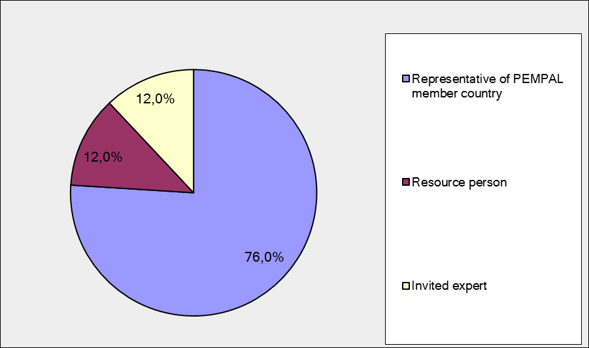

Q2. Was this your first participation in a PEMPAL event?

25 respondents (100%) answered this question.

Answer Options | Response Percent | Response Count
Yes | 20,0% | 5
No | 80,0% | 20

Q3. How many PEMPAL events have you attended before?

This question was seen only by those respondents who chose “No” in the previous question.
20 respondents answered this question.

1-2 | 3-4 | 5-6 | more than 6 | Response Count
3 | 3 | 2 | 12 | 20
PART I EVENT DELIVERY

Q4. How do you rate your participation in this event?

25 (100%) answers were given. 13 respondents think that their participation in the event was ‘Active’.11 respondents think that their participation was ‘Average’. One chose the option “Passive”.

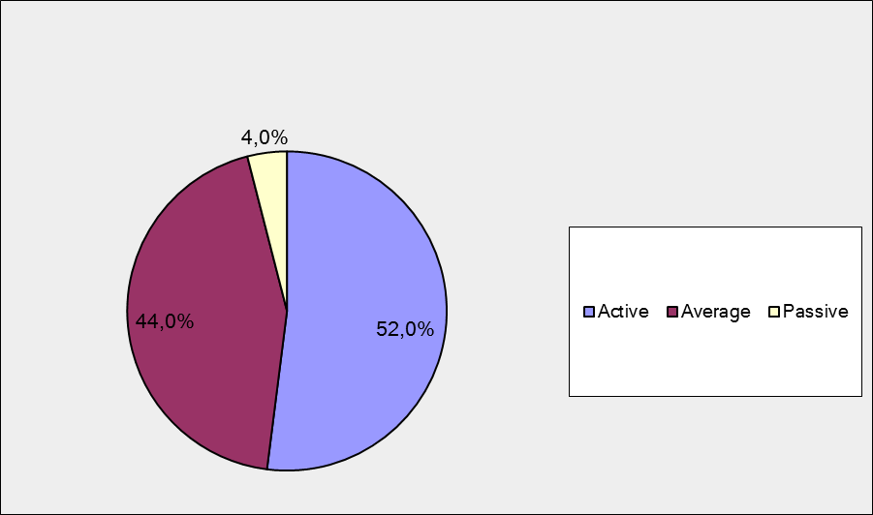

Q5. How do you rate the event duration overall?

25 respondents (100%) answered this question. Most of them rated the event duration in a positive way.

Answer Options | Response Percent | Response Count
Too short | 24,0% | 6
About right | 76,0% | 19
Too long | 0,0% | 0

Q6. How much do you agree with the following statements about the participants of the event? (Please rate each item):
24 respondents (96%) replied to this question.
Answer Options | 1 strongly disagree | 2 | 3 | 4 | 5 Strongly agree | «5», % | Response Count | Average
a) The level of the event was appropriate for a person with my experience and knowledge | 0 | 1 | 1 | 5 | 17 | 70.8 | 24 | 4,6
b) I learned from the experience of other participants in the event | 0 | 3 | 2 | 5 | 14 | 58.3 | 24 | 4,3
с) Participants had about equal level of prior expertise relevant to the event topics | 0 | 4 | 5 | 9 | 6 | 25 | 24 | 3,7
d) Content of presentations, hand-outs and other materials were appropriate for a person with my level of knowledge | 0 | 3 | 2 | 3 | 16 | 66.7 | 24 | 4,3
Q7. Describe your own level of expertise, as compared to that of other participants?
7 comments were left. Here and after comments with criticism are underlined.
- Practically equal
- I am internal and external auditor working in practice more then 10 years.
- "Particular level of expertise : - conception, implementation and follow up the PIC reform at strategic and operational level in French State administration ; - initialization, involvement and follow up of the European PIC approach and dissemination of experiences"
- Medium/high
- It is necessary to prepare a document that includes a complete analysis of the internal control system of each country, taking into account its specificity, participation of state bodies and budget organizations etc. It is difficult to understand the internal control system in the European countries, especially according to presentations of Manfred and other international consultants
- The same
- -Too many presentations.
Q8. What have you learned from other participants?
7 informative comments were left.
- Experience exchange on achievements and daily work in other countries. Their experience, arising problems and possibility to solve themя.
- "New points of views and ideas in term of adaptation of IC principles taking into account the specificities of different countries and administrative cultures.
- Good practices, relevant with my day to day stakes and objectives"
- Different perspectives on the topics IA and IC dependable on the context, culture, history and maturity levels.
- Their countries reforms and positive experience on the theme of the Plenary.
- About state of affairs of PIC in some EU countries
- Their views and experiences from their countries.
- Different cultures, different perceptions on internal control.

Q9. How much do you agree with the following statements about the content design of the event? (Please rate each item):
22 respondents (88%) replied to this question.
Answer Options | 1 strongly disagree | 2 | 3 | 4 | 5 Strongly agree | «5»,  % | Response Count | Average
a) The event agenda was properly planned | 0 | 0 | 2 | 4 | 16 | 72.7 | 22 | 4,6
b) The content of the event was properly prepared | 0 | 0 | 1 | 3 | 18 | 81.8 | 22 | 4,8
с) The event addressed issues important to my work | 0 | 0 | 2 | 5 | 15 | 68.2 | 22 | 4,6
d) The event covered a right number of topics for the amount of time available | 0 | 1 | 5 | 6 | 10 | 45.5 | 22 | 4,1
e) The topics for the group discussions were relevant | 0 | 1 | 0 | 6 | 15 | 68.2 | 22 | 4,6
f) Presentations made during the event were relevant and useful | 0 | 1 | 2 | 4 | 15 | 68.2 | 22 | 4,5
g) Enough time was reserved for questions to speakers | 0 | 0 | 2 | 8 | 12 | 55 | 22 | 4,5

4 comments were left.
- I have just attend to the 2 first days
- Agenda was too full. Reserve more time in the agenda with 'open space' for lengthier and more in depth discussions and Q&A's
- In the future, it is necessary to continue to discuss the subject of internal control in each country.
- See previous comments. Not enough group discussions.
Q 10. How much do you agree with the following statements about the outcomes of the event?
Answered question – 22 (88%).

Event objective has been achieved | 1 strongly disagree | 2 | 3 | 4 | 5 Strongly agree | «5»,  % | Response Count | Average
a) Introduce the new Internal Control Working Group (ICWG) / | 0 | 0 | 0 | 5 | 17 | 77.3 | 22 | 4,8
b) Share key principles and understanding of the Public Internal Control (PIC) from the EU among members | 0 | 0 | 1 | 7 | 14 | 63.6 | 22 | 4,6
c) Clarify key definitions and important players in PIC area | 0 | 0 | 0 | 8 | 14 | 63.6 | 22 | 4,6
d) Agree on the next steps in the ICWG | 0 | 0 | 3 | 5 | 14 | 63.6 | 22 | 4,5

4 comments were left:

- ICWG is still a bit vague in terms of clear ideas of what itr wants to achieve.
- In the future, it is necessary to continue to work in this direction
- I liked the topics for future IC WG meetings
- Not sure if there was an agreement at the end.

PART 2 EVENT ADMINISTRATION
Q 11. Please rate the quality of the organization and administration of the event:
Answered question – 22 (88%).
Answer Options | 1 low | 2 | 3 | 4 | 5 high |  | «5»,  % | Response Count | Average
Quality of organization
choice of venue | 0 | 1 | 2 | 8 | 11 |  | 50 | 22 | 4,3
travel arrangements | 0 | 0 | 1 | 5 | 15 |  | 71.4 | 21 | 4,7
event logistics | 0 | 0 | 1 | 6 | 14 |  | 66.7 | 21 | 4,6
contribution provided by hosts | 1 | 0 | 2 | 6 | 12 |  | 57.1 | 21 | 4,3
Quality of administration
Secretariat staff responsiveness | 0 | 0 | 2 | 5 | 15 |  | 68.2 | 22 | 4,6
- written communication | 0 | 0 | 3 | 4 | 14 |  | 66.7 | 21 | 4,5
- participant registration | 0 | 0 | 1 | 4 | 16 |  | 76.2 | 21 | 4,7

There were left 3 comments.
- Travel arrangements and different options in travel arrangements came rather late.
- Not enough communication with the representatives of the Czech Republic. Little excursion around Prague
- Host was a bit absent throughout the meeting.
Q 12. Did you receive agenda and event information in sufficient time before the event for them to be useful?
22 (88%) answers were given. 81.8% responses (318) were “Yes”. 18.2% responses (4) were “No”.
Q 13. Did you receive practical information (about the accommodation and other facilities, etc.) prior to the event?
22 (88%) answers were given. 90.9% responses (20) were “Yes”. 9.1% responses (2) were “No”.

Q14. Are you satisfied with the quality of simultaneous interpretation provided during the event?
22 (88%) answers were given.
Answer Options | 1 low | 2 | 3 | 4 | 5 high | «5»,  % | Response Count | Average
 | 0 | 0 | 1 | 3 | 18 | 81.8 | 22 | 4,8

2 comments were given:
- Quality of interpretation was good.
- The interpreters should remain careful as to distinguish clearly between control and audit when translating.

Q15. Are you satisfied with the quality of written translation of event materials?
22 (88%) answers were given.
Answer Options | 1 low | 2 | 3 | 4 | 5 high | «5»,  % | Response Count | Average
 | 0 | 0 | 2 | 5 | 15 | 68.1 | 22 | 4,6

3 comments were given:
- I understood that the Russian translation is not always ok. This remark was already made during the previous PemPal-session in Yerevan. It should improve.
- Quality of translation was good too.
- Complaints from Russian speaking members..

PART 3 OVERALL IMPRESSION
Q16. Did the event disappoint, meet, or exceed your expectations?

22 (88%) participants answered the question. No one was disappointed.

Answer Options | Response Percent | Response Count
Disappoint | 0,0% | 0
Meet | 86,4% | 19
Exceed | 13,6% | 3

Q17. What did you like best about the event?

9 comments were left:
- Introduction to different views of participants in the field of internal audit (especially of Russian participants)
- Possibility to discuss, multilevel, exchange of experience.
- Objectives and intentions
- The presentation and delivery of the working results on IA quality assessment
- Good exchange of different views.
- The theme of the Plenary Session selected in order to get acquainted with different systems of internal control
- Pragmatism
- "Topics for future. Experience of EU"
- -Interest in the topic.
Q18. What did you not like most about the event?

8 comments were left.
2 comment were: “there was no such thing.”
Other 6 comments:

Many topics for discussion - and time was too short.

Placed at the outside the city.

Certain presentations too formal or legislation oriented

Agenda too packed.

Less time for communication, tight rhythm, after the event I was sick 4 days

Too many presentations. Too many presenters not showing up.

Q19. Do you plan to brief your colleagues about the event?:
22 (88%) participants answered to the question. And 100% of them responded “Yes”.
Q20. How do you plan to brief your colleagues?
Answered question – 21 (84%).
Answer Options | Response Percent | Response Count
Share materials | 61,9% | 13
Make a presentation | 33,3% | 7
Prepare a back-to-office report | 85,7% | 18
1 comment was given:
- Just sharing.
Q21. How much do you agree with the following statement?

22 respondents (88%) answered this question. Average rating is positive.

Answer Options | 1 not at all | 2 | 3 | 4 | 5 completely | «5»,  % | Response Count | Average
I will be able to apply the knowledge acquired at this event to my work | 0 | 1 | 3 | 3 | 15 | 68,2 | 22 | 4,5

Q22. How can you apply the acquired knowledge?

12 comments were left.
- Knowledge on risk assessment
- The construction of the structure, the use of methodical material, I will applythe positive achievements of colleagues in my work.
- Promote lessons learned in the design and implementation of PIFC
- By integrating the new ideas, perceptions, and guide lines into my own works and proposals
- Training
- Developed products and insights are used elswehere in other projects.
- Use a positive experience and understanding of our system.
- I think it will become clear in everyday work.
- Preparation of regulations and guidelines
- By creating and applying the products of the WG
- Through my work.
- No knowledge really acquired..
Q23. Overall, my satisfaction with the event was...

Answered question – 22 (88%). There were no negative answers.
1 not satisfied | 2 | 3 | 4 | 5 highly satisfied | «5»,  % | Response Count | Average
0 | 0 | 2 | 4 | 16 | 72.7 | 22 | 4,6

PART 4 RECOMMENDATIONS FOR THE FUTURE

Q24. Do you have any suggestions to improve the content, approach and other aspects of such events in future:
5 comments were left, and 3 of them consists suggestions.
- Focus on big picture. Debate about principles and values rather than technical details
- Unique mechanism of communication and practical knowledge of international experience was created.
- More practical cases.
- -Less presentations, more expert visits to groups. Provide buffers instead of filling up agenda. Insist on discipline to get back in the room on time..

Q25. Are there any other products, research or services useful for your work that PEMPAL could provide?

5 comments were left.

The selection of teaching materials, working papers of previous meetings 2013-2015.

External audit role related to PIFC system design and implementation.

I would be pleased to have an access to the database of deliveries provided by PEMPAL

Continue to further this work

I assume that we need more practice rather than theory.

