PEMPAL IACOP WGs MEETING IN BRUSSELS
FEEDBACK SURVEY

On February, 27 - March, 2 the PEMPAL IACOP WGs meeting took place in Brussels, Belgium.
After the event, the on-line survey in three languages was created on the base of the standard set of questions developed in June 2017. The aim of the survey was to receive event feedback and to learn plans for the future.

Link to the survey – https://www.surveymonkey.com/r/XCF3R67

The survey started to collect responses on March 8 and finished on March 24, 2018.
Invitations to take part in the survey were sent to all participants of the event. We sent 49 invitations.
35 persons started to response to the survey. In this report, we analyze all 35 responses. For further calculation, we take this quantity as 100%.

All these responses will be included in the general Feedback Event Database.
The questionnaire comprises five parts: About the Respondent, Event Delivery, Event Administration, Overall Impression, and Recommendations for the Future. There are a total of 28 questions in the survey.
ABOUT THE RESPONDENT

Q1 You are...

34 (97.1%) respondents gave answers. Among them: Representatives of PEMPAL country (but not a member of the Executive Committee) — 21; Representatives of COP Executive Committee — 7; Representative of Hosting Institution — 1; Resource persons — 1; Invited experts — 4.
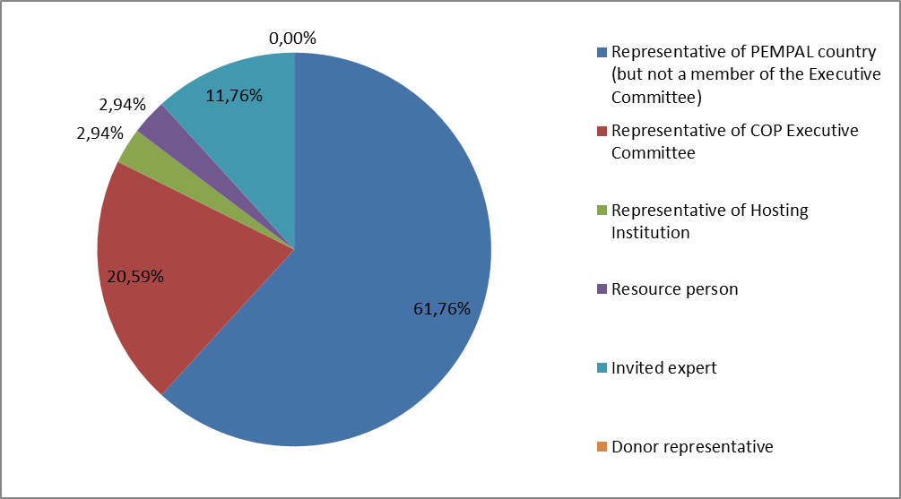

Q2. Was this your first participation in a PEMPAL event?

35 respondents (100%) answered this question. And 85.7% of them replied “No”.

Answer Options | Response Percent | Response Count
Yes | 14,3% | 5
No | 85,7% | 30

Q3. How many PEMPAL events have you attended before?

This question was seen only by those respondents who chose “No” in the previous question.
30 respondents answered this question.

1-2 | 3-4 | 5-6 | more than 6 | Response Count
3 | 8 | 6 | 13 | 30
PART I EVENT DELIVERY

Q4. How do you rate your participation in this event?

35 (100%) answers were given. 23 respondents think that their participation in the event was ‘Active’. 11 respondents think that their participation was ‘Average’. One chose the option “Passive”.

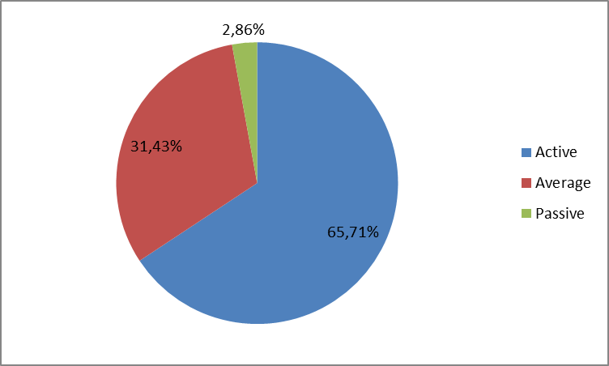

Q5. How do you rate the event duration overall?

35 respondents (100%) answered this question.

Answer choices | Response Percent | Response Count
Too short | 5,7% | 2
About right | 94,3% | 33
Too long | 0,0% | 0

Q6. How much do you agree with the following statements about the participants of the event?
34 respondents (97.1%) replied to this question.
Answer Options | 1 strongly disagree | 2 | 3 | 4 | 5 Strongly agree | “5”, % | Response Count | Average
a) The level of the event was appropriate for a person with my experience and knowledge | 0 | 0 | 1 | 10 | 23 | 67.7 | 34 | 4,6
b) I learned from the experience of other participants in the event | 0 | 0 | 5 | 10 | 19 | 55.9 | 34 | 4,4
c) Participants had about equal level of prior expertise relevant to the event topics | 0 | 1 | 11 | 15 | 7 | 20.6 | 34 | 3,8
d) Content of presentations, hand-outs and other materials were appropriate for a person with my level of knowledge | 0 | 0 | 3 | 8 | 23 | 67.7 | 34 | 4,6
Q7. What have you learned from other participants?
17 comments were left.
- Its experiences that was changed ones with othersю
- Their status of practice.
- in depth understanding of the ICS in Belgium and understanding of IA functioning in EC
- Structure of EU audit divisionsю
- 1. Centralized internal audit function experience. 2. role of internal audit in pic. 3. process from audit universe to audit plan.
- It was interesting to hear about other countries experience.
- Knowledge in the area of internal control from countries that are more developed in this area.
- The level of acceptance of the COSO framework with 17 principles of internal control in various countries. The development of the individual audit planning methodology.
- I learned about how established internal control and internal audit.
- Learning about best practices in country-members. Especially about risk management audit.
- The experience of different countries and resource team in the field which was chosen as a topic for meetings
- I exchanged experience in implementation of the internal audit function in the Kyrgyz Republic with the participants of the Working Group on Audit in practice. I liked the working atmosphere of these meetings, especially the active discussion. All participants actively manifested themselves in presentations on risk definition in control systems.
- Their experiences and different approaches.
- European experienceю
- New approaches related internal control and internal auditю
- Exchanging experiences with member states helps to advance experiences and best practicesю
- The best practice; experience; different legal framework in IC and IA.
Q8. How much do you agree with the following statements about the content design of the event?
33 respondents (94.3%) replied to this question.
Answer Options | 1 strongly disagree | 2 | 3 | 4 | 5 Strongly agree | «5»,% | Response Count | Average
a) The event agenda was properly planned | 0 | 0 | 2 | 4 | 27 | 81,8 | 33 | 4,8
b) The content of the event was properly prepared | 0 | 0 | 2 | 5 | 26 | 78,8 | 33 | 4,7
с) The event addressed issues important to my work | 0 | 0 | 0 | 11 | 22 | 66,7 | 33 | 4,7
d) The event covered a right number of topics for the amount of time available | 0 | 1 | 1 | 12 | 19 | 57,6 | 33 | 4,5
e) The topics for the group discussions were relevant | 0 | 0 | 0 | 9 | 24 | 72,7 | 33 | 4,7
f) Enough time was reserved for group discussions | 0 | 0 | 2 | 14 | 17 | 51,5 | 33 | 4,5
e) Presentations made during the event were relevant and useful | 0 | 0 | 0 | 9 | 24 | 72,7 | 33 | 4,7
h) Enough time was reserved for questions to speakers | 0 | 1 | 4 | 9 | 19 | 57,6 | 33 | 4,4

3 comments were left:
- Nothing to comment about its subject
- Generally everything was planned and organized at a high level. I'd like to wish to make a section on the website, or a separate topic at a meeting highlighting the benefits of moving to the generally accepted standards of internal control and audit for countries at the beginning of this path, as well as the World Bank position on this issue.
- No questions.
Q9. How much do you agree with the following statements about the outcomes of the event? (Internal Control Working Group (ICWG))
31 responses (88.6%) were left.
Event objectives has been achieved: | 1 strongly disagree | 2 | 3 | 4 | 5 Strongly agree | “5”, % | Response Count | Average
a) Understanding of good practices in implementing and assessing PIC including managerial accountability in the EC, Belgium, PEMPAL member countries and beyond | 0 | 0 | 2 | 11 | 24 | 58.1 | 31 | 4,5
b) Agreed PEMPAL criteria for assessment of the managerial accountability of a budget organization | 0 | 0 | 4 | 13 | 21 | 43.3 | 30 | 4,3
c) Updated PIC Glossary including its translation | 0 | 0 | 2 | 10 | 16 | 61.3 | 31 | 4,6

5 comments were left:
- As CHU, we need to see monitoring implementations / tools from other countries.
- It is crucial to present each term from the glossary at the event and be able to comment on it.
- I put “4” to all objectives as it is impossible to gain all objectives during one event.
- Unfortunately I did not participate in ICWG, I was invited only in AiP session.
- I think that we have to summarize/redesign some of our results such as the PEMPAL criteria for assessment of the managerial accountability
Q10. How much do you agree with the following statements about the outcomes of the event? (Audit in Practice (AiP) Working Group Meeting)
31 responses (88.6%) were left.
Event objectives has been achieved: | 1 strongly disagree | 2 | 3 | 4 | 5 Strongly agree | “5”, % | Response Count | Average
a) PEMPAL audit plan and program template and samples of working documents for performing an audit engagement | 0 | 0 | 1 | 11 | 19 | 61.3 | 31 | 4,6
b) Practical case studies to be used as a training tool | 0 | 0 | 2 | 12 | 17 | 54.8 | 31 | 4,5
c) Knowledge of good practices from EC and Belgium | 0 | 0 | 0 | 11 | 20 | 64.5 | 31 | 4,6

4 comments were left:
- Preparation audit plan/program engagement based on risk
- It is necessary to work more on plan and program audit template.
- Very educative.
- Short time for questions to the hosting country taking into account that Belgium is very developed country in IC and IA. The system in Belgium is more mature compared with ours.
Q11. Please rate the quality of the leadership, management and/or technical services provided to the event by the following:
33 responses (94.3/%) were given.
Answer Options | 1 low | 2 | 3 | 4 | 5 high | “5”, % | Response Count | Average
IACOP Executive Committee | 0 | 0 | 0 | 3 | 28 | 90.3 | 31 | 4,9
IACOP Resource Team | 0 | 0 | 0 | 5 | 28 | 84.9 | 33 | 4,85

5 comments were left:

All of them are amazing persons.

Thank you all for the great job!!!

The content of the event was relevant to the interests of participations. The materials which are supplied by the resource team was sufficient and appropriate.

Everything was organized on a very high level.

It was my first time in AiP PEMPAL meeting and I liked very much organizers team and active discussion by WG’s participants.
Q12. Please rate the quality of services provided by the event speaker(s):
33 responses (94.3/%) were given.
Answer Options | 1 low | 2 | 3 | 4 | 5 high | “5”, % | Response Count | Average
Quality of service | 0 | 0 | 0 | 8 | 25 | 75.8 | 33 | 4,8
2 comments were left:
- Everything was very nice on this PEMPAL meeting
- I am satisfied.

PART 2 EVENT ADMINISTRATION
Q13. Please rate the quality of the organization and administration of the event:
Answered question – 33 (94.3%).
Answer Options |  | 1 low | 2 | 3 | 4 | 5 high | “5”, % | Response Count | Average
 | Quality of organization
- choice of venue |  | 0 | 0 | 0 | 3 | 28 | 90,9 | 33 | 4,9
- travel arrangements |  | 0 | 0 | 1 | 8 | 24 | 71,9 | 32 | 4,7
- event logistics |  | 0 | 0 | 0 | 5 | 25 | 84,4 | 33 | 4,8
- contribution provided by hosts |  | 0 | 0 | 1 | 2 | 31 | 90,9 | 33 | 4,9
 | Quality of administration
- Secretariat staff responsiveness |  | 0 | 0 | 0 | 4 | 31 | 87,9 | 33 | 4,9
- written communication |  | 0 | 0 | 0 | 3 | 29 | 90,9 | 33 | 4,9
- participant registration |  | 0 | 0 | 1 | 2 | 31 | 90,9 | 33 | 4,9
There was left 2 informative comment.
- Congrats to all Arman Vatian´s WorkTeam
- The food was sometimes not qualitative as in others events..

Q14. Did you receive agenda and event information in sufficient time before the event for them to be useful?
32 (91.4%) answers were given. And 100% responses were “Yes”.
Q15. Did you receive practical information (about the accommodation and other facilities, etc.) prior to the event?
32 (91.4%) answers were given. And 100% responses were “Yes”.
Q16. Are you satisfied with the quality of simultaneous interpretation provided during the event?
30 (85.7%) answers were given.
Answer Options | 1 low | 2 | 3 | 4 | 5 high | “5”, % | Response Count | Average
Quality of sim. interpretation | 0 | 0 | 0 | 5 | 25 | 83.3 | 30 | 4.8
2 informative comments were left:
- Excellent interpreters.
- There was no Turkish translation support.
Q17. Are you satisfied with the quality of written translation of event materials?
31 (88.6%) answers were given.
Answer Options | 1 low | 2 | 3 | 4 | 5 high | “5”, % | Response Count | Average
Quality of written translation | 0 | 0 | 1 | 12 | 18 | 58.1 | 31 | 4.5
3 comments were left.
- There was no Turkish translation support.
- He were untranslated parts in hand-out materials and presentations.
- Good job.

PART 3 OVERALL IMPRESSION
Q18. Did the event disappoint, meet, or exceed your expectations?

32 (91.4%) participants answered the question.
Answer Options | Response Percent | Response Count
Disappoint | 0,0% | 0
Meet | 81,3% | 26
Exceed | 18,8% | 6

Q19. What did you like best about the event?

16 comments were left.
Participants like different aspects of the event:

- The topics were thoroughly chosen and the speakers we're concentrating on the topics with clear messages to understand the key concepts and system peculiarities.
- The high quality of the invited speakers and professionals on this meeting.
- Presentations on EC experiences (Mr. Manfred Kraff) The practical case on IA presented by Mr. Jean-Pierre Garrite.
- Examples from the European Commission internal audit practice.
- Opportunity to get direct contacts with representatives of countries in which internal control and audit are presented at a high level.
- Very good presenters and good discussions.
- Presentations of participants and hosting party.
- Practical cases, invited experts from South Amerika and Saudi Arabia.
- Working with cases
- Case studies section.
- Practical examples and workshops.
- Themes discussion
- The possibility to discuss and ask questions about the experiences of other participants.
- I liked the atmosphere of event.
- Strict compliance with agenda. A short pause between meetings of the working groups!
- Depth of the issues under discussion
Q20. What did you not like most about the event?
10 informative comments were left. 4 of them were “Nothing” or “Everything was OK”.
Rest 6 comments:

- The weather in Brussels :)
- Sightseeing in the evening, but there must be some reason behind
- Delay of flights
- Time of meetings. I propose to choose another time of year. For example, the months March, April, May or September
- .I would like to concentrate more on practical cases during our meetings.
- Time allocated for questions to the representatives of EC and Belgium. It was one of the few occasions in which we can learn from EC representatives.

Q21. Do you plan to brief your colleagues about the event?
32 (91.4%) participants answered the question. And 100% of them responded “Yes”.
Q22. How do you plan to brief your colleagues?
Answered question – 32 (91.4%). Most of respondents was going to share materials.
Answer Options | Response Percent | Response Count
Share materials | 68,75% | 22
Make a presentation | 34,4% | 11
Prepare a back-to-office report | 62,5% | 20
2 comments were given:
- At regular meetings, through discussions.
- It is a rule in our organization..
Q23. If your Ministry plans to promote this event, or PEMPAL in general, in internal or external media (e.g. MoF or other government website, MoF journal, television, radio, newspapers), please provide specific details so we can report to donors on any positive promotion of the value and benefits of PEMPAL.
7 comments were left and all of them are informative.
- See http://www.roskazna.ru/novosti-i-soobshheniya/novosti/1289860/
- We publish short information on PEM PAL events in our Bulletin for internal auditors that is published on the internet two times a year.
- I will write the article.
- There will be information about this event on the site of MoF.
- Topics and issues that were discussed during the meeting corresponded to the functions of the state internal control systems; therefore the information and experience acquired during the event will be applicable in context of work on the issues of public finance management and will help the ministry in achieving its objectives.
- Yes, there is such an opportunity, since the subject of the meeting can be of great interest to the readers of the financial press of the Republic of Belarus.
- The presentation will be posted on the website of the RT Ministry of Finance.
Q24. How much do you agree with the following statement?
32 respondents (91.4%) answered this question. Average rating is positive.
Answer Options | 1 not at all | 2 | 3 | 4 | 5 completely | “5”, % | Response Count | Average
I will be able to apply the knowledge acquired at this event to my work | 0 | 0 | 2 | 12 | 18 | 56.3 | 32 | 4,5
Q25. How can you apply the acquired knowledge?
16 comments were left.
- By improving my work system and sharing points of view with others public authorities on this subject.
- By developing methodology based on the knowledge and information i received
- Through the development of the audit methodology and through delivering education for gaining the certificate for internal auditors
- Wrote in the methodology.
- On the practice.
- Nowadays, we are working on revising all secondary and tertiary legislation.
- Preparing methodological guidance and giving lectures.
- Information and experience gained during the visit will be applicable in the context of work on issues related to public financial management and will contribute to the effective implementation of the objectives.
- By comparing the achieved level of internal audit and internal control with other countries, and in that way, based on their example, focus on system improvements.
- Putting changes in audit programs and plans.
- I will share all materials because I am trainer in Continuous Professional Training for internal audit in the public sector.
- In the designing stage of public internal financial control system and in its development stage.
- I have been working as an internal auditor for 13 years and have been applying my knowledge to practice.
- By considering the possible solutions that are in place here.
- During our internal audit work
- Through guidelines and instructions for auditors published on our website.
Q26. Overall, my satisfaction with the event was...

Answered question – 32 (91.4%). There were no negative answers.
1 not satisfied | 2 | 3 | 4 | 5 highly satisfied | “5”, % | Response Count | Average
0 | 0 | 0 | 5 | 27 | 84.4 | 32 | 4,8

Q27. If you have any other comments you would like to provide us, please provide them here.

4 informative comments were left:

Thank you so much, everything was organized well

It is necessary to organize more such events, as they gives a great opportunity to unite more countries and specialists in the field of Internal Control and Internal Audit. Thus, the quality of the concepts and guidelines developed by PEMPAL is improved. I express my gratitude to all the organizers for the work done.

I would like to propose PEMPAL networks to create questionnaires for each participant of the WG, in order to have more information about what kind of work each of us experiences. Some of us are practitioners, others are methodologists. In either case, both sides can benefit from such meetings.

For the time allocated to the host country we have 2 situations= countries which present the new developments in terms of IC and IA and some counties such as Belgium from which we must extract everything we can.

PART 4 RECOMMENDATIONS FOR THE FUTURE

Q28. Do you have any suggestions to improve the content, approach and other aspects of such events in future:
8 informative comments were left:
- It would be very useful if you provide all legislation in English related to internal control, risk management, and internal audit.
- While working in workgroup I suggest that the moderators and the reporters should be picked in advance, and thy should change on every task so (almost) everyone has the chance to be involved.
- Yes It would be very useful.
- It is essential to have a consistent system of material preparation for events. In other words, to choose either electronic or printed formats and clearly indicate what will be available in electronic format and what in the printed version.
- Increase the number of participants by inviting experts from countries such as China, Singapore, Japan.
- I would like to allocate more time to participants to get acquainted with host country sightseeing and culture during our future events.
- More time for discussions and perhaps to reintroduce the Newsletter in the printed format.
- Time allocated to host county has to be designed taking into consideration the information what we can used for our developments.

