PEMPAL IACOP WGs meeting in Moscow
FEEDBACK SURVEY
On October 17-19th, 2016, meeting of PEMPAL IACOP Internal control working group and RIFIX working group took place in Moscow, Russia.
After the event, the on-line survey in three languages was created on the base of the standard set of questions developed by Secretariat. The aim of the survey was to receive event feedback and to learn plans for the future.

Link to the survey – https://www.surveymonkey.com/r/VPJF6N9

The survey started to collect responses on October 21 and finished on November 7, 2016.
Invitations to take part in the survey were sent to all participants of the event. We sent 66 invitations.
39 persons complete their responses. In this report, we analyze all 39responses. For further calculation, we take this quantity as 100%.

All these responses will be included in the general Feedback Event Database.
The questionnaire comprises five parts: About the Respondent, Event Delivery, Event Administration, Overall Impression, and Recommendations for the Future. There are 26 questions in the survey.
ABOUT THE RESPONDENT

Q1. You are...

39 (100%) respondents gave answers. Among them: 30 representatives of PEMPAL countries, 5 invited experts, and 4 resource persons.
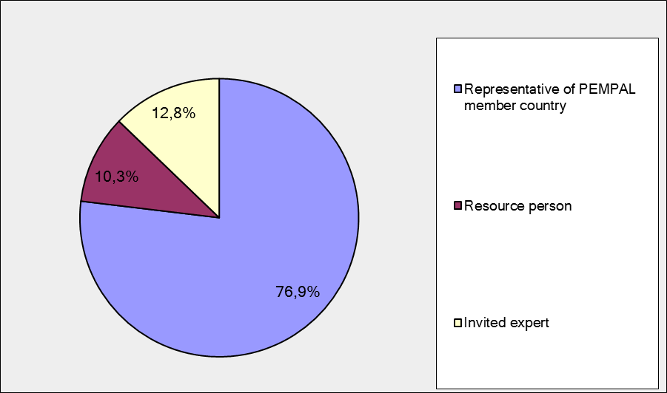

Q2. Was this your first participation in a PEMPAL event?

39 respondents (100%) answered this question.

Answer Options | Response Percent | Response Count
Yes | 17,9% | 7
No | 82,1% | 32

Q3. How many PEMPAL events have you attended before?

This question was seen only by those respondents who chose “No” in the previous question.
32 respondents answered this question.

1-2 | 3-4 | 5-6 | more than 6 | Response Count
6 | 5 | 6 | 15 | 32
PART I EVENT DELIVERY

Q4. How do you rate your participation in this event?

39 (100%) answers were given. 30 respondents think that their participation in the event was ‘Active’.9 respondents think that their participation was ‘Average’. No one choses the option “Passive”.

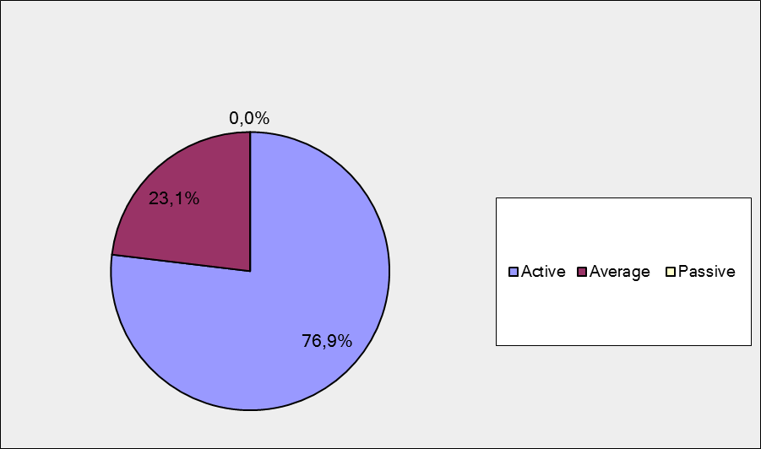

Q5. How do you rate the event duration overall?

39 respondents (100%) answered this question. Most of them rated the event duration in a positive way.

Answer Options | Response Percent | Response Count
Too short | 10,3% | 4
About right | 87,2% | 34
Too long | 2,6% | 1

Q6. How much do you agree with the following statements about the participants of the event? (Please rate each item):
39 respondents (100%) replied to this question.
Answer Options | 1 strongly disagree | 2 | 3 | 4 | 5 Strongly agree | «5», % | Response Count | Average
a) The level of the event was appropriate for a person with my experience and knowledge | 0 | 0 | 1 | 8 | 30 | 77 | 39 | 4,7
b) I learned from the experience of other participants in the event | 0 | 1 | 3 | 11 | 23 | 61 | 38 | 4,5
с) Participants had about equal level of prior expertise relevant to the event topics | 1 | 4 | 9 | 17 | 8 | 21 | 39 | 3,7
d) Content of presentations, hand-outs and other materials were appropriate for a person with my level of knowledge | 0 | 0 | 2 | 10 | 26 | 68 | 38 | 4,6
Q7. Describe your own level of expertise, as compared to that of other participants?
28 comments were left.
10 respondents think that their expertise is equal (or average) to that of others. For example:
Since my key responsibility is FMC implementation, I think my expertise in this field is equal as compared to that of most participants.
I believe that my level of expertise is average, compared to the other participants from countries which are in the PIC development process, and in relation to the topics under discussion at PEMPAL events, taking into account the level of PIC development in our countries.
5 respondents think that their expertise is higher than that of others. For example:
The answer to this question depends on the implementation level of specific areas in individual countries. I believe that for the majority of them we at the CHU in Montenegro have a high level of knowledge.
We are more advanced compared with other countries but at the same time less than others.
10 of them just described their expertise without comparing. For example:
I have 20 years of experience in public sector, and working directly in the internal control system since 2011, including coordination on partnership between public internal control units.
Practical experience in conducting audit of budget organizations and in this regard I have understanding of further practical application of the issues discussed.
3 respondents wrote that they are experts. For example: Senior expert and adequate resource.
Lack of expertise does not mentioned by respondents.
Q8. What have you learned from other participants?
25 informative comments were left.
- This event was a tremendous learning experience for me and I definitely learned from the other participants. I am going to revise the Internal Control Framework for government entities in my country and will take on board concepts that I have learned from other participants.
- Their difficulties.
- In general, the best for me was to examine the relationship between IA, SAI and FI in other countries, since in this respect we are just beginning our work. And of course, on the basis of developed and provided by the PEMPAL Concept.
- The efforts to reform the PIC system, introducing international standards of internal audit and the most adequate institutional design to improve a more efficient procedure and to achieve the best results.
- At the last meeting, I learned from several participating countries, how they have signed an agreement between IA and external audit in order to implement this experience in my country, on the basis of the Concept.
- A lot of can be learned from the majority of the participants especially from the experts.
- That the PIC is very live process that should be a part of each working process, each program or entire system of activities in each public or private entity
- The manner in which they conduct PIFC operations.
- I have learned about Russian Federation system, regarding budgetary internal control, federal treasury.
- Various good practices quite adaptable in my environment
- I learned a lot about Internal control environments in other PemPal member countries, about best practices, that will play an invaluable role in building sound internal control system in my country.
- As I mentioned in the questionnaire not too much about their experience but quite enough about standards and framework what should be done and how.
- That there are differences in internal control systems.
- I was familiarized with Moldova experience in the application of internal control in budget organizations, as well as the practical experience of other participating countries on this issue.
- It is extremely important to share experience for some areas.
- Different ways of presenting results, more understanding for different use of terms
- I learned from experience of other countries.
- How external audit, internal audit and financial control function on a global scale.
- Many thinks ! The most important i think is to change experiences as Knowledge with the members of PEMPAL IACOP community
- Country experience
- Internal control environments and understanding thereof differ significantly
- "Mmmm. Still a lot to do."
- The problems and the solutions from similar but different countries and economies.
- How the requirements from the internal audit standards have been applied, regarding quality control and setting up a continuous training system for internal auditors.
- I have learned a lot and I'm very proud because of that. First, I have learned a lot through the panel discussion and I got the idea about how to improve the relationship between internal audit, external audit and budget inspection with the goal of strengthening internal control and reducing risks to an acceptable level. Second, through the presentations and round table and panel discussions I have expanded my knowledge and solved some dilemmas when it comes to understanding the principle of internal control, and particularly which of the 17 principles are most important for the public sector and the internal control assessment, which is also important for the CHU, internal auditors and managers. So, in my opinion, this event was extremely well prepared and excellently realized. In my opinion, A+ for everything.
Q9. How much do you agree with the following statements about the content design of the event? (Please rate each item):
38 respondents (97.4%) replied to this question.
Answer Options | 1 strongly disagree | 2 | 3 | 4 | 5 Strongly agree | «5»,% | Response Count | Average
a) The event agenda was properly planned | 0 | 0 | 0 | 8 | 30 | 79 | 38 | 4,8
b) The content of the event was properly prepared | 0 | 0 | 1 | 6 | 31 | 82 | 38 | 4,8
с) The event addressed issues important to my work | 0 | 0 | 1 | 7 | 30 | 79 | 38 | 4,8
d) The event covered a right number of topics for the amount of time available | 0 | 0 | 1 | 10 | 27 | 71 | 38 | 4,7
e) The topics for the group discussions were relevant | 0 | 0 | 3 | 4 | 31 | 82 | 38 | 4,7
f) Presentations made during the event were relevant and useful | 0 | 0 | 1 | 6 | 31 | 82 | 38 | 4,8
g) Enough time was reserved for questions to speakers | 0 | 1 | 2 | 6 | 29 | 76 | 38 | 4,7

12 comments were left. Here and after comments with criticism are underlined.
- The level of discussions was at an appropriate level and the participants were obviously very knowledgeable in their respective fields
- Everything was perfectly prepared by the organizers, but it was allocated 30 minutes for the discussion of the event topic with the experts this time was not enough for us to discuss our problems with all the experts.
- Everything was well prepared, no comments.
- It would be more helpful to participants, if the presentations and topics were more practical.
- A panel discussion is an excellent example of good organization.
- Very well balanced agenda
- we have to use at maximum the practical experience of the lectors as JP Garitte.
- The event was very useful.
- It was all well organized and especially the presentations of specialists like Mr Garrett and Mr Stephan Roudien.
- The talk show could have been moderated a little more casually. It seemed to have been very much "staged" The presenter should try not to read the questions but ask them spontaneously That will help to make it feel much more "real".
- There was not enough time for discussions.
- Perhaps it would be useful to limit the time for the speakers in a panel discussion so that there is enough time left for questions, but also to limit the Q&A to specific questions, instead of making general comments.
How much do you agree with the following statements about the outcomes of the event?
Q 10. RIFIX WG outcomes.
Answered question – 37 (94.9%).

Event objective has been achieved | 1 strongly disagree | 2 | 3 | 4 | 5 Strongly agree | «5»,  % | Response Count | Average
a) To finalize and endorse the Concept Paper on Relationship of Internal Audit with Financial Inspection and External Audit. | 0 | 0 | 2 | 6 | 29 | 78 | 37 | 4,7
b) To learn good practices in RIFIX by sharing the key recent developments in the countries in the ECA region and beyond. | 0 | 0 | 3 | 8 | 26 | 70 | 37 | 4,6
c) To discuss a survey results and analyze the progress made in application of good RIFIX practices in the members countries from the beginning of the establishment of the RIFIX Working Group. | 0 | 0 | 4 | 7 | 26 | 70 | 37 | 4,6
d) To discuss the potential for further roll out of the good practice Concept Paper developed. | 0 | 0 | 2 | 9 | 26 | 70 | 37 | 4,6

4 comments were left:

- Making newspaper is a good idea in improving PEMPAL event organization.
- There is still room for work on the question concerned.
- Good job RIFIX WG
- It is necessary to periodically (annually) conduct a survey on the RIFIX situation in PEMPAL member countries and to present the results.
Q 11. ICWG outcomes.
Answered question – 38 (97.4%).
Event objective has been achieved | 1 strongly disagree | 2 | 3 | 4 | 5 Strongly agree | «5»,  % | Response Count | Average
a) Discuss the COSO Framework’s 17 principles of effective internal control to establish those most relevant for the public sector. | 0 | 0 | 1 | 8 | 29 | 76 | 38 | 4,7
b) Share member countries’ good practices in internal control (IC), and learn how countries have addressed implementation challenges. | 0 | 1 | 1 | 13 | 23 | 61 | 38 | 4,5
c) Initiate establishing a glossary for IC. | 0 | 0 | 2 | 9 | 27 | 71 | 38 | 4,7
d) Discuss the next steps for the IACOP ICWG. | 0 | 0 | 2 | 8 | 28 | 74 | 38 | 4,7

6 comments were left:
- It is necessary to work hard over the formation of the Glossary in the IC.
- Include specific examples
- There is room for further work on the questions concerned, especially when it comes to aligning the theory with practice.
- The glossary was not finalized on that meeting. So next time it will do. But there in Russia it was an improvement abt that matter .
- In the future, observe internal control from the point of view of internal audit, not from the point of view of management.
- Excellent preparation for the working group meeting and the process of defining further steps.

PART 2 EVENT ADMINISTRATION
Q 12. Please rate the quality of the organization and administration of the event:
Answered question – 38 (97.4%).
Answer Options | 1 low | 2 | 3 | 4 | 5 high |  | «5»,% | Response Count | Average
Quality of organization
choice of venue | 0 | 0 | 1 | 3 | 33 |  | 89 | 37 | 4,9
travel arrangements | 0 | 0 | 1 | 1 | 34 |  | 94 | 36 | 4,9
event logistics | 0 | 0 | 0 | 1 | 35 |  | 97 | 36 | 5,0
contribution provided by hosts | 0 | 0 | 0 | 1 | 36 |  | 97 | 37 | 5,0
Quality of administration
Secretariat staff responsiveness | 0 | 0 | 0 | 1 | 37 |  | 97 | 38 | 5,0
- written communication | 0 | 0 | 0 | 1 | 36 |  | 97 | 37 | 5,0
- participant registration | 0 | 0 | 0 | 1 | 36 |  | 97 | 37 | 5,0

There were left 13 comments.
- Great support from Secretariat
- Thank Secretariat for the good organization. Well done!!!
- Thank Secretariat so much for the qualitative organization of the workshop.
- Very professional organisation
- Special thanks to Secretariat staff. This was one of the best organized PemPal event.
- Very cold in the hotel, including the rooms.
- Very well organized and quick responses. Professionel!!!
- Perfect
- The temperature in the hotel room very low which led to a real discomfort.
- Organizing this event took a lot of effort and hard work, which is evident.
- Staff has improved a lot!
- -From sending the invitations and tickets, to transport, accommodation and return to Montenegro, everything was excellent, all activities were carried out professionally and on time. I would also like to point out the expressed tolerance and understanding. A++ for the quality of the event organisation and the manner in which the event was conducted.
- We would like to thank the Secretariat for arranging our trip and for helping us with detailed instructions regarding the visa process. All other questions and problems were immediately addressed by your colleagues (by e-mail and phone) and they were of great help.
Q 13. Did you receive agenda and event information in sufficient time before the event for them to be useful?
38 (97.4%) answers were given. 100% responses were “Yes”.
Q 14. Did you receive practical information (about the accommodation and other facilities, etc.) prior to the event?
38 (97.4%) answers were given. 100% responses were “Yes”.
Q15. Are you satisfied with the quality of simultaneous interpretation provided during the event?
37 (94.9%) answers were given.
Answer Options | 1 low | 2 | 3 | 4 | 5 high | «5»,% | Response Count | Average
 | 0 | 0 | 0 | 2 | 35 | 95 | 37 | 4,9

7 comments were given. All commenters were very satisfied. For example: “Interpretation was of high quality and very professional. We would like to thank the interpreters for doing a wonderful job and for being available to us for other activities (dinner, trip to the museum), not just during the official part of the event.”
Q16. Are you satisfied with the quality of written translation of event materials?
36 (100%) answers were given.
Answer Options | 1 low | 2 | 3 | 4 | 5 high | «5»,% | Response Count | Average
 | 0 | 0 | 2 | 6 | 30 | 79 | 38 | 4,7

1 comment was given:
- The written translations were the best so far, top quality.

PART 3 OVERALL IMPRESSION
Q17. Did the event disappoint, meet, or exceed your expectations?

38 (97.4%) participants answered the question. No one was disappointed.

Answer Options | Response Percent | Response Count
Disappoint | 0,0% | 0
Meet | 78,9% | 30
Exceed | 21,1% | 8

Q18. What did you like best about the event?
22 comments were left. All of them are valid.
Participants like different aspects of the event:

Newspaper were mentioned in 3 comments. For example: “The newspapers and the newspaper article presentation.”
Panel discussion was mentioned twice. For example: “The panel discussion was a surprise for me, but I liked it very much. This is a better method for exchanging experiences than round table discussions. Diana has excellently prepared and moderated both panel discussions. She was born to do this and she should continue doing it.”
Discussions on COSO standards was mentioned twice. For example:” 17 principles of COSO”.
Experience exchange was mentioned in 6 comments. For example: “Practical exchange of country cases,” “The possibility to share knowhow and experiences with 23 countries at the same time.”
Presentations were mentioned ones.
Experts were mentioned 3 times. For example: “…high class experts.”
Organization was mentioned in 2 comments.
Work in groups was mentioned once.

Other comments:
- I particularly liked the level of participation by delegates and the level of knowledge that they had on matters related to internal control.
- More time for Q/A after présentation
- also the location was a surprise for me beeing for the first time at Moscow.
- Talk show as a way of presenting the communication participants.
Q19. What did you not like most about the event?

15 comments were left.
8 comment were: “there was no such thing.” and “Everything was OK!” For example: “I found everything to be very useful. This event has shown how our Community is evolving quickly.”
Other 7 comments:

I think there should have been fewer participants allocated to a table since participants were sitting shoulder to shoulder and it was not comfortable to have your workshop material on the table.

Working groups on IC

"Hard to find. Although it is very practical to have the hotel accommodation and the meetings in the same building it sometimes feels a little bit 'locked up' all day, but is was very nice to have the dinner outside on Tuesday."

Some questions were left unanswered.

Temperature in the hotel room very low which led to a real discomfort.

topics very broad

The objectives of the IC group were blurred until very late into the session when there was more consensus.

Q20. Do you plan to brief your colleagues about the event?:
38 (97.4%) participants answered to the question. And 100% of them responded “Yes”.
Q21. How do you plan to brief your colleagues?
Answered question – 35 (89.7%).
Answer Options | Response Percent | Response Count
Share materials | 62,9% | 22
Make a presentation | 31,4% | 11
Prepare a back-to-office report | 80,0% | 28
7 comments were given:
- I plan on sharing the material from the workshop and conducting a brief presentation to colleagues.
- Include a feedback in my different communication with stakeholders
- I informed the Deputy Minister on further use of the knowledge gained in the Ministry of Finance activities.
- By presenting the event and sharing relevant materials.
- I intend to translate the PEMPAL materials for them and make presentations also.
- On a case-by-case basis
- I will share it with my colleagues at the CHU by making a presentation and by discussing the event with them, and I will conduct a series of lectures for internal auditors as part of our Programme for the Continuous Professional Improvement of Internal Auditors, and finally I will send the materials by e-mail.
Q22. How much do you agree with the following statement?
38 respondents (97.4%) answered this question. Average rating is positive.
Answer Options | 1 not at all | 2 | 3 | 4 | 5 completely | «5»,% | Response Count | Average
I will be able to apply the knowledge acquired at this event to my work | 0 | 0 | 1 | 13 | 24 | 63 | 35 | 4,6

Q23. How can you apply the acquired knowledge?
19 comments were left.
- I am going to revise the Internal Control Framework applicable to public sector institutions in my country and will take cognizance of the knowledge that I have learned to develop this Framework.
- To implement good practices of internal control.
- Improving national legislation and methodology.
- After returning, I have given the report the superiors in MoF and the Government on the last meeting and added that it is necessary to establish a working group of the IA, SAI and FI for the development and signing of the Agreement on the basis of the Concept.
- In practice.
- I'll start with my daily work plan and simultaneously with the working activities within the department.
- By presenting it to others.
- We will incorporate the acquired knowledge into our manuals.
- Establishment of an effective system of internal control in budget organizations on the basis of international experience.
- My role is sharing knowledge and providing other experts with materials to support their training activities. The experience of the meeting and the materials provided are very useful for this purpose.
- By implementing the positive examples and through training.
- Since I have reinforced my existing knowledge and have somewhat expanded it, I will apply it more securely and effectively.
- Stabilizing a work group with these objectives.
- we will adapt national norms.
- Use it for country comparisons in the ECA region.
- By providing input to participants.
- taking into account the presented experience.
- By presenting and explaining the principle of internal control as the criteria for assessing the effectiveness of internal control to internal auditors, through theoretical and practical training conducted by my Directorate for the harmonisation of internal audit. As a way of helping the manager prepare the agreement on the cooperation between internal audit, external audit and budget inspection.
- By sharing the information on the conclusions reached at the events and by distributing PEMPAL publications and other materials.
Q24. Overall, my satisfaction with the event was...
Answered question – 38 (97.4%). There were no negative answers.
1 not satisfied | 2 | 3 | 4 | 5 highly satisfied | «5»,  % | Response Count | Average
0 | 0 | 0 | 7 | 31 | 82 | 38 | 4,8

PART 4 RECOMMENDATIONS FOR THE FUTURE

Q25. Do you have any suggestions to improve the content, approach and other aspects of such events in future:
15 comments were left, and 9 of them consists suggestions.
- It may be worthwhile to give countries a particular topic and to participants to present on how that is being done in their respective countries. In that manner, best practices can be identified and it would also be easier to determine what works and what does not work.
- More round table discussions, experience exchange of countries.
- More precise focus for the working groups, with time enough
- Invite external associates - experts from the areas that can ensure added value in theoretical reviews and in the practical application of internal control.
- Introduction to the regulations of all the countries participating on the event topics, preferably with an electronic version in Russian. This will strengthen the implementation of further reforms on the topics.
- As it regards the IC Working Group it could be wise to extend the 'audience' and perhaps participators to the Budget and Treasury CoP by making it a cross -community activity or broaden the name of IA CoP.
- Do not overlap with other similar events.
- to organize meeting in IC on more specific topics
- I think it would be useful for the audit group to deal with the practical application of International Standards for the Professional Practice of Internal Auditing by performing individual audits (through audit phases) for the area or support system in the institution which is established in all countries. For example - payroll and payment of earnings, business trips, public procurement, etc..

Q26. Are there any other products, research or services useful for your work that PEMPAL could provide?

14 comments were left and 7 of them are informative.

I would really like to have a look at material that was previously developed by PEMPAL.

To distribute knowledge products in the country

Publication

Developing the COSO 2013 standard.

All my suggestions we discuss with the PEMPAL members and presented by Mr Arman Vatyan.

Offering consultation services for internal audit

In my opinion, it would be useful to tackle the issue of AUDIT PLANNING which would encompass designing the strategic plan, the annual plan and the plan for every individual audit pursuant to the Standards. And to develop an AUDIT PLANNING MANUAL as a knowledge product..

