PEMPAL EXECUTIVE MEETING IN BUDAPEST FEEDBACK SURVEY

On July 4—6, 2018, the PEMPAL Executive meeting took place in Budapest, Hungary.
After the event, the on-line survey in three languages was created on the base of the standard set of questions developed in June 2017. The aim of the survey was to receive event feedback and to learn plans for the future.

Link to the survey – https://www.surveymonkey.com/r/G2NX5YN

The survey started to collect responses on July 12 and finished on July 24, 2018.
Invitations to take part in the survey were sent to all participants of the event. We sent 35 invitations.
23 persons started to response to the survey. From these 23 responses 14 was from representatives of COP Executive committees, 1 — from representative of hosting institution, 6 — from resource persons, 1 — from invited expert, 1 — from donor representative. In this report, we analyze all 23 responses. For further calculation, we take this quantity as 100%.

All these responses will be included in the general Feedback Event Database.
The questionnaire comprises five parts: About the Respondent, Event Delivery, Event Administration, Overall Impression, and Recommendations for the Future. There are 30 questions in the survey.
ABOUT THE RESPONDENT

Q1 You are...

23 (100%) respondents gave answers. Among them: 14 representatives of COP Executive committees, 1 representative of hosting institution, 6 resource persons, 1 invited expert, 1 donor representative.
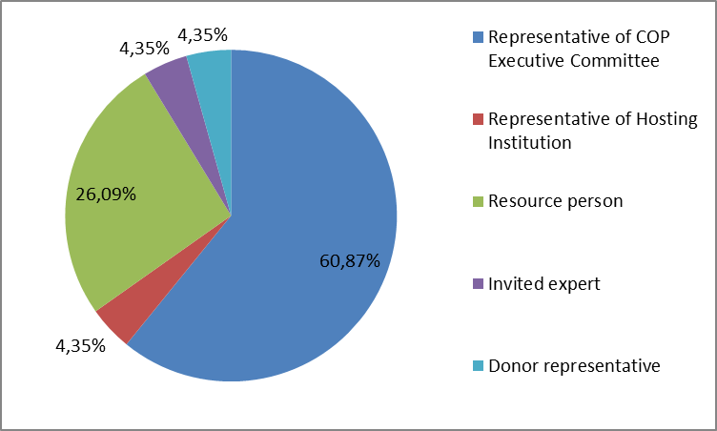

Q2. Was this your first participation in a PEMPAL Executive meeting?

22 respondents (95.6%) answered this question. And 86.4% of them replied “No”.

Answer Options | Response Percent | Response Count
 | all | all | Representatives | Resource persons
Yes | 13,6% | 3
3 | 0 | 19
13 | 6

Q3. How many PEMPAL events have you attended before?

This question was seen only by those respondents who chose “No” in the previous question.
18 respondents answered this question.

1-2 | 3-4 | 5-6 | more than 6 | Response Count
0 | 2 | 1 | 15 | 18
PART I EVENT DELIVERY

Q4. How do you rate your participation in this event?

21 (91.3%) answers were given. 13 respondents think that their participation in the event was ‘Active’. 7 respondents think that their participation was ‘Average’. 1 person chose the option “Passive”.
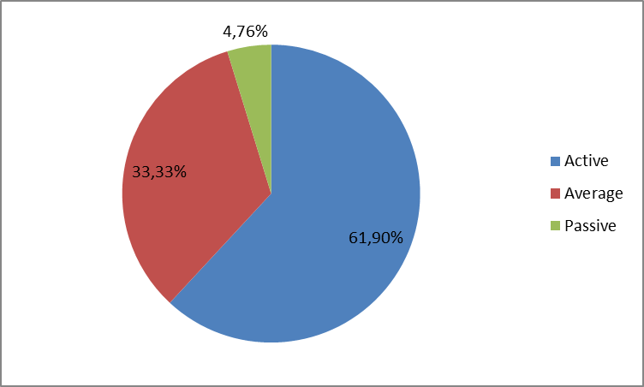
Among them:
4 resource persons were “Active”, 1 – “Average”.
9 representatives and expert were “Active”, 6 – “Average, 1 – “Passive”.

Q5. How do you rate the event duration overall?

21 respondents (91.3%) answered this question. And 100% of them rated the event duration as “About right”.

Q6. How much do you agree with the following statements about the participants of the event?
22 respondents (95.6%) replied to this question.
Answer Options | 1 strongly disagree | 2 | 3 | 4 | 5 Strongly agree | Response Count | Average
a) The level of the event was appropriate for a person with my experience and knowledge | 0 | 0 | 1 | 2 | 18 | 21 | 4,8
b) I learned from the experience of other participants in the event | 0 | 0 | 1 | 6 | 14 | 21 | 4,6
c) Participants had about equal level of prior expertise relevant to the event topics | 0 | 0 | 3 | 8 | 10 | 21 | 4,3
d) Content of presentations and other materials were appropriate for a person with my level of knowledge | 0 | 0 | 0 | 0 | 1 | 1 | 5,0
Q7. What have you learned from other participants?
10 comments were left. Here and after comments made by representatives and expert are bold.
- It was particularly useful to present the PFM of the host country. I highlight a slide showing the system of general budget in Hungary. Hungary's experience will certainly be considered when drafting a new basic budget law in my country. And we must respect the requirements of Eurostat as well as Hungary and their experience will be of help.
- It was very useful to get an overview of Hungarian PFM practices and PFM IT systems
- Experience of Hungary was very useful
- I received some answers to questions interested for me.
- The priorities of other COPs to be in interoperability for the progress of reforms of public finance management
- Make a link between internal audit and anti-corruption reforms; change management is applied in reform processes;
- For the first time I received information regarding the TCOP and BCOP.
- Hungarian experience is impressive with a systemic, conceptual and phased approach to implementing the PFM reform.
- Hungary's budget, treasury and internal audit system
- There were very interesting discussions on many organizational issues.
Q8. How much do you agree with the following statements about the content design of the event? (Please rate each item):
21 respondents (91.3%) replied to this question.
Answer Options | 1 strongly disagree | 2 | 3 | 4 | 5 Strongly agree | Response Count | Average
a) The event agenda was properly planned | 0 | 0 | 0 | 1 | 20 | 21 | 5,0
b) The content of the event was properly prepared | 0 | 0 | 0 | 0 | 21 | 21 | 5,0
с) The event addressed issues important to my work | 0 | 0 | 2 | 5 | 14 | 21 | 4,6
d) The event covered a right number of topics for the amount of time available | 0 | 0 | 1 | 4 | 16 | 21 | 4,7
e) The topics for the group discussions were relevant | 0 | 0 | 0 | 3 | 18 | 21 | 4,9
f) Enough time was reserved for group discussions | 0 | 0 | 0 | 5 | 16 | 21 | 4,8
g) Presentations made during the event were relevant and useful | 0 | 0 | 0 | 4 | 17 | 21 | 4,8
h) Enough time was reserved for questions to speakers | 0 | 0 | 5 | 5 | 11 | 21 | 4,3
4 comments were left:
- I think there is plenty of time left for questions. It is true that there are always more questions than time for answers, but it is solved during coffee breaks and lunches.
- It was not enough time for asking question to Hungarian presenters.
- In the first day (host day) was not enough time for all questions.
- Although the presentations were extremely interesting, they were too long, they had to be divided into several presentations or improved in some other way.
Q9. How much do you agree with the following statements about the outcomes of the event? (Please rate each item):
22 responses (95.6%) were left.
Event objective has been achieved: | 1 strongly disagree | 2 | 3 | 4 | 5 Strongly agree | Response Count | Average
a) Review the results of the first year of implementation of the new Strategy 2017-22 | 0 | 0 | 0 | 3 | 19 | 22 | 4,9
b) Familiarization with PFM system of Hungary | 0 | 0 | 0 | 5 | 16 | 21 | 4,8

Representatives
Answer Options | 1 strongly disagree | 2 | 3 | 4 | 5 Strongly agree | Response Count | Average
a) | 0 | 0 | 0 | 3 | 14 | 17 | 4.8
b) | 0 | 0 | 0 | 5 | 11 | 16 | 4.7
Resource persons
a) | 0 | 0 | 0 | 0 | 5 | 5 | 5
b) | 0 | 0 | 0 | 0 | 5 | 5 | 5
3 comments were left.
- It is important for us all to follow the results of implementation of the new PEMPAL strategy, and we are always glad to be familiar with the host country's PFM system, because we can always find out something that we can apply in our country.
- I would like to continue learning experience of Hungary.
- It is high performance and progress of PEMPAL network on setting the priorities of the reforms on public finance management in member countries with proper outcomes.
Q10. Please rate the quality of the leadership, management and/or technical services provided to the event by the following:
20 responses (87%) were left.
Answer Options | 1 low | 2 | 3 | 4 | 5 high | Response Count | Average
Event organizing Committee | 0 | 0 | 0 | 2 | 17 | 19 | 4,9
WB Resource Team | 0 | 0 | 0 | 1 | 19 | 20 | 4,95

2 comments were left:
- Management and technical services were, as always, extremely high quality. I have participated in numerous other events, but none has reached the level of PEMPAL.
- Thank you very much for direct fly and for the late check out until 17.30 Friday.
Q11. Please rate the quality of services provided by the event speaker(s):
21 responses (91.3%) were left.
Answer Options | 1 low | 2 | 3 | 4 | 5 high | Response Count | Average
Quality of work | 0 | 0 | 0 | 2 | 19 | 21 | 4,90
1 comments was left. "Suggested topics were relevant and detailed. One speaker was quite slow, but it was compensated by the quality of information he provided and the talk about all the questions asked, showing such an enviable level of knowledge of exposed matter."

PART 2 EVENT ADMINISTRATION
Q12. Please rate the quality of the organization and administration of the event:
Answered question — 21 (91.3%). All the ratings are very good.
Answer Options | 1 low | 2 | 3 | 4 | 5 high | Response Count | Average
Quality of organization
- choice of venue | 0 | 0 | 0 | 2 | 19 | 21 | 4,9
- travel arrangements | 0 | 0 | 2 | 1 | 17 | 20 | 4,75
- event logistics | 0 | 0 | 0 | 1 | 20 | 21 | 4,95
- contribution provided by hosts | 0 | 0 | 0 | 0 | 21 | 21 | 5,0
Quality of administration
- Secretariat staff responsiveness | 0 | 0 | 0 | 1 | 20 | 21 | 4,95
- written communication | 0 | 0 | 0 | 1 | 20 | 21 | 4,95
- participant registration | 0 | 0 | 0 | 1 | 20 | 21 | 4,95

6 comments were left:
- About the organization of travel, logistics, service of Secretariat staff, written communication, and registration it can be spoken in superlative only. Each and every small problem that appeared was resolved by the Secretariat in a record short time. Choosing an event site also deserves praise. Budapest is a very beautiful city. We had time for sightseeing, and the dinner on the terrace of the hotel with a beautiful view of the city was a real surprise. The host was particularly impressive. Presentation of PFM host country was useful. Dinner is organized in an interesting restaurant. The visit to Parliament was also an extraordinary event. I particularly emphasize the readiness of the host to help us choose a visit to a cultural event in leisure time. We watched ballet Big Gatsby, which was a memorable event.
- 2. Complicated connecting flights. There is not enough time for transfer taking into account the period of holidays and congestion of airports.
- Maybe I am not objective on this matter :)
- Thank you very much to the secretariat. Very good job with the all technical arrangements. Good translation, good interpreters.
- Result of the meeting of three COPs and the representatives of WB and donors confirmed need for coordinated work on the implementation of the PEMPAL strategic indicators.
- Secretariat staff has done its job well, as always.
Q13. Did you receive agenda and event information in sufficient time before the event for them to be useful?
21 (91.3%) answers were given. And 100% of responses were “Yes”.
Q14. Did you receive practical information (about the accommodation and other facilities, etc.) prior to the event?
21 (91.3%) answers were given. And 100% of responses were “Yes”.
Q15. Did the paperless approach in distributing materials affect your ability to understand/absorb information during the event?
21 responses (91.3%) were left.
Answer Options | 3 | 1
 | 13 | 4 | representatives | Resource persons
Yes | 19,1% | 4 | 3 | 1
No | 81% | 17 | 13 | 4
Q16. Did you try to access event presentations on the web site in preparation for the event?
21 responses (91.3%) were left. 18 (85.7%) of them was “Yes”.
Q17. Did you find the practice of posting presentations on the web site before the event helpful?
21 responses (91.3%) were left. 20 (95.2%) of them was “Yes”.
Q18. Are you satisfied with the quality of simultaneous interpretation provided during the event?
21 (91.3%) answers were given.
Answer Options | 1 low | 2 | 3 | 4 | 5 high | Response Count | Average
 | 0 | 0 | 0 | 3 | 18 | 21 | 4,9
Representatives
Answer Options | 1 low | 2 | 3 | 4 | 5 high | Response Count | Average
 | 0 | 0 | 0 | 2 | 14 | 16 | 4.9
Resource persons
 | 0 | 0 | 0 | 1 | 4 | 5 | 4.8
2 comments were given.
- Translators are familiar with the subject and have no problems with translating. They also help us communicate with other participants during breaks and in leisure time.
- Very good interpreters.
Q19. Are you satisfied with the quality of written translation of event materials?
21 (91.3%) answers were given.
Answer Options | 1 low | 2 | 3 | 4 | 5 high | Response Count | Average
 | 0 | 0 | 1 | 5 | 15 | 21 | 4,7
Representatives
Answer Options | 1 low | 2 | 3 | 4 | 5 high | Response Count | Average
 | 0 | 0 | 1 | 4 | 11 | 16 | 4.6
Resource persons
 | 0 | 0 | 0 | 1 | 4 | 5 | 4.8
No comment was given.
PART 3 OVERALL IMPRESSION
Q20. Did the event disappoint, meet, or exceed your expectations?
21 (91.3%) participants answered the question.
Answer Options | Response Percent | Response Count
 | all | all | representatives | Resource persons
Disappoint | 0% | 0 | 0 | 0
Meet | 81% | 17 | 15 | 2
Exceed | 19,1% | 4 | 1 | 3

Q21. What did you like best about the event?
9 comments were left. Participants like different aspects of the event.
Presentations and hospitality of Hungary were mentioned in 5 comments/ For example: «Experience of Hungary», «An exceptional organization by the host».

Other comments:
- The idea to have an EU participant in the last day's discussion of the meeting. The visit to Parliament building.
- Active participation of all participants; very engaged discussions;
- The location, the hotel, the roof view, the food quality, very good internet.
- … discussions with representatives of other countries on topical issues of PFM.
- The group discussions on different issues.
Q22. What did you not like most about the event?
4 comments were left and 3 of them consists the piece of criticism.
- Participation on Steering Committee meeting.
- The meeting room had no windows; we were constantly behind schedule;
- The inconsistency of positions at the Steering Committee meeting on previously agreed positions in small groups of three COPs.

Q23. Do you plan to brief your colleagues about the event?
21 (91.3%) participants answered the question. And 18 (86.7%) of them responded “Yes”.
Q24. How do you plan to brief your colleagues?
Answered question – 16. Most of respondents were going to prepare a back-to-office report.
Answer Options | Response Percent | Response Count
 | all | all | representatives | Resource persons
Share materials | 50,0% | 8 | 7 | 1
Make a presentation | 12,5% | 2 | 2 | 0
Prepare a back-to-office report | 87,5% | 14 | 13 | 1
2 comments were given:
- I have already presented some ideas at a meeting on the drafting of a new basic budget law.
- Decision of the leadership of the Ministry of Finance on the application of international experience on the basis of the participant's report.
Q25. If your Ministry plans to promote this event, or PEMPAL in general, in internal or external media (e.g. MoF or other government website, MoF journal, television, radio, newspapers), please provide specific details so we can report to donors on any positive promotion of the value and benefits of PEMPAL.
1 comment was left: “We consider the possibility of presenting PEMPAL events on the Ministry of Finance website”.
Q26. How much do you agree with the following statement?
21 respondents (91.3%) answered this question. Average rating is positive.
Answer Options | 1 not at all | 2 | 3 | 4 | 5 completely | Response Count | Average
I will be able to apply the knowledge acquired at this event to my work | 0 | 0 | 4 | 7 | 10 | 21 | 4,3
Representatives
Answer Options | 1 not at all | 2 | 3 | 4 | 5 completely | Response Count | Average
 | 0 | 0 | 4 | 4 | 8 | 16 | 4.25
Resource persons
 | 0 | 0 | 0 | 3 | 2 | 5 | 4.4
Q27. How can you apply the acquired knowledge?
5 informative comments were left.
- When drafting a new basic budget law.
- Hungary's experience is useful in implementation of the strategy for reforming public finance.
- To collaborate and coordinate the action plans of our strategy between Treasury-Budget-Internal Control
- 4 In development of new norms of budget legislation. Using the practical experience of PEMPAL member countries to justify the application of new norms.
- The acquired knowledge contributes to my overall understanding of the internal control system, in some way I understand this event as a continuous professional development.
Q28. Overall, my satisfaction with the event was...
Answered question – 21 (91.3%). There were no negative answers.
1 not satisfied | 2 | 3 | 4 | 5 highly satisfied | Response Count | Average
0 | 0 | 1 | 2 | 18 | 21 | 4,8
Representatives
1 not satisfied | 2 | 3 | 4 | 5 highly satisfied | Response Count | Average
0 | 0 | 1 | 2 | 13 | 16 | 4.75
Resource persons
1 not satisfied | 2 | 3 | 4 | 5 highly satisfied | Response Count | Average
0 | 0 | 0 | 0 | 5 | 5 | 5

Q29. If you have any other comments you would like to provide us, please provide them here.

1 informative comment was left: “I disagree in principle because we are the experts that you use to transfer expertise, for free. And we don't have any per diem for this travel. If I will pay for meals probably I will reduce my participation (no of the days to your meetings)”.

PART 4 RECOMMENDATIONS FOR THE FUTURE

Q30. Do you have any additional suggestions according to questions discussed in small groups on the second day of the event?
2 comments were left.
- It may be possible to choose cheaper hotels for accommodation at events, which could help host countries. Some host countries have educational centers that could be used to organize events.
- The conceptual decisions adopted by the majority of participants should be documented.

Here and after – the representatives of ExComs, hosting institution, and donors plus an invited expert.

