PEMPAL TCOP Thematic Group on Use of Information Technologies in Treasury Operations in Tbilisi
FEEDBACK SURVEY

On October 5-7th, 2015, the PEMPAL TCOP thematic group on use of information technologies in treasury operations in Tbilisi, Georgia, took place.
After the event, the on-line survey in two languages was created on the base of the standard set of questions developed by Secretariat. The aim of the survey was to receive event feedback and to learn plans for the future.

Link to the survey – https://ru.surveymonkey.com/r/PF53Q79

The survey started to collect responses on October 12 and finished on October 26, 2015.
Invitations to take part in the survey were sent to all participants of the event. We sent 35 invitations.
26 persons started to response to the survey. From these 26 responses – 5 were from the resource persons, 2 — from invited experts, and 19 from the representatives of PEMPAL countries.
In this report, we analyze all 26 responses. For further calculation, we take this quantity as 100%.

All these responses will be included in the general Feedback Event Database.
The questionnaire comprises five parts: About the Respondent, Event Delivery, Event Administration, Overall Impression, and Recommendations for the Future. There are 25 questions in the survey.
ABOUT THE RESPONDENT

Q1. You are...

26 (100%) respondents gave answers. Among them: 19 representatives of PEMPAL countries, 2 invited experts and 5 Resource persons.
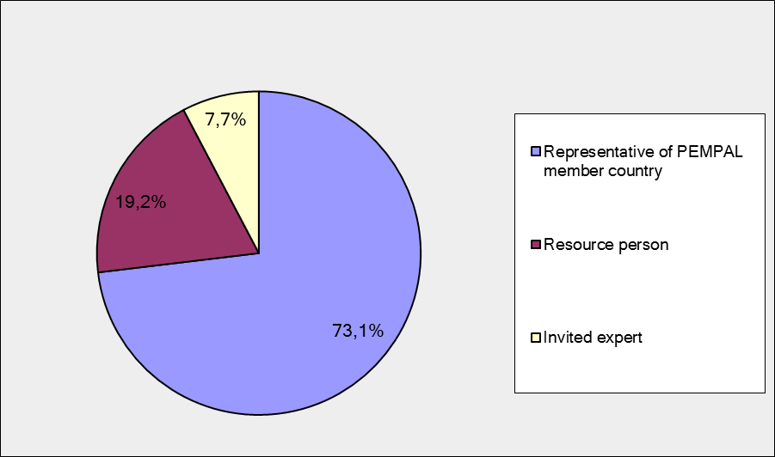

Q2. Was this your first participation in a PEMPAL event?

25 respondents (96.2%) answered this question. And 84% of them replied “No”.

Answer Options | Response Percent | Response Count
 | all | all | representatives | Resource persons
Yes | 16,0% | 4 | 3 | 1
No | 84,0% | 21 | 16 | 5

Q3. How many PEMPAL events have you attended before?

This question was seen only by those respondents who chose “No” in the previous question.
22 respondents answered this question.

1-2 | 3-4 | 5-6 | more than 6 | Response Count
2 | 8 | 2 | 10 | 22
PART I EVENT DELIVERY

Q4. How do you rate your participation in this event?

26 (100%) answers were given. 17 respondents think that their participation in the event was ‘Active’. 9 respondents think that their participation was ‘Average’. No one chose the option “Passive”.

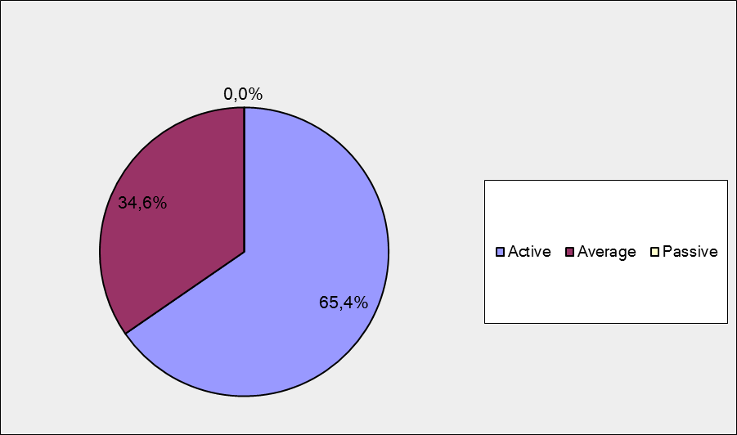

Among them:
6 resource persons were “Active”, 1 – “Average.”
11 representatives of PEMPAL countries were “Active”, 8 – “Average.

Q5. How do you rate the event duration overall?

26 respondents (100%) answered this question. And most of them rated the event duration in a positive way.

Answer Options | Response Percent | Response Count
 | all | all | representatives | Resource persons
Too short | 3,8% | 1 | 0 | 1
About right | 92,3% | 24 | 18 | 6
Too long | 3,8% | 1 | 1 | 0

Q6. How much do you agree with the following statements about the participants of the event? (Please rate each item):
25 respondents (96.2%) replied to this question.
Answer Options | 1 strongly disagree | 2 | 3 | 4 | 5 Strongly agree | Response Count | Average
a) The level of the event was appropriate for a person with my experience and knowledge | 0 | 0 | 1 | 7 | 17 | 25 | 4,6
b) I learned from the experience of other participants in the event | 0 | 0 | 2 | 8 | 15 | 25 | 4,5
с) Participants had about equal level of prior expertise relevant to the event topics | 0 | 2 | 6 | 11 | 6 | 25 | 3,8
d) Content of presentations, hand-outs and other materials were appropriate for a person with my level of knowledge | 0 | 0 | 1 | 8 | 16 | 25 | 4,6
Q7. Describe your own level of expertise, as compared to that of other participants?
13 comments were left.
1 respondent wrote that he/she has a lack of expertise: “I still have a lot to learn.”
4 respondents thought that their level of expertise is equal to others. “Equal or higher”; “Similar“; “It was an average level compared with other participants”; “I believe I have substantial expertise in topics discussed and so do many other participants of this event.”
5 respondent mentioned that due the topic of the meeting some participants had specific knowledge or lack of them. «Treasury worker does not always understand the language of the programmer”; “It is difficult to assess the experience and knowledge of other members, especially since some of them had specific knowledge”; “My professional skills are based on economic (finance/accounting) science (not IT skills)’; “I have more technical / business process oriented knowledge’; ‘I have IT background and I can easily understand the topics which is related to Georgia FMIS IT part. And I tried to understand the topics which is about to financial management.»
Other 3 comments: “More than half of the participants were competent in the issues addressed at the seminar was therefore a great opportunity to share experiences, not only during the sessions, but also in informal communication.”; ”It was a pleasure to share my experiences and useful to listen to the experience of colleagues”; ”The knowledge and experience of participants is growing rapidly, it makes to improve ourselves.”

Q8. What have you learned from other participants?
12 informative comments were left.
- Upon our request, the host country experts found time to answer all of our highly technical questions informally.
- We confirmed the correctness of the chosen path of development and learned about other country experience and possible problems.
- Organization of IT and some technical IT solutions to be followed in the future.
- I got insight into security mechanisms implemented by other countries.
- Georgian experience in developing IT service is priceless
- I have learned other countries' FMIS systems, IT infrastructure, security models and application models and these knowledge was very useful for me.
- I learned about standards and methodology used in IT
- I have learnt from Georgian experience that the IT treasury system covers also the detailed information on payrolls of budgetary institutions and detailed debt data, which are missing in our treasury database. It carries out the payment of transactions in foreign currency. This system has interface (exchange data) with public procurement database. There is specific software that monitors the realization of the IT development projects to get more efficiency and proper benefits.
- How to develop IT service
- Specific country experiences useful for application in other countries and as reference for case studies and as examples
- How to effectively implement methodology, what methodology to use in delivering IT projects etc.
- About IT solution
Q9. How much do you agree with the following statements about the content design of the event? (Please rate each item):
25 respondents (96.2%) replied to this question.
Answer Options | 1 strongly disagree | 2 | 3 | 4 | 5 Strongly agree | Response Count | Average
a) The event agenda was properly planned | 0 | 0 | 2 | 2 | 21 | 25 | 4,8
b) The content of the event was properly prepared | 0 | 0 | 0 | 4 | 21 | 25 | 4,8
с) The event addressed issues important to my work | 0 | 0 | 2 | 3 | 19 | 24 | 4,7
d) The event covered a right number of topics for the amount of time available | 0 | 1 | 1 | 4 | 18 | 24 | 4,6
e) The topics for the group discussions were relevant | 0 | 0 | 0 | 6 | 19 | 25 | 4,8
f) Presentations made during the event were relevant and useful | 0 | 0 | 0 | 4 | 21 | 25 | 4,8
g) Enough time was reserved for questions to speakers | 0 | 1 | 2 | 7 | 15 | 25 | 4,4

8 comments were left. Practically all of them are positive.
- Agenda, topics and content of the presentation very well satisfied me
- The Hosts were very responsible. Their presentations were constructed so that in a short time they gave the participants an opportunity to form an idea of the developing system.
- Thank you. Everything was organized at a very high level. There was not enough time to discuss some of the presentation, but, in principle, we solved that in an informal conversations.
- All questions are important, but not in my specific work as a treasurer, but for treasurer work performance. The group does not have to meet for discussion only IT issues, we must not forget that the group called IT in treasury operations!
- The event agenda was very intensive, but the presentations were very useful.
- Everything was great
- Some speakers would have benefited from greater timekeeping and this did impact somewhat on the length of time available for questions, but did not detract from the event
- Everything was organized just about right. There was enough time for everything.
Q 10. How much do you agree with the following statements about the outcomes of the event?

23 responses (88.5%) were left.
Answer Options | 1 strongly disagree | 2 | 3 | 4 | 5 Strongly agree | Response Count | Average
a) The participants have got comprehensive information regarding the PFMS of Georgia and the plans for its further development | 0 | 0 | 0 | 3 | 20 | 23 | 4,9
b) The participants have been familiarized with various approaches applied in TCOP countries and worldwide, regarding the organization of IT support function within the Ministries of Finance (Treasuries) | 0 | 0 | 1 | 7 | 15 | 23 | 4,6
c) The participants have got useful information on FMIS information security policies and infrastructure, applied in participating countries | 0 | 0 | 2 | 7 | 14 | 23 | 4,5
d) Participants had the opportunity to make their proposals for updating the Action Plan of the TCOP thematic group on Use of information technologies in treasury operations | 0 | 0 | 1 | 9 | 13 | 23 | 4,5

Representatives of PEMPAL countries
Answer Options | 1 strongly disagree | 2 | 3 | 4 | 5 Strongly agree | Response Count | Average
a) | 0 | 0 | 0 | 3 | 14 | 17 | 4,8
b) | 0 | 0 | 1 | 6 | 10 | 17 | 4,5
c) | 0 | 0 | 2 | 5 | 10 | 17 | 4,5
d) | 0 | 0 | 1 | 7 | 9 | 17 | 4,5
Resource persons + invited expert
Answer Options | 1 strongly disagree | 2 | 3 | 4 | 5 Strongly agree | Response Count | Average
a) | 0 | 0 | 0 | 0 | 6 | 6 | 5.0
b) | 0 | 0 | 0 | 1 | 5 | 6 | 4.8
c) | 0 | 0 | 0 | 2 | 4 | 6 | 4.7
d) | 0 | 0 | 0 | 2 | 4 | 6 | 4.7

3 comments were left.

Points c) d) b) were not discussed, in my opinion

I propose to include in the action plan the following topic: "Project Risk Management at creation, modernization and maintenance PFMS, timely risks identification and selection of response methods. The danger of underestimating the project risks."

Everything was remarkable

PART 2 EVENT ADMINISTRATION
Q 11. Please rate the quality of the organization and administration of the event:
Answered question – 25 (96.2%).
Answer Options | 1 low | 2 | 3 | 4 | 5 high | Response Count | Average
Quality of organization
choice of venue | 0 | 0 | 1 | 4 | 20 | 25 | 4,8
travel arrangements | 1 | 0 | 5 | 3 | 16 | 25 | 4,3
event logistics | 0 | 0 | 2 | 4 | 19 | 25 | 4,7
Quality of administration (staff responsiveness, written communication, participant registration, etc.) | 0 | 0 | 0 | 5 | 20 | 25 | 4,8

Representatives of PEMPAL countries
Answer Options | 1 low | 2 | 3 | 4 | 5 high | Response Count | Average
Quality of organization
choice of venue | 0 | 0 | 1 | 4 | 13 | 18 | 4,4
travel arrangements | 1 | 0 | 4 | 3 | 10 | 18 | 4,2
event logistics | 0 | 0 | 2 | 3 | 13 | 18 | 4,6
Quality of administration (staff responsiveness, written communication, participant registration, etc.) | 0 | 0 | 0 | 5 | 13 | 18 | 4,7
Resource persons
Answer Options | 1 low | 2 | 3 | 4 | 5 high | Response Count | Average
Quality of organization
choice of venue | 0 | 0 | 0 | 0 | 7 | 7 | 5.0
travel arrangements | 0 | 0 | 1 | 0 | 6 | 7 | 4.7
event logistics | 0 | 0 | 0 | 1 | 6 | 7 | 4.9
Quality of administration (staff responsiveness, written communication, participant registration, etc.) | 0 | 0 | 0 | 0 | 7 | 7 | 5.0
There were left 4 informative comments. 1 of the was negative.
- High level organization as usually
- In the struggle to save, the bankrupt airline was chosen. So our plane landed at another airport (not planned), and we barely missed the other plane. Tried not to be late, we had to pay big money for a timely transfer from the airport of landing to the desired one..
- Well organized and executed
- Organization was flawless. Thank you
Q 12. Did you receive agenda and event information in sufficient time before the event for them to be useful?
24 (92.3%) answers were given. And 100% responses were “Yes”
Q 13. Did you receive practical information (about the accommodation and other facilities, etc.) prior to the event?
24 (92.3%) answers were given. 100% of them are “Yes”.
2 comments were left: “Everything was received in time.” and “Thank you”.
Q14. Are you satisfied with the quality of simultaneous interpretation provided during the event?
25 (96.2%) answers were given.
Answer Options | 1 low | 2 | 3 | 4 | 5 high | Response Count | Average
 | 0 | 0 | 3 | 7 | 15 | 25 | 4,5
Representatives of PEMPAL countries
Answer Options | 1 low | 2 | 3 | 4 | 5 high | Response Count | Average
 | 0 | 0 | 2 | 6 | 10 | 18 | 4,4
Resource persons + invite expert
Answer Options | 1 low | 2 | 3 | 4 | 5 high | Response Count | Average
 | 0 | 0 | 1 | 1 | 5 | 7 | 4,6
6 comments were given. 2 commenters were satisfied. For example: “Thanks to the translation team - without them the event would not have been as successful.”
Other 4 comments:
- Sometimes a translator was not able to translate in time, sometimes - the translation was incorrect
- Sometimes technical terms was not entirely correct translated which could be misleading to some participants. This was especially true for those terms that are used in Russian without translation.
- Translators had lacked knowledge in the subject area (IT).
- There were technical problems.

Q15. Are you satisfied with the quality of written translation of event materials?
24 (92.3%) answers were given.
Answer Options | 1 low | 2 | 3 | 4 | 5 high | Response Count | Average
 | 1 | 0 | 0 | 7 | 16 | 24 | 4,5
Representatives of PEMPAL countries
Answer Options | 1 low | 2 | 3 | 4 | 5 high | Response Count | Average
 | 0 | 0 | 0 | 6 | 12 | 18 | 4,7
Resource persons + invited expert
Answer Options | 1 low | 2 | 3 | 4 | 5 high | Response Count | Average
 | 1 | 0 | 0 | 1 | 4 | 6 | 4.2

1 comment was given: “Generally not bad”.

PART 3 OVERALL IMPRESSION
Q16. Did the event disappoint, meet, or exceed your expectations?

25 (96.2%) participants answered the question. No one was disappointed.

Answer Options | Response Percent | Response Count
 | all | all | representatives | Resource persons
Disappoint | 0,0% | 0 | 0 | 0
Meet | 60,0% | 15 | 10 | 5
Exceed | 40,0% | 10 | 8 | 2

Q17. What did you like best about the event?

15 comments were left. All of them are valid.
Participants like different aspects of the event:
There was 1 comment: “I cannot single out one thing. I liked all of them”.
Host country presentations and their work overall were mentioned in 4 comments:
- Georgian presentation about their security system
- The engagement of the Georgian staff
- Hosts business approach.
- The quality of the Georgian counterparts presentation and engagement and the overall group interaction
Experience exchange was mentioned once: “Learning the experience of other countries…”
“Discussion of the challenge” was mentioned twice: “…and discussion of the challenges that participants face while implementing these methodologies was very useful.”

Topic of the meeting was mentioned 3 times:
- List of the themes and their content.
- Big focus was made on technical aspects of the FMIS.
- Topics covered
Presentations were mentioned 5 times. For example: “Very useful presentations”; “Also presentations of different project management methodologies…”

Other comments:
- Openness of the specialists form MoF and FAS in discussing the problems of IT.
- Nowadays a treasurer, and in particular a manager must know even general information on IT and the problems faced by the IT department.
- I like the simultaneous translation and application demo most about the event.
Q18. What did you not like most about the event?

10 comments were left.
8 of them is comments like: “There is no such thing”. For example: “I was satisfied with the whole process. Nothing to dislike.”

Other 2 comments:

Treasury employees did not participate in the discussion when purely IT issues were submitted for discussion.

Very intensive agenda, not so much time for assimilation.

Q19. Do you plan to brief your colleagues about the event?:
23 (88.5%) participants answered the question. And 91.3% of them (21) responded “Yes”. 2 respondents did not plan to brief their colleagues.
Q20. How do you plan to brief your colleagues?
Answered question – 20 (76.9%).

Answer Options | Response Percent | Response Count
 | all | all | representatives | Resource persons
Share materials | 60,0% | 12 | 9 | 3
Make a presentation | 15,0% | 3 | 2 | 1
Prepare a back-to-office report | 60,0% | 12 | 10 | 2

2 comments were given:
- In conversations
- I will prepare the presentation and submitted it to our MoF
Q21. How much do you agree with the following statement?

22 respondents (84.6%) answered this question. Average rating is positive.

Answer Options | 1 not at all | 2 | 3 | 4 | 5 completely | Response Count | Average
I will be able to apply the knowledge acquired at this event to my work | 0 | 1 | 3 | 7 | 11 | 22 | 4,3
Representatives of PEMPAL countries
Answer Options | 1 not at all | 2 | 3 | 4 | 5 completely | Response Count | Average
 | 0 | 1 | 3 | 6 | 8 | 18 | 4,2
Resource persons+ invite expert
Answer Options | 1 not at all | 2 | 3 | 4 | 5 completely | Response Count | Average
 | 0 | 0 | 0 | 1 | 3 | 4 | 4.75

Q22. How can you apply the acquired knowledge?

12 comments were left.

- As an example for the real work of our departments similar to FAS.
- I will adjust plans.
- I will apply theoretically, and as a leader in relations with the IT department.
- First step by proposing to the managers and getting their support and next step explaining and discussing them with IT staff.
- Consider security issues that other countries faced when implementing security policies
- I will formulate practical measures to implement
- With the help of my IT knowledge
- with implementation of standards
- By preparing the report to proper staff and discuss how to fit the best solution by our environment.
- International practice should be more widely implemented
- Integrating country examples into future presentations and material and being able to share relevant country anecdotes
- The outlined path to building the right methodology will go a long in serving our Treasury's needs and requirements
Q23. Overall, my satisfaction with the event was...

Answered question – 24 (92.3%). There were no negative answers.
1 not satisfied | 2 | 3 | 4 | 5 highly satisfied | Response Count | Average
0 | 0 | 0 | 4 | 20 | 24 | 4,8
Representatives of PEMPAL countries
1 not satisfied | 2 | 3 | 4 | 5 highly satisfied | Response Count | Average
0 | 0 | 0 | 4 | 14 | 18 | 4,8
Resource person+ invited person
1 not satisfied | 2 | 3 | 4 | 5 highly satisfied | Response Count | Average
0 | 0 | 0 | 0 | 6 | 6 | 5.0

PART 4 RECOMMENDATIONS FOR THE FUTURE

Q24. Do you have any suggestions to improve the content, approach and other aspects of such events in future:
7 comments were left, and 3 of them consists suggestions.
- More focus on functionality and business processes, more active involve in discussions the representatives of the Treasury, as well as other participants of the budget process (state employees, auditors).
- Spend more time studying different methodologies and standards(Security, PM, IT Management). Discussing how these standards can be implemented in our organizations
- I think the discussion parts should be longer. And all countries' participants can make discussion with each other about their FMIS.

Q25. Are there any other products, research or services useful for your work that PEMPAL could provide?

7 comments were left and 3 of them are informative.

Guides for users of the system

More study visits to countries with successful experience in the implementation of integrated PFMS.

I wonder about strategic planning about IT.

Here and after - Resource persons plus the invited experts

