PEMPAL TCOP MEETING IN ANKARA FEEDBACK SURVEY

On March 16-18nd , 2016, the PEMPAL TCOP meeting on Cash management in Ankara, Turkey, took place.
After the event, the on-line survey in two languages was created on the base of the standard set of questions developed by Secretariat. The aim of the survey was to receive event feedback and to learn plans for the future.

Link to the survey – https://ru.surveymonkey.com/r/BR6989V

The survey started to collect responses on March 22 and finished on April 6, 2016.
Invitations to take part in the survey were sent to all participants of the event. We sent 32 invitations.
16 persons started to response to the survey. From these 16 responses – 2 were from the resource persons, 1 — from invited experts, and 13 from the representatives of PEMPAL countries.
In this report, we analyze all 16 responses. For further calculation, we take this quantity as 100%.

All these responses will be included in the general Feedback Event Database.
The questionnaire comprises five parts: About the Respondent, Event Delivery, Event Administration, Overall Impression, and Recommendations for the Future. There are a total of 27 questions in the survey.
ABOUT THE RESPONDENT

Q1 You are...

16 (100%) respondents gave answers. Among them: 13 representatives of PEMPAL countries, 1 invited experts and 2 Resource persons.
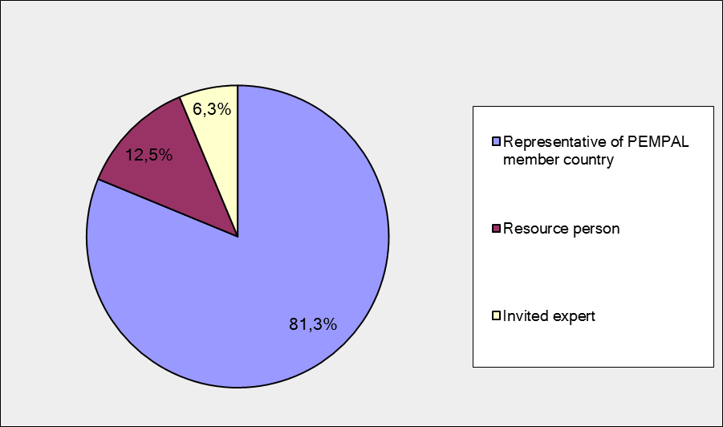

Q2. Was this your first participation in a PEMPAL event?

16 respondents (100%) answered this question. And 81.3% of them replied “No”.

Answer Options | Response Percent | Response Count
 | all | all | representatives | Resource persons
Yes | 18,8% | 3 | 2 | 1
No | 81,3% | 13 | 11 | 2

Q3. How many PEMPAL events have you attended before?

This question was seen only by those respondents who chose “No” in the previous question.
16 respondents answered this question.

1-2 | 3-4 | 5-6 | more than 6 | Response Count
4 | 4 | 1 | 4 | 13
PART I EVENT DELIVERY

Q4. How do you rate your participation in this event?

16 (100%) answers were given. 13 respondents think that their participation in the event was ‘Active’. 3 respondents think that their participation was ‘Average’. No one chose the option “Passive”.

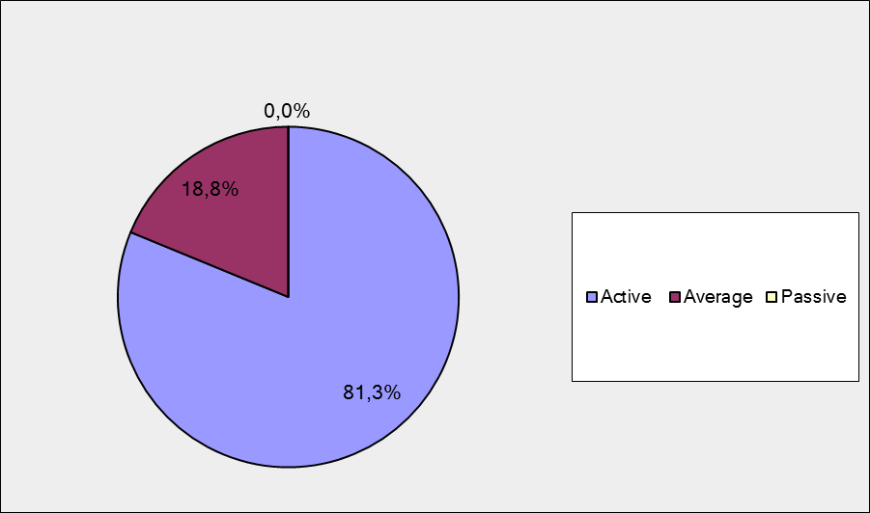

Among them:
3 resource persons and invited expert were “Active”
10 representatives of PEMPAL countries were “Active”, 3 – “Average.

Q5. How do you rate the Ankara event duration overall?

16 respondents (100%) answered this question. And most of them rated the event duration in a positive way.

Answer Options | Response Percent | Response Count
 | all | all | representatives | Resource persons
Too short | 12,5% | 2 | 2 | 0
About right | 87,5% | 14 | 11 | 3
Too long | 0,0% | 0 | 0 | 0

Q6. How much do you agree with the following statements about the participants of the event? (Please rate each item):
15 respondents (93.8%) replied to this question.
Answer Options | 1 strongly disagree | 2 | 3 | 4 | 5 Strongly agree | Response Count | Average
a) The level of the event was appropriate for a person with my experience and knowledge | 0 | 0 | 1 | 4 | 10 | 15 | 4,6
b) I learned from the experience of other participants in the event | 0 | 0 | 0 | 5 | 9 | 14 | 4,6
с) Participants had about equal level of prior expertise relevant to the event topics | 1 | 0 | 3 | 6 | 4 | 14 | 3,9
d) Content of presentations, hand-outs and other materials were appropriate for a person with my level of knowledge | 0 | 0 | 0 | 5 | 9 | 14 | 4,6
Q7. Describe your own level of expertise, as compared to that of other participants?
9 comments were left. Here and after comments made by representatives of PEMPAL-member countries are bold.
No one wrote about a lack of expertise.
3 respondents wrote that they have average level of knowledge: “I would say – average... .better in TSA than in the cash buffer topics”, “medium term of expertise and less knowledge about banking instruments used to increase liquidity such as REPO , and overnight deposits because are not used in our country”, “Among the participants of the event there were specialists who had more knowledge and understanding than me and persons with more narrow knowledge”.
3 respondents thought that their level of expertise is equal to others. “equal or higher”, ”Participated in the same level of events, presentations and professional trainings but overall the event was professional”, “I am working in cash management department as a Treasury expert. I have knowledge about issues as much as other participants”,.
1 respondent rated his/her level of expertise as high comparing to that of other participants. “There was a range of expertise in the room. On some aspects I had more experience/expertise than others - but that was intentional; as an "expert" I should have!»
2 respondents described their own level expertise and did not compare it with the expertise of the other participants: “I have been working in Ministry of Finance over 10 years and I have been working at the department related to cash management about 7 years.”; “I know complete picture of the entire treasury system in my country, which allows me to join the discussion and share experiences not only in the fields of management and forecasting of TSA. am familiar with treasury experience in some European countries. In matters of fiscal and political sphere my competence is not enough”.
Q8. What have you learned from other participants?
11 informative comments were left.
- I had a chance to compare Turkish PFM system with the other countries and I was very pleased to work with Mark Silins
- Different approaches to cash buffer determination, different PFM systems, particularly some cash forecasting’s models, ideas of idle cash engagement....to name a few
- new country examples and status of the reforms in each country
- I've learnt that the structure of treasury is organized by accounting units, which is the similar with our treasury that consists in treasury districts' offices with accounting functions and others, such as: registrations, checking against cash plan, authorizations, central payment of the expenditures transactions of the local and central government units. The Undersecretariat of Treasury develop the medium term fiscal plan in detail (total income and expenditure estimates, targeted deficit and borrowing situation, appropriation ceiling). KBS (Public expenditure and accounting information system) is an automated one that includes public personnel expenditure management system, and interface data also with tax revenues administration, customs, public procurement agency, social security institution. There is no paper in process and all transactions are electronically performed. It's used credit card in collection of revenues and virtual payment through post office, which are transferred into account of Treasury within 3.7 days. It's developed an internet portal for collecting cash requests, online and in real time, (eliminated paper based documentation) and saved to treasury database to produce different reports upon the needs. deviation from monthly program are examined and spending units are evaluated and ranked according this criteria of performance.
- Self confidence, brief introduction and conclusion.
- There are several new approaches for cash management operations. Especially the operations regarding to active cash management and expansion of treasury single account. Also we get valuable information regarding to liquidity buffer subject from world bank experts. In addition during the discussions the challenges that can be faced regarding to liquidity buffer, tsa expansion and active cash management operation have been stated by the country experts and world bank experts in a clear manner.
- "new instruments used by other countries to increase liquidity or to cover cash gap. the actual state of TSA and the steps of increasing TSA passed by the member countries"
- Mostly factual material on specific countries
- I learned information about their countries experiences, problems and challenges.
- I received experience in presentations, my knowledge on treasury execution of budgets in other countries was expanded, there are positive things that we should try to implement or improve in our country.
- We get a wide range of information on the experience of countries which allows us to have the broader approach to solving the problems in our country.
Q9. How much do you agree with the following statements about the content design of the event? (Please rate each item):
16 respondents (100%) replied to this question.
Answer Options | 1 strongly disagree | 2 | 3 | 4 | 5 Strongly agree | Response Count | Average
a) The event agenda was properly planned | 0 | 0 | 0 | 1 | 15 | 16 | 4,9
b) The content of the event was properly prepared | 0 | 0 | 0 | 2 | 14 | 16 | 4,9
с) The event addressed issues important to my work | 0 | 0 | 0 | 2 | 13 | 15 | 4,9
d) The event covered a right number of topics for the amount of time available | 0 | 0 | 1 | 7 | 8 | 16 | 4,4
e) The topics for the group discussions were relevant | 0 | 0 | 0 | 5 | 11 | 16 | 4,7
f) Presentations made during the event were relevant and useful | 0 | 0 | 0 | 4 | 11 | 15 | 4,7
g) Enough time was reserved for questions to speakers | 0 | 0 | 1 | 7 | 8 | 16 | 4,4

6 comments were left:
2 of them are totally positive: “Well run event as always”, “It was really great and very useful information related to my job. It was a pleasure to be there, to change experience with high experienced specialists..”
Other comments consists some criticism or suggestions: Here and after pieces of critical feedback are underlined.
“Some questions were not answered in full because of lack of time for workshop part ‘Discussions and answers to the questions’”,
“This plenary meeting should be at least four days long. Because the topics are very important and the subjects are very complex”.
“In order to prepare for questions to speakers I would advise, if it is possible, that participants receive presentations before of the conference's start”
“I thought that is was all well managed and controlled - a few speakers spoke for a little too long”.

Q 10. How do you appreciate the idea of allocating one day of the workshop agenda to the presentation of hosting country experience in different PFM reforms?
16 responses (100%) were left.
1 Bad idea | 2 | 3 | 4 | 5very good idea | Response Count | Average
0 | 0 | 0 | 4 | 12 | 16 | 4,75

Representatives of PEMPAL countries
1 Bad idea | 2 | 3 | 4 | 5 very good idea | Response Count | Average
0 | 0 | 0 | 2 | 11 | 13 | 4,85
Resource persons + invited expert
1 Bad idea | 2 | 3 | 4 | 5very good idea | Response Count | Average
0 | 0 | 0 | 2 | 1 | 3 | 4.3

Q 11. Please, comment what you liked or not liked about the 1st day of the workshop program.

9 comments were left.
3 of them was comments like “I liked everything”. For example, “No comments everything was very well organized.” “It was very well organized, the presentations content was interesting and comprehensive. The discussion after presentations was very productive and the hosting country done the best to answer to all the question that have been asked.’

3 participants liked Turkish presentations. For example: “I liked to hear all of the Turkish presentations but it was quite challenging after all seven presentations on the first day to make a quality discussion immediately after”.
“I found the Turkish presentations well structured and informative and the group work useful.”

There were pieces of criticism in 3 comments:
“Difficulties in understanding of provided information. Discussion in groups was very useful.”
”Despite the importance of presentations, the time was very limited.”
”It was good - although perhaps too many different Turkish speakers - the presentations did not all hang together well (partly because of the separation of the Treasury and the MoF)”

Q 12. How much do you agree with the following statements about the outcomes of the event? (Please rate each item):

16 responses (100%) were left.
Answer Options | 1 strongly disagree | 2 | 3 | 4 | 5 Strongly agree | Response Count | Average
a) The participants have got comprehensive information on the hosting country’s approaches to cash management, the role of cash management in broader PFM system, and identified dimensions of the Turkish experience that are of particular interest for their countries | 0 | 0 | 2 | 5 | 9 | 16 | 4,4
b) Participants received comprehensive information regarding the TSA mechanisms applied in TCOP member countries and identified the areas for their improvement | 0 | 0 | 0 | 6 | 10 | 16 | 4,6
c) Participants received comprehensive information on the concept of the cash buffer and clarified its applicability for TCOP countries | 0 | 0 | 2 | 4 | 10 | 16 | 4,5

Representatives of PEMPAL countries
Answer Options | 1 strongly disagree | 2 | 3 | 4 | 5 Strongly agree | Response Count | Average
a) | 0 | 0 | 2 | 4 | 7 | 13 | 4,4
b) | 0 | 0 | 0 | 5 | 8 | 13 | 4,6
c) | 0 | 0 | 1 | 4 | 8 | 13 | 4,5
Resource persons + invited expert
Answer Options | 1 strongly disagree | 2 | 3 | 4 | 5 Strongly agree | Response Count | Average
a) | 0 | 0 | 0 | 1 | 2 | 3 | 4.7
b) | 0 | 0 | 0 | 1 | 2 | 3 | 4.7
c) | 0 | 0 | 1 | 0 | 2 | 3 | 4.3

4 comments were left.
- I think that there is a room for further, in depth discussion of introduction of cash buffer concept. We primarily got the idea that it is a recommended good public finance practice.
- I feel every country has left with new knowledge and a stronger understanding of where they sit relative to other countries
- Due to time constraints, the information on liquidity management and TSA mechanisms was perfunctory, without any in-depth details of the process.
- on (c) clearly for some people this was only a first step - more thinking to be done.

PART 2 EVENT ADMINISTRATION
Q 13. Please rate the quality of the organization and administration of the event:
Answered question – 16 (100%). All the ratings are positive.
Answer Options | 1 low | 2 | 3 | 4 | 5 high | Response Count | Average
Quality of organization
choice of venue | 0 | 0 | 1 | 3 | 12 | 16 | 4,7
travel arrangements | 0 | 0 | 0 | 2 | 14 | 16 | 4,9
event logistics | 0 | 0 | 0 | 1 | 15 | 16 | 4,9
Quality of administration (staff responsiveness, written communication, participant registration, etc.) | 0 | 0 | 0 | 2 | 14 | 16 | 4,9

Representatives of PEMPAL countries
Answer Options | 1 low | 2 | 3 | 4 | 5 high | Response Count | Average
Quality of organization
choice of venue | 0 | 0 | 1 | 3 | 9 | 13 | 4,6
travel arrangements | 0 | 0 | 0 | 2 | 11 | 13 | 4,8
event logistics | 0 | 0 | 0 | 1 | 12 | 13 | 4,9
Quality of administration (staff responsiveness, written communication, participant registration, etc.) | 0 | 0 | 0 | 2 | 11 | 13 | 4,8
Resource persons + invited expert
Answer Options | 1 low | 2 | 3 | 4 | 5 high | Response Count | Average
Quality of organization
choice of venue | 0 | 0 | 0 | 0 | 3 | 3 | 5.0
travel arrangements | 0 | 0 | 0 | 0 | 3 | 3 | 5.0
event logistics | 0 | 0 | 0 | 0 | 3 | 3 | 5.0
Quality of administration (staff responsiveness, written communication, participant registration, etc.) | 0 | 0 | 0 | 0 | 3 | 3 | 5.0
There were left 4 informative comments.
3 of them are comments like “all great - everyone helpful.”. “Well done to the resource team.”
Other comment:
“4 - because I came during the night and was a little bit tiring on the next day.”
Q 14. Did you receive agenda and event information in sufficient time before the event for them to be useful?
16 (100%) answers were given. And 100% responses were “Yes”
Q 15. Did you receive practical information (about the accommodation and other facilities, etc.) prior to the event?
16 (100%) answers were given. 93.8% of them (15) are “Yes”, 1 (6.3%) – “No”.
Q16. Are you satisfied with the quality of simultaneous interpretation provided during the event?
16 (100%) answers were given.
Answer Options | 1 low | 2 | 3 | 4 | 5 high | Response Count | Average
 | 0 | 0 | 1 | 5 | 10 | 16 | 4, 6
Representatives of PEMPAL countries
Answer Options | 1 low | 2 | 3 | 4 | 5 high | Response Count | Average
 | 0 | 0 | 1 | 4 | 8 | 13 | 4,5
Resource persons + invite expert
Answer Options | 1 low | 2 | 3 | 4 | 5 high | Response Count | Average
 | 0 | 0 | 0 | 1 | 2 | 3 | 4,7
5 comments were given. 2 commenters were fully satisfied. For example: “Very well prepared interpreters for the topics presented”
Other 3 comments:
- There were some breaks in simultaneous interpretation, sometimes presenter’s logic was missed
- The seminar was conducted in 4 languages and times to times I was confused, but during coffee breaks and question session i have clarified all i have had doubt about how it goes.
- mostly yes - but some of the technicalities were not perfect.

Q17. Are you satisfied with the quality of written translation of event materials?
16 (100%) answers were given.
Answer Options | 1 low | 2 | 3 | 4 | 5 high | Response Count | Average
 | 0 | 0 | 0 | 3 | 13 | 16 | 4,8
Representatives of PEMPAL countries
Answer Options | 1 low | 2 | 3 | 4 | 5 high | Response Count | Average
 | 0 | 0 | 0 | 3 | 10 | 13 | 4,8
Resource persons + invited expert
Answer Options | 1 low | 2 | 3 | 4 | 5 high | Response Count | Average
 | 0 | 0 | 0 | 0 | 3 | 3 | 5.0

There was not any informative comment.

PART 3 OVERALL IMPRESSION
Q18. Did the event disappoint, meet, or exceed your expectations?

16 (100 %) participants answered the question.

Answer Options | Response Percent | Response Count
 | all | all | representatives | Resource persons
Disappoint | 0,0% | 0 | 0 | 0
Meet | 62,5% | 10 | 9 | 1
Exceed | 37,5% | 6 | 4 | 2

Q19. What did you like best about the event?

11 comments were left. All of them are valid.
Participants like different aspects of the event:
There was 2 comments: “Everything”. For example: “I can not name anything specific one. Overall impression is very positive and informative. Organizers of the made their best. The invited expert's knowledge was very high. Hosting party showed us their hospitality and openness”.
Host country presentations and hospitality were mentioned in 2 comments. For example: “country examples and discussions”
Experience exchange was mentioned in 3 comments. For example: “Sharing experience…”
Work in small groups was mentioned twice: Presentation and discussion in small groups.”

Invited experts were mentioned in 3 comments. For example: “Experts meanings and their active participations”.

Other comments:
- The topic was very good.
- Good atmosphere - people wanted to work
- World bank experts contributions and social event
- There is a professional approach by PEMPAL officers to the processes included in the agenda. This brings the quality and efficiency. Again PEMPAL officers encourage participants to participate the discussions. This also increase information sharing and efficiency.
Q20. What did you not like most about the event?

8 comments were left.
2 of them is comments like: “There is no such thing”. For example: “No comments.”

- I was expected to see more participants.
- A lot of new material and presentations at the very beginning of the conference. it was somehow overwhelming.
- The time is so limited that the issues regarding to topic are not discussed deeply. Some details may not be understood by the participants.
- the time when is ending because I realize that event passed so quickly
- "Room was too long and thin - difficult to read slides from the back. Q 21 below not relevant for me"
- The first day lunch.

Q21. Do you plan to brief your colleagues about the event?
15 (93.8%) participants answered the question. And 93.3% of them (14) responded “Yes”. 1 person respond “No”.
Q22. How do you plan to brief your colleagues?
Answered question – 14 (87.5%). Most of respondents was going to share materials.

Answer Options | Response Percent | Response Count
 | all | all | representatives | Resource persons
Share materials | 71,4% | 10 | 9 | 1
Make a presentation | 28,6% | 4 | 4 | 0
Prepare a back-to-office report | 42,9% | 6 | 6 | 0

No comments were given:
Q23. How much do you agree with the following statement?

15 respondents (93.8%) answered this question. Average rating is positive.

Answer Options | 1 not at all | 2 | 3 | 4 | 5 completely | Response Count | Average
I will be able to apply the knowledge acquired at this event to my work | 0 | 0 | 3 | 2 | 10 | 15 | 4,5
Representatives of PEMPAL countries
Answer Options | 1 not at all | 2 | 3 | 4 | 5 completely | Response Count | Average
 | 0 | 0 | 3 | 1 | 9 | 13 | 4,5
Resource persons+ invite expert
Answer Options | 1 not at all | 2 | 3 | 4 | 5 completely | Response Count | Average
 | 0 | 0 | 0 | 1 | 1 | 2 | 4.5

Q24. How can you apply the acquired knowledge?

8 comments were left.
- The knowledge will be useful before making analysis
- In suggesting some ideas in for example cash buffer introduction, making useful contacts for further discussion on some topics with PEMPAL colleagues and experts, learning from others experience
- integrate into discussions and presentations elsewhere
- Developing a cash management IT system containing cash management database (data warehouse or web portal), automated controls, decision support systems and flexible planning infrastructure for sophisticated; also ability to manage integrated business processes to smooth the cash flows, at the same time meeting our cash balance target. Lesson learnt: a large cash buffer is expensive (cost of carry), but if there are limited safety nets available, cost of carry is less important than maintaining the minimum buffer; the better forecasts, the less buffer.
- Inform bosses, prepare projects of legislative acts for improvement PFM processes
- Improve the quality of Treasury
- The challenges that has been discussed during the sessions, will be considered during the process of reforms. Also the participant country’s' experiences will be utilized. On the other hand the ongoing processes will be reviewed according to world bank experts briefings.
- examples for others!
Q25. Overall, my satisfaction with the event was...

Answered question – 16 (100%). There were no negative answers.
1 not satisfied | 2 | 3 | 4 | 5 highly satisfied | Response Count | Average
0 | 0 | 0 | 4 | 12 | 16 | 4,75
Representatives of PEMPAL countries
1 not satisfied | 2 | 3 | 4 | 5 highly satisfied | Response Count | Average
0 | 0 | 0 | 3 | 10 | 13 | 4,8
Resource person+ invited person
1 not satisfied | 2 | 3 | 4 | 5 highly satisfied | Response Count | Average
0 | 0 | 0 | 1 | 2 | 3 | 4.7

PART 4 RECOMMENDATIONS FOR THE FUTURE

Q26. Do you have any suggestions to improve the content, approach and other aspects of such events in future:
7 comments were left, and 6 of them consists suggestions.
- I would like to see developed countries' PFM systems and especially cash management processes
- If it would be possible sending presentations to the participants before of the conference's start, electronically.
- Provide for familiarization with the treasury execution processes and the host country PFM not only in the form of presentations, but also directly in practiceon site in the Treasury.
- To invite more professional employees from improved countries and with sharing their experience can help to improve the quality and work of the Treasury
- The best applications of the processes that will be the subject for the PEMPAL meetings can be explained by the world bank experts. Also the allocated time for this event was very limited. The time allocation should be determined specifically according to the content. The cash management operations are very complex, there are several sub-subject below this specific subject. In order to understand the country experiences and the best applications, the participants need more time.
- At some stage the group will need more on active cash management - instruments etc - but there is a choice about how far to go in that direction and how quickly given the group's diversity.

Q27. Are there any other products, research or services useful for your work that PEMPAL could provide?

4 comments were left and 2 of them are informative.

Further in depth research of cash buffer implementation...different countries experiences, methodology, advantages and disadvantages of different approaches...

Analyze similar experience in TSA organization, PFM and forecasting in other European countries.

PART 5 TCOP ACTIVITY RESULTS 2013-2015

Q28. Are there any methodological materials (manuals, guidelines, etc) or legal documents that have been developed in your country using the knowledge and experience gained during TCOP events?

20 responses (69%) were given.
Answer Options |  | Response Percent |  | Response Count
 | all |  | all |  | representatives | Resource persons
No | 60,0% |  | 12 |  | 10 | 2
Yes | 40,0% |  | 8 |  | 8 | 0

8 comments to the option “Yes”:

Guidance on the application of ECS, EPS (ЭКС, ЭПС).

Maybe it is not directly within the scope of TCOP practice, but the Republic of Croatia has implemented the Methodology for Expenditure Reviews or expenditures in-depth analysis at the beginning of this year.

I am relatively new to these tasks and do not have sufficient knowledge about it.

"Ministry of Finance has compiled the new strategy to pay outstanding arrears and elimination the arising of new ones since 2014 year;It has shifted VAT reimbursement directly from banking system (as deduction of revenues collection before swept to Single Treasury Account), through treasury financial system as a payment; (By Ukraine event), It has amended the public procurement law to get authorization by treasury before tendering process to frozen budget plan; (By Georgia event), It has revised the public assets management; (By experience gained in thematic group discussion), It has improved the financial reporting data publication (open budget data) etc. "

Adding spot changes in the guidelines of the Treasury work

"The knowledge obtained through PEMPAL have been used in the process of drafting a new law on public finances, as well as a new methodology regarding the budget process. The strategy of reforming and improving public finance management takes into account the experience of the members of PEMPAL. "

Knowledge and experience gained at TCOP workshops was applied for drafting the Strategy for Introducing Accrual Accounting and for amending the Instruction on State Treasury.

Manuals for TIMS

Q29. Please provide cases of good PFM practices implemented in your country, resulting from using knowledge gained during TCOP events (ie any success stories).

12 comments were left: and 7 of them consist cases.

Instructions on the procedure of registration of contracts and budgetary commitments for the republican and local budget institutions of the Kyrgyz Republic

The transition from the strong expenditure control and methods of stopping payments and tax refunds and payments under certain prescribed priorities, the task of the Treasury to provide funds for all payments due. Focusing on the improvement of the budgeting and compliance with payment deadlines established by law.

"Public Financial Management Information System Cover Local Budgets in the Integrated PFMS Enhance TSA Coverage of LEPLs "

treasury coverage increased towards local self governments just like other countries do in the regions

Creation of a single treasury account, the medium-term plan for 3 years, program budgeting, budget classification and chart of accounts based on the standards GFS 2001, financial statements, etc.

We shall apply the experience gained during this particular workshop for the ongoing project on recording contracts, because we are now in the stage of developing the software concept.

Portal solution for Treasury management information system

Here and after - Resource persons plus the invited expert

