PEMPAL TCOP PLENARY MEETING IN CHISINAU FEEDBACK SURVEY

On June 1-3d , 2016, the PEMPAL TCOP plenary meeting on Evolution of the Treasury role and function in Chisinau, Moldova, took place.
After the event, the on-line survey in three languages was created on the base of the standard set of questions developed by Secretariat. The aim of the survey was to receive event feedback and to learn plans for the future.

Link to the survey – https://www.surveymonkey.com/r/T66227C

The survey started to collect responses on June 10 and finished on June 20, 2016.
Invitations to take part in the survey were sent to all participants of the event. We sent 49 invitations.
29 persons started to response to the survey. From these 29 responses – 5 were from the resource persons, 4 — from invited experts, and 20 from the representatives of PEMPAL countries.
In this report, we analyze all 29 responses. For further calculation, we take this quantity as 100%.

All these responses will be included in the general Feedback Event Database.
The questionnaire comprises five parts: About the Respondent, Event Delivery, Event Administration, Overall Impression, and Recommendations for the Future. There are a total of 27 questions in the survey.
ABOUT THE RESPONDENT

Q1 You are...

29 (100%) respondents gave answers. Among them: 20 representatives of PEMPAL countries, 4 invited experts and 5 Resource persons.
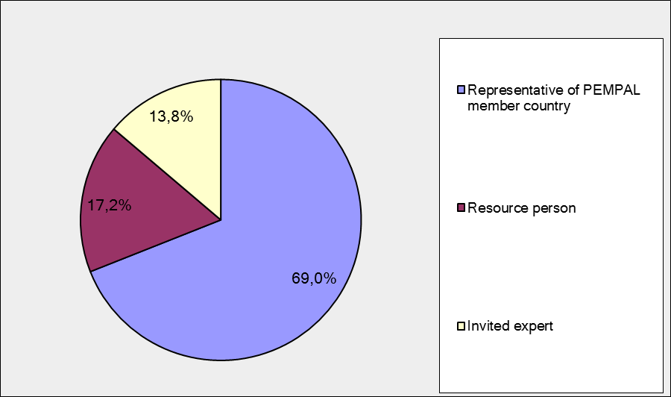

Q2. Was this your first participation in a PEMPAL event?

29 respondents (100%) answered this question. And 75.9% of them replied “No”.

Answer Options | Response Percent | Response Count
 | all | all | representatives | Resource persons
Yes | 24,1% | 7 | 4 | 3
No | 75,9% | 22 | 16 | 6

Q3. How many PEMPAL events have you attended before?

This question was seen only by those respondents who chose “No” in the previous question.
16 respondents answered this question.

1-2 | 3-4 | 5-6 | more than 6 | Response Count
5 | 1 | 4 | 12 | 22
PART I EVENT DELIVERY

Q4. How do you rate your participation in this event?

27 (93.1%) answers were given. 17 respondents think that their participation in the event was ‘Active’. 8 respondents think that their participation was ‘Average’. 2 respondents chose the option “Passive”.

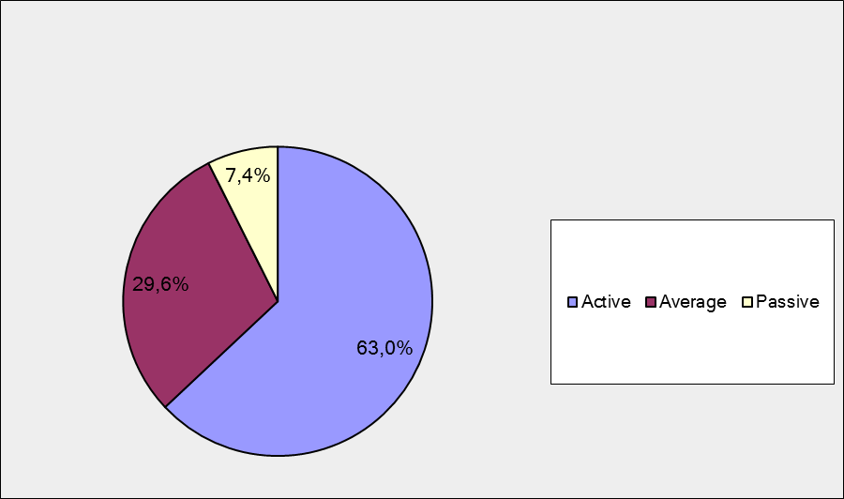

Among them:
5 resource persons and invited experts were “Active”, 2 – “Average”, 1 – “Passive”
12 representatives of PEMPAL countries were “Active”, 6 – “Average”, 1 – “Passive”.

Q5. How do you rate the Chisinau event duration overall?

27 respondents (93.1%) answered this question. And most of them rated the event duration in a positive way.

Answer Options | Response Percent | Response Count
 | all | all | representatives | Resource persons
Too short | 7,4% | 2 | 1 | 1
About right | 85,2% | 23 | 17 | 6
Too long | 7,4% | 2 | 1 | 1

Q6. How much do you agree with the following statements about the participants of the event? (Please rate each item):
25 respondents (86.2%) replied to this question.
Answer Options | 1 strongly disagree | 2 | 3 | 4 | 5 Strongly agree | Response Count | Average
a) The level of the event was appropriate for a person with my experience and knowledge | 0 | 0 | 0 | 5 | 20 | 25 | 4,8
b) I learned from the experience of other participants in the event | 0 | 0 | 3 | 5 | 17 | 25 | 4,6
с) Participants had about equal level of prior expertise relevant to the event topics | 0 | 0 | 5 | 13 | 7 | 25 | 4,1
d) Content of presentations, hand-outs and other materials were appropriate for a person with my level of knowledge | 0 | 0 | 0 | 4 | 21 | 25 | 4,8
Q7. Describe your own level of expertise, as compared to that of other participants?
15 comments were left. Here and after comments made by representatives of PEMPAL-member countries are bold.

One person wrote about a lack of expertise: “Since I work in the treasury operation sector at the position - senior associate, I'm glad that I had the chance to hear the thoughts of the participants who have more experience and knowledge.”
One respondent wrote that he/she has an average level of knowledge: “Average”.
3 respondents thought that their level of expertise is equal to others. “My experience and knowledge in many ways coincided with expertize of other participants”,. “Participants' expertise are almost equal”, “I have the same field of expertise and theoretical background knowledge but less experience in IFMIS project implementation”.
3 respondents rated their level of expertise as high comparing to that of other participants. “Experience and knowledge above medium level”, “In my view my country's level and experience is more advanced compared to other participant countries”, “Relatively higher than average »
5 respondents described their own level expertise and did not compare it with the expertise of the other participants: “I am an operational staff involved on all treasury functions and budget execution processing’, “I have expertise in realization of reforms in the area of fulfilment treasury functions: control, commitments recordings, payments, accounting and reporting, development and implementation of national standards», «I worked in many countries so have broad experience”, “My expertise fields are: cash management, forecasting of the cashflows, TSA implementation.“, “State Treasury of the Republic of Croatian includes following functions: budget preparation, budget execution, accounting, IT support and public debt. As a head of the Department of State Accounting I am involved myself in development of the Croatian state treasury since 2003, in particular in development of the functions of budget preparation, budget execution and accounting”.
2 rest comments: "Many countries have improved their treasury functions by implementing new ones.”, “Transactions in the State Treasury of Georgia fully are provided electronically. For this reason, we have closed regional offices and reduces the staff.”
Q8. What have you learned from other participants?
15 informative comments were left.
- Discussing with my pears helps my work to identify and share best practices on the next stage reforms issues and challenges, such as: using e-invoice in treasury operations, interface of treasury automated system with others systems like: human resources, external assistance, debt management, public procurement and risk management.
- "I had a chance to get an overall impression of the extent of such an IFMIS project implementation which has been put in place in Moldova and some other participating countries. I could also see some differences of priorities amongst the lecturing countries. I had a real life example of the already studied World Bank material in the field."
- We realized that we are moving in the same direction, there are similar problems, and we discussed them.
- Some very interesting country examples of reforms
- Treasury structure and function specifics in other countries.
- Shared different experiences and views about Treasury's functions which was important
- every event brings new knowledge of different country practices and this was not an exception - the most valuable part of this plenary was learning of the recent Moldova's experience in PFM reform and IT system implementation
- I liked the idea of switching to electronic-remote training; providing a link between liquidity management and public debt management; dual control of tax invoices by entering the system from the part of a buyer and a supplier / contractor; sale of government securities to individuals. Also I liked the idea that establishment of control before making a commitment; to give more responsibility to budget organizations in use of budget funds; assessment activities of the chief accountants of budgetary organizations by Treasury after the end of a financial year, and so on.
- details about mpay
- There were presented a negative and a positive experience
- I have learned from Moldova's experience how to handle multiple reforms at the same time and how to organize effective IT function. I have learned from other countries experience what are the main functions that evolving for the Treasuries in modern world
- For me Presentation of the Treasury of Hungary was very interesting in case of cash management
- Learning experience in paying payments to the budget by taxpayers, implementation of supervisory powers (denial of pre-payment for goods and services); TSA management; operation and prospects of treasury IT system development; trends in development of treasury systems in different countries
- Moldavian recent reforms about PFM systems. Organizational and functional structure of their own Treasury's.
- Given that there were participants from multiple sectors (Treasury, Budget and IT activity) there was also a lot of new information to create a fuller picture of the system of financial operations..
Q9. How much do you agree with the following statements about the content design of the event? (Please rate each item):
25 respondents (86.2%) replied to this question.
Answer Options | 1 strongly disagree | 2 | 3 | 4 | 5 Strongly agree | Response Count | Average
a) The event agenda was properly planned | 0 | 0 | 1 | 2 | 22 | 25 | 4,8
b) The content of the event was properly prepared | 0 | 0 | 0 | 5 | 20 | 25 | 4,8
с) The event addressed issues important to my work | 0 | 0 | 1 | 8 | 15 | 24 | 4,6
d) The event covered a right number of topics for the amount of time available | 0 | 0 | 1 | 9 | 15 | 25 | 4,6
e) The topics for the group discussions were relevant | 0 | 0 | 0 | 5 | 20 | 25 | 4,8
f) Presentations made during the event were relevant and useful | 0 | 0 | 1 | 3 | 21 | 25 | 4,8
g) Enough time was reserved for questions to speakers | 0 | 0 | 2 | 9 | 14 | 25 | 4,5

4 comments were left:
3 of them are totally positive: “Event was planned very well”, “The event agenda was on a very high level, properly planned and organized”, “Everything was well-balanced”.
One comment consists some criticism. Here and after pieces of critical feedback are underlined.
“I think the event should last up to 17 hours. After that it is too hard.

Q 10. How do you appreciate the idea of allocating one day of the workshop agenda to the presentation of hosting country experience in different PFM reforms?
25 responses (86.2%) were left.
1 Bad idea | 2 | 3 | 4 | 5very good idea | Response Count | Average
0 | 0 | 2 | 6 | 17 | 25 | 4,6

Representatives of PEMPAL countries
1 Bad idea | 2 | 3 | 4 | 5 very good idea | Response Count | Average
0 | 0 | 2 | 5 | 11 | 18 | 4,5
Resource persons + invited expert
1 Bad idea | 2 | 3 | 4 | 5very good idea | Response Count | Average
0 | 0 | 0 | 1 | 6 | 7 | 4.85

Q 11. Please, comment what you liked or not liked about the 1st day of the workshop program.

14 comments were left.
2 of them was comments “I liked everything”.

Practically all commenters liked Moldavian presentations. For example: “It was really impressing to see that the implementation of an IFMIS project requires a large team with several years of common work, enthusiasm, and result-orientation. Sure, exterior support was a driving force and a source of stability. For the specific aim it seemed useful to have the treasury department as part of the Ministry of Finance.”.
“It was very enlightening to learn how financial operations in Moldova work, to learn about their experience both positive and negative. I have no objections to the program of the workshop..”, “I learned a lot about the work of the Treasury of Moldova”.

There were pieces of criticism and suggestions in 2 comments:
“The workshop program is required to include experience of a host country. This allows on the one hand showing all achievements, on the other hand - discuss questions of interest. Maybe no need to have in presentations so much terminology details, texts of regulations, since it is difficult to percept a large amount of information on a slide. Perhaps t would be better to submit information in charts, graphs, etc. It’s just my suggestions for the future.
It is sensible idea that allocating one day for the host country experience. But a lot of presentation presents for the general structure of the PFM reforms. I think this can be spread to more than one day. It becomes harder to absorb the all topics.
”
4 commenters wrote probably about the event in whole. For example: “Workshop was very good in terms of the information sharing and learning, as well as network creation. In addition it was very well-organized”, “Presentation about ”Law on public finance and fiscal responsibility; competences and roles of participants of the budgetary process” was too interesting for me”.

Q 12. How much do you agree with the following statements about the outcomes of the event? (Please rate each item):

25 responses (86.2%) were left.
Answer Options | 1 strongly disagree | 2 | 3 | 4 | 5 Strongly agree | Response Count | Average
a) The participants have got comprehensive information on Moldova’s Treasury system, as well as on this country’s plans for its further development. The participants identified dimensions of the Moldova experience that are of particular interest for their countries | 0 | 0 | 1 | 7 | 17 | 25 | 4,6
b) The participants received comprehensive information on the available paths for further development of the role and functions of the government treasury institutions | 0 | 0 | 0 | 13 | 12 | 25 | 4,5

Representatives of PEMPAL countries
Answer Options | 1 strongly disagree | 2 | 3 | 4 | 5 Strongly agree | Response Count | Average
a) | 0 | 0 | 1 | 5 | 12 | 18 | 4,6
b) | 0 | 0 | 0 | 10 | 8 | 18 | 4,4
Resource persons + invited experts
Answer Options | 1 strongly disagree | 2 | 3 | 4 | 5 Strongly agree | Response Count | Average
a) | 0 | 0 | 0 | 2 | 5 | 7 | 4.7
b) | 0 | 0 | 0 | 3 | 4 | 7 | 4.6

2 comments were left.
- I liked the Moldavian practice on transfer public institutions into self-government, and state-owned enterprises, joint-stock companies into TSA.
- Participants have not got comprehensive information on possible ways of further development of the role and functions of government treasury systems. Possible trends of development in many countries have been identified and views of many of us were coincided. Question of TSA management, risks creating systems improvement of control in the context of strengthening the internal audit function in budgetary institutions. (Вопрос управления ЕКС, создания систем рисков, усовершенствование контроля в контексте усиления функций внутреннего аудита в бюджетных учреждениях.)

PART 2 EVENT ADMINISTRATION
Q 13. Please rate the quality of the organization and administration of the event:
Answered question – 26 (89,7%). Most of the ratings are positive.
Answer Options | 1 low | 2 | 3 | 4 | 5 high | Response Count | Average
Quality of organization
choice of venue | 0 | 0 | 0 | 0 | 26 | 26 | 5,0
travel arrangements | 0 | 1 | 0 | 6 | 19 | 26 | 4,7
event logistics | 0 | 0 | 1 | 3 | 22 | 26 | 4,8
Quality of administration (staff responsiveness, written communication, participant registration, etc.) | 0 | 0 | 0 | 2 | 24 | 26 | 4,9

Representatives of PEMPAL countries
Answer Options | 1 low | 2 | 3 | 4 | 5 high | Response Count | Average
Quality of organization
choice of venue | 0 | 0 | 0 | 0 | 18 | 18 | 5.0
travel arrangements | 0 | 0 | 0 | 4 | 14 | 18 | 4,8
event logistics | 0 | 0 | 1 | 0 | 17 | 18 | 4,9
Quality of administration | 0 | 0 | 0 | 0 | 18 | 18 | 5.0
Resource persons + invited experts
Answer Options | 1 low | 2 | 3 | 4 | 5 high | Response Count | Average
Quality of organization
choice of venue | 0 | 0 | 0 | 0 | 8 | 8 | 5.0
travel arrangements | 0 | 1 | 0 | 2 | 5 | 8 | 4.4
event logistics | 0 | 0 | 0 | 3 | 5 | 8 | 4.6
Quality of administration | 0 | 0 | 0 | 2 | 6 | 8 | 4.8
There were left 7 informative comments.
3 of them are comments like “Everything was organized on a high level.”. “Thank you for organization.”
Other comments:
- Connected flight via Russian Federation was not very nice
- Late departure did not allowed me to take part in the evening opening of the event; 2) Flight delay due to weather conditions - lack of transport at the airport. It is necessary in case of force majeure, as an option, to leave information at the help desk in an airport .Arrival logistics of the event should be monitored more clearly. "
- Our suggestion for further improvement would be to use clip on badges - ones used at this event hide under the table or flip not allowing to see the name of a person
- I'd appreciate presence of Mr. Adrian Fozzard. Ion was great as always and Special Thanks to Katya and Ksenia
Q 14. Did you receive agenda and event information in sufficient time before the event for them to be useful?
26 (89.7%) answers were given. And 96.2% responses were “Yes”.1 person (resource person or invited expert) (3.8%) did not receive event information in sufficient time.
Q 15. Did you receive practical information (about the accommodation and other facilities, etc.) prior to the event?
26 (89.7%) answers were given. 100% of them were “Yes”.
Q16. Are you satisfied with the quality of simultaneous interpretation provided during the event?
26 (89.7%) answers were given.
Answer Options | 1 low | 2 | 3 | 4 | 5 high | Response Count | Average
 | 0 | 0 | 0 | 7 | 19 | 26 | 4,7
Representatives of PEMPAL countries
Answer Options | 1 low | 2 | 3 | 4 | 5 high | Response Count | Average
 | 0 | 0 | 0 | 4 | 14 | 18 | 4,8
Resource persons + invite experts
Answer Options | 1 low | 2 | 3 | 4 | 5 high | Response Count | Average
 | 0 | 0 | 0 | 3 | 5 | 8 | 4,6
5 comments were given. 4 commenters were fully satisfied. For example: “Thank you so much, high quality interpretation.”
Other comment:
As I'm fluent in English and Russian, I've only used simultaneous interpretation from Serbo-Croatian.

Q17. Are you satisfied with the quality of written translation of event materials?
26 (89.7%) answers were given.
Answer Options | 1 low | 2 | 3 | 4 | 5 high | Response Count | Average
 | 0 | 0 | 0 | 7 | 19 | 26 | 4.7
Representatives of PEMPAL countries
Answer Options | 1 low | 2 | 3 | 4 | 5 high | Response Count | Average
 | 0 | 0 | 0 | 3 | 15 | 18 | 4,8
Resource persons + invited expert
Answer Options | 1 low | 2 | 3 | 4 | 5 high | Response Count | Average
 | 0 | 0 | 0 | 4 | 4 | 8 | 4.5

There were 3 informative comment:
- in a few cases the slides were not available in English
- I understood everything
- Everything was Ok

PART 3 OVERALL IMPRESSION
Q18. Did the event disappoint, meet, or exceed your expectations?

26 (89.7 %) participants answered the question. No one was disappointed.

Answer Options | Response Percent | Response Count
 | all | all | representatives | Resource persons
Disappoint | 0,0% | 0 | 0 | 0
Meet | 69,2% | 18 | 14 | 4
Exceed | 30,8% | 8 | 4 | 4

Q19. What did you like best about the event?

16 comments were left. All of them are valid.
Participants like different aspects of the event:
There was 1 comment like “Everything”: “Every aspect of the workshop was highly satisfactory, presenters were very informative and delivered everything very clearly”
Experience exchange was mentioned in 10 comments. For example:
“The possibility to get acquainted not only with the experience of Moldova, but also to exchange views with colleagues on interesting issues. In the course of communication to get ideas for further development and implementation of reforms…”
“To have the possibility to compare systems of different countries”
“In all PEMPAL event the most I like to exchange experiences with other countries.”
Work in small groups was mentioned once: “Discussion in small groups.”

Invited experts were mentioned in 1 comment: “I liked Mark's presentation on potential development paths for Treasuries. The social program was excellent.”

Other comments:
- Quality of information provided
- Organization and agenda of the event.
- open atmosphere that allowed for the fruitful debate
- Liquidity management and obligations monitoring
- Good time schedule.
Q20. What did you not like most about the event?

10 comments were left. Practically all of them are positive.
6 of them is comments like: “There is no such thing”. For example: “No issues.”

- I think the event should last one hour shorter.
- Rainy weather.
- Some presentations have taken more time than scheduled (because of question from audience), but it underlines the great interest of it
- Rain.

Q21. Do you plan to brief your colleagues about the event?
25 (86.2%) participants answered the question. And 100% of them responded “Yes”.
Q22. How do you plan to brief your colleagues?
Answered question – 24 (82.8%). Most of respondents was going to share materials.

Answer Options | Response Percent | Response Count
 | all | all | representatives | Resource persons
Share materials | 75,0% | 18 | 13 | 5
Make a presentation | 29,2% | 7 | 4 | 3
Prepare a back-to-office report | 62,5% | 15 | 12 | 3

4 comments were given:
- We have made all 3 options already, and also we have informed the Minister of Finance.
- Include country examples in my work
- I will discuss with colleagues
- In addition, I will prepare the staff report to the management and propose to introduce in our country PFM system some of the experiences of other countries, which I learned during this event
Q23. How much do you agree with the following statement?

25 respondents (86.2%) answered this question. Average rating is positive.

Answer Options | 1 not at all | 2 | 3 | 4 | 5 completely | Response Count | Average
I will be able to apply the knowledge acquired at this event to my work | 0 | 0 | 3 | 10 | 12 | 25 | 4,4
Representatives of PEMPAL countries
Answer Options | 1 not at all | 2 | 3 | 4 | 5 completely | Response Count | Average
 | 0 | 0 | 2 | 8 | 8 | 18 | 4,3
Resource persons+ invite expert
Answer Options | 1 not at all | 2 | 3 | 4 | 5 completely | Response Count | Average
 | 0 | 0 | 1 | 2 | 4 | 7 | 4.4

Q24. How can you apply the acquired knowledge?

12 comments were left.
- Discussing with proper managers and changing the legislation, then training staff to implement the procedures.
- Include country examples in my work
- Further enhance role and functions of the Treasury
- I will be able to apply this knowledge in my work on other projects
- Right now I am preparing a draft of a manual on commitment control and I think it would be useful to incorporate into it the experience of other countries, which I learned in this event
- When working on the development of our treasury we always use the experience of other countries.
- At the beginning, I will present them to my managers and will try to convince them.
- By using some of the Moldova's practical experience in implementing IPSASs as well as other countries experience in investing on a financial markets.
- Apply during preparation projects of legal documents; in educational and scientific purposes
- Share information with my colleagues
- New experiences and the way other countries do business gave me an idea that some kind of jobs can be organized and utilize information in other manner.
- Transfer and application of these knowledge in my daily workflow.
Q25. Overall, my satisfaction with the event was...

Answered question – 25 (86.2%). There were no negative answers.
1 not satisfied | 2 | 3 | 4 | 5 highly satisfied | Response Count | Average
0 | 0 | 0 | 5 | 20 | 25 | 4,8
Representatives of PEMPAL countries
1 not satisfied | 2 | 3 | 4 | 5 highly satisfied | Response Count | Average
0 | 0 | 0 | 4 | 14 | 18 | 4,8
Resource person+ invited person
1 not satisfied | 2 | 3 | 4 | 5 highly satisfied | Response Count | Average
0 | 0 | 0 | 1 | 6 | 7 | 4.85

PART 4 RECOMMENDATIONS FOR THE FUTURE

Q26. Do you have any suggestions to improve the content, approach and other aspects of such events in future?
7 comments were left, and 4 of them consists suggestions.
- I support the proposal to prepare methodical documents of PEMPAL, uttered on the last day
- I am very interested in topics such as improving the system of revenue forecasting, preparation of cash spending plan and establishment of effective control over the budget and financial obligations
- Think over the methodology of information in slides. The survey on event topics and generalization of the results prior to a workshop.
- My expectation is that in visible future treasuries of PEMPAL participating countries will face to risk management issues.

Q27. Are there any other products, research or services useful for your work that PEMPAL could provide?

6 comments were left and 4 of them are informative.

Me and my colleagues always use PEMPAL researches in our work and we hope that every event will bring us more benefits

It might be interesting to learn more about decentralization of the Treasury and allocation of functions with spending units

Best practices in the form of recommendations, reviews, guides, road maps on topics (eg, preparation and implementation of accounting standards, asset management and TSA, etc.)

Risk management issues, as I've already mentioned.

Here and after - Resource persons plus invited experts

