PEMPAL TCOP WORKSHOP IN MINSK FEEDBACK SURVEY

On October 3-5th , 2016, the PEMPAL TCOP workshop in Minsk, Belarus, took place.
After the event, the on-line survey in two languages was created on the base of the standard set of questions developed by Secretariat. The aim of the survey was to receive event feedback and to learn plans for the future.

Link to the survey – https://www.surveymonkey.com/r/RGRCGH9

The survey started to collect responses on October 12 and finished on November 7, 2016.
Invitations to take part in the survey were sent to all participants of the event. We sent 42 invitations.
25 persons started to response to the survey. From these 25 responses – 4 were from the resource persons, 2 — from invited experts, and 19 from the representatives of PEMPAL countries.
In this report, we analyze all 25 responses. For further calculation, we take this quantity as 100%.

All these responses will be included in the general Feedback Event Database.
The questionnaire comprises five parts: About the Respondent, Event Delivery, Event Administration, Overall Impression, and Recommendations for the Future. There are a total of 27 questions in the survey.
ABOUT THE RESPONDENT

Q1 You are...

25 (100%) respondents gave answers. Among them: 19 representatives of PEMPAL countries, 2 invited experts and 4 Resource persons.
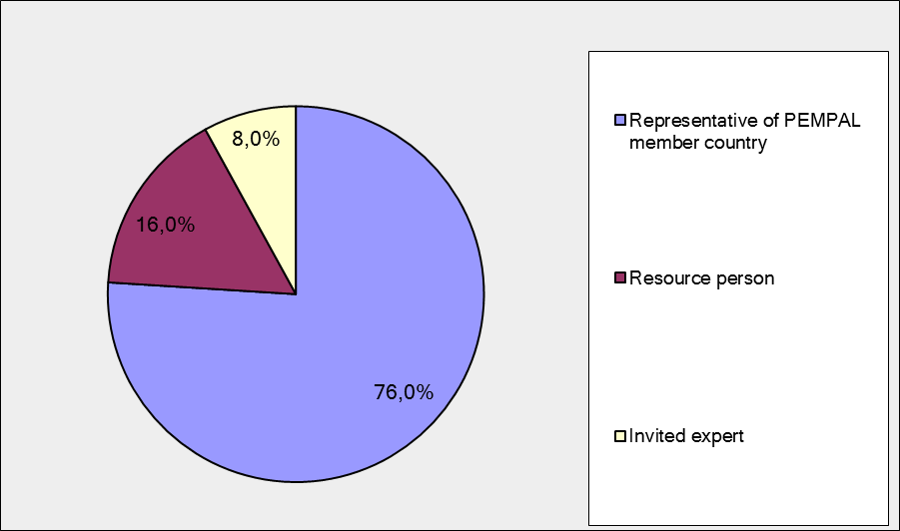

Q2. Was this your first participation in a PEMPAL event?

25 respondents (100%) answered this question. And 76% of them replied “No”.

Answer Options | Response Percent | Response Count
 | all | all | representatives | Resource persons
Yes | 24,0% | 6 | 4 | 2
No | 76,0% | 19 | 15 | 4

Q3. How many PEMPAL events have you attended before?

This question was seen only by those respondents who chose “No” in the previous question.
18 respondents answered this question.

1-2 | 3-4 | 5-6 | more than 6 | Response Count
4 | 3 | 3 | 9 | 19
PART I EVENT DELIVERY

Q4. How do you rate your participation in this event?

24 (96%) answers were given. 13 respondents think that their participation in the event was ‘Active’. 11 respondents think that their participation was ‘Average’. No one chose the option “Passive”.

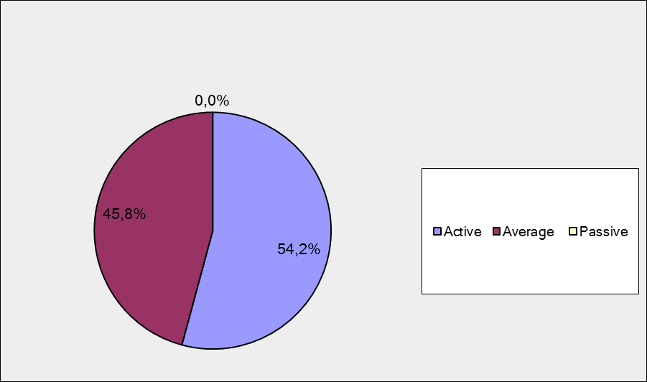

Among them:
4 resource persons and invited experts were “Active”, 1 – “Average”.
9 representatives of PEMPAL countries were “Active”, 10 – “Average.

Q5. How do you rate the Minsk event duration overall?

24 respondents (96%) answered this question. And most of them rated the event duration in a positive way.

Answer Options | Response Percent | Response Count
 | all | all | representatives | Resource persons
Too short | 20,8% | 5 | 5 | 0
About right | 79,2% | 19 | 14 | 5
Too long | 0,0% | 0 | 0 | 0

Q6. How much do you agree with the following statements about the participants of the event? (Please rate each item):
24 respondents (96%) replied to this question.
Answer Options | 1 strongly disagree | 2 | 3 | 4 | 5 Strongly agree | Response Count | Average
a) The level of the event was appropriate for a person with my experience and knowledge | 0 | 0 | 0 | 6 | 18 | 24 | 4,8
b) I learned from the experience of other participants in the event | 0 | 0 | 3 | 7 | 14 | 24 | 4,5
с) Participants had about equal level of prior expertise relevant to the event topics | 0 | 3 | 4 | 11 | 6 | 24 | 3,8
d) Content of presentations, hand-outs and other materials were appropriate for a person with my level of knowledge | 0 | 0 | 1 | 5 | 17 | 23 | 4,7
Q7. Describe your own level of expertise, as compared to that of other participants?
17 comments were left. Here and after comments made by representatives of PEMPAL-member countries are bold.
1 respondent wrote about a lack of expertise: «My level is not enough, I desire to get more information”.
3 respondents wrote that they have enough level of knowledge. For example: “My expertise allowed me to participate equally in discussions and debates with other participants and to share my country's experience.”
5 respondents thought that their level of expertise is equal to others. For example:” I believe that most of the participants, including myself, are actively engaged in the accounting reform process in our countries and that our levels of expertise are similar”, “my level of expertise is almost equal with that of other participants on public accounting field. however I learned a lot about new experiences in other PEMPAL member countries and from resource team also.”
6 respondents described their own level expertise and did not compare it with the expertise of the other participants. For example: My work is related to the development of financial indicators, I participate in the accounting and reporting reforms, i.e. in the process of developing the budgeting and reporting methodology”, “I developed the methodology of reforms in public sector accounting and reporting (chart of accounts, which functions in the payment system, harmonized with budget classification, national accounting standards, treasury services procedures), now I am doing research of treasury services of the state budget of Ukraine, introduction of national standards in the public sector ( lecture). In general, it is difficult to compare because we do not know all about many participants, not all tell about themselves and not all participate in the discussion.”
2 other comments:
- It is not modest
- We learned a lot from other participants.
Q8. What have you learned from other participants?
16 informative comments were left.
- I studied their experience in the implementation of standards, received answers to my questions, which was important for our reform.
- Do not make hasty steps in making decisions, consider the experience of other participants.
- The ability achieve the goal consistently, in accordance with the approved plan and despite the political situation in the country.
- I had a chance to discuss with colleagues our experience in development and implementation of standards.
- I learned a lot about the achievements in accounting reforms in other countries, received cognitive information on how to address problematic issues that have arisen in the countries in reform implementation.
- I got information on their experiences.
- I became familiar with the challenges presented by the public sector accounting reform in other countries, especially countries from our region.
- I learned a lot from the Russian colleagues and found the answer to some questions that interested and I learned a lot of interesting things from the experts.
- I learned a lot of interesting about the work in other countries.
- The flexibility and wisdom of decision-making in reform implementation in other countries taking into account their reality. If we had in the decision-making stage the current level of knowledge and experience of the implementation of reforms in other countries, we could rewrite from the beginning a lot of things. There are rules and art in accounting as well as in chess... Road by walking. We need to move forward.
- Details of the reforms, arising problems.
- Practical skills for the implementation of IPSAS
- Regardless of the level of reforms in certain countries, you can always learn from other participants. It was interesting to hear the Russian experience ("open government") and the Kazakh experience (all civil servants have to undergo retraining every three years). Most countries base their reforms on their budget acts, and their ministries of finance are competent for carrying out the reforms.
- The application level of the IPSAS standards in other countries was presented.
- I definitely concluded that the level of IPSAS implementation/adoption is very much depended on the specifics of each country and not all countries must go with IPSAS. The experience of Turkey and Russia could be a very good example on this topic since those two countries has a long way working on accrual implementation.
- Steps in developing and implementing accounting and reporting standards in public sector.

Q9. How much do you agree with the following statements about the content design of the event? (Please rate each item):
25 respondents (100%) replied to this question.
Answer Options | 1 strongly disagree | 2 | 3 | 4 | 5 Strongly agree | Response Count | Average
a) The event agenda was properly planned | 0 | 0 | 2 | 3 | 20 | 25 | 4,7
b) The content of the event was properly prepared | 0 | 0 | 0 | 4 | 21 | 25 | 4,8
с) The event addressed issues important to my work | 0 | 0 | 0 | 4 | 20 | 24 | 4,8
d) The event covered a right number of topics for the amount of time available | 0 | 0 | 0 | 6 | 18 | 24 | 4,8
e) The topics for the group discussions were relevant | 0 | 0 | 0 | 4 | 21 | 25 | 4,8
f) Presentations made during the event were relevant and useful | 0 | 0 | 0 | 5 | 20 | 25 | 4,8
g) Enough time was reserved for questions to speakers | 0 | 1 | 0 | 3 | 21 | 25 | 4,8

4 comments were left:
- Very useful.
- I think that the Workshop was well planned out, the chosen topics were appropriate, the presenters were skilled and prepared, so I found my participation in the Workshop useful.
- Some of the handouts on presentations (such as Russia) were not delivered on the presentation day. I would appreciate it if you could provide these presentations and also the study notes including answers of three questions focused on the last day (regarding both two group discussions). Thank you in advance.
- All topics covered were extremely important for my work.

Q 10. How do you appreciate the idea of allocating one day of the workshop agenda to the presentation of hosting country experience in different PFM reforms?
25 responses (100%) were left.
1 Bad idea | 2 | 3 | 4 | 5very good idea | Response Count | Average
0 | 0 | 0 | 1 | 24 | 25 | 5

Representatives of PEMPAL countries
1 Bad idea | 2 | 3 | 4 | 5 very good idea | Response Count | Average
0 | 0 | 0 | 1 | 18 | 19 | 4,9
Resource persons + invited expert
1 Bad idea | 2 | 3 | 4 | 5very good idea | Response Count | Average
0 | 0 | 0 | 0 | 6 | 6 | 5

Q 11. Please, comment what you liked or not liked about the 1st day of the workshop program.

10 comments were left.
All commenters like the 1st day of the workshop program. For example: “The workshop was aimed at assisting the host country in determining its further steps in the accounting reform process, which is why it was a good decision to familiarise us with the state of the reforms on the first day. I liked everything”, “Workshop was well planned. In the first day we learned about the state of the accounting reforms in Belarus, it gave us the opportunity to further discuss the experience of other countries and give direction Belarussian colleagues”, “I do not have any complaints regarding the programme on the first day, or any of the other days.”

Q 12. How much do you agree with the following statements about the outcomes of the event? (Please rate each item):
24 responses (96%) were left.
Answer Options | 1 strongly disagree | 2 | 3 | 4 | 5 Strongly agree | Response Count | Average
a) The participants have got comprehensive information on the public sector accounting practices of Belarus and reforms planned in this area. | 0 | 1 | 0 | 11 | 12 | 24 | 4,4
b) The participants were familiarized with the progress achieved by participating countries in public sector accounting reforms, with focus on the lessons learned and recommendations for the next steps. | 0 | 0 | 1 | 10 | 13 | 24 | 4,5

Representatives of PEMPAL countries
Answer Options | 1 strongly disagree | 2 | 3 | 4 | 5 Strongly agree | Response Count | Average
a) | 0 | 1 | 0 | 9 | 9 | 19 | 4.4
b) | 0 | 0 | 1 | 8 | 10 | 19 | 4.5
Resource persons + invited experts
Answer Options | 1 strongly disagree | 2 | 3 | 4 | 5 Strongly agree | Response Count | Average
a) | 0 | 0 | 0 | 2 | 3 | 5 | 4.6
b) | 0 | 0 | 0 | 2 | 3 | 5 | 4.6

6 comments were left.
- . Some of the recommendations of the participating countries that have made success in accounting reforms were generalized.
- There were many participating countries, but, time, unfortunately, was limited. Therefore we cannot say that to fully learn about the progress of reforms in other countries, only general points were highlights. This was especially true for discussion of country experiences in small groups.
- I completely agree with the statements.
- It possible to be more detailed [?]
- We have learned to implement changes gradually, with a gradual development of capacities and engaging local experts, whereby it is very important to communicate with other participants in the process who need to understand the objective of the reform. The accounting reform is a part of the wider public sector reform. The process has to fall under the jurisdiction of the decision-making ministry of finance. Not everyone should be expected to do everything. It is enough to train a smaller number of experts to apply IPSAS. Budgetary, statistical and financial reports need to be integrated since they are all developed from the same data. Accrual accounting does not necessarily mean having a budget based on accruals. There aren't many countries with this type of budget. However, the cash-based budget also needs to include certain accrual data because they are important for making decisions such as whether to buy or rent equipment, hire employees or recruit external experts, sell property or not. It is important to introduce a unique chart of accounts for the public sector.
- It would be better if more countries tell us about their experience in this area.

PART 2 EVENT ADMINISTRATION
Q 13. Please rate the quality of the organization and administration of the event:
Answered question – 25 (100%). All the ratings are positive.
Answer Options | 1 low | 2 | 3 | 4 | 5 high | Response Count | Average
Quality of organization
choice of venue | 0 | 0 | 0 | 5 | 20 | 25 | 4,8
travel arrangements | 0 | 0 | 1 | 3 | 19 | 23 | 4,8
event logistics | 0 | 0 | 0 | 4 | 21 | 25 | 4,8
Quality of administration (staff responsiveness, written communication, participant registration, etc.) | 0 | 0 | 1 | 3 | 21 | 25 | 4,8

Representatives of PEMPAL countries
Answer Options | 1 low | 2 | 3 | 4 | 5 high | Response Count | Average
Quality of organization
choice of venue | 0 | 0 | 0 | 5 | 14 | 19 | 4.7
travel arrangements | 0 | 0 | 1 | 3 | 13 | 17 | 4.7
event logistics | 0 | 0 | 0 | 4 | 15 | 19 | 4.8
Quality of administration (staff responsiveness, written communication, participant registration, etc.) | 0 | 0 | 1 | 3 | 15 | 19 | 4.7
Resource persons + invited experts
Answer Options | 1 low | 2 | 3 | 4 | 5 high | Response Count | Average
Quality of organization
choice of venue | 0 | 0 | 0 | 0 | 6 | 6 | 5
travel arrangements | 0 | 0 | 0 | 0 | 6 | 6 | 5
event logistics | 0 | 0 | 0 | 0 | 6 | 6 | 5
Quality of administration (staff responsiveness, written communication, participant registration, etc.) | 0 | 0 | 0 | 0 | 6 | 6 | 5
There were left 8 informative comments.
6 of them are comments like “Thank you. All great”, “The entire trip, accommodation, written and oral communication were at a high level.”
2 other comments:
- When purchasing tickets Bishkek-Moscow-Minsk and back were not taken into account the time for registration for the next flight, and there was not enough time: because of the Minsk-Moscow flight delayed for 30 minutes there were big risks to be late for the flight Moscow-Bishkek.
- We organized travel ourselves.
Q 14. Did you receive agenda and event information in sufficient time before the event for them to be useful?
24 (96%) answers were given. And 100% responses were “Yes”.
Q 15. Did you receive practical information (about the accommodation and other facilities, etc.) prior to the event?
25 (100%) answers were given. And 100% responses were “Yes”.
Q16. Are you satisfied with the quality of simultaneous interpretation provided during the event?
24 (96%) answers were given.
Answer Options | 1 low | 2 | 3 | 4 | 5 high | Response Count | Average
 | 0 | 0 | 1 | 6 | 17 | 24 | 4,7
Representatives of PEMPAL countries
Answer Options | 1 low | 2 | 3 | 4 | 5 high | Response Count | Average
 | 0 | 0 | 1 | 5 | 13 | 19 | 4.6
Resource persons + invite experts
Answer Options | 1 low | 2 | 3 | 4 | 5 high | Response Count | Average
 | 0 | 0 | 0 | 1 | 4 | 5 | 4.8
6 comments were given. 1 commenter did not use translation. 4 commenters were fully satisfied. For example: “Translation in all PEMPAL events are always very professional and accessible to understanding. For this huge thank PEMPAL team.”, “I do not have any complaints. The translation was very good throughout the event, even during the informal segments.”
1 commenter wrote that “sometimes the translation was not properly clear.”

Q17. Are you satisfied with the quality of written translation of event materials?
25 (100%) answers were given.
Answer Options | 1 low | 2 | 3 | 4 | 5 high | Response Count | Average
 | 0 | 0 | 1 | 5 | 19 | 25 | 4,7
Representatives of PEMPAL countries
Answer Options | 1 low | 2 | 3 | 4 | 5 high | Response Count | Average
 | 0 | 0 | 1 | 3 | 15 | 19 | 4.7
Resource persons + invited expert
Answer Options | 1 low | 2 | 3 | 4 | 5 high | Response Count | Average
 | 0 | 0 | 0 | 2 | 4 | 6 | 4.7

There was not any negative comment:
- The material was written in three languages, which was necessary to understand the contents and I was completely content with this form of translation.
- I would like to have all the presentations' documents in English version.
- Thank you!
- The written translation was excellent.

PART 3 OVERALL IMPRESSION
Q18. Did the event disappoint, meet, or exceed your expectations?

24 (96 %) participants answered the question.

Answer Options | Response Percent | Response Count
 | all | all | representatives | Resource persons
Disappoint | 0,0% | 0 | 0 | 0
Meet | 83,3% | 20 | 15 | 5
Exceed | 16,7% | 4 | 3 | 1

Q19. What did you like best about the event?

14 comments were left. All of them are valid.
Participants like different aspects of the event:
Host country presentations were mentioned in 1 comments.
Experience exchange was mentioned in 8 comments. «We had the opportunity to see how the accounting reform is being implemented in other participating countries», "The openness of the dialogue and the desire of all to exchange views, knowledge… ", “Familiarizing with the state of IPSAS application in other countries”, “The possibility of live communication with representatives of other countries. This makes possible to discuss informally emerging issues and to hear about ways to solve them”.
Work in small groups was mentioned twice. For example: “I liked more the group discussions”.
Invited experts were mentioned in 3 comments. For example: “Also, experts answered some of our open questions and doubts we had. For instance, Mark explained that cash-based IPSAS does not entail the application of the cash basis in revenue and expense entries”.
Other comments:
- New information on the overall situation in the area of accounting, reform support instruments.
- discussed practical issues.
- All content was appropriate and well presented.
Q20. What did you not like most about the event?

8 comments were left.
7 of them is comments like: “There is no such thing”. For example: “I liked everything.”

- I did not liked some interventions from some participants countries during question & answer sessions, because they were not questions but just general comments.

Q21. Do you plan to brief your colleagues about the event?
25 (100%) participants answered the question. And 100% of them responded “Yes”.
Q22. How do you plan to brief your colleagues?
Answered question – 23 (92%). Most of respondents was going to prepare a back-to-office report.

Answer Options | Response Percent | Response Count
 | all | all | representatives | Resource persons
Share materials | 56,5% | 13 | 11 | 2
Make a presentation | 21,7% | 5 | 3 | 2
Prepare a back-to-office report | 65,2% | 15 | 11 | 4

5 comments were given:
- In conversation with colleagues.
- An article in the "Treasury" magazine.
- We plan to write an article in a magazine.
- They will be used in scientific research and publications.
- Collective review of findings and lessons.
Q23. How much do you agree with the following statement?

24 respondents (96%) answered this question. Average rating is positive.

Answer Options | 1 not at all | 2 | 3 | 4 | 5 completely | Response Count | Average
I will be able to apply the knowledge acquired at this event to my work | 0 | 1 | 2 | 6 | 15 | 24 | 4,5
Representatives of PEMPAL countries
Answer Options | 1 not at all | 2 | 3 | 4 | 5 completely | Response Count | Average
 | 0 | 1 | 2 | 4 | 12 | 19 | 4.4
Resource persons+ invite experts
Answer Options | 1 not at all | 2 | 3 | 4 | 5 completely | Response Count | Average
 | 0 | 0 | 0 | 2 | 3 | 5 | 4.6

Q24. How can you apply the acquired knowledge?

13 comments were left.
- I will use the knowledge in development of future plans of reform implementation.
- In provision of proposals for changes in the regulatory framework/
- I will presenting them to my superiors and try to convince them/
- In development of normative legal acts which regulates public sector accounting issues/
- Will use expert opinions and experience of other countries in reforms carrying out.
- I will not be able to apply the acquired knowledge in my country due to the specificity of our accounting and reporting systems.
- With the introduction of IFRS operating system, experience of other countries will help very well.
- Since I am participating in all of the public sector reforms, especially regarding the budget and budget accounting, I will apply the acquired knowledge in the further reform process in my country.
- In the preparation and examination of normative document projects, scientific research and dissemination of international experience.
- With the introduction of IPSAS, the ENP and the new forms of financial statements.
- I'm more aware now about challenges and constraints that the IPSAS implementation/accrual implementation process will have, so I'll be more careful and strong enough on this difficult process.
- The preparation of appropriate procedures.
- The sequence and timing of the development of standards implementation.
Q25. Overall, my satisfaction with the event was...

Answered question – 25 (100%). There were no negative answers.
1 not satisfied | 2 | 3 | 4 | 5 highly satisfied | Response Count | Average
0 | 0 | 0 | 5 | 20 | 25 | 4,8
Representatives of PEMPAL countries
1 not satisfied | 2 | 3 | 4 | 5 highly satisfied | Response Count | Average
0 | 0 | 0 | 5 | 14 | 19 | 4.7
Resource person+ invited persons
1 not satisfied | 2 | 3 | 4 | 5 highly satisfied | Response Count | Average
0 | 0 | 0 | 0 | 6 | 6 | 5

PART 4 RECOMMENDATIONS FOR THE FUTURE

Q26. Do you have any suggestions to improve the content, approach and other aspects of such events in future:
12 comments were left, and 8 of them consists suggestions.
- It would be better if more time was devoted to presentations on the experiences of the participating countries in the groups. Time allotted for questions was not sufficient.
- Combine questions of different groups.
- Events were organized at the proper level, significant aspects were announced, since reform is difficult to carry out for a long time, I would like to participate in such meetings where more involved employees participate at the expense of the inviting party.
- I applaud the use of videoconferences in the future, since they are cheaper and more people can participate. The venue and equipment of the World Bank should be used during such events since our Ministry of Finance does not have the adequate technical equipment nor is it possible to organize interpretation there.
- During the events to inform us about new documents adopted by the IMF, the risks in their rejection of the countries on the subject. If possible, talk about their new norms
- IPSAS standards should be considered in detail.
- It can include some more practice sessions on different concrete topics, like exercises, where different countries will give the solution/explanations according to their country rules.
- More examples.

Q27. Are there any other products, research or services useful for your work that PEMPAL could provide?

8 comments were left and 7 of them are informative.

It would be useful to develop a roadmap for the introduction of IFRS OS, based on the experience of other countries

Perhaps it would be better to involve more EU countries participating in workshops.

I would like to learn more about the results of the EU reform.

Start to release of a review on all issues FMIS by countries.

Synopses or information on the new instruments adopted by the IMF (GFS 2014, Transparency Code).

management of IT systems: rules, certifications, administration etc.

Activities regarding the development of IPSAS implementation methodology.

Here and after - Resource persons plus the invited experts

