PEMPAL TCOP PLENARY MEETING IN TIRANA FEEDBACK SURVEY

On May 21-23, 2018, the PEMPAL Treasury COP Plenary meeting "Measuring and Monitoring Treasury Performance” took place in Tirana, Albania.
After the event, the on-line survey in two languages was created on the base of the standard set of questions developed in June 2017. The aim of the survey was to receive event feedback and to learn plans for the future.

Link to the survey – https://www.surveymonkey.com/r/YGZC7T3

The survey started to collect responses on May 28 and finished on June 11, 2018.
Invitations to take part in the survey were sent to all participants of the event. We sent 49 invitations.
29 persons started to response to the survey. From these 29 responses 23 was from representative of PEMPAL countries, 2 — from resource persons, 4 respondents did not indicate themselves. In this report, we analyze all 29 responses. For further calculation, we take this quantity as 100%.

All these responses will be included in the general Feedback Event Database.
The questionnaire comprises five parts: About the Respondent, Event Delivery, Event Administration, Overall Impression, and Recommendations for the Future. There are 31 questions in the survey.
ABOUT THE RESPONDENT

Q1 You are...

25 (86.2%) respondents gave answers. Among them: 23 representatives of PEMPAL countries and 2 resource persons.
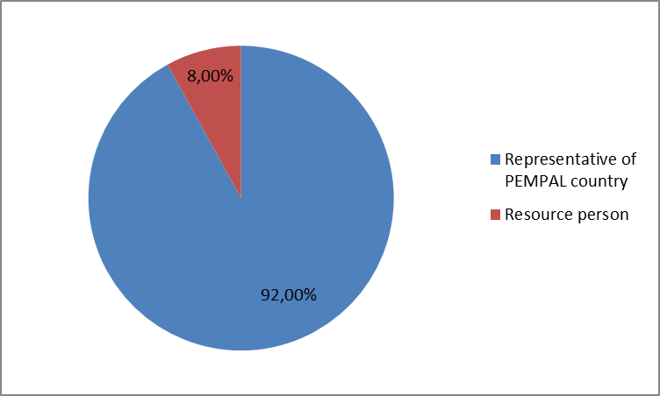

Q2. Was this your first participation in a PEMPAL event?

28 respondents (96.6%) answered this question. And 71.4% of them replied “No”.

Answer Options | Response Percent | Response Count
 | all | all | representatives | Resource persons
Yes | 28,6% | 8 | 6 | 2
No | 71,4% | 20 | 17 | 3

Q3. How many PEMPAL events have you attended before?

This question was seen only by those respondents who chose “No” in the previous question.
20 respondents answered this question.

1-2 | 3-4 | 5-6 | more than 6 | Response Count
4 | 4 | 3 | 9 | 20
PART I EVENT DELIVERY

Q4. How do you rate your participation in this event?

28 (96.6%) answers were given. 16 respondents think that their participation in the event was ‘Active’. 9 respondents think that their participation was ‘Average’. 3 persons chose the option “Passive”.
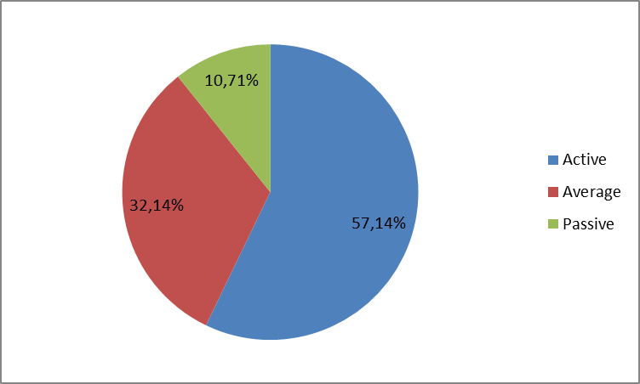
Among them:
4 resource persons were “Active”, 1 – “Passive”.
12 representatives of PEMPAL countries were “Active”, 9 – “Average, 2 – “Passive”

Q5. How do you rate the event duration overall?

28 respondents (96.6%) answered this question. And 92.9% of them rated the event duration as “About right”.
Answer Options | Response Percent | Response Count
 | all | all | representatives | Resource persons
Too short | 7,1% | 2 | 1 | 1
About right | 92,9% | 26 | 22 | 4
Too long | 0,0% | 0 | 0 | 0

Q6. How much do you agree with the following statements about the participants of the event?
28 respondents (96.6%) replied to this question.
Answer Options | 1 strongly disagree | 2 | 3 | 4 | 5 Strongly agree | Response Count | Average
a) The level of the event was appropriate for a person with my experience and knowledge | 0 | 0 | 1 | 9 | 17 | 27 | 4,6
b) I learned from the experience of other participants in the event | 0 | 0 | 1 | 8 | 19 | 28 | 4,6
c) Participants had about equal level of prior expertise relevant to the event topics | 1 | 3 | 6 | 11 | 6 | 27 | 3,7
d) Content of presentations, hand-outs and other materials were appropriate for a person with my level of knowledge | 0 | 0 | 0 | 9 | 18 | 27 | 4,7
Q7. What have you learned from other participants?
16 comments were left. Here and after comments made by representatives of PEMPAL-member countries are bold.
- Methodology for assessing the efficiency of a treasury. The process of assessing treasury employees.
- Various treasury measurement and monitoring methods
- Experience of assessing effectiveness of the Federal Treasury of Russia was interesting. I liked ability to work in groups of World Bank coordinators.
- Information was received on organization of work, as well as answers to selected questions about the treasury system of member countries.
- We have learned from their best experiences and best practice.
- We learned the experience of Albanian, Turkish and Russian colleagues in measuring and monitoring the efficiency of the Treasury, which is very important for further assessment of our work
- I have learned for PEFA framework in measuring PFM performance and performance evaluation at other country.
- Experience of the countries in setting and measuring the treasury performance indicators is useful.
- Turkey and Albania case was very much important for us.
- Assessment methods, performance indicators.
- Experience exchange.
- New КРI, measurement tools (templates, methodologies).
- Feasibility and experience of participants in those countries where effectiveness of a treasury is already assessed.
- I have learnt that measuring of treasury performance indicators is done through IT systems. These required sophisticated systems take time to be developed. If we do not measure it, we cannot manage it. Performance measurement is key but ultimately we must move up the hierarchy to assess whether the activities of government are contributing to positive outcomes.
- How to approach KPI implementation.
- Their strong interest to improve treasury role in the public finance performance in general and the good work and active role of each of them on defining the treasury KPI's and understanding their impact in daily work and treasury performance.
Q8. How much do you agree with the following statements about the content design of the event? (Please rate each item):
27 respondents (93.1%) replied to this question.
Answer Options | 1 strongly disagree | 2 | 3 | 4 | 5 Strongly agree | Response Count | Average
a) The event agenda was properly planned | 0 | 0 | 0 | 4 | 23 | 27 | 4,9
b) The content of the event was properly prepared | 0 | 0 | 1 | 3 | 22 | 26 | 4,8
с) The event addressed issues important to my work | 0 | 0 | 1 | 3 | 23 | 27 | 4,8
d) The event covered a right number of topics for the amount of time available | 0 | 0 | 3 | 7 | 17 | 27 | 4,5
e) Presentations made during the event were relevant and useful | 0 | 0 | 0 | 8 | 19 | 27 | 4,7
f) Enough time was reserved for questions to speakers | 0 | 0 | 1 | 11 | 15 | 27 | 4,5
4 comments were left:
- Presentations of the host party were very detailed and informative
- Slightly it was not enough time for discussion in small group.
- Very interesting and useful themes.
- Everything was delivered in a timely fashion and very well presented.
Q9. The afternoon of the second day was devoted to small groups discussions. How satisfied were you with the results of that session?
27 responses (93.1%) were left.
Answer Options | Response Percent | Response Count
 | all | all | representatives | Resource persons
Very successful | 44,4% | 12 | 10 | 2
Successful | 55,6% | 15 | 11 | 4
Unsuccessful | 0,0% | 0 | 0 | 0
7 comments were left:
- Pity that it was not enough time to discuss functional questions in small groups.
- While working in small groups, we became familiar with information on the topic about all the member countries of the group, which was very useful and interesting.
- When scheduling time for discussion should take into account the questions of participants.
- Presentation template for each country is very effective, but not all countries adhered to this template, this caused certain difficulties, the loss of time etc.
- I think it is necessary to add more time for group discussions.
- Broad ideas in regards to what to do and what to avoid when implementing KPI based system.
- It was a very good methodology and to assure that all the participants could have enough information.

Q10. How much do you agree with the following statements about the outcomes of the event? (Please rate each item):
27 responses (93.1%) were left.
Event objective has been achieved: | 1 strongly disagree | 2 | 3 | 4 | 5 Strongly agree | Response Count | Average
a) Participants received information regarding the approaches to measuring and monitoring performance | 0 | 0 | 2 | 3 | 22 | 27 | 4,7
b) Participants have shared the ideas and experiences on how these could be applied to the core national treasury functions in the participating countries | 0 | 0 | 2 | 5 | 20 | 27 | 4,7
с) Participants have reviewed the results of TCOP activities over the last year and discussed plans for the future period / | 0 | 0 | 0 | 8 | 19 | 27 | 4,7

Representatives of PEMPAL countries
Answer Options | 1 strongly disagree | 2 | 3 | 4 | 5 Strongly agree | Response Count | Average
a) | 0 | 0 | 2 | 3 | 16 | 21 | 4.7
b) | 0 | 0 | 2 | 2 | 17 | 21 | 4.7
c) | 0 | 0 | 0 | 5 | 16 | 21 | 4.8
Resource persons
a) | 0 | 0 | 0 | 0 | 6 | 6 | 5
b) | 0 | 0 | 0 | 3 | 3 | 6 | 4,5
c) | 0 | 0 | 0 | 3 | 3 | 6 | 4.5
2 comments were left.
- Everything from A to Z was covered.
- There was a lot of information of the way the monitoring process of PFM indicator was managed. It gives good insight that could be applicable in your country.
Q11. Please rate the quality of the leadership, management and/or technical services provided to the event by the following:
27 responses (93.1%) were left.
Answer Options | 1 low | 2 | 3 | 4 | 5 high | Response Count | Average
TCOP Executive Committee | 0 | 1 | 1 | 4 | 21 | 27 | 4,7
WB Resource Team | 0 | 0 | 0 | 3 | 24 | 27 | 4,9

3 comments were left:
- The meeting was very well organized.
- Thank you.
- Smooth.
Q12. Please rate the quality of services provided by the event speaker(s):
27 responses (93.1%) were left.
Answer Options | 1 low | 2 | 3 | 4 | 5 high | Response Count | Average
Quality of service | 0 | 0 | 1 | 4 | 22 | 27 | 4,8
No comments were left.

PART 2 EVENT ADMINISTRATION
Q13. Please rate the quality of the organization and administration of the event:
Answered question — 27 (93.1%). All the ratings are very good.
Answer Options | 1 low | 2 | 3 | 4 | 5 high | Response Count | Average
Quality of organization
- choice of venue | 0 | 0 | 0 | 4 | 23 | 27 | 4,9
- travel arrangements | 0 | 0 | 2 | 2 | 23 | 27 | 4,8
- event logistics | 0 | 0 | 1 | 1 | 24 | 26 | 4,9
- contribution provided by hosts | 0 | 0 | 0 | 5 | 21 | 26 | 4,8
Quality of administration
- Secretariat staff responsiveness | 0 | 0 | 0 | 1 | 25 | 26 | 5,0
- written communication | 0 | 0 | 0 | 2 | 25 | 27 | 4,9
- participant registration | 0 | 0 | 0 | 0 | 27 | 27 | 5.0

3 comments were left:
- We have been the hosts country in this event.
- Thanks to the Secretariat and the Host Party for a very well organized meeting, logistics was on high level; especially I would like to outline meeting room.
- Excellent choice of venue, hassle free logistics.
Q14. Did you receive agenda and event information in sufficient time before the event for them to be useful?
27 (93.1%) answers were given. And 26 (96.3%) responses were “Yes”. 1 person (representative of the PEMPAL countries) responded “No”.
Q15. Did you receive practical information (about the accommodation and other facilities, etc.) prior to the event?
27 (93.1%) answers were given. And 26 (96.3%) responses were “Yes”. 1 person (representative of the PEMPAL countries) responded “No”.
Q16. Did the paperless approach in distributing materials affect your ability to understand/absorb information during the event?
27 responses (93.1%) were left.
Answer Options | Response Percent | Response Count
 | all | all | representatives | Resource persons
Yes | 25.9% | 7 | 5 | 2
No | 74.1% | 20 | 16 | 4

Q17. Did you try to access event presentations on the web site in preparation for the event?
27 responses (93.1%) were left. 100% of them was “Yes”.
Q18. Did you find the practice of posting presentations on the web site before the event helpful?
27 responses (93.1%) were left. 100% of them was “Yes”.
3 comments were left:
- Presentations were uploaded on web-site in advance which was very helpful; however some presentations were changed after upload which has caused some kind of inconvenience.
- The presentations had some changes compared to the original versions.
- Paperless approach is head and shoulders above of paper based distribution.
Q19. Are you satisfied with the quality of simultaneous interpretation provided during the event?
26 (89.7%) answers were given.
Answer Options | 1 low | 2 | 3 | 4 | 5 high | Response Count | Average
 | 0 | 0 | 1 | 8 | 17 | 26 | 4,6
Representatives of PEMPAL countries
Answer Options | 1 low | 2 | 3 | 4 | 5 high | Response Count | Average
 | 0 | 0 | 1 | 6 | 13 | 20 | 4.6
Resource persons
 | 0 | 0 | 0 | 2 | 4 | 6 | 4.7
4 comments were given.
- For other meetings please see the possibility of translation in Albanian,
- No Albanian translation was provided, even though we asked for it before the workshop.
- One of the interpreters translated not so accurately.
- Thank you for qualitative interpretation.
Q20. Are you satisfied with the quality of written translation of event materials?
26 (89.7%) answers were given.
Answer Options | 1 low | 2 | 3 | 4 | 5 high | Response Count | Average
 | 0 | 0 | 0 | 5 | 21 | 26 | 4,8
Representatives of PEMPAL countries
Answer Options | 1 low | 2 | 3 | 4 | 5 high | Response Count | Average
 | 0 | 0 | 0 | 3 | 18 | 21 | 4.85
Resource persons
 | 0 | 0 | 0 | 2 | 3 | 5 | 4.6
1 comment was given: Too much Russian language used during a formal workshop of WB. This was quite uncommon for me.
PART 3 OVERALL IMPRESSION
Q21. Did the event disappoint, meet, or exceed your expectations?
26 (89.7%) participants answered the question.
Answer Options | Response Percent | Response Count
 | all | all | representatives | Resource persons
Disappoint | 0,0% | 0 | 0 | 0
Meet | 80.7% | 21 | 16 | 5
Exceed | 19.3% | 5 | 5 | 0

Q22. What did you like best about the event?

20 comments were left. Participants like different aspects of the event. 4 of them liked everything: «Everything was fine and all I liked».

Hospitality and experience of the host country were mentioned in 5 comments. For example: “Readiness of the host country to share their experience, tell us about their problems, to hear our recommendations.”

Good atmosphere during the event was mentioned in 4 comments. For example: “During the workshop a very busy working and at the same time a pleasant atmosphere was created”. “The optimistic and cheerful disposition of participants during the event, their high participation on various discussions which taken place during the event and joyful atmosphere during dinner”.

Experience exchange was mentioned in 5 comments. For example: “International experience in measuring and monitoring treasury performance. Knowing and exchanging experiences with different colleagues.”

Presentations were mentioned in 5 comments. For example: “Russian and Albanian presentations. Introducing an integrated approach to the issue.”

Other comments:
- The new people I met.
- Topics covered, group discussions, choice of venue, weather.
- The initiative to monitor the treasury performance using the KPI's as a concrete tool to measure it and valuate the work of treasury staff.
Q23. What did you not like most about the event?
6 comments were left and only 3 of them consists the piece of criticism.
- There is little time for discussion in small groups.
- Not using English as the only seminar language.
- The raining during walking to museums visit.

Q24. Do you plan to brief your colleagues about the event?
27 (93.1%) participants answered the question. And 100% of them responded “Yes”.
Q25. How do you plan to brief your colleagues?
Answered question – 26 (89.7%). Most of respondents were going to share materials.
Answer Options | Response Percent | Response Count
 | all | all | representatives | Resource persons
Share materials | 61,5% | 16 | 12 | 4
Make a presentation | 19,2% | 5 | 4 | 1
Prepare a back-to-office report | 57,7% | 15 | 14 | 1
3 comments were given:
- We will present the report to the management and deliver information to the staff.
- Verbally.
- As well as through verbal communication.
Q26. If your Ministry plans to promote this event, or PEMPAL in general, in internal or external media (e.g. MoF or other government website, MoF journal, television, radio, newspapers), please provide specific details so we can report to donors on any positive promotion of the value and benefits of PEMPAL.
7 comments were left, 5 respondents wrote that “No plans as far as I know” and 2 of the comments are informative.
- On the Ministry of Finance web-site.
- The Minister of Finance and Economy introduced himself welcoming session and media reported on it.
Q27. How much do you agree with the following statement?
27 respondents (93.1%) answered this question. Average rating is positive.
Answer Options | 1 not at all | 2 | 3 | 4 | 5 completely | Response Count | Average
I will be able to apply the knowledge acquired at this event to my work | 0 | 0 | 2 | 10 | 15 | 27 | 4,5
Representatives of PEMPAL countries
Answer Options | 1 not at all | 2 | 3 | 4 | 5 completely | Response Count | Average
 | 0 | 0 | 1 | 8 | 12 | 21 | 4.5
Resource persons
 | 0 | 0 | 1 | 2 | 3 | 6 | 4.3

Q28. How can you apply the acquired knowledge?
15 informative comments were left.
- We will collaborate with colleagues from the countries that participated in the PEMPAL meeting.
- By shearing the material and all of your presentations will my staff and college.
- In accordance with the legislative amendments made in our country, from the current year the employee's assessment system will be introduced. The information received and gained experience will help me to plan and evaluate my department's activities.
- Measures to improve organization of work of our Treasury.
- In adaption.
- Presentations, workshop.
- We will study new methods of assessment, develop new indicators, suggest introducing periodic assessment reports.
- In reviewing the using KPIs and improving measurement and monitoring process.
- In order to develop a methodology for self-assessment of Treasury effectiveness.
- I will report the best approaches of other member countries of TCOP to top management, like Russian and Turkey, especially to develop sophisticated systems of IT for measuring of performance indicators.
- Improving development and monitoring of performance indicators for management, the ministry.
- We would certainly benefit from the experience of Albania, Turkey and Russian Federation.
- Information presented at the event will enable me to come up with better indicators to measure treasury performance in the future projects.
- By proposing some changes and introducing some new indicators.
- Explaining to my staff the importance of measuring our work performance systematically and exploring new ways of defining concrete KPI's in order to mitigate the risk on our work to achieve the objectives.
Q29. Overall, my satisfaction with the event was...
Answered question – 27 (93.1%). There were no negative answers.
1 not satisfied | 2 | 3 | 4 | 5 highly satisfied | Response Count | Average
0 | 0 | 1 | 5 | 21 | 27 | 4,7
Representatives of PEMPAL countries
1 not satisfied | 2 | 3 | 4 | 5 highly satisfied | Response Count | Average
0 | 0 | 1 | 3 | 17 | 21 | 4.8
Resource persons
1 not satisfied | 2 | 3 | 4 | 5 highly satisfied | Response Count | Average
0 | 0 | 0 | 2 | 4 | 6 | 4.7

Q30. If you have any other comments you would like to provide us, please provide them here.

No informative comments were left.

PART 4 RECOMMENDATIONS FOR THE FUTURE

Q31. Do you have any suggestions to improve the content, approach and other aspects of such events in future?
7 comments were left and 3 of them are informative.
- Everything was fine. Considering that Kosovo needs support for the application of good practices, I propose that in such meetings of such a level be seen the possibility of translating in Albanian language.
- Diversify the presentation of experience of other countries, not to repeat the presentations of countries that have already shared their experience on this topic in other TCOP events.
- Experiencing the best practice of countries other than TCOP members.

Here and after resource persons + persons who did not indicate themselves.

