PEMPAL TCOP Plenary Meeting on Risk Management
FEEDBACK SURVEY

On May 30 — June 1, 2017, the PEMPAL TCOP Plenary meeting on Risk Management took place in Vienna, Austria.

After the event, the on-line survey in three languages was created on the base of the standard set of questions developed by Secretariat. The aim of the survey was to receive event feedback and to learn plans for the future.

Link to the survey – https://www.surveymonkey.com/r/BK69FMX

The survey started to collect responses on June 9 and finished on June 22, 2017.
Invitations to take part in the survey were sent to all participants of the event. We sent 53 invitations.
36 persons started to response to the survey. From these 36 responses – 8 were from the resource persons, and 27 from the representatives of PEMPAL countries. 1 person did not indicate him/herself.
In this report, we analyze all 36 responses. For further calculation, we take this quantity as 100%.

All these responses will be included in the general Feedback Event Database.
The questionnaire comprises five parts: About the Respondent, Event Delivery, Event Administration, Overall Impression, and Recommendations for the Future. There are a total of 26 questions in the survey.
ABOUT THE RESPONDENT

Q1 You are...

35 (97.2%) respondents gave answers. Among them: 27 representatives of PEMPAL countries and 8 Resource persons.
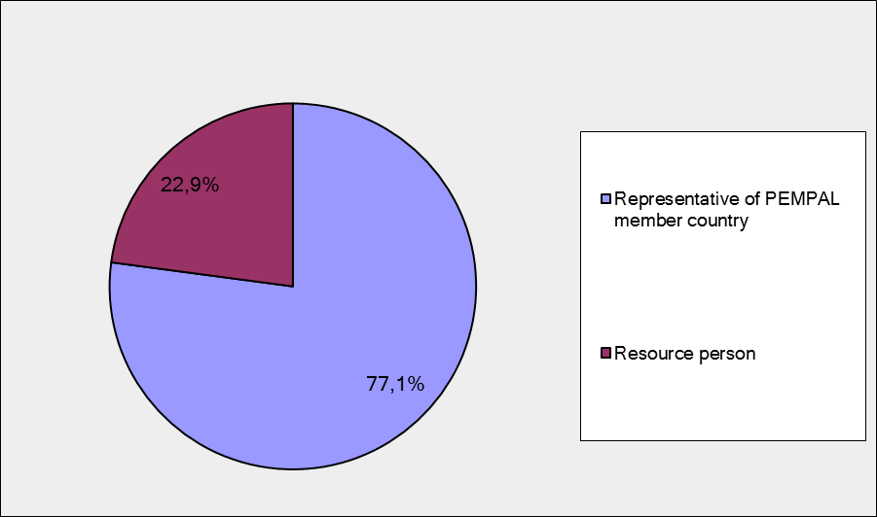

Q2. Was this your first participation in a PEMPAL event?

35 respondents (91.2%) answered this question. And 68.6% of them replied “No”.

Answer Options | Response Percent | Response Count
 | all | all | representatives | Resource persons
Yes | 31,4% | 11 | 6 | 5
No | 68,6% | 24 | 21 | 3

Q3. How many PEMPAL events have you attended before?

This question was seen only by those respondents who chose “No” in the previous question (plus 1 person who skipped previous question).
25 respondents answered this question.

1-2 | 3-4 | 5-6 | more than 6 | Response Count
4 | 4 | 3 | 14 | 25
PART I EVENT DELIVERY

Q4. How do you rate your participation in this event?

35 (97.2%) answers were given. 20 respondents think that their participation in the event was ‘Active’. 14 respondents think that their participation was ‘Average’. One chose the option “Passive”.

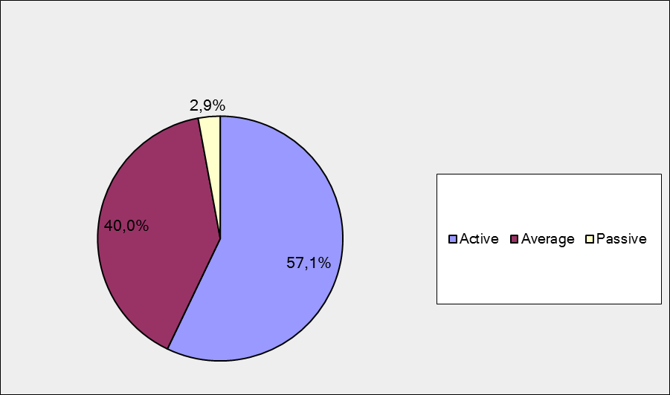

Among them:
5 resource persons were “Active”, 2 – “Average.
15 representatives of PEMPAL countries were “Active”, 11 – “Average. 1 – “Passive”

Q5. How do you rate the Vienna event duration overall?

35 respondents (97.2%) answered this question. Most of them rated the event duration in a positive way.

Answer Options | Response Percent | Response Count
 | all | all | representatives | Resource persons
Too short | 2,9% | 1 | 1 | 0
About right | 97,1% | 34 | 25 | 7
Too long | 0,0% | 0 | 0 | 0

Q6. How much do you agree with the following statements about the participants of the event? (Please rate each item):
34 respondents (94.4%) replied to this question.
Answer Options | 1 strongly disagree | 2 | 3 | 4 | 5 Strongly agree | Response Count | Average
a) The level of the event was appropriate for a person with my experience and knowledge | 0 | 0 | 2 | 6 | 26 | 34 | 4,7
b) I learned from the experience of other participants in the event | 0 | 1 | 1 | 6 | 26 | 34 | 4,7
с) Participants had about equal level of prior expertise relevant to the event topics | 1 | 0 | 5 | 15 | 13 | 34 | 4,1
d) Content of presentations, hand-outs and other materials were appropriate for a person with my level of knowledge | 0 | 0 | 0 | 5 | 29 | 34 | 4,9
Q7. Describe your own level of expertise, as compared to that of other participants?
24 comments were left. Here and after comments made by representatives of PEMPAL-member countries are bold.
- It was much more practical and deeper, because the risk management is my professional
- I have experience in developing normative documents on risk management
- We participated as audit director and head of internal control unit. Our level of expertise was more operative. The lectures were useful for us.
- Thanks to the sphere in which I work I know a lot of theory, but my colleagues' experience has enriched my knowledge in the field of risk management.
- Same level
- The experience of some participants was higher, so it was interesting to listen to them, even in free time from the workshops. We share some experience of tour country, too.
- "I'm general director of Treasury in Ministry of Finance and I’m responsible to take measures to mitigate the risk related to treasury functions"
- I think most of the participants were on a high level of expertise. I would only remove [from this list?] those participants who only appeared at the beginning of the meeting.
- My expertise are is risk management of the debt stock. We analyze risk profile of the debt stock and we set strategic benchmarks to improve the risk profile and market risk exposure of the debt stock.
- Higher than average
- Opposite other countries, in our country a certain work on risk management is carried out.
- Kyrgyz Republic is on the initial stage of risk management implementation.
- I'm involved in the preparation of the risk management registry and key performance indicators evaluation/monitoring by point of view on Treasury operations.
- Some country have more expertise that I have .
- High professional level of all participants. Personally I know general procedures and processes.
- My expertise is practically the same. When communicating with colleagues (round tables) we exchanged views and problems that our countries have, and we understood what was being discussed.
- I am member of IACOP, so it was my first time at TCOP. I am not expert in Treasury, but I have experience on the field of internal controls and risk management.
- My country’s experience regarding the topic of the event is considerable, while the questions raised from participants were very interesting in terms of experience sharing.
- Given the fact that the main topic of the meeting was risk management in treasury operations, we have a "green corridor": experience, which includes the automated processing of documents Treasury system. The Green Corridor itself is contained in the risk factors that are in charge of the treasury. The internal control methodology was also developed, which was approved by the Minister of Finance.
- Each of the participants is literate in their field. I learned a lot from my colleagues, and my experience was useful, I hope, to some other representatives.
- All participants have a very high professional level of their knowledge and skills. I consider my experience in the field of Management of payment systems at a sufficiently high level.
- I'm familiar with definitions and fundamentals of risk management, as well as processes of identification, analysis and assessment of debt management risks, which in some countries is part of treasury operations and activities.
- The subject of the plenary session is not directly related to my workplace, but by sharing the experience of other participants I conclude that my level of knowledge is not negligible, since I indirectly meet this topic at work.
- I am chief of department with extensive background in risk management.
Q8. What have you learned from other participants?
25 informative comments were left.
- "I got information about the level of risk management in other countries. The green corridor gave a good inspiration for us."
- Information given by experts on Green corridor conception and list of risks in Russian Treasury
- The most useful was the possibility of using the green corridor.
- Be confident.
- Information acquired from experts and participants are important for work with system organization and risk management.
- It was very interesting to hear about Green corridor in Georgia, other presentations also were thoughtful and qualitative, useful, we could compare our finance management system with systems of other countries.
- The procedures for electronic payments through "Green Corridor" of Georgia's Treasury System
- Repetitive payments (utilities, pensions, travel costs) are not a big risk because possible mistakes can be corrected with the next payment. Most of the risks are concentrated in a small number of transactions that are of great value. So you have to concentrate on it. Most of the risks are not under direct control of the treasury. Controls focused on the end of the process, when it comes to the treasury, are delayed. Controls should focus on the beginning of the process
- Green corridor application of Georgia, risk management system of Russia, role of internal auditor in risk management and so many conceptual information and country cases etc.
- Country presentations are of the highest standard and provide useful information for application elsewhere
- How to develop the complete ledger of risks
- Regulatory-legislative framework and organization of the risk management process
- It is necessary have high effective and safe automated system for implementing risk management.
- "Green Corridor" of Georgia's Treasury System
- How to manage risk.
- Experience in solving problems of treasury budget execution. Green corridor. Formalization of the risk management process
- It was interesting to listen to colleagues, about their achievements and at what stage the risk management is.
- It was very interesting to see the existing practice from other countries. Especially I liked the example of Turkey and we can use some inputs from it to improve our (Hungarian) risk management methodology.
- To assess my working experience more critically.
- Experts studied risk management techniques, risk assessment, risk factors and mitigation methods. In addition, I learned from other countries on how to maintain a risk register.
- For me, the practice of the green corridor, as well as Mark's information about the problems of risks, has become very useful.
- Now I know risk management better in details. Also, the experience of other countries in centralizing treasury services for budgets was useful. Interesting and useful experience of Georgia — "Green Corridor"
- How are interpreted risks in the public sector and what solutions are applied to mitigate their impact, how the country's risk management units are organized and how the introduction of risk management systems has influenced the activities of organizations.
- The exchange of experiences with other participating countries has largely influenced my level of knowledge on this topic which I note is not directly related to my workplace.
- Insights into how risk classification is categorized and what steps are being taken only once in a while and which once are performed proactively.
Q9. How much do you agree with the following statements about the content design of the event? (Please rate each item):
33 respondents (91.7%) replied to this question.
Answer Options | 1 strongly disagree | 2 | 3 | 4 | 5 Strongly agree | Response Count | Average
a) The event agenda was properly planned | 0 | 1 | 0 | 5 | 27 | 33 | 4,8
b) The content of the event was properly prepared | 0 | 0 | 1 | 5 | 27 | 33 | 4,8
с) The event addressed issues important to my work | 0 | 0 | 2 | 4 | 27 | 33 | 4,8
d) The event covered a right number of topics for the amount of time available | 0 | 0 | 0 | 6 | 27 | 33 | 4,8
e) Presentations made during the event were relevant and useful | 0 | 0 | 1 | 6 | 26 | 33 | 4,8
f) Enough time was reserved for questions to speakers | 0 | 1 | 0 | 6 | 26 | 33 | 4,7

8 comments were left:
- The program of the event was really well planned, as was its content. Unfortunately, there was not enough time during all the presentations to ask questions. But in general, it was possible to ask.
- Of particular interest were presentations on "The experience of the Russian Federation in identifying and classifying risks in treasury operations" and "Green Corridor for Automating Transactions with Insignificant Risk. The reorganization of the treasury function due to automation"
- It was not enough time for question to speakers.
- Content, presentations of speakers, organization are fully consistent with the program of the event, highly organized.
- Presentations were very interesting and informative. Topic of the conference is closely related to my work, which is unexhausted
- Thanks again expert Mark Silinss for his presentation and comprehensive answer to all questions.
- I liked everything. I am very glad that I was lucky to participate in this event.
- Everything went smoothly as expected and a lot of useful information was presented for the participants.

Q 10. How much do you agree with the following statements about the outcomes of the event? (Please rate each item):
34 responses (94.4%) were left.
Answer Options | 1 strongly disagree | 2 | 3 | 4 | 5 Strongly agree | Response Count | Average
Participants have got comprehensive information on the concepts and evolution of risk management in Public Financial Management | 0 | 0 | 2 | 8 | 24 | 34 | 4,6 | 0 | 11 | 12 | 24
Participants were familiarized with various experiences in applying the Risk Management in the core national treasury functions in the participating countries | 0 | 0 | 0 | 12 | 22 | 34 | 4,6

Representatives of PEMPAL countries
Answer Options | 1 strongly disagree | 2 | 3 | 4 | 5 Strongly agree | Response Count | Average
a) | 0 | 0 | 0 | 6 | 19 | 25 | 4.8
b) | 0 | 0 | 0 | 7 | 18 | 25 | 4.7
Resource persons
Answer Options | 1 strongly disagree | 2 | 3 | 4 | 5 Strongly agree | Response Count | Average
a) | 0 | 0 | 1 | 2 | 5 | 8 | 4.5
b) | 0 | 0 | 0 | 4 | 4 | 8 | 4.5

7 comments were left.
- The risk management at Hungarian State Treasury is built up at operational level, based on process management.
- Experience in risk management in public financial management can be adopted in some points, but in presentations there were not enough practical examples on its use and development.
- From Mark Silins we have learned a lot about risk and risk management. I learned the difference between risks and problems. We cannot eliminate all risks, but we must not neglect them. We met with the "green corridor" "in Georgia and we could compare it with the situation in other countries.
- At present in the treasury system of the Kyrgyz Republic only the control activities of territorial offices in functional areas are conducted and the country's experience shows the need to implement a treasury risk management system and the development of a treasury risk classifier.
- In some countries, risk management is new, and it will be easier for these countries to promote and develop such ideas after the seminar.
- Shared experience on risk management from participant countries will be very helpful in my further working activities
- Mr. Mark Sillins shared with us his wealth of experience, reps from Russia demonstrated how it is done in their Treasury, Ms. Edit spoke about Hungary's experience.
PART 2 EVENT ADMINISTRATION
Q 11. Please rate the quality of the organization and administration of the event:
Answered question – 33 (91.7%). Practically all the ratings are the highest.
Answer Options | 1 low | 2 | 3 | 4 | 5 high | Response Count | Average
Quality of organization
choice of venue | 0 | 0 | 0 | 1 | 32 | 33 | 4,97
travel arrangements | 0 | 0 | 0 | 1 | 31 | 32 | 4,97
event logistics | 0 | 0 | 0 | 2 | 29 | 31 | 4,94
Quality of administration (staff responsiveness, written communication, participant registration, etc.) | 0 | 0 | 0 | 0 | 33 | 33 | 5,00

9 comments were left.
- The organizer staff was very helpful, thank you for the high-level organization
- We have got useful information connected to accommodation, travelling, lectures and other technical topics.
- Everything was organized on a high level, including quality of administration!
- The administration of PEM-PAL events is always at an enviable level.
- Organizational preparation of the seminar was provided at a high level and we were assisted in obtaining a visa, daily correspondence on accommodation, flights and even lunch on the day of arrival. It was very touching!
- All organization was great.
- Thank you for well-organized event
- I just want to point to the over-air-conditioned space in which the event was held.
- Katya and Kristina did everything and some more to make sure that everything is taken care of.
Q 12. Did you receive agenda and event information in sufficient time before the event for them to be useful?
34 (94.4%) answers were given. And 100% responses were “Yes”.
Q 13. Did you receive practical information (about the accommodation and other facilities, etc.) prior to the event?
34 (94.4%) answers were given. And 100% responses were “Yes”.
Q14. Are you satisfied with the quality of simultaneous interpretation provided during the event?
34 (94.4%) answers were given.
Answer Options | 1 low | 2 | 3 | 4 | 5 high | Response Count | Average
 | 0 | 0 | 0 | 4 | 30 | 34 | 4,9
Representatives of PEMPAL countries
Answer Options | 1 low | 2 | 3 | 4 | 5 high | Response Count | Average
 | 0 | 0 | 0 | 1 | 24 | 25 | 4.96
Resource persons
Answer Options | 1 low | 2 | 3 | 4 | 5 high | Response Count | Average
 | 0 | 0 | 0 | 3 | 5 | 8 | 4.6
7 comments were given.
- The English translators were not on the same level.
- The English translations weren't on the same level.
- I did not use headphones when the speech was in English and Russian, but I heard what the translation was in the second day, when the participants were divided into 3 groups. I liked the quality and synchronism of the interpretation, so after the seminar I praised the translators.
- A quality translation enabled us to keep track of the issues and participate in the discussion without any problems. Translators are always ready to help, even outside the official part of the event.
- As always, instant translation was provided.
- Simultaneous interpretation was on a high level.
- Interpretation was impeccable.

Q15. Are you satisfied with the quality of written translation of event materials?
34 (94.4%) answers were given.
Answer Options | 1 low | 2 | 3 | 4 | 5 high | Response Count | Average
 | 0 | 0 | 0 | 2 | 32 | 34 | 4,9
Representatives of PEMPAL countries
Answer Options | 1 low | 2 | 3 | 4 | 5 high | Response Count | Average
 | 0 | 0 | 0 | 1 | 24 | 25 | 4.9
Resource persons
Answer Options | 1 low | 2 | 3 | 4 | 5 high | Response Count | Average
 | 0 | 0 | 0 | 1 | 7 | 8 | 4.9

There were 4 comments:
- If it is a matter of translating presentations into different languages, then yes..
- Written translation of event materials accessible and understandable.
- Everything was clear and understandable.
- Everything is very well translated.

Q16. According to the PEMPAL Executive decision to adopt the ‘go green approach’, no hard copy materials have been provided to the event participants. All the relevant materials were circulated through email prior to the event. Did the paperless approach in distributing materials affect your ability to understand/absorb information during the event?
33 respondents (91.7%) answered this question.

Answer Options | Response Percent | Response Count
 | all | all | representatives | Resource persons
Yes | 21,2% | 7 | 4 | 2
No | 78,8% | 26 | 21 | 5

9 comments were left:
- It was OK!
- The paperless distribution was perfect for us.
- I think it was right decision of PEMPAL managers. All who wanted printed the presentations at home, others looked at them in their notebook/computer/phone… Those who had not done that can do that after the presentation.
- This approach has enabled us to get to know the topics that will be processed before the event itself. Furthermore, we did not have to carry a bunch of printed materials, we could all record on their tablets or laptops and monitor presentations in their own language. I welcome this approach.
- Due to the fact that we received all the presentations before the beginning of the event, and all of them were previously studied and printed out, it was not difficult for us to evaluate the information provided during the event.
- We were prepared beforehand; it did not pose a problem for me.
- It's a very good decision not to provide materials in printed form. In our time of digital technology, most participants had the opportunity to view presentations in the desired language from a phone / tablet / laptop.
- Almost everyone had printed the materials individually
- Paperless is just as good as paper based.

PART 3 OVERALL IMPRESSION
Q17. Did the event disappoint, meet, or exceed your expectations?

34 (94.4%) participants answered the question.

Answer Options | Response Percent | Response Count
 | all | all | representatives | Resource persons
Disappoint | 0,0% | 0 | 0 | 0
Meet | 52,9% | 18 | 12 | 5
Exceed | 47,1% | 16 | 13 | 3

Q18. What did you like best about the event?

26 comments were left. All of them are valid. 6 participants liked everything. For example: “I cannot extract anything concrete because the event has met all my expectations”.
Participants like different aspects of the event:
Share experience was mentioned in 8 comments. For example: “Participants were very active and open to share information. It was a good opportunity to share experience”; “There were some countries represented who are far more advanced compared to others. Their experience was very valuable”.
Presentations/experts were mentioned in 7 comments. For example: “It is good to hear the presentation of experts, and then hear the experiences of other countries and to share the experience of your country”. ”Quantity of presentations, their content high professionalism of experts from all the countries”, “I liked presentations, especially of expert Mark Silins.”
Organization was mentioned in 4 comments. For example: “I liked the organizational moments of the meeting, because the proper organization of the process is a larger part of the well-established work. Quality presentations and interesting speaches.”; “Organization was on a high level…”
Theme was mentioned in 2 comments. For example: “…, and the subject very useful”, … theme of the event was new for me and in the near future it will be implemented in our country too.
Other aspects:
- Conducting table discussions allowing everyone to participate in the deliberation.
- First of all it was in Vienna, that already stressed the prestige of the event itself…
- Nice and friendly atmosphere.
- The location and quality of the hotel is perfect. The PEMPAL meeting was very interactive.
- The whole concept of PEM-PAL where we learn from each other.
- Social program
- Integrity of the whole event, a uniform high contribution of each participant (speaker)
- It was very interesting to learn working experience of PEMPAL internal audit.

Q19. What did you not like most about the event?

19 comments were left. 13 of them is comments like: “I'm happy with the whole event. I did not notice anything negative.”
So it was only 6 comments with the piece of criticism:
- It would be nice to start the program at 9:30 am.
- The start up time was early. It would be more convenient at 9,30.
- 3. I cannot say that I did not leke the fact that one or two performances did not have time to ask questions, because the presentations shifted. It just means that the presentations were broad and deep. That's why I liked everything.
- poor meal service by the hotel!
- It would be better to have the future event agenda a bit earlier. It is important for the visa obtain process.
- As I mentioned the overly air-conditioned event space

Q20. Do you plan to brief your colleagues about the event?
33 (91.7%) participants answered the question. And 100% of them responded “Yes”.
Q21. How do you plan to brief your colleagues?
Answered question – 33 (91.7%). Most of respondents was going to prepare a back-to-office report.
Answer Options | Response Percent | Response Count
 | all | all | representatives | Resource persons
Share materials | 57,6% | 19 | 15 | 4
Make a presentation | 27,3% | 9 | 7 | 2
Prepare a back-to-office report | 72,7% | 24 | 19 | 4
6 comments were given:
- In addition to the above, I am writing an article about the event and experience for the magazine on state finance..
- I will use the lessons learned when planning future treasury activities.
- Use some of the examples of good practice in my work
- After my return from the plenary I informed the deputy minister – chef of the Central Treasury of the Kyrgyz Republic MoF A. Bekataev and made a report.
- I will make the report to my colleagues; also I will publish the content of the workshop in the ministry web-site.
- Share material and if deemed necessary I will get in touch with our colleagues from Russia to rely on their experience.
Q22. How much do you agree with the following statement?

33 respondents (91.7%) answered this question. Average rating is positive.
Answer Options | 1 not at all | 2 | 3 | 4 | 5 completely | Response Count | Average
I will be able to apply the knowledge acquired at this event to my work | 0 | 1 | 3 | 10 | 19 | 33 | 4,4
Representatives of PEMPAL countries
Answer Options | 1 not at all | 2 | 3 | 4 | 5 completely | Response Count | Average
 | 0 | 1 | 1 | 8 | 15 | 25 | 4.5
Resource persons
Answer Options | 1 not at all | 2 | 3 | 4 | 5 completely | Response Count | Average
 | 0 | 0 | 1 | 2 | 4 | 7 | 4.4

Q23. How can you apply the acquired knowledge?

20 comments were left.
- Share the knowledge with my colleges and start brainstorming
- I will apply them in developing normative documents in this sphere
- "By discussing with our colleagues the possibility of using the green corridor. By suggesting for our staff to read PEMPAL web sites and issued materials."
- I will apply acquired knowledge in the process of risk identification and monitoring.
- Regulatory documents will be prepared.
- First, in our country we have risk management in many areas only in a different way, so it would be good to standardize the risk processes. The experience of the green corridor can also be applied in some moments.
- I will explain to my team the experience in applying the Risk Management in the treasury functions by best experience gained in this workshop through participating countries’ presentations to enhance the treasury operations carry out through treasury district offices.
- "Experience shared by colleagues will be helpful in my further working activities"
- I propose to make: List of offenses established in the monitoring procedure. List of impacts that a particular offense has this action proposal for their reduction.
- Use my knowledge in developing risk assessment and ledger.
- Improvement of the regulatory framework for risk management, organization of the process, use of various controls in payment authorization, introduction of a concept of the green corridor.
- On the basis of monitoring the activities of territorial offices, develop a treasury risk classifier.
- Enhance the Treasury procedures to mitigate the operational risk and assigning the proper KPIs.
- Work on the issue of implementing procedures for automatic payment authorization. System work on risk management.
- In carrying out my tasks, I can use knowledge about job planning, analytics, risk assessment, and so on.
- As it was already mentioned, risk management is a new concept for my country, in the future, risk management will be applied and spread, as this trend is already working in other countries successfully.
- I plan on applying the experience of Georgia to introduce payments without additional control, but previously me and my colleagues have to determine priorities. Now we are working hard on this. I think that by September 1, we will be more specific.
- In centralization process in our country.
- We could consider improving the risk analysis applied to debt management.
- Use presentation and based on the experience of our colleagues make smart decisions when it comes to implementing Risk Management Strategy in our Treasury.
Q24. Overall, my satisfaction with the event was...

Answered question – 33 (91.7%). There were no negative answers.
1 not satisfied | 2 | 3 | 4 | 5 highly satisfied | Response Count | Average
0 | 0 | 0 | 5 | 28 | 33 | 4,8
Representatives of PEMPAL countries
1 not satisfied | 2 | 3 | 4 | 5 highly satisfied | Response Count | Average
0 | 0 | 0 | 3 | 22 | 25 | 4.9
Resource persons
1 not satisfied | 2 | 3 | 4 | 5 highly satisfied | Response Count | Average
0 | 0 | 0 | 2 | 5 | 7 | 4.7

PART 4 RECOMMENDATIONS FOR THE FUTURE

Q25. Do you have any suggestions to improve the content, approach and other aspects of such events in future:
14 comments were left, and 7 of them consists suggestions.

The integrity management would be a very good topic for the future.

We think that it would be useful to deal with integrity management (fraud and corruption at the level of organization). At Hungarian State Treasury, we built up a proper operational manual and a reporting system linked to integrity management. We analyze data based on a query yearly.

As I have already mentioned, PEMPAL internal audit presentation was very informative. It was interesting to know the experience of Budget Commonwealth representative and general introduction to the analysis of the activities of all three commonwealth communities. How close is the interaction of commonwealth members under PFMS. Which countries have the best cooperation practice in terms of risk reduction and how it is implemented.

I would like to have some more technical discussions.

Creation of event video data base

Expand the library as a part of methodical support.

More practical knowledge, examples, presentation.

Q26. Are there any other products, research or services useful for your work that PEMPAL could provide?.

11 comments were left and 7 of them were informative.

Prepare summarizing documents on specific theme.

We are interested in Cash Management

Brochures with an overview of the event, bulletins

At present, in the Kyrgyz Republic, along with the issue discussed above, the are actual questions on cash management and placement of temporarily free budget funds.

A very good presentation was provided by the representative of the IACOP thematic group on internal audit on risk management methodology. It would be nice if you got acquainted with the model of a country which practices these methods in practice, classifies the risks and constantly analyzes them.

More information, exchange of experience of countries successfully implemented treasury innovations.

As discussed in the close session, it would be useful to send out a typical example of a list of risks (part of which was shown by Albania), which would form the basis for the creation of the same list in each country.

