PEMPAL TCOP THEMATIC GROUP MEETING ON PUBLIC SECTOR ACCOUNTING AND FINANCIAL REPORTING IN BAKU FEEDBACK SURVEY

On April 12—13, 2018, the workshop of the PEMPAL TCOP thematic group on Public Sector Accounting and Financial Reporting took place in Baku, Azerbaijan.
After the event, the on-line survey in three languages was created on the base of the standard set of questions developed in June 2017. The aim of the survey was to receive event feedback and to learn plans for the future.

Link to the survey – https://www.surveymonkey.com/r/ZPP9HW8

The survey started to collect responses on April 20 and finished on May 10, 2018.
Invitations to take part in the survey were sent to all participants of the event. We sent 37 invitations.
26 persons started to response to the survey. From these 26 responses 16 was from representative of PEMPAL countries and 8 — from resource persons. 2 persons did not indicate who they were. In this report, we analyze all 26 responses. For further calculation, we take this quantity as 100%.

All these responses will be included in the general Feedback Event Database.
The questionnaire comprises five parts: About the Respondent, Event Delivery, Event Administration, Overall Impression, and Recommendations for the Future. There are 32 questions in the survey.
ABOUT THE RESPONDENT

Q1 You are...

24 (92.3%) respondents gave answers. Among them: 16 representative of PEMPAL countries and 8 resource persons.
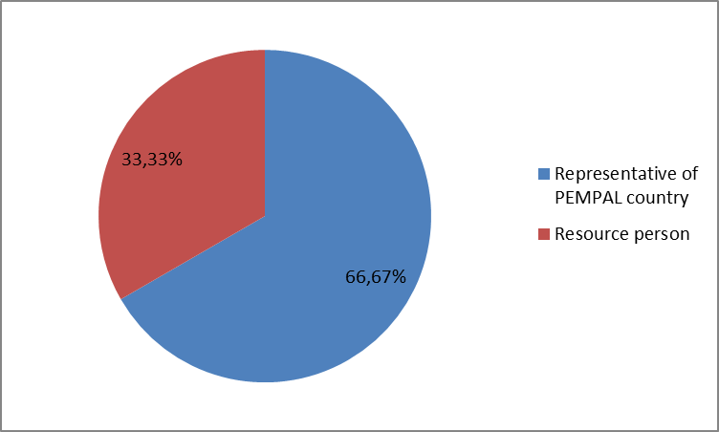

Q2. Was this your first participation in a PEMPAL event?

26 respondents (100%) answered this question. And 14 of them replied “No”.

Answer Options | Response Percent | Response Count
 | all | all | representatives | Resource persons
Yes | 46.2% | 12 | 6 | 6
No | 53.9% | 14 | 10 | 4

Q3. How many PEMPAL events have you attended before?

This question was seen only by those respondents who chose “No” in the previous question.
12 respondents answered this question.

1-2 | 3-4 | 5-6 | more than 6 | Response Count
2 | 5 | 1 | 6 | 14
PART I EVENT DELIVERY

Q4. How do you rate your participation in this event?

25 (96.2%) answers were given. 13 respondents think that their participation in the event was ‘Active’. 12 respondents think that their participation was ‘Average’. No one chose the option “Passive”.
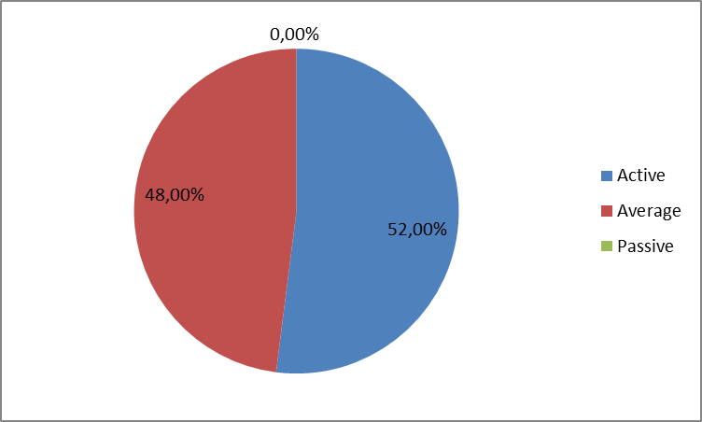

Among them:
4 resource persons were “Active”, 5 – “Average”.
9 representatives of PEMPAL countries were “Active”, 7 – “Average.

Q5. How do you rate the event duration overall?

26 respondents (100%) answered this question. And 84.6% of them rated the event duration as “About right”.
Answer Options | Response Percent | Response Count
 | all | all | representatives | Resource persons
Too short | 15.4% | 4 | 2 | 2
About right | 84.6% | 22 | 14 | 8
Too long | 0% | 0 | 0 | 0

Q6. How much do you agree with the following statements about the participants of the event?
23 respondents (88.5%) replied to this question.
Answer Options | 1 strongly disagree | 2 | 3 | 4 | 5 Strongly agree | Response Count | Average
a) The level of the event was appropriate for a person with my experience and knowledge | 0 | 0 | 1 | 6 | 16 | 23 | 4,7
b) I learned from the experience of other participants in the event | 0 | 0 | 5 | 5 | 13 | 23 | 4,4
c) Participants had about equal level of prior expertise relevant to the event topics | 1 | 0 | 4 | 12 | 6 | 23 | 4.0
d) Content of presentations, hand-outs and other materials were appropriate for a person with my level of knowledge | 0 | 0 | 1 | 7 | 15 | 23 | 4,6
Q7. What have you learned from other participants?
11 comments were left. Here and after comments made by representatives of PEMPAL-member countries are bold.
- Approach to solve the tasks is different, the experience and ideas of other countries can be used to make decisions in our country.
- Most of all I liked the work done in the Russian and Moldovan treasuries in terms of improving reporting, as well as the use of reports in the process of budget formation and analysis.
- Different approaches to accounting and reporting systems due to differences of treasury systematization in each country, solutions of collecting financial reports and all other information needed from budget users.
- It was interesting to learn about other countries experience in accounting and reporting.
- I have learned that in other countries there are also difficulties with collecting financial statements from budget users and problems in consolidation of financial statements. Some of them have good solutions but it takes time to come to one point where everything functions as it should.
- From some countries - Enough to understand the situation what is really happening with their own software or system of public finance but I was most interested for Baku and Azerbaijan, because we were already in Baku so its normal to try to discover as much as possible all about the host country. Every experience its part of Treasury of life, Thank you.
- Experience of other participants will allow us to take advantage of their experience in development of our treasury systems.
- I learned about the IT systems and priorities of financial statistics on the participants' countries.
- We share experiences about the topics.
- I have learned the structure of the Treasury Department of the states that we were in the same group, their experiences and achievements in the field of treasury sector.
- The experiences of the other countries and the system of financial reports etc.
Q8. How much do you agree with the following statements about the content design of the event? (Please rate each item):
23 respondents (88.5%) replied to this question.
Answer Options | 1 strongly disagree | 2 | 3 | 4 | 5 Strongly agree | Response Count | Average
a) The event agenda was properly planned | 0 | 0 | 0 | 6 | 17 | 23 | 4,7
b) The content of the event was properly prepared | 0 | 0 | 0 | 6 | 17 | 23 | 4,7
с) The event addressed issues important to my work | 0 | 0 | 2 | 3 | 18 | 23 | 4,7
d) The event covered a right number of topics for the amount of time available | 0 | 0 | 1 | 8 | 14 | 23 | 4,6
e) Presentations made during the event were relevant and useful | 0 | 0 | 1 | 6 | 15 | 22 | 4,6
f) Enough time was reserved for questions to speakers | 0 | 0 | 0 | 6 | 17 | 23 | 4,7
2 comments were left:
- I am just 100% happy and very glad to for this experience, Thank you
- Yes, I agree enough time was reserved for questions to speaker.
Q9. The Baku event agenda included joint sessions with the TCOP thematic group on use of IT in treasury operations. How would you rate this experience?
23 responses (88.5%) were left.
Answer Options | Response Percent | Response Count
 | all | all | representatives | Resource persons
Very successful | 60.9% | 14 | 10 | 4
Successful | 39.1% | 9 | 4 | 5
Unsuccessful | 0% | 0 | 0 | 0
2 comments were left:
- These two topics are in strong correlation so we had a benefit from hearing experiences on both fields.
- I would rate this experience very successful because use of IT in treasury operations is very important I would say crucial.
Q10. The Baku event agenda envisaged a session devoted to sharing news by participating country delegations on the recent developments in the area of public sector accounting and financial reporting in the ECA region. How would you rate this innovation for the TCOP events agenda?
23 responses (88.5%) were left.
Answer Options | Response Percent | Response Count
 | all | all | representatives | Resource persons
Very successful | 43.5% | 10 | 8 | 2
Successful | 56.5% | 13 | 6 | 7
Unsuccessful | 0% | 0 | 0 | 0
1 comment was left:
- This innovation for the TCOP events agenda I would rate successful because I think ta sharing news on the recent developments in the area of public sector accounting and financial reporting in the ECA region it was very important for others participants and for me it was a chance to be informed on recent developments and to get experience for the future.
Q11. How much do you agree with the following statements about the outcomes of the event? (Please rate each item):
23 responses (88.5%) were left.
Answer Options | 1 strongly disagree | 2 | 3 | 4 | 5 Strongly agree | Response Count | Average
a) Participants received comprehensive information regarding the approaches for automating accounting and reporting at the spending unit level and integration of the respective solutions with the central financial management information systems | 0 | 0 | 1 | 6 | 16 | 23 | 4,7
b) Participants exchanged information on recent developments in the area of public sector accounting and financial reporting in the ECA region | 0 | 0 | 1 | 7 | 15 | 23 | 4,6
с) Participants discussed plans for future activities of thematic groups | 0 | 0 | 1 | 7 | 15 | 23 | 4,6

Representatives of PEMPAL countries
Answer Options | 1 strongly disagree | 2 | 3 | 4 | 5 Strongly agree | Response Count | Average
a) | 0 | 0 | 1 | 1 | 12 | 14 | 4.8
b) | 0 | 0 | 1 | 1 | 12 | 14 | 4.8
c) | 0 | 0 | 1 | 2 | 11 | 14 | 4.7
Resource persons
a) | 0 | 0 | 0 | 5 | 4 | 9 | 4.4
b) | 0 | 0 | 0 | 6 | 3 | 9 | 4.3
c) | 0 | 0 | 0 | 5 | 4 | 9 | 4.4
3 comments were left.
- It's very importance to analyze and discuss the gaps in intend of integration the budget classification with Chart of accounts
- I think everything went according to what to what it was planned.
- Participants received and share useful information.
Q12. Please rate the quality of the leadership, management and/or technical services provided to the event by the following:
23 responses (88.5%) were left.
Answer Options | 1 low | 2 | 3 | 4 | 5 high | Response Count | Average
TCOP Executive Committee | 0 | 0 | 0 | 1 | 22 | 23 | 4.95
WB Resource Team | 0 | 0 | 0 | 3 | 19 | 22 | 4.9
2 comments were left:

Well done...

The quality of the leadership, management and/or technical services provided to the event it was in the highest level.
Q13. Please rate the quality of services provided by the event speaker(s):
23 responses (88.5%) were left.
Answer Options | 1 low | 2 | 3 | 4 | 5 high | Response Count | Average
Quality of service | 0 | 0 | 0 | 5 | 18 | 23 | 4,8
2 comments were left:

Well done...

The speakers were well prepared and able to respond all the questions.

PART 2 EVENT ADMINISTRATION
Q14. Please rate the quality of the organization and administration of the event:
Answered question — 23 (88.5%). All the ratings are very good.
Answer Options | 1 low | 2 | 3 | 4 | 5 high | Response Count | Average
Quality of organization
- choice of venue | 0 | 0 | 0 | 1 | 22 | 23 | 5
- travel arrangements | 0 | 0 | 0 | 1 | 21 | 22 | 5
- event logistics | 0 | 0 | 0 | 2 | 21 | 23 | 4.9
- contribution provided by hosts | 0 | 0 | 0 | 2 | 20 | 22 | 4.9
Quality of administration
- Secretariat staff responsiveness | 0 | 0 | 0 | 1 | 22 | 23 | 5
- written communication | 0 | 0 | 0 | 3 | 20 | 23 | 4,9
- participant registration | 0 | 0 | 0 | 1 | 22 | 23 | 5
There were 4 informative comments:
- Well done...
- Thank you very much to Katya for her kindness and supports.
- I think it would be useful for the participants in the end to receive a written paper that shows they participated in this event.
- Very good organization.
Q15. Did you receive agenda and event information in sufficient time before the event for them to be useful?
23 (88.5%) answers were given. And 100% responses were “Yes”.
Q16. Did you receive practical information (about the accommodation and other facilities, etc.) prior to the event?
23 (88.5%) answers were given. And 100% responses were “Yes”.
Q17. Did the paperless approach in distributing materials affect your ability to understand/absorb information during the event?
23 (88.5%) answers were left.
Answer Options | Response Percent | Response Count
 | all | all | representatives | Resource persons
Yes | 30.4% | 7 | 2 | 5
No | 69.6% | 16 | 12 | 4
Q18. Did you try to access event presentations on the web site in preparation for the event?
23 (88.5%) responses were left.
Answer Options | Response Percent | Response Count
 | all | all | representatives | Resource persons
Yes | 91.3% | 21 | 13 | 8
No | 8.7% | 2 | 1 | 1
Q19. Did you find the practice of posting presentations on the web site before the event helpful?
23 (88.5%) responses were left.
Answer Options | Response Percent | Response Count
 | all | all | representatives | Resource persons
Yes | 95.7% | 22 | 14 | 8
No | 4.4% | 1 | 0 | 1
1 comment was given: Well done...
Q20. Are you satisfied with the quality of simultaneous interpretation provided during the event?
23 (88.5%) answers were given.
Answer Options | 1 low | 2 | 3 | 4 | 5 high | Response Count | Average
 | 0 | 0 | 1 | 1 | 21 | 23 | 4,9
Representatives of PEMPAL countries
Answer Options | 1 low | 2 | 3 | 4 | 5 high | Response Count | Average
 | 0 | 0 | 0 | 0 | 14 | 14 | 5
Resource persons
 | 0 | 0 | 1 | 1 | 7 | 9 | 4.7
1 comment was given: Well done...
Q21. Are you satisfied with the quality of written translation of event materials?
23 (88.5%) answers were given.
Answer Options | 1 low | 2 | 3 | 4 | 5 high | Response Count | Average
 | 0 | 0 | 0 | 4 | 19 | 23 | 4,8
Representatives of PEMPAL countries
Answer Options | 1 low | 2 | 3 | 4 | 5 high | Response Count | Average
 | 0 | 0 | 0 | 0 | 14 | 14 | 5
Resource persons
 | 0 | 0 | 0 | 4 | 5 | 9 | 4.6
1 comment was given: Well done...
PART 3 OVERALL IMPRESSION
Q22. Did the event disappoint, meet, or exceed your expectations?

23 (88.5%) participants answered the question.
Answer Options | Response Percent | Response Count
 | all | all | representatives | Resource persons
Disappoint | 0,0% | 0 | 0 | 0
Meet | 73.9% | 17 | 11 | 6
Exceed | 26.1% | 6 | 3 | 3

Q23. What did you like best about the event?

11 informative comments were left. Participants like different aspects of the event:
- Group discussions that allow the dissemination of international practices.
- News exchange, interest to the theme.
- Most of all I liked the general atmosphere of openness, desire to share knowledge, as well as opportunity to discuss issues, problems, experience of other countries.
- Excellent format and content very interesting — no specific element.
- In addition that it was my first time in such an event, it was interesting to hear experiences from different countries that participate this event. Everything was good organized, and interaction with other participants was also very good.
- All together - the example of one successful country, range of officials, topic of meeting, accommodation, Beauty of Baku, etc.
- Activity of the participants.
- To find practice of posting presentations on the web site before the event.
- Hospitality of the host members of Azerbaijan, very polite staff at Hilton Baku Hotel and very good organization of the event.
- The share of experiences among countries.
- Country presentations.
Q24. What did you not like most about the event?

6 comments were left and 5 of them consists the piece of criticism.
- That some participants were not active.
- Breaks could be shorter.
- The time could be longer.
- Maybe it was too short, one day more to visit this beautiful city of Baku would be perfect.
- It was too intense for two days ıt could be 3 -4 days for those activities.

Q25. Do you plan to brief your colleagues about the event?
23 (88.5%) participants answered the question.

Answer Options | Response Percent | Response Count
 | all | all | representatives | Resource persons
Yes | 95.7% | 22 | 14 | 8
No | 4.4% | 1 | 0 | 1
Q26. How do you plan to brief your colleagues?
Answered question – 21. Most of respondents were going to share materials and prepare a report.
Answer Options | Response Percent | Response Count
 | all | all | representatives | Resource persons
Share materials | 66.7% | 12 | 8 | 4
Make a presentation | 4.8% | 1 | 0 | 1
Prepare a back-to-office report | 66.7% | 13 | 11 | 2
3 comments were given:
- Using the information during meetings and discussion of current problems.
- I will try to talk as much as possible about the topics that have been touched upon, the achievements of other countries, as well as about all aspects which we can use in our country.
- Orally.
Q27. If your Ministry plans to promote this event, or PEMPAL in general, in internal or external media (e.g. MoF or other government website, MoF journal, television, radio, newspapers), please provide specific details so we can report to donors on any positive promotion of the value and benefits of PEMPAL.
5 comments were left and 2 of them are informative.
- April 13, 2018, our report about the meeting was published on the MoF web-site: http://maliyye.gov.az/node/2155
- Our report about the meeting in Baku was published on the web-site of MoF of Kazakhstan: www.mingin.gov.kz
Q28. How much do you agree with the following statement?
23 respondents (88.5%) answered this question. Average rating is positive.
Answer Options | 1 not at all | 2 | 3 | 4 | 5 completely | Response Count | Average
I will be able to apply the knowledge acquired at this event to my work | 0 | 1 | 3 | 5 | 14 | 23 | 4,4
Representatives of PEMPAL countries
Answer Options | 1 not at all | 2 | 3 | 4 | 5 completely | Response Count | Average
 | 0 | 0 | 3 | 1 | 10 | 14 | 4.5
Resource persons
 | 0 | 1 | 0 | 4 | 4 | 9 | 4.2

Q29. How can you apply the acquired knowledge?
8 informative comments were left.
- In the process of elaboration and implementation of National Standards Accounting for the public system.
- I will use acquired knowledge and other country experience in making decisions.
- In making decisions during the reform.
- For now, I can apply information about examples of countries which have implemented automating reporting at the spending unit level because my country is in process of developing procedures for collecting financial statements (different from what we have in present).
- Team of experts preparing the new software for public finance in my country, so in meantime while we cooperate...
- Cooperation with the treasury bodies of the participating countries makes it possible to use the experience gained in implementation of certain treasury systems. I will allow to exclude many problems at introduction or improvement of treasury systems.
- There are ongoing studies in my country.
- To improve my work.
Q30. Overall, my satisfaction with the event was...
Answered question – 23 (88.5%). There were no negative answers.
1 not satisfied | 2 | 3 | 4 | 5 highly satisfied | Response Count | Average
0 | 0 | 0 | 6 | 17 | 23 | 4,7
Representatives of PEMPAL countries
1 not satisfied | 2 | 3 | 4 | 5 highly satisfied | Response Count | Average
0 | 0 | 0 | 3 | 11 | 14 | 4.8
Resource persons
1 not satisfied | 2 | 3 | 4 | 5 highly satisfied | Response Count | Average
0 | 0 | 0 | 3 | 6 | 9 | 4.7

Q31. If you have any other comments you would like to provide us, please provide them here.

No informative comments were left.

PART 4 RECOMMENDATIONS FOR THE FUTURE

Q32. Do you have any suggestions to improve the content, approach and other aspects of such events in future?
3 comments were left and 2 of them are informative.
- Invite international experts in this field.
- I think it would be useful for the participants in the end to receive a written paper that shows they participated in this event.

Here and after: Resource persons + the persons who did not indicate themselves.

