PEMPAL TCOP THEMATIC GROUP MEETING ON IT IN TREASURY OPERATIONS IN BAKU FEEDBACK SURVEY

On April 110-12, 2018, the workshop of the PEMPAL TCOP thematic group on IT in Treasury Operations took place in Baku, Azerbaijan.
After the event, the on-line survey in two languages was created on the base of the standard set of questions developed in June 2017. The aim of the survey was to receive event feedback and to learn plans for the future.

Link to the survey – https://www.surveymonkey.com/r/FSCTQ3N

The survey started to collect responses on April 18 and finished on May 3, 2018.
Invitations to take part in the survey were sent to all participants of the event. We sent 38 invitations.
27 persons started to response to the survey. From these 27 responses 22 was from representative of PEMPAL countries and 5 — from resource persons. In this report, we analyze all 27 responses. For further calculation, we take this quantity as 100%.

All these responses will be included in the general Feedback Event Database.
The questionnaire comprises five parts: About the Respondent, Event Delivery, Event Administration, Overall Impression, and Recommendations for the Future. There are 32 questions in the survey.
ABOUT THE RESPONDENT

Q1 You are...

27 (100%) respondents gave answers. Among them: 22 representative of PEMPAL countries and 5 resource persons.
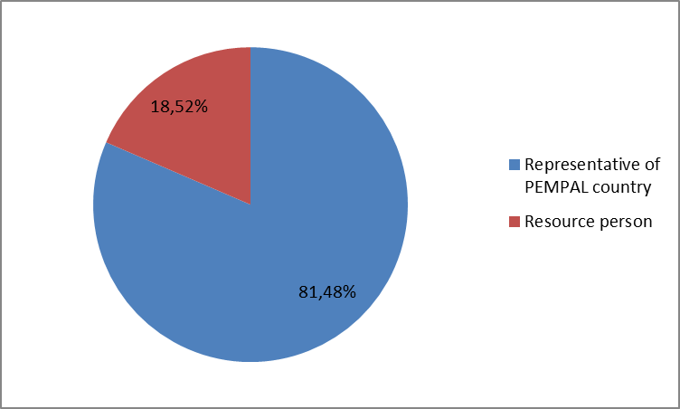

Q2. Was this your first participation in a PEMPAL event?

27 respondents (100%) answered this question. And 62.9% of them replied “No”.

Answer Options | Response Percent | Response Count
 | all | all | representatives | Resource persons
Yes | 37,0% | 10 | 8 | 2
No | 63,0% | 17 | 14 | 3

Q3. How many PEMPAL events have you attended before?

This question was seen only by those respondents who chose “No” in the previous question.
17 respondents answered this question.

1-2 | 3-4 | 5-6 | more than 6 | Response Count
3 | 3 | 2 | 9 | 17
PART I EVENT DELIVERY

Q4. How do you rate your participation in this event?

27 (100%) answers were given. 16 respondents think that their participation in the event was ‘Active’. 10 respondents think that their participation was ‘Average’. One person chose the option “Passive”.

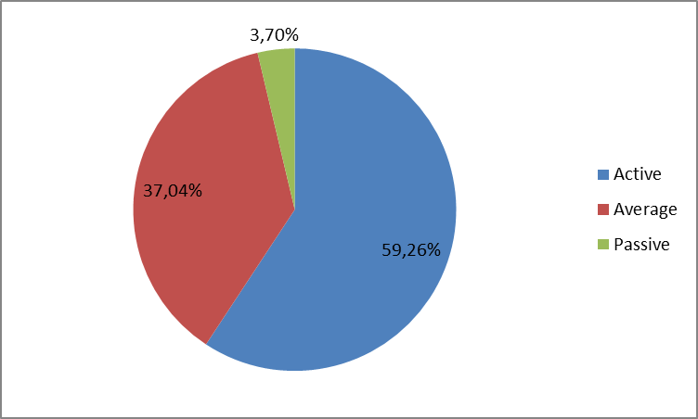
Among them:
3 resource persons were “Active”, 2 – “Average
13 representatives of PEMPAL countries were “Active”, 8 – “Average. 1 – “Passive”

Q5. How do you rate the event duration overall?

27 respondents (100%) answered this question. And 85.2% of them rated the event duration as “About right”.
Answer Options | Response Percent | Response Count
 | all | all | representatives | Resource persons
Too short | 14,8% | 4 | 3 | 1
About right | 85,2% | 23 | 19 | 4
Too long | 0% | 0 | 0 | 0

Q6. How much do you agree with the following statements about the participants of the event?
27 respondents (100%) replied to this question.
Answer Options | 1 strongly disagree | 2 | 3 | 4 | 5 Strongly agree | Response Count | Average
a) The level of the event was appropriate for a person with my experience and knowledge | 0 | 0 | 0 | 5 | 22 | 27 | 4,8
b) I learned from the experience of other participants in the event | 0 | 0 | 1 | 4 | 22 | 27 | 4,8
c) Participants had about equal level of prior expertise relevant to the event topics | 1 | 2 | 5 | 8 | 11 | 27 | 4,0
d) Content of presentations, hand-outs and other materials were appropriate for a person with my level of knowledge | 0 | 0 | 0 | 8 | 18 | 26 | 4,7
Q7. What have you learned from other participants?
13 comments were left. Here and after comments made by representatives of PEMPAL-member countries are bold.
- It was interesting to learn about experience of Georgia, Azerbaijan, and the Russian Federation.
- Experience of integration of the procurement system with the Treasury information system.
- I liked the Georgian experience more than others, I still get information from them on AIS (АИС) (on accounting and PFM).
- Rather did not learn, but took experience on implementation and realization of automated systems from participants in the PEMPAL program.
- QA process should be separated from business
- The Webportal is the tool to reduce the cost of physically submits of the justified documents of the payments to Treasury offices, to provide the electronic trail of audit and to speed up the formal communication between the institution and the Treasury. Also, transition from fragmented and outdated information systems into integrated FMIS which combines core FMIS modules (for online transaction processing to support daily PFM operations) with powerful Data Warehouse capabilities by extracting data from core FMIS and other government systems and transforming these to suitable forms for multidimensional data analysis tools for effective forecasting, improving of data quality and value, supporting decisions and monitoring of performance.
- In general, it was useful to learn about the implemented treasury management information systems in different countries and also about electronic document management systems.
- How to use new technologies.
- There was a lot of interesting information about other countries systems.
- Trends in extension of FMIS capabilities to support spending units and local governments. Improvements in service delivery channels linked to FMIS.
- Clarity of presentation.
- I learnt how to share my experience – it was my first public speech.
- Other countries' experiences.
Q8. How much do you agree with the following statements about the content design of the event? (Please rate each item):
24 respondents (88.9%) replied to this question.
Answer Options | 1 strongly disagree | 2 | 3 | 4 | 5 Strongly agree | Response Count | Average
a) The event agenda was properly planned | 0 | 0 | 1 | 3 | 23 | 27 | 4,8
b) The content of the event was properly prepared | 0 | 0 | 1 | 3 | 22 | 26 | 4,8
с) The event addressed issues important to my work | 0 | 0 | 0 | 5 | 22 | 27 | 4,8
d) The event covered a right number of topics for the amount of time available | 0 | 0 | 2 | 6 | 18 | 26 | 4,6
e) Presentations made during the event were relevant and useful | 0 | 0 | 0 | 7 | 20 | 27 | 4,7
f) Enough time was reserved for questions to speakers | 1 | 0 | 4 | 5 | 17 | 27 | 4,4
4 comments were left:
- Time reserved for questions to speakers was not enough, I could not ask all my questions.
- Everything was great and informative!
- There could be less focus on country specific solutions (two days) and more discussion on country cases and new technologies (instead of one day).
- It was not enough time to develop some topics.
Q9. The Baku event agenda envisaged a session devoted to sharing news by participating country delegations on the recent developments in the area of use of IT for public financial management. How do you rate this innovation for the TCOP events agenda?
26 responses (96.3%) were left.
Answer Options | Response Percent | Response Count
 | all | all | representatives | Resource persons
Very successful | 69,2% | 18 | 13 | 5
Successful | 30,8% | 8 | 8 | 0
Unsuccessful | 0% | 0 | 0 | 0
3 comments were left:
- After this program, I am receiving information from other participating countries and we are still sharing our experiences in the field of automation.
- I would like to inform you that everything was on an excellent level, but it would be better if the participants changed places each day, because on the first day of a session participants learnt enough about the systems of other participants in their table, and they would like to know a little about participants from other tables. Thank you!
- Additional incentive for participation.

Q10. The Baku event agenda included joint sessions with the TCOP thematic group on public sector accounting and reporting. How would you rate this experience?
26 responses (96.3%) were left.

Answer Options | Response Percent | Response Count
 | all | all | representatives | Resource persons
Very successful | 57.7% | 15 | 11 | 4
Successful | 42.3% | 11 | 11 | 0
Unsuccessful | 0% | 0 | 0 | 0
2 comments were left:
- I received a lot of useful information about accounting.
- Everything was to the propose...
Q11. How much do you agree with the following statements about the outcomes of the event? (Please rate each item):
26 responses (96.3%) were left.
Answer Options | 1 strongly disagree | 2 | 3 | 4 | 5 Strongly agree | Response Count | Average
a) Participants have got comprehensive information on the hosting country’s experience in developing and maintaining the treasury information system, challenges faced and lessons learnt, and identified dimensions of the Azerbaijan experience that are of particular interest for their countries | 0 | 0 | 1 | 7 | 18 | 26 | 4,7
b) Participants have got information on examples of use of modern information technologies for improving selected government services in Azerbaijan and identified dimensions of the Azerbaijan experience that are of particular interest for their countries | 0 | 0 | 1 | 4 | 21 | 26 | 4,8
с) Participants received comprehensive information regarding the approaches for automating accounting and reporting at the spending unit level and integration of the respective solutions with the central financial management information systems | 0 | 1 | 3 | 7 | 15 | 26 | 4.4

Representatives of PEMPAL countries
Answer Options | 1 strongly disagree | 2 | 3 | 4 | 5 Strongly agree | Response Count | Average
a) | 0 | 0 | 1 | 6 | 14 | 21 | 4.6
b) | 0 | 0 | 1 | 3 | 17 | 21 | 4.8
c) | 0 | 0 | 3 | 7 | 11 | 21 | 4.4
Resource persons
a) | 0 | 0 | 0 | 1 | 4 | 5 | 4.8
b) | 0 | 0 | 0 | 1 | 4 | 5 | 4.8
c) | 0 | 1 | 0 | 0 | 4 | 5 | 4.4
1 comments was left.
- There was not enough information about accounting in the automation sphere.
Q12. Please rate the quality of the leadership, management and/or technical services provided to the event by the following:
26 responses (96.3%) were left.
Answer Options | 1 low | 2 | 3 | 4 | 5 high | Response Count | Average
TCOP Executive Committee | 0 | 0 | 0 | 3 | 23 | 26 | 4.9
WB Resource Team | 0 | 0 | 0 | 4 | 21 | 25 | 4.8

1 comment was left:
- Organization was very qualitative. It would be better to have such events more often.
Q13. Please rate the quality of services provided by the event speaker(s):
26 responses (96.3%) were left. All the ratings are high.
Answer Options | 1 low | 2 | 3 | 4 | 5 high | Response Count | Average
Quality of service | 0 | 0 | 0 | 6 | 20 | 26 | 4,8
3 comments were left:

Please include a practical part.

I appreciate very much the presentations and advise of Cem Dener which are very helpful and useful for our countries PFM systems.

Consider changing question from services to competence of speakers

PART 2 EVENT ADMINISTRATION
Q14. Please rate the quality of the organization and administration of the event:
Answered question — 26 (96.3%). All the ratings are very good.
Answer Options | 1 low | 2 | 3 | 4 | 5 high | Response Count | Average
Quality of organization
- choice of venue | 0 | 0 | 0 | 0 | 26 | 26 | 5,0
- travel arrangements | 0 | 0 | 1 | 1 | 22 | 24 | 4.9
- event logistics | 0 | 0 | 0 | 1 | 23 | 24 | 5,0
- contribution provided by hosts | 0 | 0 | 0 | 0 | 25 | 25 | 5,0
Quality of administration
- Secretariat staff responsiveness | 0 | 0 | 0 | 1 | 25 | 26 | 5,0
- written communication | 0 | 0 | 0 | 1 | 25 | 26 | 5,0
- participant registration | 0 | 0 | 0 | 0 | 25 | 25 | 5,0

There was no any informative comment.

Q15. Did you receive agenda and event information in sufficient time before the event for them to be useful?
26 (96.3%) answers were given. And 100% responses were “Yes”.
Q16. Did you receive practical information (about the accommodation and other facilities, etc.) prior to the event?
24 (88.9%) answers were given. And 100% responses were “Yes”.
Q17. Did the paperless approach in distributing materials affect your ability to understand/absorb information during the event?
26 responses (96.3%) were left.
Answer Options | Response Percent | Response Count
 | all | all | representatives | Resource persons
Yes | 26.9% | 7 | 4 | 3
No | 73.1% | 19 | 17 | 2
Q18. Did you try to access event presentations on the web site in preparation for the event?
26 responses (96.3%) were left.
Answer Options | Response Percent | Response Count
 | all | all | representatives | Resource persons
Yes | 96.15% | 25 | 21 | 4
No | 3.85% | 1 | 0 | 1

Q19. Did you find the practice of posting presentations on the web site before the event helpful?
26 responses (96.3%) were left. All the responses (100%) were “Yes”.
2 comments were left:
- Presentation on information security helped a lot to solve some problems.
- Very convenient.
Q20. Are you satisfied with the quality of simultaneous interpretation provided during the event?
24 (88.9%) answers were given.
Answer Options | 1 low | 2 | 3 | 4 | 5 high | Response Count | Average
 | 0 | 0 | 1 | 2 | 21 | 24 | 4,8
Representatives of PEMPAL countries
Answer Options | 1 low | 2 | 3 | 4 | 5 high | Response Count | Average
 | 0 | 0 | 1 | 1 | 17 | 19 | 4.8
Resource persons
 | 0 | 0 | 0 | 1 | 4 | 5 | 4.8
3 comments were given.
- Interpreter who was with us in Mangal restaurant is better than other one.
- Score refers to Azerbaijan English translation only.
- Interpretation sometimes was late. But there was also fault of the speakers - a very fast speech.
Q21. Are you satisfied with the quality of written translation of event materials?
25 (92.6%) answers were given.

Answer Options | 1 low | 2 | 3 | 4 | 5 high | Response Count | Average
 | 0 | 0 | 0 | 5 | 20 | 25 | 4,8
Representatives of PEMPAL countries
Answer Options | 1 low | 2 | 3 | 4 | 5 high | Response Count | Average
 | 0 | 0 | 0 | 4 | 16 | 20 | 4.8
Resource persons
 | 0 | 0 | 0 | 1 | 4 | 5 | 4.8
1 comment was given: We received all materials already translated.
PART 3 OVERALL IMPRESSION
Q22. Did the event disappoint, meet, or exceed your expectations?

26 (96.3%) participants answered the question.

Answer Options | Response Percent | Response Count
 | all | all | representatives | Resource persons
Disappoint | 0,0% | 0 | 0 | 0
Meet | 61.5% | 16 | 14 | 2
Exceed | 38.5% | 10 | 7 | 3

Q23. What did you like best about the event?

- informative comments were left. Participants like different aspects of the event:

Hospitality and experience of the host country were mentioned in 6 comments. For example: “A clear example of how to work the Agency for provision of services to population of Azerbaijan (ASAN)“and “Openness and willingness of the host country to share their experiences.”

Experience exchange was mentioned in 6 comments. For example: “Networking opportunity and learning from country experiences” and “I liked the colorful experience and opinions of the participants.”

Presentations were mentioned in 2 comments.

Organization was mentioned in 2 comments.

Other comments:
- Meeting of all three parties, the political component, business processes and technical component, which is the executor of all requirements
- Contribution to my knowledge base for future use.
- I received clear, understandable answers to all my questions put by me before the beginning of the event. I was pleasantly surprised by this fact.
- Joint session with Reporting and Accounting group. (Small group discussions).
Q24. What did you not like most about the event?

6 comments were left and only one of them consists the piece of criticism.

- Some topics covered other areas, and it was not enough information about automation of accounting.

Q25. Do you plan to brief your colleagues about the event?
26 (96.3%) participants answered the question. And 100% of them responded “Yes”.
Q26. How do you plan to brief your colleagues?
Answered question – 24 (88.9%). Most of respondents were going to prepare a report.
Answer Options | Response Percent | Response Count
 | all | all | representatives | Resource persons
Share materials | 66.7% | 16 | 12 | 4
Make a presentation | 29.2% | 7 | 5 | 2
Prepare a back-to-office report | 75% | 18 | 17 | 1
3 comments were given:
- I have already held meetings, since we are engaged in automation of accounting and formation of the budget process and discussed in detail in each area all the handouts with my colleagues..
- Oral report!
- In private communication with the core personnel.
Q27. If your Ministry plans to promote this event, or PEMPAL in general, in internal or external media (e.g. MoF or other government website, MoF journal, television, radio, newspapers), please provide specific details so we can report to donors on any positive promotion of the value and benefits of PEMPAL.
8 comments were left and 4 of them are informative.
- We will post an article in the practical magazine "Treasury of Ukraine" about the trip, purposes of the stay, acquired experience.
- Web-site of our Treasury.
- We have placed a material about the trip of delegates from Kazakhstan on the Kazakhstan MoF website, as well as on news sites, such as tengrinews.kz and zakon.kz.
- See http://maliyye.gov.az/node/2155.
Q28. How much do you agree with the following statement?
26 respondents (96.3%) answered this question. Average rating is positive.
Answer Options | 1 not at all | 2 | 3 | 4 | 5 completely | Response Count | Average
I will be able to apply the knowledge acquired at this event to my work | 0 | 0 | 1 | 7 | 18 | 26 | 4,7
Representatives of PEMPAL countries
Answer Options | 1 not at all | 2 | 3 | 4 | 5 completely | Response Count | Average
 | 0 | 0 | 1 | 7 | 13 | 21 | 4.6
Resource persons
 | 0 | 0 | 0 | 0 | 5 | 5 | 5

Q29. How can you apply the acquired knowledge?
12 informative comments were left.
- Take into account the acquired experience and ways to overcome the emerging difficulties in development of the treasury system.
- In practice, as well as by the method of bringing the acquired information to specialists dealing with such issues.
- When planning integration of the procurement system with the Treasury information system.
- Integration of STA with account and with the portal of the state purchase.
- At the implementation stages!
- I will use them for preparing proposals to my management.
- I have prepared an explanatory memo to the high management for this event to report the best experience that was presented in this event to adapt it with the environment under which the IT system of the Treasury is operating.
- Review of business processes.
- Use it when discussing country experience.
- By sharing good practices and lessons learned with the project teams involved.
- In practical work.
- I cannot describe all details of acquired experience because they are very technical and specific.
Q30. Overall, my satisfaction with the event was...
Answered question – 26 (96,3%). There were no negative answers.
1 not satisfied | 2 | 3 | 4 | 5 highly satisfied | Response Count | Average
0 | 0 | 0 | 3 | 23 | 26 | 4,9
Representatives of PEMPAL countries
1 not satisfied | 2 | 3 | 4 | 5 highly satisfied | Response Count | Average
0 | 0 | 0 | 3 | 18 | 21 | 4.85
Resource persons
1 not satisfied | 2 | 3 | 4 | 5 highly satisfied | Response Count | Average
0 | 0 | 0 | 0 | 5 | 5 | 5

Q31. If you have any other comments you would like to provide us, please provide them here.

4 comments were left.

If possible we would like to see the Georgian experience.

High level of preparation of the host, presentations, 2d and 3 d days were particularly interesting, work in small groups systematizes information.

Adhere to this format of a meeting. Technical part and business processes.

Thank you and once again I hope to be invited to the next meetings.

PART 4 RECOMMENDATIONS FOR THE FUTURE

Q32. Do you have any suggestions to improve the content, approach and other aspects of such events in future?
7 comments were left and 4 of them are informative.
- Please more often hold such events in the field of automation.
- As a new participant I would suggest looking at the implementation experience in the most developed countries.
- Participation of the WB expert report is extremely necessary with an overview of the latest trends in the use of IT.
- Continue the exchange of news, attract more practical experts."

