PEMPAL TCOP IT TG MEETING IN BUDAPEST FEEDBACK SURVEY
On June 4-5, 2019, the workshop of the PEMPAL TCOP thematic group on the use of IT in Treasury Operations took place in Budapest, Hungary.
After the event, the on-line survey in two languages was created on the base of the standard set of questions developed in June 2017. The aim of the survey was to receive event feedback.

Link to the survey – https://www.surveymonkey.com/r/WVB2ZPY

The survey started to collect responses on June 17 and finished on June 26, 2019.
Invitations to take part in the survey were sent to all participants of the event. We sent 45 invitations.
28 persons started to response to the survey. From these 28 responses 20 were from representatives of PEMPAL countries, 7 — from resource persons, 1 respondent did not indicate themselves. In this report, we analyze all 28 responses. For further calculation, we take this quantity as 100%.

All these responses will be included in the general Feedback Event Database.
The questionnaire comprises five parts: About the Respondent, Event Delivery, Event Administration, Overall Impression, and Recommendations for the Future. There are 30 questions in the survey.
ABOUT THE RESPONDENT

Q1 You are...

27 (96.4%) respondents gave answers. Among them: 20 representatives of PEMPAL countries, 7 resource persons.
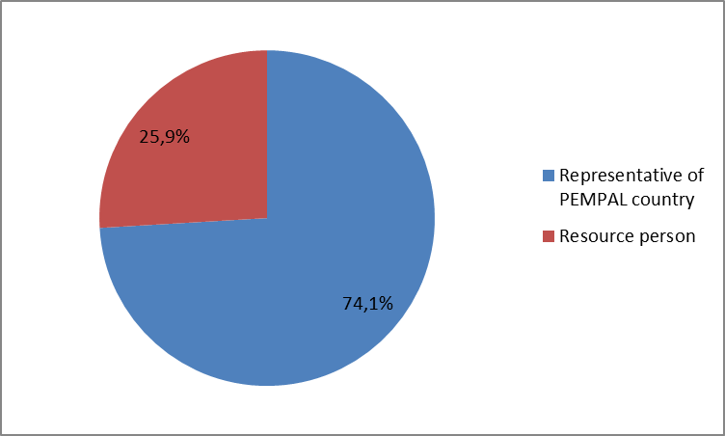

Q2. Was this your first participation in a PEMPAL event?

28 respondents (100%) answered this question. And 60.7% of them replied “Yes”.

Answer Options | Response Percent | Response Count
 | all | all | Representatives | Resource persons
Yes | 60,7% | 17 | 11 | 6
No | 39,3% | 11 | 9 | 2

Q3. How many PEMPAL events have you attended before?

This question was seen only by those respondents who chose “No” in the previous question.
11 respondents answered this question.
1-2 | 3-4 | 5-6 | more than 6 | Response Count
3 | 2 | 2 | 4 | 11
PART I EVENT DELIVERY

Q4. How do you rate your participation in this event?

28 (100%) answers were given. 11 respondents think that their participation in the event was ‘Active’. 14 respondents think that their participation was ‘Average’. 3 persons chose the option “Passive”.
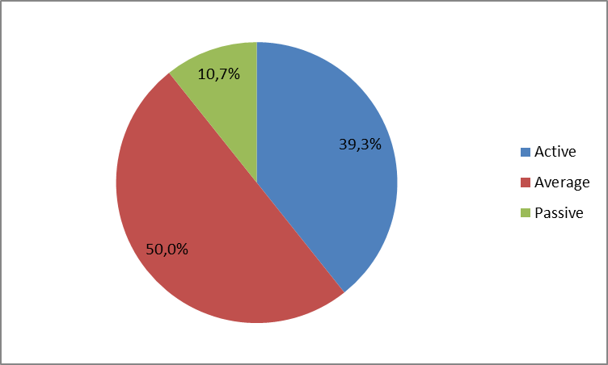
Among them:
4 resource persons were “Active”, 4 – “Average”.
7 representatives were “Active”, 10 – “Average, 3 – “Passive”.

Q5. How do you rate the event duration overall?

28 respondents (100%) answered this question. And 82.1% of them rated the event duration as “About right”.
Answer Options | Response Percent | Response Count
 | all | all | representatives | Resource persons
Too short | 17,9% | 5 | 4 | 1
About right | 82,1% | 23 | 16 | 7
Too long | 0,0% | 0 | 0 | 0

Q6. How much do you agree with the following statements about the participants of the event?
25 respondents (89.3%) replied to this question.
Answer Options | 1 strongly disagree | 2 | 3 | 4 | 5 Strongly agree | Response Count | Average
a) The level of the event was appropriate for a person with my experience and knowledge | 0 | 0 | 2 | 5 | 18 | 25 | 4,6
b) I learned from the experience of other participants in the event | 0 | 0 | 4 | 3 | 18 | 25 | 4,6
c) Participants had about equal level of prior expertise relevant to the event topics | 0 | 1 | 5 | 12 | 7 | 25 | 4,0
d) Content of presentations, hand-outs and other materials were appropriate for a person with my level of knowledge | 0 | 0 | 2 | 8 | 14 | 24 | 4,5
Q7. What have you learned from other participants?
7 comments were left. Here and after comments made by representatives are bold.
- I really liked the experience of colleagues from Russia, Kazakhstan and Georgia. The presentation of the colleagues from the treasury of Hungary was very interesting.
- Experience in using Opensourse solutions in the development of systems.
- For example, with the Russian Federation - hold the balances of fixed assets in the program and keep their records, from Rwanda - exchange of information on the conduct of public procurement with the treasury, the tax authorities, the bank, the supplier. I think this is a very good method for paying taxes on time.
- Ability to competently express my thoughts.
- How the similar projects are going.
- We have learned that e-procurement system should be in interoperability with e-treasury system.
- How to do presentations.
Q8. How much do you agree with the following statements about the content design of the event? (Please rate each item):
24 respondents (85.7%) replied to this question.
Answer Options | 1 strongly disagree | 2 | 3 | 4 | 5 Strongly agree | Response Count | Average
a) The event agenda was properly planned | 0 | 1 | 0 | 5 | 18 | 24 | 4,7
b) The content of the event was properly prepared | 0 | 1 | 0 | 4 | 18 | 23 | 4,7
с) The event addressed issues important to my work | 0 | 1 | 0 | 5 | 18 | 24 | 4,7
d) The event covered a right number of topics for the amount of time available | 0 | 1 | 2 | 7 | 14 | 24 | 4,4
e) The topics for the group discussions were relevant | 0 | 0 | 3 | 6 | 14 | 23 | 4,5
f) Enough time was reserved for group discussions | 0 | 0 | 1 | 7 | 15 | 23 | 4,6
g) Presentations made during the event were relevant and useful | 0 | 1 | 0 | 4 | 19 | 24 | 4,7
h) Enough time was reserved for questions to speakers | 0 | 0 | 2 | 6 | 16 | 24 | 4,6
5 comments were left:
- Both the topics for the presentations and the presentations themselves were well chosen and turned out to be very interesting.
- During the group discussion, the opinions of all the participants were taken into account and it was enough time. Presentations from other countries and Hungary about payroll accounting, taking into account the time worked, this accounting as in the 1C program is the best option for all states.
- The established time limits are precisely maintained. The participants of our table had time to exchange a wider range of questions close to the topic of discussion.
- The team did not prepare (rehearsed) reports from the host country.
- There was not enough time for questions to speakers. Good content of the event. Important topics.
Q9. How much do you agree with the following statements about the outcomes of the event?
21 responses (75%) were left.
Event objective has been achieved: | 1 strongly disagree | 2 | 3 | 4 | 5 Strongly agree | Response Count | Average
a) Participants were familiarized with the IT systems used by the Treasury of Hungary and discussed the latest developments on the use of IT for public financial management in other participating countries | 0 | 1 | 1 | 7 | 12 | 21 | 4,4
b) Participants have explored the links between budget execution and public procurement processes and respective IT systems in participating countries and enhanced their understanding of the topic | 0 | 0 | 2 | 5 | 14 | 21 | 4,6

Representatives
Answer Options | 1 strongly disagree | 2 | 3 | 4 | 5 Strongly agree | Response Count | Average
a) | 0 | 1 | 1 | 6 | 8 | 16 | 4.3
b) | 0 | 0 | 1 | 5 | 10 | 16 | 4.6
Resource persons
a) | 0 | 0 | 0 | 1 | 4 | 5 | 4,8
b) | 0 | 0 | 1 | 0 | 4 | 5 | 4,6
3 comments were left.
- Experience of Hungary in creating a platform for servicing municipalities, the experience of Russia in integrating the procurement system with the treasury system were interesting.
- Possibly the novice member factor influenced me. After returning, I looked at the noted made at meetings, some questions appeared that I would have asked the speakers.
- As a participant in the event, I studied the relationship between budget execution and government procurement.
Q10. Please rate the quality of the leadership, management and/or technical services provided to the event by the following:
21 responses (75%) were left.
Answer Options | 1 low | 2 | 3 | 4 | 5 high | Response Count | Average
TCOP Executive Committee | 0 | 0 | 2 | 3 | 18 | 21 | 4,9
WB Resource Team | 0 | 0 | 2 | 1 | 20 | 21 | 4,95

4 comments were left:
- Everything was meaningful, interesting, a special gratitude to Mr. C. Dener for the presentation and for inviting a colleague from Rwanda who introduced us to the experience of implementing systems based on Open Source solutions.
- Great!
- The quality of the resource team was highly professional and their advice was very useful for us.
- Leadership, management and / or technical services were at good level.
Q11. Please rate the work of the event speaker(s):
22 responses (78.6%) were left.
Answer Options | 1 low | 2 | 3 | 4 | 5 high | Response Count | Average
Quality of service | 0 | 0 | 1 | 8 | 13 | 22 | 4,5
1 comment was left: “Absolutely all the speakers did a wonderful job, very interesting and informative presentations.”

PART 2 EVENT ADMINISTRATION
Q12. Please rate the quality of the organization and administration of the event:
Answered question — 22 (78.6%). Practically all the ratings are very good.
Answer Options | 1 low | 2 | 3 | 4 | 5 high | Response Count | Average
Quality of organization
- choice of venue | 0 | 0 | 0 | 1 | 20 | 21 | 5,0
- travel arrangements | 0 | 0 | 0 | 1 | 20 | 21 | 5,0
- event logistics | 0 | 0 | 0 | 1 | 20 | 21 | 5,0
- contribution provided by hosts | 0 | 0 | 0 | 2 | 20 | 22 | 4,9
Quality of administration
- Secretariat staff responsiveness | 0 | 0 | 0 | 1 | 21 | 22 | 5,0
- written communication | 0 | 1 | 0 | 0 | 21 | 22 | 4,9
- participant registration | 0 | 0 | 1 | 0 | 21 | 22 | 4,9

5 comments were left:
- For us, a flight with stop overs and with a car trip was very inconvenient: more spending, more time waiting and on the plane and painfully.
- Everything, as always, was organized flawlessly. Excellent choice of the hotel, convenient flight, a wonderful walk along the Danube.
- The quality of the organizational preparation for the workshop was quite appropriate for me.
- Thanks to Ekaterina Zaleeva. Before obtaining a visa, there were issues that she promptly resolved.
- The quality of the preparatory events was a good one.
Q13. Did you receive agenda and event information in sufficient time before the event for them to be useful?
23 (82.1%) answers were given. And 100% responses were “Yes”.
Q14. Did you receive practical information (about the accommodation and other facilities, etc.) prior to the event?
22 (78.6%) answers were given. And 100% responses were “Yes”.
Q15. Did the paperless approach in distributing materials affect your ability to understand/absorb information during the event?
23 responses (82.1%) were left.
Answer Options | Response Percent | Response Count
 | all | all | representatives | Resource persons
Yes | 30,4% | 7 | 6 | 1
No | 69,6% | 16 | 12 | 4
Q16. Did you try to access event presentations on the web site in preparation for the event?
23 responses (82.1%) were left.
Answer Options | Response Percent | Response Count
 | all | all | representatives | Resource persons
Yes | 78,3% | 18 | 13 | 5
No | 21,7% | 5 | 5 | 0
Q17. Did you find the practice of posting presentations on the web site before the event helpful?
23 responses (82.1%) were left.
Answer Options | Response Percent | Response Count
 | all | all | representatives | Resource persons
Yes | 95,7% | 22 | 17 | 5
No | 4,4% | 1 | 1 | 0

Q18. Are you satisfied with the quality of simultaneous interpretation provided during the event?
22 (78.6%) answers were given.
Answer Options | 1 low | 2 | 3 | 4 | 5 high | Response Count | Average
 | 0 | 1 | 4 | 5 | 12 | 22 | 4,3
Representatives
Answer Options | 1 low | 2 | 3 | 4 | 5 high | Response Count | Average
 | 0 | 0 | 3 | 5 | 9 | 17 | 4.4
Resource persons
 | 0 | 1 | 1 | 0 | 3 | 5 | 4.0
4 comments were given.
- Translators tried to do their best.
- The translation was very high quality and good.
- The presenters performed very quickly, so for the interpreters it was a difficult task.
- Delighted with the skill of the interpreters!
Q19. Are you satisfied with the quality of written translation of event materials?
22 (78,6%) answers were given.
Answer Options | 1 low | 2 | 3 | 4 | 5 high | Response Count | Average
 | 0 | 1 | 0 | 6 | 15 | 22 | 4,6
Representatives
Answer Options | 1 low | 2 | 3 | 4 | 5 high | Response Count | Average
 | 0 | 0 | 0 | 6 | 11 | 17 | 4.6
Resource persons
 | 0 | 1 | 0 | 0 | 4 | 5 | 4,4
2 comments were given: “The translation was excellent ”,“ No comments.”
PART 3 OVERALL IMPRESSION
Q20. Did the event disappoint, meet, or exceed your expectations?
23 (82.1%) participants answered the question.
Answer Options | Response Percent | Response Count
 | all | all | representatives | Resource persons
Disappoint | 4,4% | 1 | 1 | 0
Meet | 73,9% | 17 | 14 | 3
Exceed | 21,7% | 5 | 3 | 2

Q21. What did you like best about the event?

8 comments were left. Participants like different aspects of the event:

- Meeting at the tables, presentations of speakers, time for questions.
- Opportunity to discuss with colleagues the questions covered at this event, small group discussions were very useful and interesting.
- Professionalism and openness of participants, relevance of the selected topics for discussion.
- Correctness and respect for each other. Active participation of the members.
- Communication with the colleagues.
- Social event
- The country contributions and international speakers
- Group discussions. Presentations. News exchange.
Q22. What did you not like most about the event?
6 comments were left and only 2 of them consist the piece of criticism:

The whole day long we spent as students at the table, it was possible to organize city-tours that would be perfect and would give the participants a chance to get to know each other better.

The first day was not prepared. There was not any fault of the speakers in this.

Q23. Do you plan to brief your colleagues about the event?
23 (82.1%) participants answered the question. And 95.7% of them responded “Yes”. 1 respondent (resource person) replied “No”.
Q24. How do you plan to brief your colleagues?
Answered question – 22 (78.6%). Most of the respondents were going to prepare back-to-office report.
Answer Options | Response Percent | Response Count
 | all | all | representatives | Resource persons
Share materials | 45,5% | 10 | 7 | 3
Make a presentation | 9,1% | 2 | 2 | 0
Prepare a back-to-office report | 77,3% | 17 | 16 | 1
2 comments were given:
- And talked more about my impressions about this workshop.
- I have already provided a report to the management on all presentations in the event, on new solutions and on integration of treasury and procurement systems
Q25. If your Ministry plans to promote this event, or PEMPAL in general, in internal or external media (e.g. MoF or other government website, MoF journal, television, radio, newspapers), please provide specific details so we can report to donors on any positive promotion of the value and benefits of PEMPAL.
1 informative comment was left: “News on the Treasury web-site on participation at the event: https://www.treasury.gov.ua/ua/news/shchorichne-plenarne-zasidannya-mizhnarodnoyi-kaznachejskoyi-spilnoti-pempal-u-budapeshti.”
Q26. How much do you agree with the following statement?
22 respondents (78.6%) answered this question. Average rating is positive.
Answer Options | 1 not at all | 2 | 3 | 4 | 5 completely | Response Count | Average
I will be able to apply the knowledge acquired at this event to my work | 0 | 0 | 4 | 7 | 11 | 22 | 4,3
Representatives
Answer Options | 1 not at all | 2 | 3 | 4 | 5 completely | Response Count | Average
 | 0 | 0 | 2 | 7 | 8 | 17 | 4.4
Resource persons
 | 0 | 0 | 2 | 0 | 3 | 5 | 4.2

Q27. How can you apply the acquired knowledge?
9 informative comments were left.
- In working on the projects in my country
- When integrating the treasury system with the procurement system, we will take into account the experience of the countries that have carried out this implementation, as well as will consider how effective such an implementation is in terms of budget execution.
- For future development.
- The experience was useful and will be used in the development of future plans for the development of IS of our MoF and Treasury.
- Speakers' presentations motivated me to make proposals for improving the Kazakhstan treasury service system.
- Establishing contacts with the countries where positive experience was noted.
- Participating and contributing in the solution design and implementation of the systems.
- Use of country examples as examples for other countries.
- I will apply the acquired knowledge in my work.
Q28. Overall, my satisfaction with the event was...
Answered question – 22 (78.6%). There were no negative answers.
1 not satisfied | 2 | 3 | 4 | 5 highly satisfied | Response Count | Average
0 | 0 | 1 | 3 | 18 | 22 | 4,8
Representatives
1 not satisfied | 2 | 3 | 4 | 5 highly satisfied | Response Count | Average
0 | 0 | 1 | 2 | 14 | 17 | 4.8
Resource persons
1 not satisfied | 2 | 3 | 4 | 5 highly satisfied | Response Count | Average
0 | 0 | 0 | 1 | 4 | 5 | 4.8

Q29. If you have any other comments you would like to provide us, please provide them here.

1 informative comment was left: “The selected format to exchange experience is useful for all participants. Even when talking to participants informally we were discussing business issues.”

PART 4 RECOMMENDATIONS FOR THE FUTURE

Q30. Do you have any suggestions to improve the content, approach and other aspects of such events in future?
4 comments were left and 3 of them are informative.
- For your consideration. A report from representatives of participating countries (selectively, or optionally, or from a list) on actual achievements / plans that resulted from participation in meetings organized by PEMPAL.
- To change the approach to the preparation of the event to better explain information system of a country presenting its case.
- Consider the possibility of holding a workshop - guided tour on site (in the Ministry of Finance or Treasury) of holding events (in the host country) and see the material presented at the workplace.

1 respondent did not indicate themselves.
Here and after “resource persons” we understand resource persons + person who did not indicate themselves.

