Videoconference of the Thematic Group of the PEMPAL Treasury Community of Practice on Use of Information Technologies in Treasury Operations
April 5, 2016
___________________________________________________

According to the Action Plan of the Thematic Group on Use of Information Technologies in Treasury Operations, on April 5, 2016, a videoconference of the group took place. It covered experience of Kazakhstan in the field of interaction with providers of services related to maintenance of the FMIS. Twenty-two members of the thematic group from 8 countries (Albania, Azerbaijan, Belarus, Georgia, Kazakhstan, Moldova, Russian Federation and Turkey) took part in the videoconference. In addition, Elena Nikulina, PEMPAL Task Team Leader, and Ion Chicu, TCOP consultant participated in the videoconference. The agenda of the videoconference is inserted in the paragraph.
Mr. Erlan Shalghimbaev. Head of the IT Department of the Treasury Committee of the Republic of Kazakhstan made a presentation “Experience of Kazakhstan in the interaction with the service providers supporting the FMIS”. The presentation contained comprehensive information on stages of development of the treasury information system of Kazakhstan and on the relevant experience of interaction with providers of services related to its maintenance at all stages. In his speech, Mr. Shalghimbaev described in details the specifics of organization of public procurements for ensuring smooth functioning of the FMIS in Kazakhstan; he presented positive and negative aspects and risks associated with different approaches in organization of public procurements of relevant services (by means of a tender or through a single operator); informed the participants about legislative changes in Kazakhstan related to acquisition of services needed for smooth functioning of information systems used by public bodies; he described the service model of informatization of public bodies and criteria for selecting the service creation model.
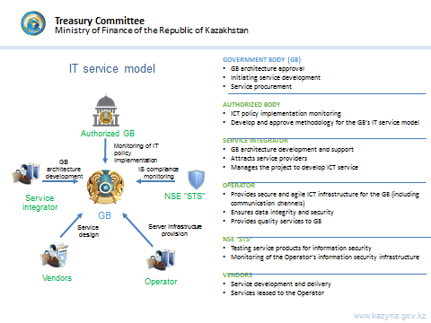

At present, according to the legislation of the Republic of Kazakhstan, information resources included in the list of National Information Systems approved by the Decree of the Government of the Republic of Kazakhstan should be supported by the single operator of the information-communication infrastructure. The operator is the JSC “National Information Technologies”, a company with 100% share of the state in the statutory capital.
After the presentation, a question and answer session was held. Questions of the participants were related both to characteristics of the FMIS as such, and directly to aspects of relations with service providers with respect to system maintenance. In the course of the question and answer session the group members received more detailed information on the list (coverage) of services provided to the Treasury Committee of Kazakhstan by the JSC “National Information Technologies”; on aspects related to liability in case there are failures in the system operation; on ensuring information security in the framework of work on maintenance of the information system; on approaches to organization of work of certification authorities in Kazakhstan.
At the same time, since the time reserved for this session expired, the participants of the videoconference did not manage to get answers and to discuss questions related to the process of making changes in the system, fine-tuning of the system and building-up functional parameters, allocation of roles in these processes, etc. The participants of the videoconference decided that these aspects would be discussed in the framework of one of the subsequent meetings of the group.
The second issue of the videoconference agenda was related to preparation of the thematic group meeting that would be held on June 3-4, 2016, in Kishinev, Moldova. The main goal of the workshop in Kishinev is to give an opportunity to the members of the TCOP thematic group on use of information technologies in treasury operations to discuss issues that are of priority interest to them based on the experience of the hosting country – Moldova. Representatives of Moldova presented brief information to the participants of the videoconference on presentations that would be made by the hosting country at the meeting, and also informed on planned demonstration of operation in real time of the new FMIS. At the suggestion of the group members, in the course of the meeting Moldova would prepare and deliver an additional presentation that demonstrates the experience of organizing the project on implementation of the FMIS, of project management, lessons learnt in the course of implementing the new information system.
The participants of the videoconference made their proposals concerning the thematic part of the meeting in Kishinev; on the basis of these proposals the event agenda has been developed.

