Videoconference of the PEMPAL TCOP Thematic Group on
Use of IT in Treasury Operations
March 1, 2018
___________________________________________________

In accordance with the Action Plan of the TCOP Thematic Group on the Use of IT in Treasury Operations, a videoconference was held on March 1, 2018 to discuss Georgia’s experience in accounting automation. The videoconference also discussed issues related to preparing the Thematic Group meeting scheduled to take place on April 10-12, 2018 in Baku, Azerbaijan. The videoconference gathered 28 Thematic Group members from 7 countries: Albania, Azerbaijan, Belarus, Georgia, Moldova, Turkey, and Ukraine. Members of the TCOP resource team Ms. Elena Nikulina (PEMPAL program coordinator) and Ms. Ekaterina Zaleeva (PEMPAL Secretariat) also took part in the event. The videoconference agenda is provided in the insert.
Representatives of the Georgian Ministry of Finance Mr. Guram Shvangiradze, Chief Analyst, and Mr. Levan Todua, Head of State Loans and Deposit Operation Department, State Treasury, MoF, presented Georgian experience in developing a PFM information system as the country is moving to the accrual method of accounting in the public sector. Government entities in Georgia use various software products to maintain their accounts. Parallel with the decision on moving to the accrual method of accounting, the Financial Analysis Service at the Ministry of Finance, which is responsible for designing and supporting an electronic system for public financial management in Georgia, was charged with the task to satisfy government-financed organizations’ needs in accounting and financial reporting directly through the centralized MoF system. Development of the relevant functionality is now under way. Salaries accounting is already performed within the centralized system.
Videoconference participants commented on the presentation of their Georgian colleagues. They decided to include a revised version of the presentation into the agenda of a joint meeting of TCOP IT and accounting thematic groups, scheduled to take place in April 2018 in Baku. Additions will be incorporated in the presentation to reflect comments by videoconference participants and TCOP resource team.

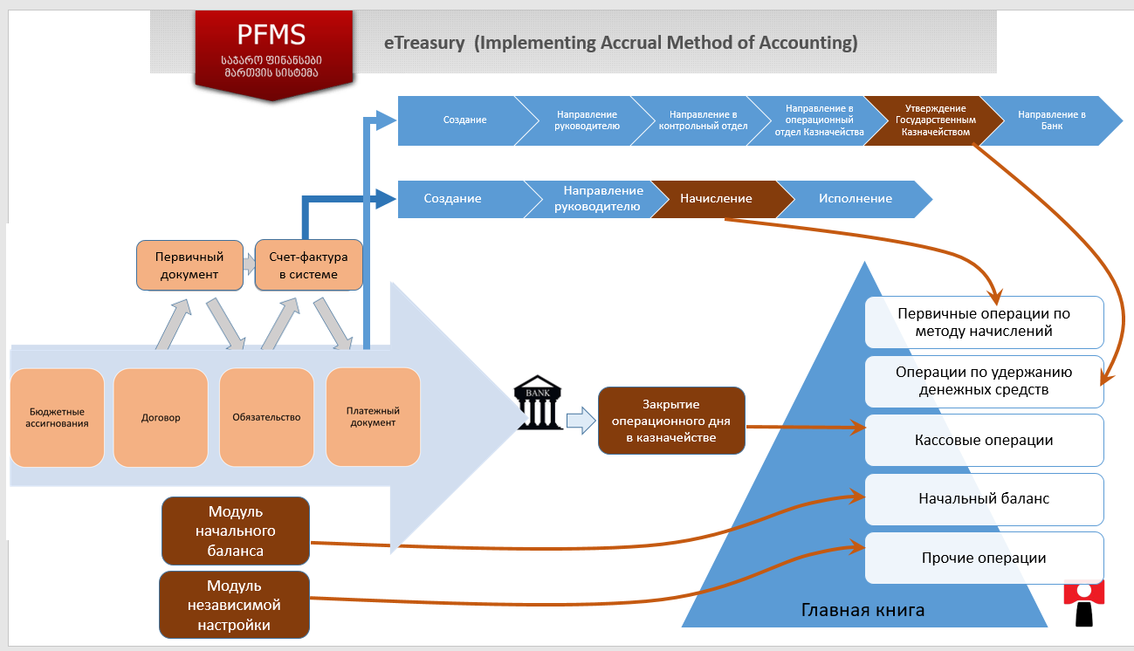

Opening the second part of the VC agenda, Elena Nikulina gave a brief overview of preparations for the TCOP Thematic Group meeting on the use of IT in treasury operations, planned to take place on April 10-12, 2018 in Baku, Azerbaijan. As decided by the TCOP Executive Committee, the agenda of the first two days of the meeting will focus on issues directly concerning the IT topics, while the third day will be dedicated to automation of accounting. The format of Day 3 also envisages the participation of members of another TCOP thematic group focusing on accounting and reporting in the public sector. Ms. Nikulina asked the participants to come up with suggestions on the Baku meeting agenda and nominate their candidates for the session on new developments in the member countries.
Mr. Nazim Kasum-zade, a representative of Azerbaijan, told the participants that the hosts are intensively preparing for the meeting. He also mentioned that some changes had to be made to the agenda because of presidential elections that are to take place on April 11.
On Day 1 there will be presentations by the Central Bank on payment systems and by ASAN on the provision of various government services. In the afternoon of Day 1 the participants will visit the Agency for Public Service Delivery and Social Innovations.
On Day 2, representatives of the Azerbaijan Treasury Agency will give several presentations reflecting, in particular, the experience of their country in developing the State Treasury Agency web portal (portal for the PFM system, portal for government reports, etc.); in creating a flexible IT infrastructure (how they migrated the system to the cloud, prepared the project, etc.); in implementing the project on upgrading the technology framework of the PFM system; in designing security solutions for the Treasury IT systems (attack protection system, network identification system, etc.); in managing access to and creating roles in the PFM system; in providing support for end users; in reforming accounting in the public sector with the use of cloud IT technologies on the basis of the Farabi project; and in improving the quality and reliability of financial reporting in the public sector through creating an integrated automated ERP platform.
The agenda of Day 3 of the Baku meeting will be prepared on the basis of suggestions made at the videoconference and with consideration for opinions of members of the Thematic Group on Public Sector Accounting and Reporting.

